Very early pulsed dye lase intervention for optimal cosmetic outcome in post-thyroidectomy scars

¹Yul Hee Kim, ¹Han Seul Kim, ²Hyeung Kyoo Kim, ²Soo Young Kim, ²Jeonghun Lee, ¹You Chan Kim, ¹Young Joon Park

¹Department of Dermatology, Ajou University, School of Medicine, Suwon, Korea
²Department of Surgery, Ajou University School of Medicine, Suwon, Republic of Korea

Correspondence to: Young Joon Park, MD, PhD
Department of Dermatology, Ajou University Hospital, 164, World cup-ro, Yeongtong-gu, Suwon-si, Gyeonggi-do, Republic of Korea
Tel: +82-31-219-5187
Email: aro@ajou.ac.kr

‘

Table S1. Demographic and clinical characteristics comparing the extra-early treatment group
Characteristics | Very early  treatment group | Early  treatment group | P
Period from surgery to initial PDL treatment,  mean (SD), days | 14.9 (2.6) | 31.0 (5.5)
Case No. | 56 | 35
Antera 3D camera measurement, N (%) | 33 (58.9) | 20 (65.7)
Sex, N (%) |  |  | 0.065
Female | 48 (85.7) | 24 (68.6)
Male | 8 (14.3) | 11 (31.4)
Age, mean (SD), years old | 41.3 (9.3) | 41.5 (9.3) | 0.917
Initial VSS, median (IQR) | 6.00 (3.00) | 5.00 (3.00) | 0.395
End VSS, median (IQR) | 2.00 (3.00) | 2.00 (3.00) | 0.220

SD: standard deviation, IQR: Interquartile Range, VSS: Vancouver Scar Scale

Table S2. Comparison of VSS and Antera scores according to triamcinolone intralesional injection
Total VSS (Mean±SD) | TAILI (+)  (n=39) | TAILI (-)  (n=52) | p-value
Initial | 6.23±1.83 | 5.16±1.67 | 0.0046
End | 2.62±1.55 | 1.37±1.48 | 0.0002
Percent change (%) | 59.30±22.04 | 75.11±26.80 | 0.0036
TAILI (+) group | WTH3  (n=25) | BTW4-6  (n=14) | p-value
Initial | 6.52±1.85 | 5.71±1.73 | 0.1903
End | 2.48±1.58 | 2.86±1.51 | 0.4733
Percent change (%) | 64.26±22.54 | 50.43±18.69 | 0.0591
TAILI (-) group | WTH3  (n=31) | BTW4-6  (n=21) | p-value
Initial | 5.16±1.73 | 5.15±1.60 | 0.9814
End | 1.25±1.37 | 1.55±1.67 | 0.4979
Percent change (%) | 78.58±22.18 | 69.73±32.61 | 0.2540
Antera (Mean±SD) | TAILI (+)  (n=39) | TAILI (-)  (n=52) | p-value
Color variation | 4.68±0.87 | 4.10±0.71 | 0.0094
Height | 0.07±0.01 | 0.06±0.01 | 0.0080
Pigmentation | 0.61±1.28 | 0.64±0.07 | 0.1809
Vascularity | 1.42±1.30.26 | 1.29±0.30 | 0.1184
TAILI (+) group | WTH3  (n=25) | BTW4-6  (n=14) | p-value
Color variation | 4.69±1.00 | 4.66±0.70 | 0.9354
Height | 0.07±0.01 | 0.07±0.01 | 0.9002
Pigmentation | 0.58±0.16 | 0.64±0.06 | 0.3132
Vascularity | 1.38±0.27 | 1.47±0.26 | 0.4110
TAILI (-) group | WTH3  (n=31) | BTW4-6  (n=21) | p-value
Color variation | 4.22±0.62 | 3.93±0.80 | 0.2983
Height | 0.06±0.01 | 0.06±0.01 | 0.8937
Pigmentation | 0.64±0.08 | 0.65±0.05 | 0.6255
Vascularity | 1.20±0.26 | 1.42±0.32 | 0.0642
SD: Standard Deviation, TAILI: Triamcinolone intralesional injection
WTH3: Initial treatment initiated within 3 weeks, BTW4-6: Between 4 to 6 weeks

Fig. S1 Flowchart of patient selection
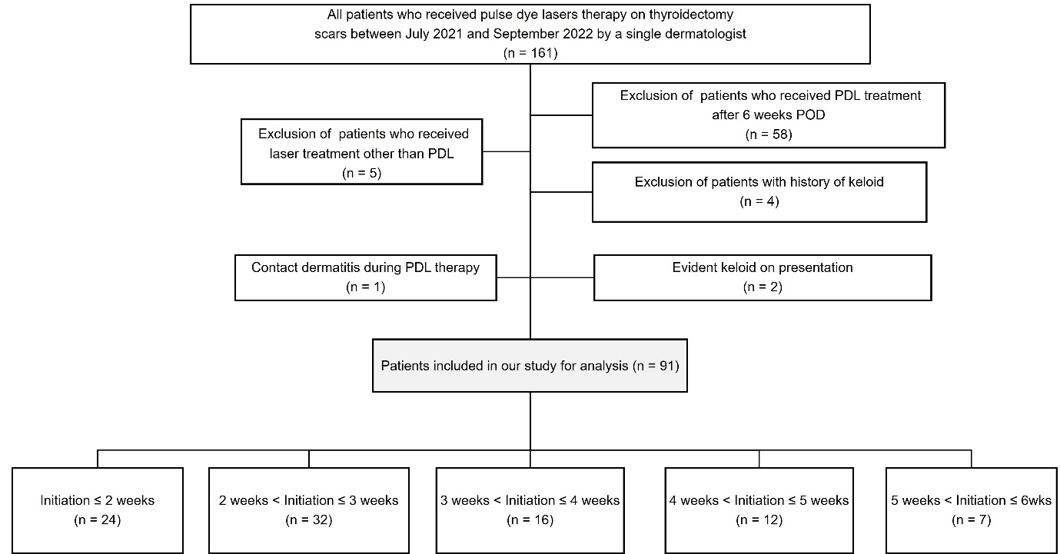
Fig. S2 (A) VSS at the initiation of treatment by date. (B) VSS at the initiation of treatment grouped by initiation week of therapy.
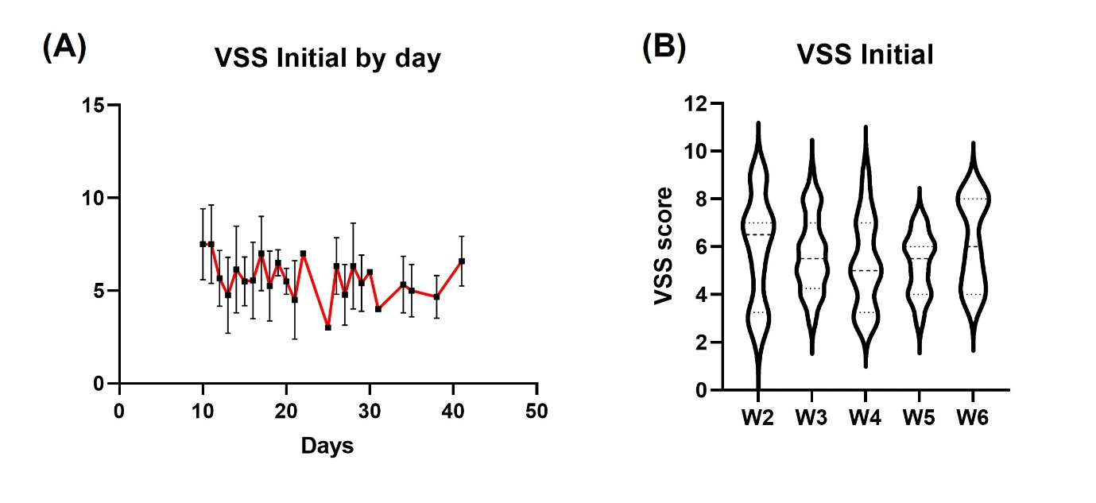

Fig. S3 Comparison of scar-related values, variation level of hemoglobin, and melanin obtained using Antera 3D camera. WTH3 represents the very early treatment group, where PDL treatment was initiated within 3 weeks post-surgery, while BTW4-6 represents the early treatment group, in which the treatment began between weeks 4 and 6 post-surgery.
