 |  | Control | AR
Subjects(n) |  | 22 | 22
Age(year) |  | 26.23±2.91 | 23.91±3.33
Gender(male/female) |  | 12/10 | 9/13
History(year) |  | 0 | 1.88±0.26
Dermatophagoides farina (+, n) |  | 0 | 22
House dust mite (+, n) |  | 0 | 22
Animal dander (+, n) |  | 0 | 4
Allergen-specific lgE (IU/ml) | Dermatophagoides farina | 0.08±0.02 | 26.28±5.17
 | House dust mite | 0.05±0.01 | 25.87±6.04
 | Animal dander | 0.05±0.01 | 0.24±0.11
Table S1. Clinical characteristics of included patients (The format of mean ± SEMs is utilized for presenting the data).

Genes | Primer
Human-β-actin | Forward primer: CCTGGCACCCAGCACAAT  Reverse primer: GGCCGGACTCGTCATAC
LINC00998 | Forward primer: GCTCTGCACTGACTCTAGCTG  Reverse primer: GCTCCGGATGCTGAGATTAAGA
Human-CD206 | Forward primer: TTGGACGGATGGACGAGGAGT  Reverse primer: TTGCTGGAGGATTAGTCAAGGAAGG
Human-ARG1 | Forward primer: CCAAGGTCTGTGGGAAAAGCA  Reverse primer: TACAGGGAGTCACCCAGGAG
Human-CD80 | Forward primer: TTTGACCCTAAGCATCTGAAGC  Reverse primer: ACCAGCCAGCACCAAGAG
Human-iNOS | Forward primer: CATCATGGACCACTCGGCTGC  Reverse primer: CCAGGTGGGACAGCTTCTGATCAA
Human-BOB.1 | Forward primer: AGCCTCAGCCAGAAGTACCA  Reverse primer: GTGAGCCAGTTCCCAAGGTA
Human-PU.1 | Forward primer: AAGTCCCAGTAATGGTCGCT  Reverse primer: AAGACCTGGTGCCCTATGAC
Human-IL-1β | Forward primer: AGAAGTACCTGAGCTCGCCA  Reverse primer: CTGGAAGGAGCACTTCATCTGT
Mouse-β-actin | Forward primer: GTGCTATGTTGCTCTAGACTTCG  Reverse primer: ATGCCACAGGATTCCATACC
Mouse-CD206 | Forward primer: GTTCACCTGGAGTGATGGTTCTC  Reverse primer: AGGACATGCCAGGGTCACCTTT
Mouse- ARG1 | Forward primer: GCATATCTGCCAAAGACATCGT  Reverse primer: TCTTCCATCACCTTGCCAATC
Table S2. List of primers used for qRT-PCR analysis.

Figure S1. Animal model making.
A: The procedure for mouse AR model; B: Evaluation of the symptoms. The nasal symptom score was based on three features(running nose, sneezing, and scratching): (1) Running nose: 0, none; 1, mucus in nostrils; 2, mucus outflow from nostrils; 3, mucus outflow to face; (2) Sneezing: 0, none; 1, 1-3 sneezes per 20 min; 2, 4-10 sneezes per 20 min; 3, ≥11 sneezes per 20 min; and (3) Scratching: 0, none; 1, nose rubbing 1-2 times per min; 2, nose rubbing 3-5 times per min; 3, nose rubbing >6 times per min; C: HE and PAS staining for nasal mucosa. **p <0.01.

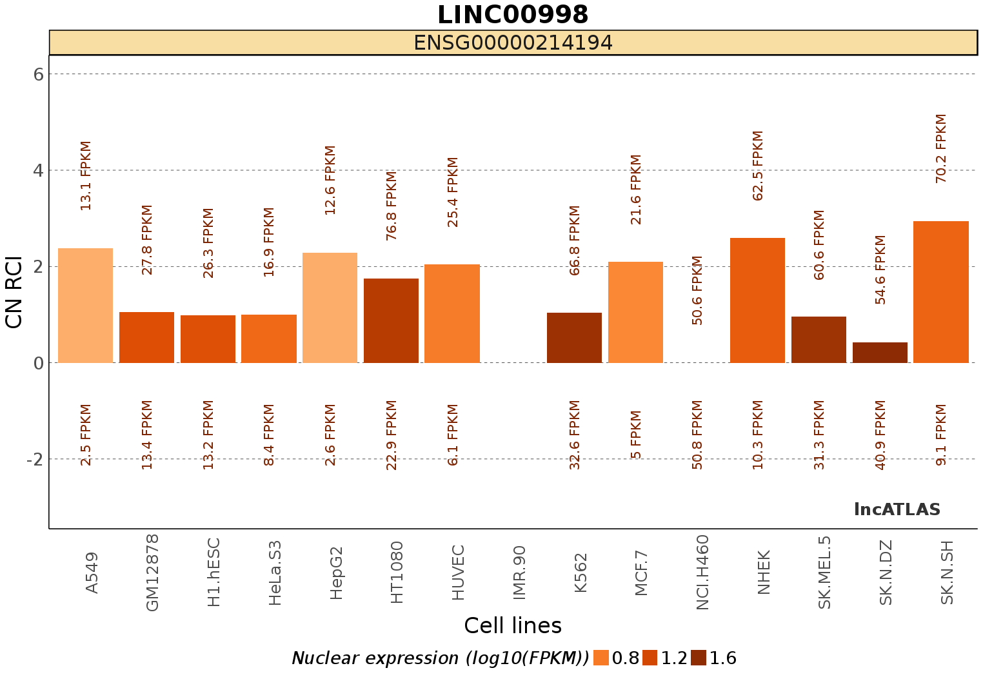
Figure S2. Cytoplasmic/Nuclear Localisation: RCI and expression values (all cell types) of LINC00998(https://lncatlas.crg.eu/)

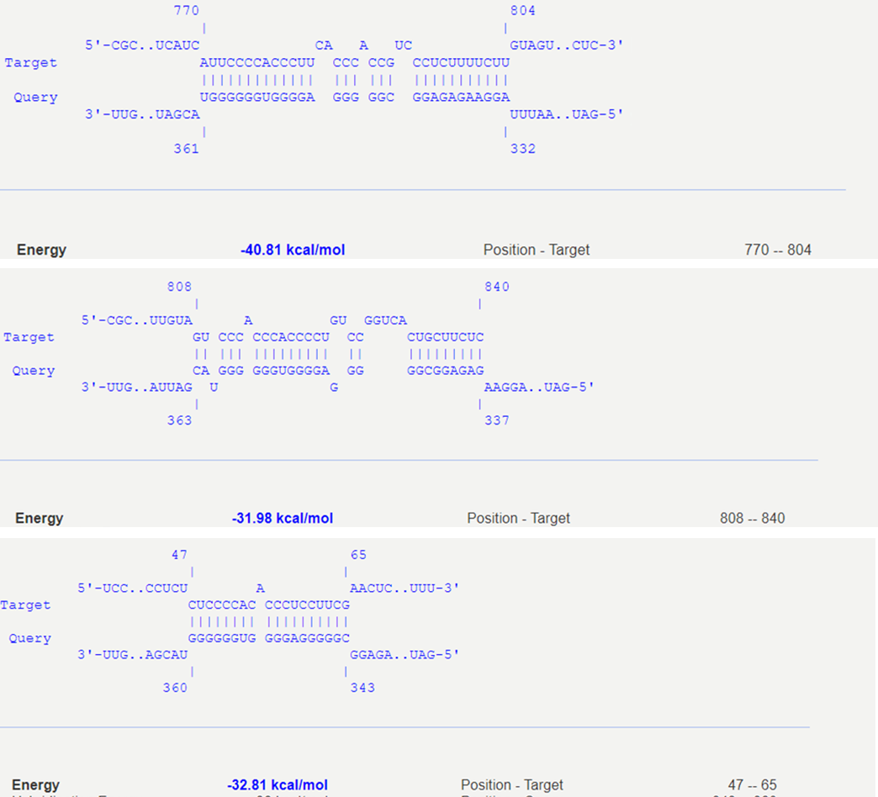
Figure S3. multiple binding sites between LINC00998 and BOB.1 mRNA 3’UTR (intaRNA program)

