Analysis and validation of critical signatures and immune cell infiltration characteristics in doxorubicin-induced cardiotoxicity by integrating bioinformatics and machine learning
Chao Huang^{1, #}, Jixiang Pei^{1, #}, Daisong Li¹, Tao Liu², Zhaoqing Li¹, Guoliang Zhang¹, Ruolan Chen¹, Xiao jian Xu¹, Bing Li^{3 4,} Zhexun Lian^{1, *}, Xian-Ming Chu^{1 5, *}

Supplemental Fig
Fig S1. Analysis of network topology for various soft-thresholding powers
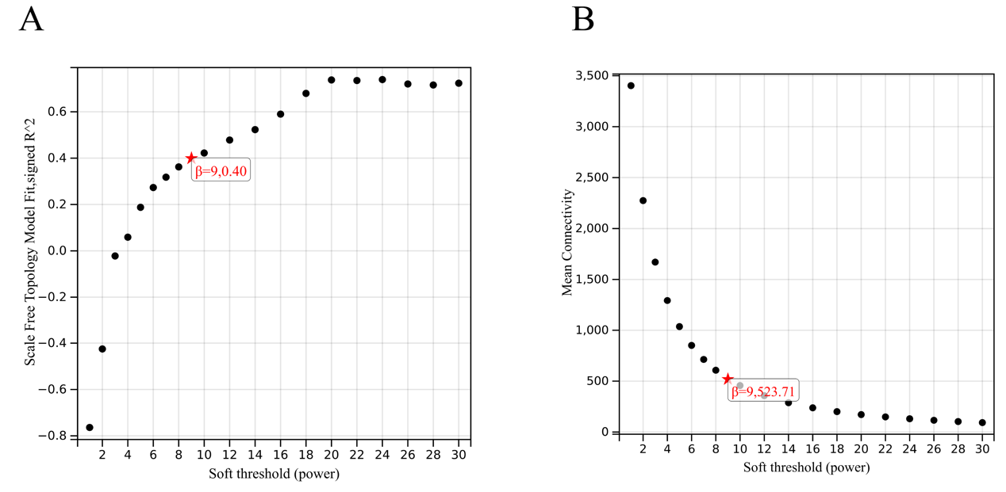Fig S1 (A-B) Analysis of network topology for various soft-thresholding powers. (A) Clustering dendrogram of differentially expressed genes related to DOX-induced cardiotoxicity, with dissimilarity based on topological overlap, together with assigned module colors. (B) Module feature vector clustering.
Supplemental table
Table S1. Primer sequences used in this study.
Gene | Primer sequence (5'→3')
GAPDH | Forward: AGCCACATCGCTCAGACAC
GAPDH | Reverse: AATACGACCAAATCCGTTGACT
mus-CSGALNACT1 | Forward: GCGTAATCTACGGCCATCACGA
mus-CSGALNACT1 | Reverse: TCCCAAATCCAAAGTCCCTCCAA
hsa-CSGALNACT1 | Forward: AGCCGTACAGCCTACTACCTCATG
hsa-CSGALNACT1 | Reverse: TCTTCACAGACACCCGCATCAATC
mus-FANCB | Forward: TTGTGGAGCACTCTTCTCCTG
mus-FANCB | Reverse: CAAAACTCCTTGGCTCCTGCAA
hsa-FANCB | Forward: TCGGGAATTACGGCAGCATCT
hsa-FANCB | Reverse: TCCTTCTCCTCTGCACTTGACG
mum-ZNF296 | Forward: CCGACCCCATCTCAGAATCCA
mum-ZNF296 | Reverse: CGTGGCACAGCAACTTCCAA
hsa-ZNF296 | Forward: GCTCAGAACGAGAGGAGCTGA
hsa-ZNF296 | Reverse: GGTAGATGGACAGTCCGTGGTC

Table S2. Information of DEGs identified from three strategies.
Strategies | Gene name
RF  (90) | GPD1, DTWD2, PCYT1B, ALKBH8, COL27A1, SASS6, VMO1, ZNF296, CSGALNACT1, FANCB, OVGP1, PNKD, CBFB MCMBP, SFMBT1, PPT1, RBM48, DNAJC21, MTHFD1L, NT5DC3, STAT1, BCKDK, NOL8, SAR1B, KHK, VWA9, FAM134B, HOGA1, POLD1, CSNK2A3, CENPH ZNF408, KCNQ1, LEPROTL1, C6orf47, NXF4, TGFB3, NIF3L1, ZNF800, MUM1, MEIG1, FBXL18, RAB33A, APBB3, HSBP1L1, DPH5, SLC25A25, KL GALM, DRG2, ACOT11, ZNF37A, SLC32A1, ZCCHC2, MAF, ABHD15, NUDT18, CREBRF, FANCD2, FOXD2, SPPL2C, PCYOX1L, FAM175A, C22orf46, ZNF605, SPATA6, SLC22A4, MYRF, KIF14, DOCK8, ZNF821, TBX5, CAND2, RBM28, TP73, ENKUR, PLEKHG4B, KCNN3, SLFN12, ALKBH3, PNP, OLFM2, ADAMTS3, MATN1, EEFSEC, FURIN, TRMT61, BNCEH1, SH3RF2, ALPK2;
LASSO  (15) | SH3TC2, RHBDL3, FANCB, CSGALNACT1, ADAMTS8, ZNF296, C1orf112, DCAF12L1, IRX5, PAQR6, JRK, MTFR2, ZBTB37, GRIP2, CYGB;
WGCNA  (3370) | AADAT, AAR2, AARD, AARS2, AASDH, ABAT, ABCA1, ABCA7, ABCB10, ABCB6, ABCB7, ABCC10, ABCC11, ABCC12, ABCC4, ABCC6, ABCE1, ABCG1, ABHD12, ABHD15, ABHD3, ABHD5, ABHD8, ABTB1, ABTB2, ACAD10, ACADS, ACADVL, ACBD4, ACBD6, ACBD7, BICD2, ACD, BMP1, BOD1L1, BRAF, BRAT1, BRCA1, BRCA2, BRF2, BRPF3, BSDC1, BST2, BTBD11, BTBD2, BTC, BTD, BTG3, BTN2A2, ……

