Drug Repurposing in Crohn’s Disease using Danish real-world data
Saeed Shakibfar¹, Kristine H. Allin², Tine Jess², Maria Antonietta Barbieri^{1,3}, Vera Battini^{1,4}, Eva Simoncic¹, Julien Kirchgesner⁵, Trond Ulven^{1*} & Maurizio Sessa^{1*}
¹Department of Drug Design and Pharmacology, University of Copenhagen, Copenhagen, Denmark; ²Center for Molecular Prediction of Inflammatory Bowel Disease (PREDICT), Department of Clinical Medicine, Aalborg University, Copenhagen, Denmark; ³Department of Clinical and Experimental Medicine, University of Messina, Messina, Italy; ⁴Pharmacovigilance & Clinical Research, International Centre for Pesticides and Health Risk Prevention, Department of Biomedical and Clinical Sciences (DIBIC), ASST Fatebenefratelli-Sacco University Hospital, Università degli Studi di Milano, Milan, Italy; ⁵Department of Gastroenterology, INSERM, Institut Pierre Louis d'Epidémiologie et de Santé Publique, AP-HP, Hôpital Saint-Antoine, Sorbonne Université, Paris, France.
*Equally contributed as last author for this manuscript
Correspondence: Saeed Shakibfar,
Department of Drug Design and Pharmacology,
University of Copenhagen,
Copenhagen, Denmark
Email saeed.shakibfar@sund.ku.dk

Supplementary Material 1

1. Search methods
The search for literature for the systematic review was performed in Pubmed MEDLINE on the 21st of September 2023. The terms included in the search query were previously used in different systematic reviews of drug repurposing using EHR and systematic reviews of drug repurposing using real-world data. ^{1,2} The search query is described in table 1.
2. Eligibility criteria
We assessed observational studies, meta-analyses, and clinical trials that utilized EHRs for drug repurposing. Only studies with full-text available in the English language were deemed eligible. Abstracts submitted to international or national conferences, letters to the editor, and case reports/series were considered ineligible. Additionally, we conducted a screening of the reference lists in narrative and systematic reviews obtained through our MEDLINE query to identify any potentially overlooked records.
3. Selection of studies
In the first screening title and abstracts of retrieved articles were screened. Articles that were considered eligible after the first screening, underwent a second title and abstract screening, and sometimes full text evaluation, so they could be grouped based on similar approaches used in the study.
Supplementary Table 1. MEDLINE research query.
MEDLINE Research Query – performed on 21/9/2023 at 12:08
Blocks | Query | N. of articles | References
Final research block | ("Drug repositioning"[tiab] OR reposit* [keyword] OR "Drug Repositioning" [MeSH] OR repurpos* [keyword] OR "drug repurpose"[tiab: ~3] OR "drug repurposing" [tiab] or "drug reprofiling"[tiab] OR "new therapeutic indication"[tiab] OR "medication repositioning"[tiab] OR "medication repurposing" [tiab] or “drug discovery”[tiab] or “drug development”[tiab] or “drug re-profiling”[tiab] or “drug redirect*”[tiab] or “drug recycl*”[tiab] or “drug rediscover*”[tiab] or “drug retask*”[tiab] or “novel indication”[tiab] or “alternative indication”[tiab] or “new indication”[tiab] or “new use”[tiab] or “novel use”[tiab] or “alternative use”[tiab])  AND  ("Medical Records Systems, Computerized"[Mesh] or "health register"[tiab] or "multi-register"[tiab] or "healthcare database"[tiab] or "nationwide database"[tiab] or "nationwide cohort"[tiab] or "health registers"[tiab] or "healthcare databases"[tiab] or "nationwide databases"[tiab] or "administrative database" [tiab] or "administrative databases" [tiab] or "administrative data"[tiab] or EMR[tiab] or EHR[tiab] or EMR[keyword] or HER[keyword] or EMRs[tiab] or EHRs[tiab] or "electronic medical record*"[tiab] or "Electronic Heath Record*"[tiab] or "electronic medical record*"[keyword] or "Electronic Heath Record*"[keyword] or "Electronic Patient Record*"[tiab] OR "computerized medical record system"[tiab] or ˝computerized medical record˝[tiab] or ˝computerized medical record systems˝[tiab] or ˝computerized patient record˝[tiab] or “medical record”[tiab] or “medical records”[tiab] or “registry data”[tiab] or “health record”[tiab] or “health records”[tiab]) | 419
Block 2 – drug repositioning | ("Drug repositioning"[tiab] OR reposit* [keyword] OR "Drug Repositioning" [MeSH] OR repurpos* [keyword] OR "drug repurpose"[tiab: ~3] OR "drug repurposing" [tiab] or "drug reprofiling"[tiab] OR "new therapeutic indication"[tiab] OR "medication repositioning"[tiab] OR "medication repurposing" [tiab] or “drug discovery”[tiab] or “drug development”[tiab] or “drug re-profiling”[tiab] or “drug redirect*”[tiab] or “drug recycl*”[tiab] or “drug rediscover*”[tiab] or “drug retask*”[tiab] or “novel indication”[tiab] or “alternative indication”[tiab] or “new indication”[tiab] or “new use”[tiab] or “novel use”[tiab] or “alternative use”[tiab]) | 103,611 | ¹⁶
Block 1 - database | ("Medical Records Systems, Computerized"[Mesh] or "health register"[tiab] or "multi-register"[tiab] or "healthcare database"[tiab] or "nationwide database"[tiab] or "nationwide cohort"[tiab] or "health registers"[tiab] or "healthcare databases"[tiab] or "nationwide databases"[tiab] or "administrative database" [tiab] or "administrative databases" [tiab] or "administrative data"[tiab] or EMR[tiab] or EHR[tiab] or EMR[keyword] or HER[keyword] or EMRs[tiab] or EHRs[tiab] or "electronic medical record*"[tiab] or "Electronic Heath Record*"[tiab] or "electronic medical record*"[keyword] or "Electronic Heath Record*"[keyword] or "Electronic Patient Record*"[tiab] OR "computerized medical record system"[tiab] or ˝computerized medical record˝[tiab] or ˝computerized medical record systems˝[tiab] or ˝computerized patient record˝[tiab] or “medical record”[tiab] or “medical records”[tiab] or “registry data”[tiab] or “health record”[tiab] or “health records”[tiab]) | 247,706 | ¹⁷

4. Results
The search query retrieved 419 articles in MEDLINE. After the first title and abstract screening, 329 articles were excluded. The articles were excluded if the article did not mention drug repurposing, did not use EHRs for drug repurposing or if they were not in English. This left 88 articles for further review. Out of the 88 articles, 22 were review articles, 1 was a commentary, 1 was a perspective article, 1 was an editorial article, and 63 articles were studies that included the use of EHRs in the discovery of new drug candidates for drug repurposing, with one being a preprint.
41 studies used EHRs only to do a cohort study to validate the drug repurposing candidates, identified using other methods. 3 studies combined EHRs with a biomedical database to discover potential drugs to repurpose, 15 studies only used EHRs to identify the drug repurposing candidates, and in 1 study they used a computational approach to find potential drugs in parallel to using an EHR to identify drugs to repurpose.
The references of the review, editorial, perspective and commentary articles were looked at, to see if the search query missed any relevant article. From that 1 new article that used only EHR was identified and added to the screening. The now 16 articles that only used EHRs for drug repurposing were selected for full text screening. The different approaches in methodology for drug repurposing using EHRs were identified based on these 16 articles. Figure 1 depicts the PRISMA flowchart.
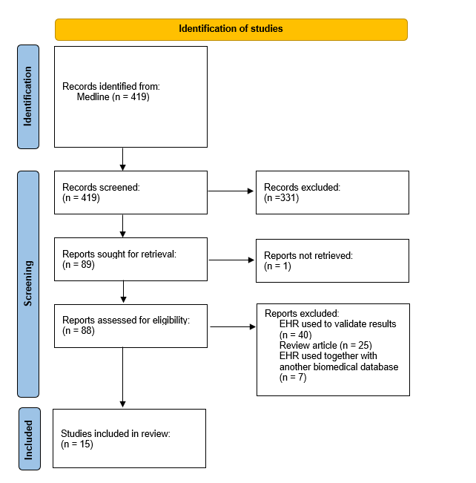
Supplementary Figure 1. PRISMA flowchart. EHR = Electronic Healthcare Record.

In the following section the different methodologies for drug repurposing using EHRs identified during the systematic review are presented.
4.1 Cohort studies
The most common approach in drug repurposing using EHRs was to do a pharmacoepidemiological cohort study. The general flow of these studies was to first identify the exposure and relevant confounders, followed by effect estimation of the repurposed drug using survival analysis. ³⁻⁹ In this group the articles can be further separated into studies that used a traditional pharmacoepidemiological study design ³⁻⁶ and the studies that used machine learning approaches. ⁷⁻⁹
4.1.1 Traditional pharmacoepidemiological studies
Bejan et al. conducted a study to address the urgent need for novel COVID-19 treatments by employing drug repurposing methodologies. Leveraging real-world data from EHRs, they conduct a drug-wide association study (DrugWAS) to systematically investigate various drug exposures, encompassing prescription drugs and dietary supplements, as potential treatments for COVID-19. Their hypothesis revolves around identifying drug exposures linked to a reduced risk of severe outcomes or death due to COVID-19, thus pinpointing candidates for further therapeutic investigation. The study's design involves a retrospective cohort analysis of data from the Vanderbilt University Medical Center (VUMC) Research Derivative, a comprehensive repository of EHR data. The study population comprises individuals tested for SARS-CoV-2 at VUMC between specific dates and diagnosed with a confirmed infection. The study period considered various COVID-19 outcomes, including hospitalization severity and all-cause mortality, with a focus on associations between drug exposures and these outcomes. Covariates such as age, sex, race, ethnicity, and comorbidity scores were incorporated to account for patient differences. Statistical analysis involved propensity score methods to adjust for observed patient characteristics, ultimately leading to the identification of potential candidates for COVID-19 treatment repurposing. More precisely, the propensity score for drug exposure was calculated through a multivariable logistic regression model that took into account variables such as age, sex, race, ethnicity, and the weighted Elixhauser comorbidity score. Subsequently, this estimated propensity score was employed in a weighted multivariable logistic regression analysis, which adjusted for factors including drug exposure, age, sex, race, ethnicity, and the weighted Elixhauser comorbidity score. This analysis aimed to gauge the impact of drug exposure on the study's outcomes. They did not perform any adjustments for multiple testing.³
Woo et al. investigated the relationship between prescription drugs and mortality in patients diagnosed with colorectal cancer, utilizing the Korean National Health Insurance Service-National Sample Cohort database (KNHIS-NSC). The KNHIS-NSC database, containing comprehensive data on medical institutions and patient demographics, served as the primary source of information. The study focused on colorectal cancer patients, identified through specific diagnostic codes and treatments, with a wash-out period to include newly diagnosed cases. To ensure the reliability of results, cross-validation was conducted, splitting participants into drug discovery and validation sets. Exposure to drugs, categorized using the Anatomical Therapeutic Chemical (ATC) Classification System, was analyzed, considering factors such as prevalent and incident users. Outcomes included all-cause mortality and colorectal cancer-specific mortality, with follow-up data until the end of the KNHIS-NSC follow-up period. Covariates such as sex, age, and comorbidity index were adjusted for, alongside cancer treatments. Statistical analysis employed Cox proportional hazards models, controlling for type I errors using the false discovery rate (FDR). Significant findings were first detected in the drug discovery set with an FDR of 5% and then verified in the drug validation set. Results were visualized using volcano plots, providing insight into the relationships between drugs and outcomes. ⁴
Wu et al. used a data-driven approach to identify potential drug repurposing opportunities for cancer treatment. The researchers evaluated 146 drugs typically used for noncancerous conditions in the VUMC EHR to assess their impact on cancer patients' survival. The study also aimed to replicate significant associations in the Mayo Clinic's EHR, searched for supporting evidence in the biomedical literature, and checked cancer clinical trials for corroboration. Using a synthetic derivative of VUMC's EHR and extensive patient data, the study defined patients with cancer, selected candidate drugs, and conducted retrospective cohort studies comparing drug-exposed and non-exposed groups. A multivariable Cox proportional hazards regression model was employed, adjusting for various covariates. The study used stringent criteria for detecting survival-associated drugs and underwent validation processes involving data replication, literature search, and clinical trial examination. At the end they also used FDR. Later on they validated their detected signals with a replication using another EHR, searching biomedical literature for supporting evidence, and searching of clinical trials for supporting evidence. ⁵
Reznikov et al. conducted a comprehensive investigation into the potential repurposing of antihistamines for the treatment of SARS-CoV-2 infection. They analyzed EHRs from over 219,000 patients within the University of California Health System to identify candidate antihistamines. To assess the direct antiviral effects of these antihistamines, the researchers performed in vitro experiments using infectious SARS-CoV-2 cell-based drug susceptibility assays, measuring their impact on virus production over time. Molecular docking techniques were employed to identify possible binding sites for these antiviral antihistamines on ACE2 and the sigma-1 receptor. The study also involved association analysis based on EHRs, taking into account patient demographics and prior antihistamine prescriptions. The results were rigorously analyzed, and statistical significance was determined while correcting for false discovery rate. Specifically, they used an adjusted logistic regression to estimate the treatment effect. They later stratified their analysis based on age. At the end they used FDR. To provide supporting evidence they also conducted a number of in vitro and in in silico experiments. ⁶
4.1.2 Studies using machine learning
Lerner er al. aimed to develop and validate a data-driven pipeline to identify potential drug associations with 28-day mortality in adults hospitalized for COVID-19. The research used data from the Entrepôt de Données de Santé (EDS)-COVID database, encompassing information from 39 sites in the Greater Paris area. The study population consisted of patients aged 18 to 95 years hospitalized in conventional wards for at least 48 hours due to COVID-19. Medications prescribed within the first 48 hours after admission were analyzed, and associations with 28-day mortality were investigated while adjusting for various covariates. The pipeline employed an adaptive LASSO ¹⁰ procedure and considered multiple measures of association, including conditional odds ratios and propensity score-based analyses. The results were carefully adjusted for multiple testing, and a knowledge-based approach was used to validate the data-driven adjustment sets. Missing data were addressed through multiple imputation, and analyses were conducted using R statistical software. After they used a multivariate logistic regression model to estimate the treatment effect. As secondary analyses they did 2 supplementary measures of association based on propensity scores, they did propensity score matching and inverse probability weighting after trimming. To account for alpha risk inflation caused by multiple testing they used FDR. ⁷
Ryu et al presents a novel approach using explainable machine learning on electronic medical records to identify potential drug repurposing candidates for Monoclonal Gammopathy of Undetermined Significance (MGUS). The research leveraged clinical data from a large cohort of MGUS patients at the Mayo Clinic, paired with medication data obtained from EHR. The objective was to uncover associations between medications prescribed for other conditions and the progression of MGUS to multiple myeloma, Waldenström macroglobulinemia, or systemic amyloidosis. The study employed a gradient-boosted machines Cox survival model, assessing the time from MGUS diagnosis to disease progression. Results were evaluated using the concordance index and Shapley Additive Explanation values to estimate hazard ratios. After fitting the model they computed the concordance index of test set predictions with the inverse probability weighting. To estimate hazard ratios and their distributions they performed bootstrapping and Shapley Additive Explanation values. Sensitivity analyses were also conducted to explore specific subgroups within the MGUS population. The findings offer valuable insights that could inform further investigations, including synthetic clinical trials or traditional clinical trials, to explore potential drug repurposing strategies for MGUS treatment. ⁸
Koren et al. presents compelling evidence that alpha 1 (α1)‐adrenoceptor antagonists, when combined with existing antidiabetic drugs, have a notably positive impact on managing type 2 diabetes mellitus (DM-2). Using data extracted from electronic medical records of patients receiving their first-ever drug treatment for DM-2 at Maccabi Health Services in Israel, the study examined factors such as initial blood glucose values, weight, age, BMI, smoking status, and HgA1c levels over a specific time period following diagnosis. Patients with HgA1c levels below 6.5 were considered successfully treated. The research employed machine learning algorithms, including decision trees and neural networks, to assess the effectiveness of various drug groups. They used propensity score matching, and then trained a regression model to predict the treatment effect. During the matching process they used the rate of resampling and Kolmogorov-Smirnof goodness-of-fit tests. To see if the success rates differed among groups, they did the Pearson’s chi-squared test and corrected the P-values according to the Bonferroni correction. The study identified 73 such groups, comparing treatment success rates of patients receiving specific drugs to matched groups of untreated patients. The findings suggest that α1-adrenoceptor antagonists, when integrated into antidiabetic drug regimens, could offer a promising approach to improving DM-2 management. ⁹
Emulated clinical trials
Based on the articles identified in my systematic review, the second approach used in drug repurposing using electronic healthcare data was to emulate a clinical trial in the dataset. In this group I identified 4 articles. These articles share a similar workflow of the methods used. They all first construct the cohorts, then use inverse probability weighting and at the end apply bootstrapping. The 4 articles differ in the way the calculated the treatment effect. ¹¹⁻¹⁴
Ozery-Flato et al. presented a framework for systematic drug repurposing through the emulation of randomized controlled trials (RCTs) using observational healthcare data. The authors applied this framework to Parkinson's disease (PD), aiming to identify potential drug candidates for slowing disease progression. They conducted emulated RCTs for hundreds of drugs, including those indicated for PD, to estimate their effects on disease progression outcomes. The framework considered various data sources, study designs, eligibility criteria, treatment assignments, outcomes, and hypothesized confounders. It identified major confounders and generated balancing weights to correct for bias, thus enabling the estimation of treatment effects. The study represents an innovative approach to systematically screen drug repurposing candidates using observational data, with a focus on the PD case study. The framework includes procedures for estimating treatment effects and statistical significance. ¹⁵ Specifically, they used inverse probability weighting with stabilization and modeled the propensity score with logistic regression. To estimate the treatment effect they used causal inference, either the Kaplan-Meier estimator or the average expected outcome. In the end they used bootstrapping to get the p-value of the computed effect.¹¹ A year later Laifenfeld et al. used the Ozery-flato drug repurposing framework¹¹ in their study.¹²
Shahn et al. conducted a study that aims to estimate the effects of antihypertensive drugs on 262 different outcomes. To do this, they follow a target trial emulation framework and specify protocols for the trials they wish they could conduct. Patients are included if they meet certain criteria, such as having hypertension, being over 50 years old, and starting antihypertensive treatment for the first time. They are then randomly assigned to one of five first-line mechanistic classes of antihypertensives. The study uses observational data from over 6.5 million patients in the United States and employs inverse probability weighting to adjust for confounding and informative censoring. Hierarchical models are applied to account for multiple comparisons and interpret the results. The goal is to explore the repurposing potential of antihypertensive drugs and the challenges of screening for repurposing opportunities. Specifically, they constructed their cohorts and then used inverse probability weighting to adjust for confounding and informative censoring. They capped the extreme weights when needed to make sure the cohorts were balanced. For each drug/outcome pair they estimated the counterfactual cumulative incidence curve. To achieve this, they fitted 4 models for each drug/outcome pair. To compute stabilized weights, they used 3 models: a logistic regression model for probability of receiving a specific treatment conditional on the confounders, a Cox hazard model for loss to follow-up given baselined confounders and treatment assignment and another Cox hazard model for loss to follow-up conditional only on treatment assignment. In the end they fit a weighted Cox proportional hazards model to compute the estimated counterfactual cumulative incidence curve. They used bootstrapping to estimate covariance matrices of the incidence curve estimates and confidence intervals. To account for multiple comparisons, share strength across analyses, and use posterior probabilities to help interpret results, they fit hierarchical models to the counterfactual incidence curve and bootstrap covariance matrix estimates.¹³
Liu et al. presents a computational framework for drug repurposing, employing real-world data to emulate RCTs and estimate drug effects on disease outcomes. Specifically, the framework is applied to a coronary artery disease (CAD) cohort with millions of patients to emulate RCTs for various drug candidates and assess their effects on CAD progression outcomes. The framework defines user and non-user cohorts based on treatment criteria, employs deep learning and causal inference methods to control confounding variables in real-world data, and assesses drug effects using long short-term memory (LSTM) and inverse probability of treatment weighting (IPTW). The study demonstrates the potential of this approach for identifying drug repurposing candidates for CAD and offers a detailed model to estimate average treatment effects (ATE). It presents a novel way of utilizing observational data for drug repurposing and highlights the application of deep learning and causal inference in the healthcare domain. Specifically, the authors developed a framework that first generates user and non-user cohorts. Then they used a deep learning model to calculate the propensity scores to correct for confounding from time sequence data. The model they used consisted of three main components: an embedding module a recurrent neural network and a prediction module. These propensity scores were then used for inverse probability weighting. To estimate the treatment effect, they used the average treatment effect. They also tested their model’s performance by measuring features’ balance between the weighted user and non-user cohorts generated by inverse probability weighting with standardized mean difference. To calculate the confidence intervals and statistical significance of the calculated treatment effect they used bootstrapping.¹⁴
Self-controlled case series
A self-controlled case series approach was used in two of the articles. Kuang et al. used a continuous self-controlled case series model for drug repurposing ¹⁶ while Cepeda et al. used a self-controlled cohort design.¹⁷
Baseline regularization
Two of the articles by the same first author used baseline regularization for their drug repurposing approach. In the article from 2016 Kuang et al. proposed a baseline regularization model and a variant that extends the one-ways fixed effect model.¹⁸ In 2019 Kuang et al. published their protocol that uses baseline regularization in a book about called Computational Methods for Drug Repurposing.¹⁹
New algorithm
Kim et al. developed a novel high-throughput data-driven algorithm for drug repurposing using EHRs called large scale EMR-based analytic method for old drugs new uses (LEMON) algorithm.²⁰
References
1. Tan GSQ, Sloan EK, Lambert P, Kirkpatrick CMJ, Ilomäki J. Drug repurposing using real-world data. Drug Discov Today. 2023;28(1):103422. doi:10.1016/j.drudis.2022.103422
2. Zong N, Wen A, Moon S, et al. Computational drug repurposing based on electronic health records: a scoping review. NPJ Digit Med. 2022;5(1):77. doi:10.1038/s41746-022-00617-6
3. Bejan CA, Cahill KN, Staso PJ, Choi L, Peterson JF, Phillips EJ. DrugWAS: Drug-wide Association Studies for COVID-19 Drug Repurposing. Clin Pharmacol Ther. 2021;110(6):1537-1546. doi:10.1002/cpt.2376
4. Woo HT, Jeong SY, Shin A. The association between prescription drugs and colorectal cancer prognosis: a nationwide cohort study using a medication-wide association study. BMC Cancer. 2023;23(1):643. doi:10.1186/s12885-023-11105-9
5. Wu Y, Warner JL, Wang L, et al. Discovery of Noncancer Drug Effects on Survival in Electronic Health Records of Patients With Cancer: A New Paradigm for Drug Repurposing. JCO Clin Cancer Inform. 2019;3:1-9. doi:10.1200/CCI.19.00001
6. Reznikov LR, Norris MH, Vashisht R, et al. Identification of antiviral antihistamines for COVID-19 repurposing. Biochem Biophys Res Commun. 2021;538:173-179. doi:10.1016/j.bbrc.2020.11.095
7. Lerner I, Serret-Larmande A, Rance B, et al. Mining Electronic Health Records for Drugs Associated With 28-day Mortality in COVID-19: Pharmacopoeia-wide Association Study (PharmWAS). JMIR Med Inform. 2022;10(3):e35190. doi:10.2196/35190
8. Ryu AJ, Kumar S, Dispenzieri A, Kyle RA, Rajkumar SV, Kingsley TC. Artificial intelligence-enabled screening strategy for drug repurposing in monoclonal gammopathy of undetermined significance. Blood Cancer J. 2023;13(1):28. doi:10.1038/s41408-023-00798-7
9. Koren G, Nordon G, Radinsky K, Shalev V. Identification of repurposable drugs with beneficial effects on glucose control in type 2 diabetes using machine learning. Pharmacol Res Perspect. 2019;7(6):e00529. doi:10.1002/prp2.529
10. Zou H. The Adaptive Lasso and Its Oracle Properties. J Am Stat Assoc. 2006;101(476):1418-1429. doi:10.1198/016214506000000735
11. Ozery-Flato M, Goldschmidt Y, Shaham O, Ravid S, Yanover C. Framework for identifying drug repurposing candidates from observational healthcare data. JAMIA Open. 2020;3(4):536-544. doi:10.1093/jamiaopen/ooaa048
12. Laifenfeld D, Yanover C, Ozery-Flato M, et al. Emulated Clinical Trials from Longitudinal Real-World Data Efficiently Identify Candidates for Neurological Disease Modification: Examples from Parkinson’s Disease. Front Pharmacol. 2021;12:631584. doi:10.3389/fphar.2021.631584
13. Shahn Z, Spear P, Lu H, et al. Systematically exploring repurposing effects of antihypertensives. Pharmacoepidemiol Drug Saf. 2022;31(9):944-952. doi:10.1002/pds.5491
14. Liu R, Wei L, Zhang P. A deep learning framework for drug repurposing via emulating clinical trials on real-world patient data. Nat Mach Intell. 2021;3(1):68-75. doi:10.1038/s42256-020-00276-w
15. Ozery-Flato M, Yanover C, Gottlieb A, Weissbrod O, Parush Shear-Yashuv N, Goldschmidt Y. Fast and Efficient Feature Engineering for Multi-Cohort Analysis of EHR Data. Stud Health Technol Inform. 2017;235:181-185.
16. Kuang Z, Thomson J, Caldwell M, Peissig P, Stewart R, Page D. Computational Drug Repositioning Using Continuous Self-Controlled Case Series. KDD Proc Int Conf Knowl Discov Data Min. 2016;2016:491-500. doi:10.1145/2939672.2939715
17. Cepeda MS, Kern DM, Seabrook GR, Lovestone S. Comprehensive Real-World Assessment of Marketed Medications to Guide Parkinson’s Drug Discovery. Clin Drug Investig. 2019;39(11):1067-1075. doi:10.1007/s40261-019-00830-4
18. Kuang Z, Thomson J, Caldwell M, Peissig P, Stewart R, Page D. Baseline Regularization for Computational Drug Repositioning with Longitudinal Observational Data. IJCAI Proc Conf. 2016;2016:2521-2528.
19. Kuang Z, Bao Y, Thomson J, et al. A Machine-Learning-Based Drug Repurposing Approach Using Baseline Regularization. Methods Mol Biol Clifton NJ. 2019;1903:255-267. doi:10.1007/978-1-4939-8955-3_15
20. Kim DH, Lee JE, Kim YG, et al. High-Throughput Algorithm for Discovering New Drug Indications by Utilizing Large-Scale Electronic Medical Record Data. Clin Pharmacol Ther. 2020;108(6):1299-1307. doi:10.1002/cpt.1980

Supplementary Material 2

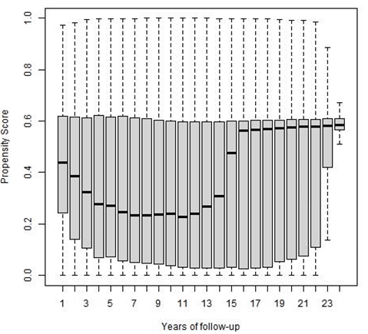 | A
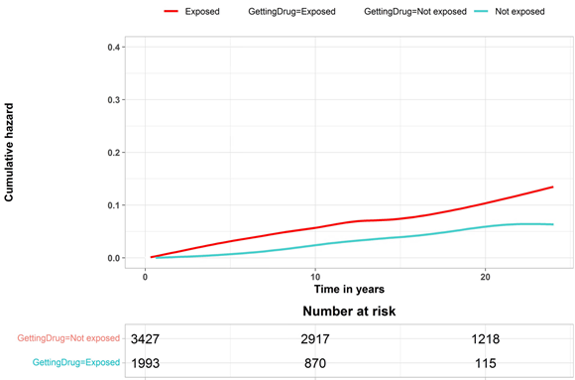 | B
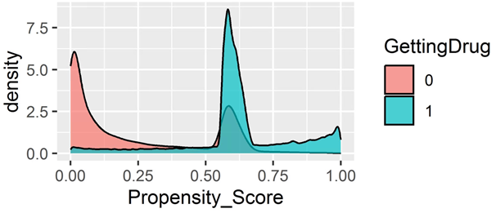 | C
Supplementary Figure 1: Enalapril - A) Propensity score over time B) Cumulative Hazard C) Propensity score density. GettingDrug = 0 means Not exposed. GettingDrug=1 means Exposed.

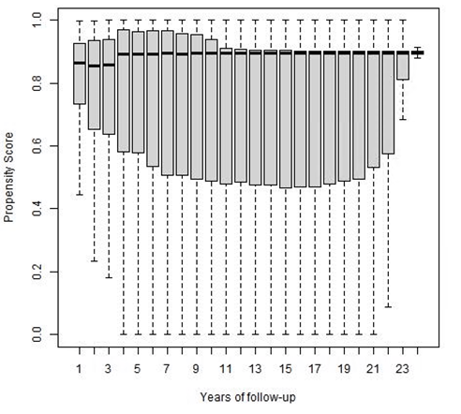 | A
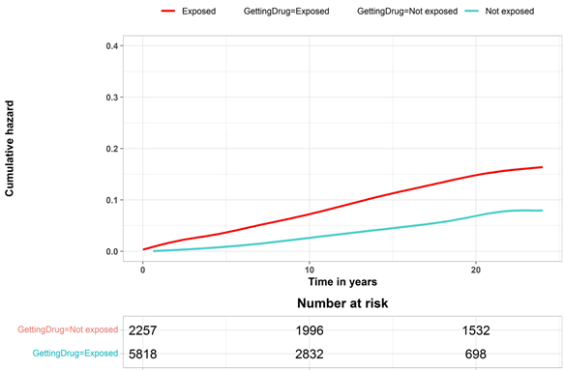 | B
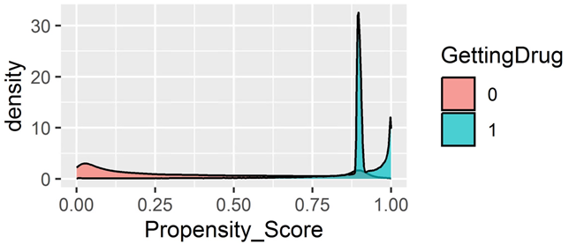 | C
Supplementary Figure 2: Tramadol - A) Propensity score over time B) Cumulative Hazard C) Propensity score density. GettingDrug = 0 means Not exposed. GettingDrug=1 means Exposed.

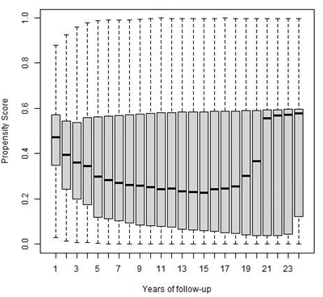 | A
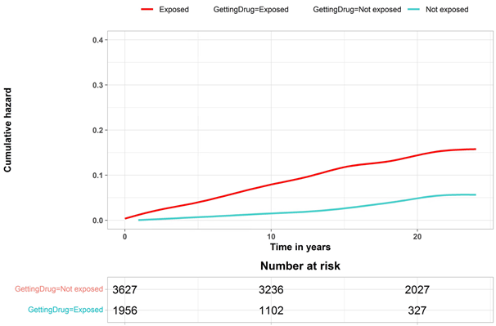 | B
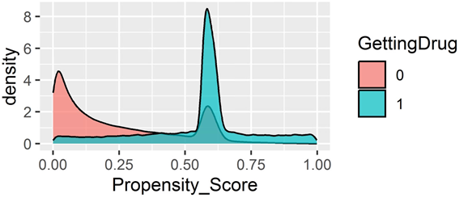 | C
Supplementary Figure 3: Zolpidem- A) Propensity score over time B) Cumulative Hazard C) Propensity score density. GettingDrug = 0 means Not exposed. GettingDrug=1 means Exposed.

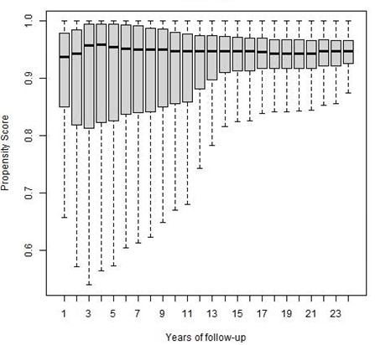 | A
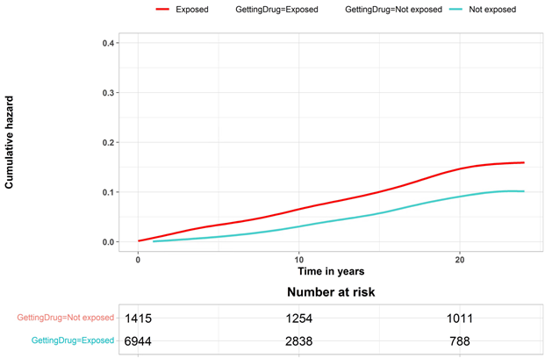 | B
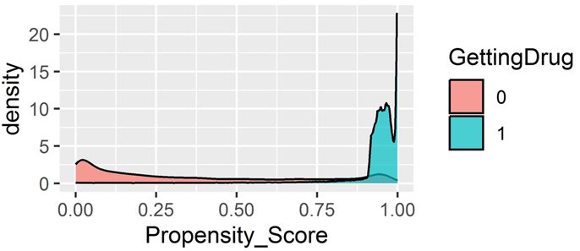 | C
Supplementary Figure 4: Paracetamol- A) Propensity score over time B) Cumulative Hazard C) Propensity score density. GettingDrug = 0 means Not exposed. GettingDrug=1 means Exposed.

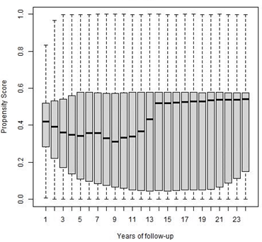 | A
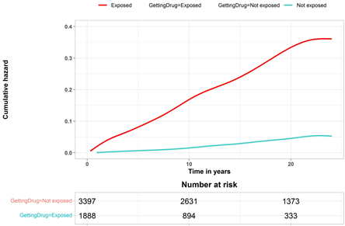 | B
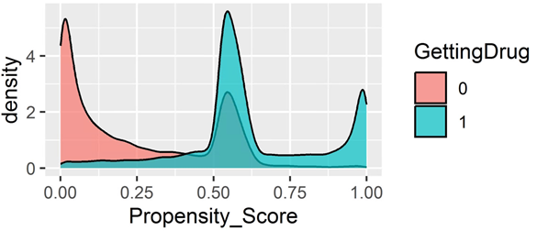 | C
Supplementary Figure 5: Hydroxocobalamin- A) Propensity score over time B) Cumulative Hazard C) Propensity score density. GettingDrug = 0 means Not exposed. GettingDrug=1 means Exposed.

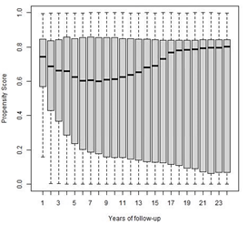 | A
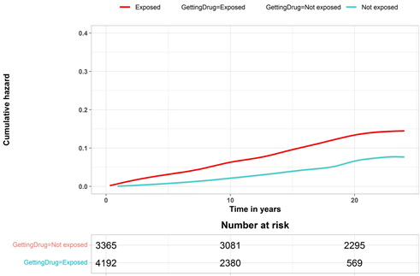 | B
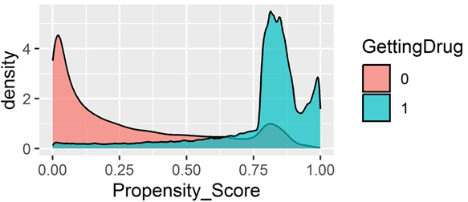 | C
Supplementary Figure 6: Bendroflumethiazide and potassium- A) Propensity score over time B) Cumulative Hazard C) Propensity score density. GettingDrug = 0 means Not exposed. GettingDrug=1 means Exposed.

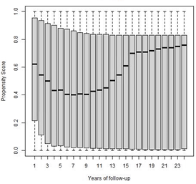 | A
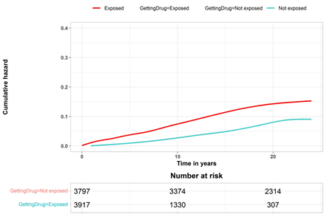 | B
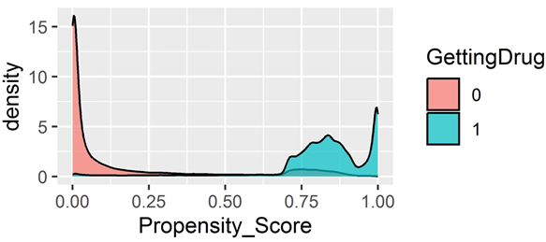 | C
Supplementary Figure 7: Furosemide- A) Propensity score over time B) Cumulative Hazard C) Propensity score density. GettingDrug = 0 means Not exposed. GettingDrug=1 means Exposed.

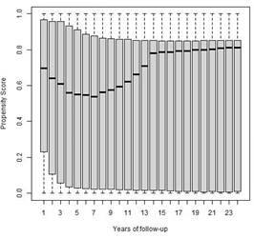 | A
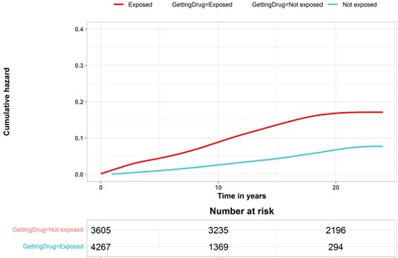 | B
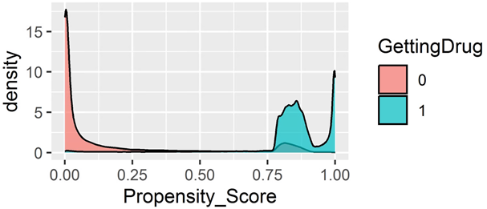 | C
Supplementary Figure 8: Potassium chloride- A) Propensity score over time B) Cumulative Hazard C) Propensity score density. GettingDrug = 0 means Not exposed. GettingDrug=1 means Exposed.

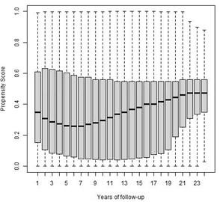 | A
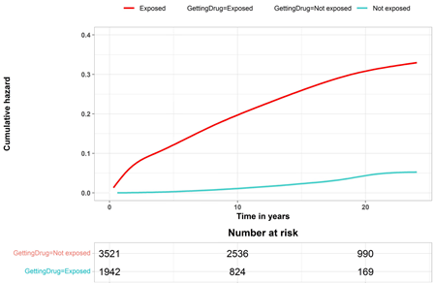 | B
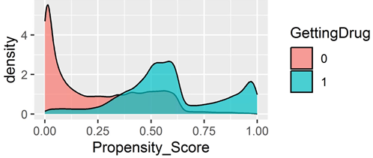 | C
Supplementary Figure 9: Azathioprine- A) Propensity score over time B) Cumulative Hazard C) Propensity score density. GettingDrug = 0 means Not exposed. GettingDrug=1 means Exposed.

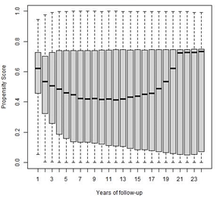 | A
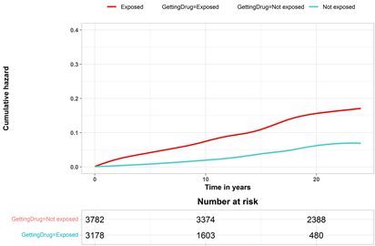 | B
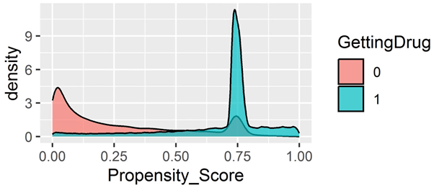 | C
Supplementary Figure 10: Zopiclone- A) Propensity score over time B) Cumulative Hazard C) Propensity score density. GettingDrug = 0 means Not exposed. GettingDrug=1 means Exposed.

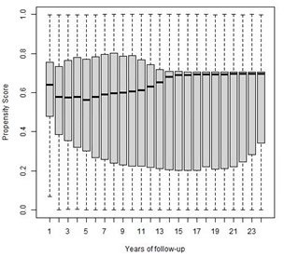 | A
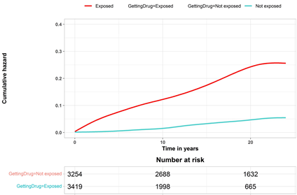 | B
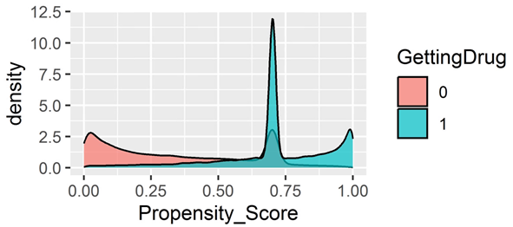 | C
Supplementary Figure 11: Mesalazine- A) Propensity score over time B) Cumulative Hazard C) Propensity score density. GettingDrug = 0 means Not exposed. GettingDrug=1 means Exposed.

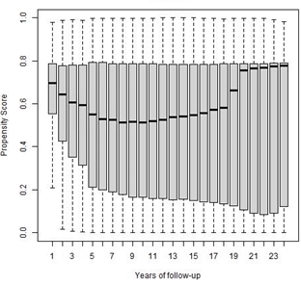 | A
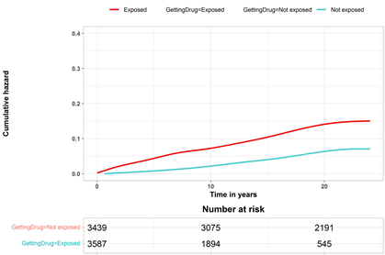 | B
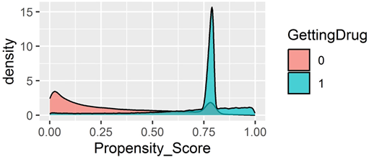 | C
Supplementary Figure 12: Amoxicillin- A) Propensity score over time B) Cumulative Hazard C) Propensity score density. GettingDrug = 0 means Not exposed. GettingDrug=1 means Exposed.

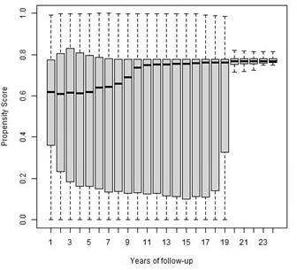 | A
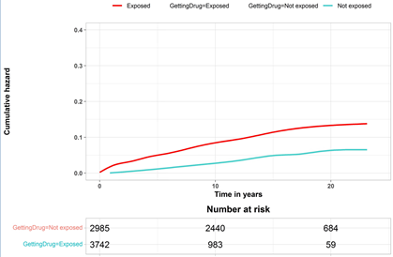 | B
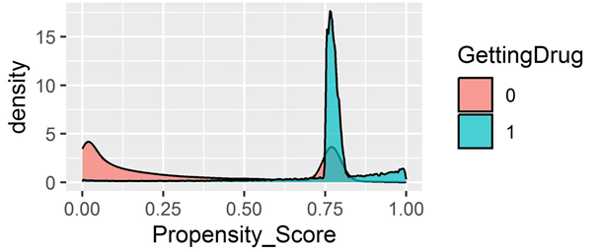 | C
Supplementary Figure 13: Pantoprazole- A) Propensity score over time B) Cumulative Hazard C) Propensity score density. GettingDrug = 0 means Not exposed. GettingDrug=1 means Exposed.

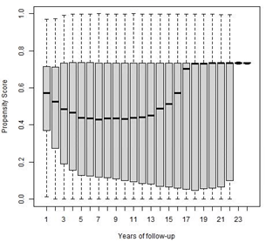 | A
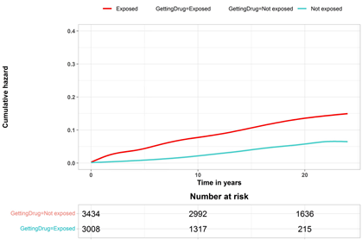 | B
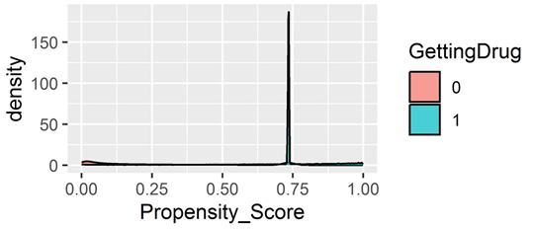 | C
Supplementary Figure 14: Lansoprazole- A) Propensity score over time B) Cumulative Hazard C) Propensity score density. GettingDrug = 0 means Not exposed. GettingDrug=1 means Exposed.

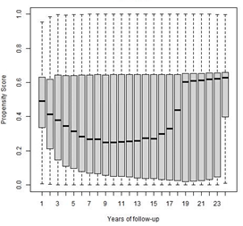 | A
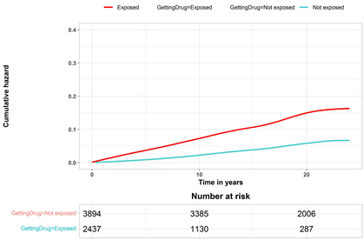 | B
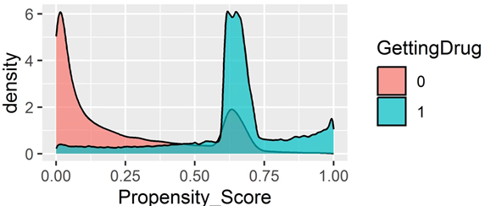 | C
Supplementary Figure 15: Citalopram- A) Propensity score over time B) Cumulative Hazard C) Propensity score density. GettingDrug = 0 means Not exposed. GettingDrug=1 means Exposed.

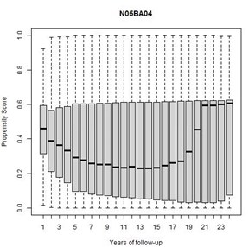 | A
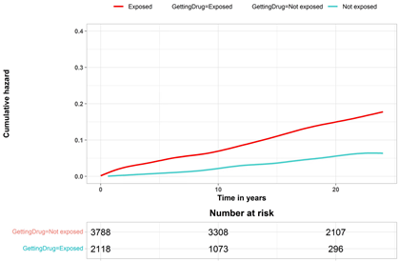 | B
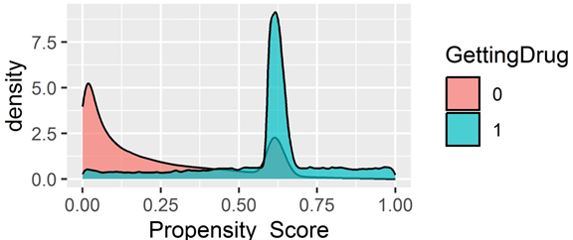 | C
Supplementary Figure 16: Oxazepam- A) Propensity score over time B) Cumulative Hazard C) Propensity score density. GettingDrug = 0 means Not exposed. GettingDrug=1 means Exposed.

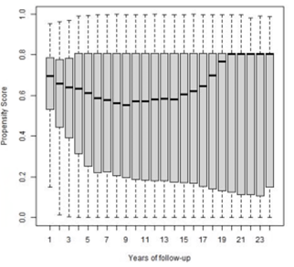 | A
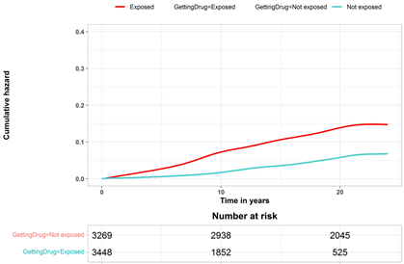 | B
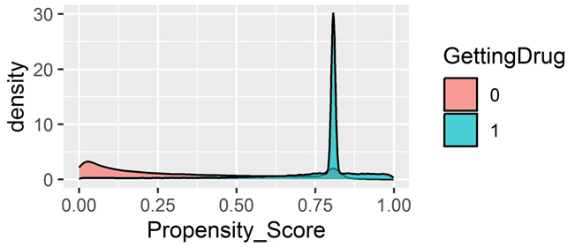 | C
Supplementary Figure 17: Hydrocortisone butyrate- A) Propensity score over time B) Cumulative Hazard C) Propensity score density. GettingDrug = 0 means Not exposed. GettingDrug=1 means Exposed.

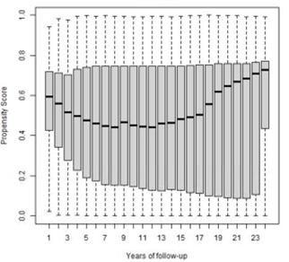 | A
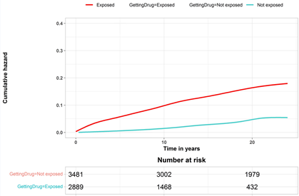 | B
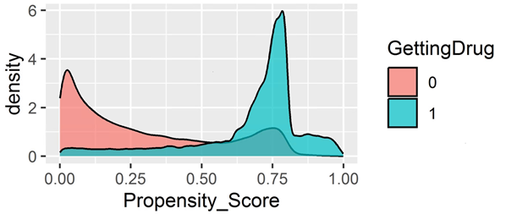 | C
Supplementary Figure 18: Metronidazole- A) Propensity score over time B) Cumulative Hazard C) Propensity score density. GettingDrug = 0 means Not exposed. GettingDrug=1 means Exposed.

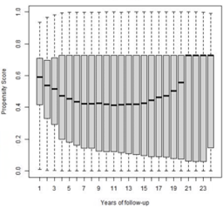 | A
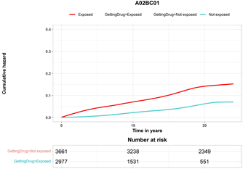 | B
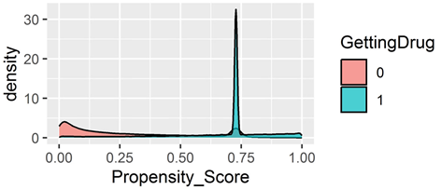 | C
Supplementary Figure 19: Omeprazole- A) Propensity score over time B) Cumulative Hazard C) Propensity score density. GettingDrug = 0 means Not exposed. GettingDrug=1 means Exposed.

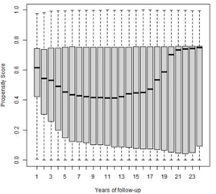 | A
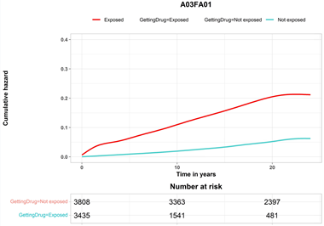 | B
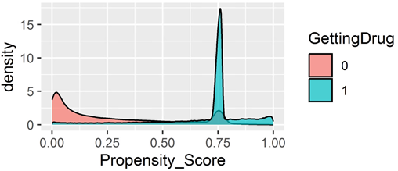 | C
Supplementary Figure 20: Metoclopramide- A) Propensity score over time B) Cumulative Hazard C) Propensity score density. GettingDrug = 0 means Not exposed. GettingDrug=1 means Exposed.

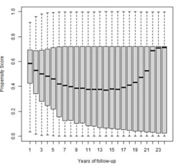 | A
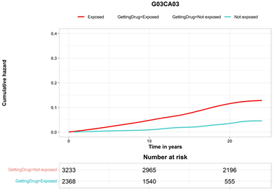 | B
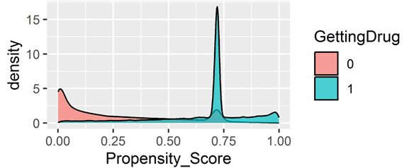 | C
Supplementary Figure 21: Estradiol- A) Propensity score over time B) Cumulative Hazard C) Propensity score density. GettingDrug = 0 means Not exposed. GettingDrug=1 means Exposed.

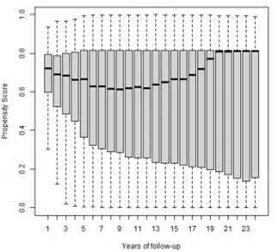 | A
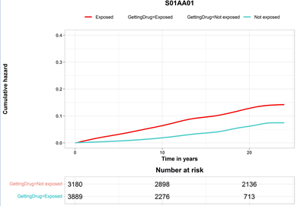 | B
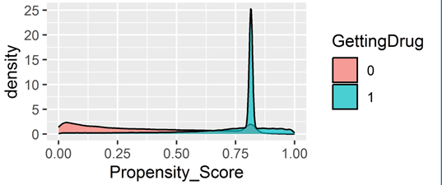 | C
Supplementary Figure 22: Chloramphenicol- A) Propensity score over time B) Cumulative Hazard C) Propensity score density. GettingDrug = 0 means Not exposed. GettingDrug=1 means Exposed.

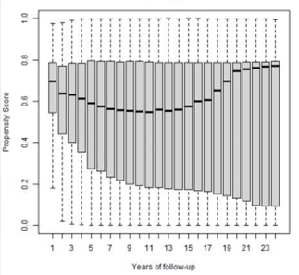 | A
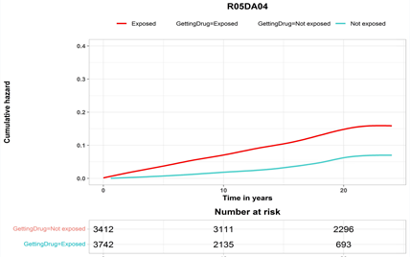 | B
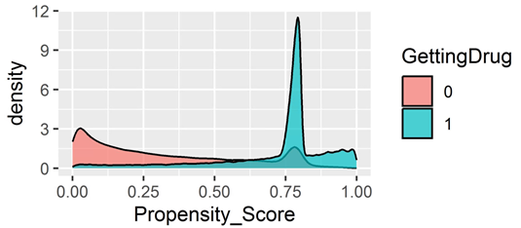 | C
Supplementary Figure 23: Codeine- A) Propensity score over time B) Cumulative Hazard C) Propensity score density. GettingDrug = 0 means Not exposed. GettingDrug=1 means Exposed.

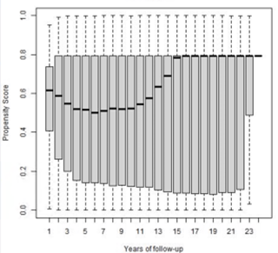 | A
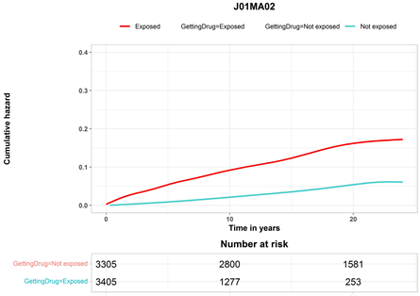 | B
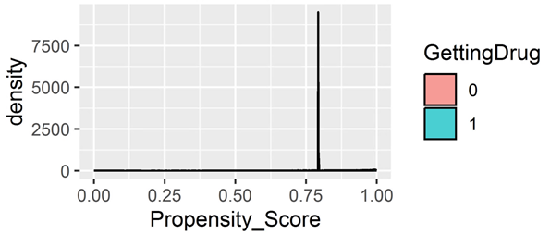 | C
Supplementary Figure 24: Ciprofloxacin- A) Propensity score over time B) Cumulative Hazard C) Propensity score density. GettingDrug = 0 means Not exposed. GettingDrug=1 means Exposed.

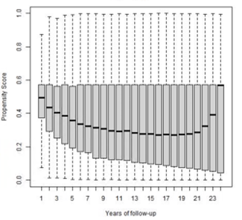 | A
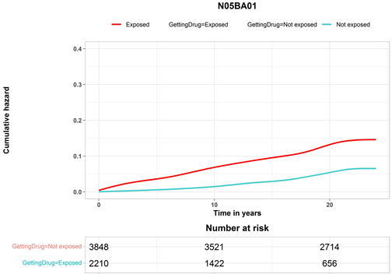 | B
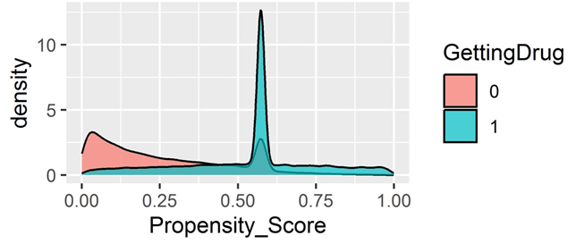 | C
Supplementary Figure 25: Diazepam- A) Propensity score over time B) Cumulative Hazard C) Propensity score density. GettingDrug = 0 means Not exposed. GettingDrug=1 means Exposed.

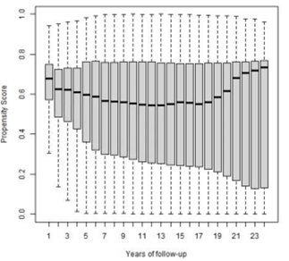 | A
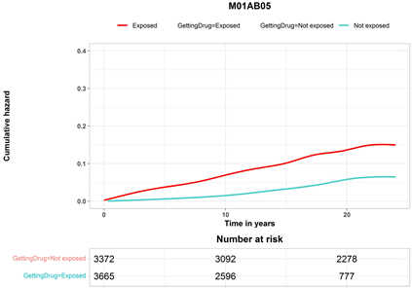 | B
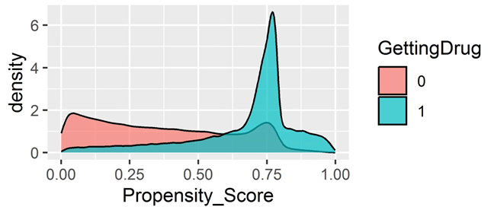 | C
Supplementary Figure 26: Indometacin- A) Propensity score over time B) Cumulative Hazard C) Propensity score density. GettingDrug = 0 means Not exposed. GettingDrug=1 means Exposed.

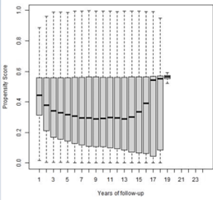 | A
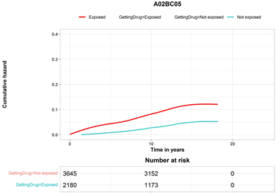 | B
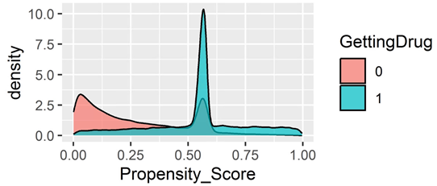 | C
Supplementary Figure 27: Esomeprazole- A) Propensity score over time B) Cumulative Hazard C) Propensity score density. GettingDrug = 0 means Not exposed. GettingDrug=1 means Exposed.

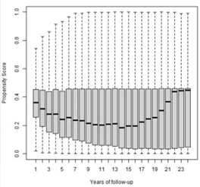 | A
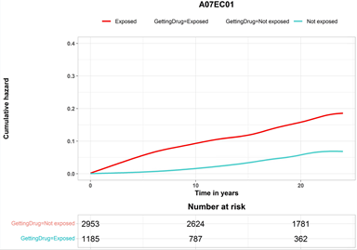 | B
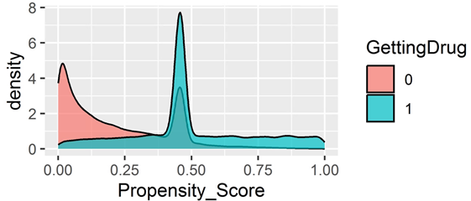 | C
Supplementary Figure 28: Sulfasalazine- A) Propensity score over time B) Cumulative Hazard C) Propensity score density. GettingDrug = 0 means Not exposed. GettingDrug=1 means Exposed.

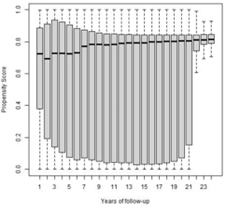 | A
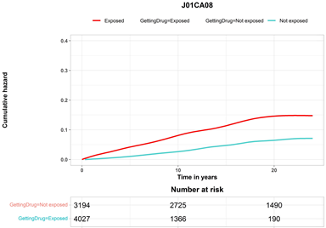 | B
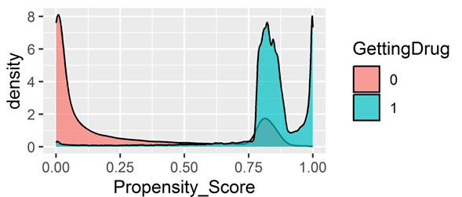 | C
Supplementary Figure 29: Pivmecillinam- A) Propensity score over time B) Cumulative Hazard C) Propensity score density. GettingDrug = 0 means Not exposed. GettingDrug=1 means Exposed.

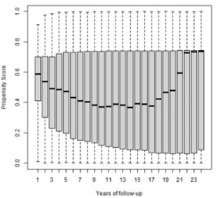 | A
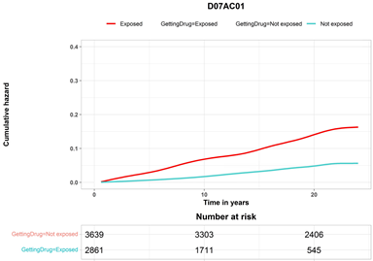 | B
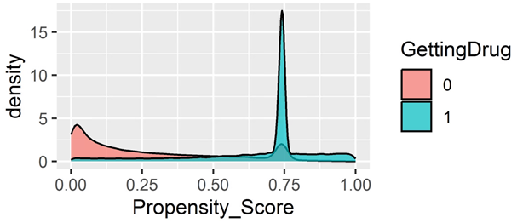 | C
Supplementary Figure 30: Betamethasone- A) Propensity score over time B) Cumulative Hazard C) Propensity score density. GettingDrug = 0 means Not exposed. GettingDrug=1 means Exposed.

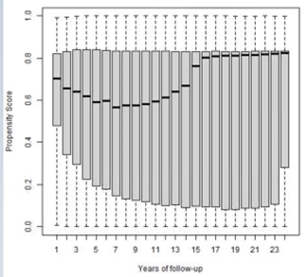 | A
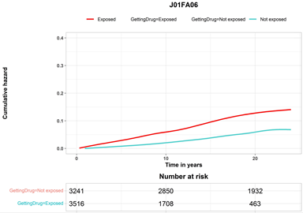 | B
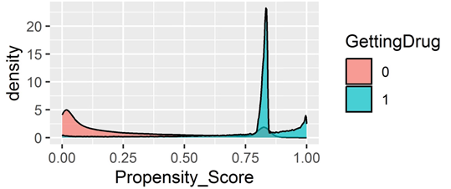 | C
Supplementary Figure 31: Roxithromycin- A) Propensity score over time B) Cumulative Hazard C) Propensity score density. GettingDrug = 0 means Not exposed. GettingDrug=1 means Exposed.

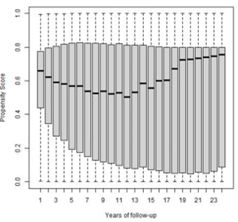 | A
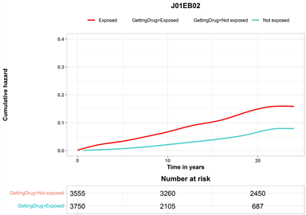 | B
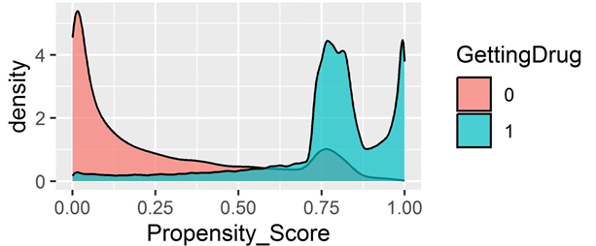 | C
Supplementary Figure 32: Sulfamethizole- A) Propensity score over time B) Cumulative Hazard C) Propensity score density. GettingDrug = 0 means Not exposed. GettingDrug=1 means Exposed.

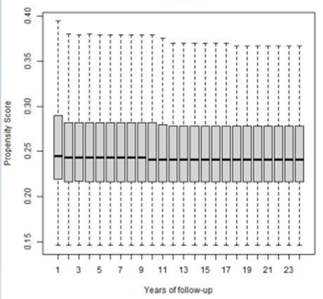 | A
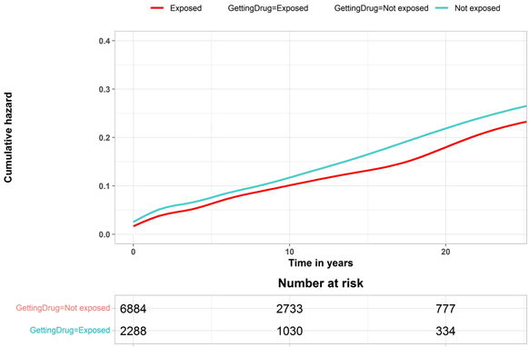 | B
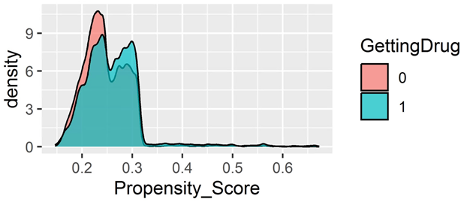 | C
Supplementary Figure 33: Erythromycin - A) Propensity score over time B) Cumulative Hazard C) Propensity score density. GettingDrug = 0 means Not exposed. GettingDrug=1 means Exposed.

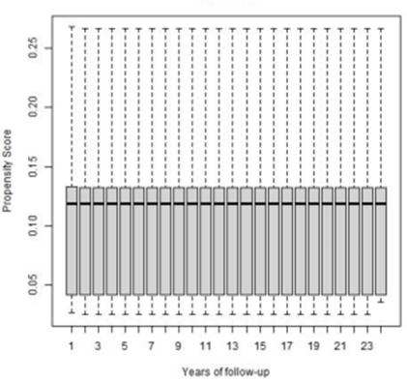 | A
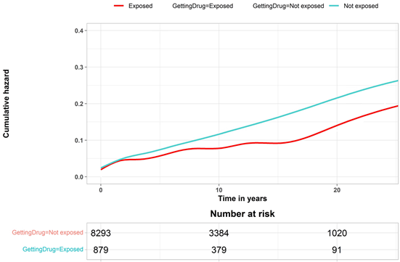 | B
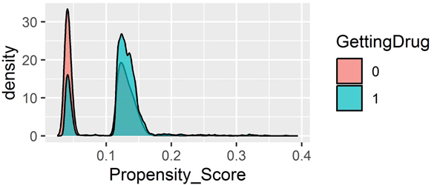 | C
Supplementary Figure 34: Levothyroxine sodium- A) Propensity score over time B) Cumulative Hazard C) Propensity score density. GettingDrug = 0 means Not exposed. GettingDrug=1 means Exposed.

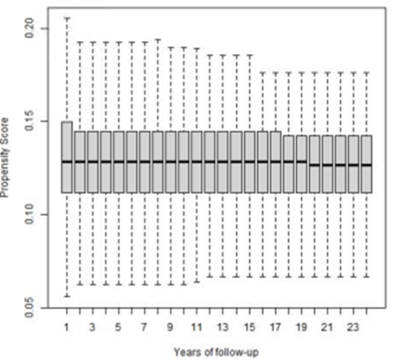 | A
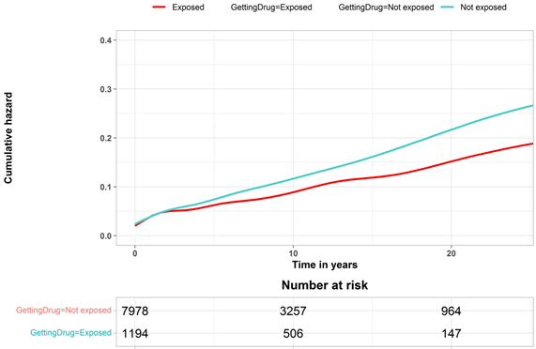 | B
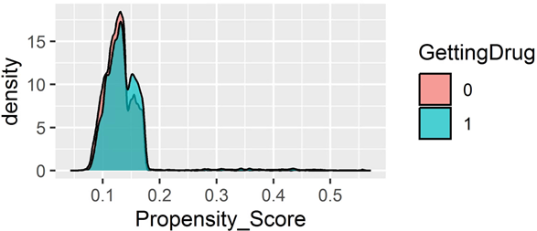 | C
Supplementary Figure 35: Metformin- A) Propensity score over time B) Cumulative Hazard C) Propensity score density. GettingDrug = 0 means Not exposed. GettingDrug=1 means Exposed.

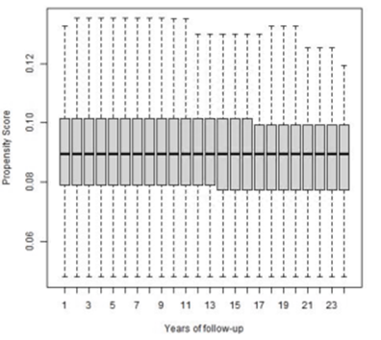 | A
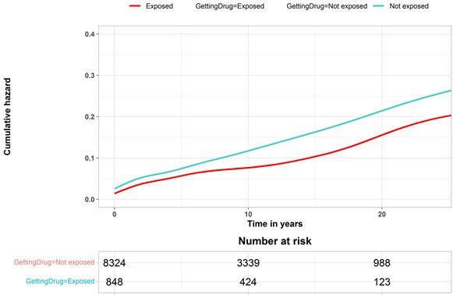 | B
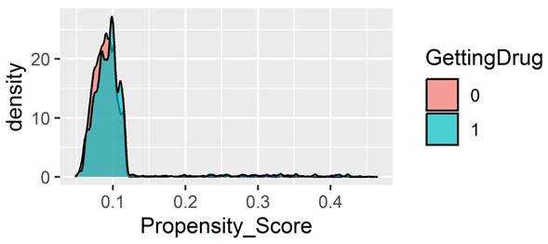 | C
Supplementary Figure 36: Fluticasone- A) Propensity score over time B) Cumulative Hazard C) Propensity score density. GettingDrug = 0 means Not exposed. GettingDrug=1 means Exposed.

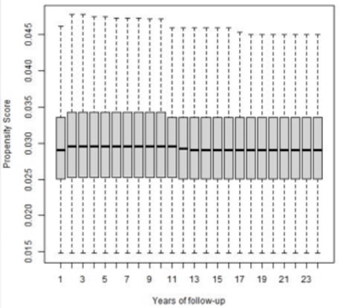 | A
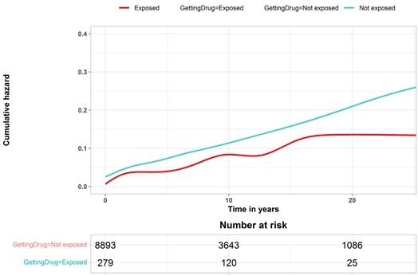 | B
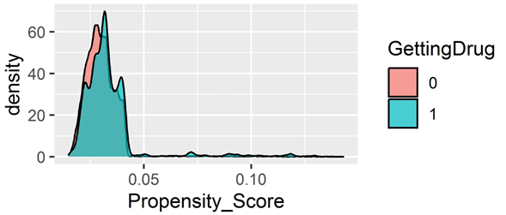 | C
Supplementary Figure 37: Montelukast - A) Propensity score over time B) Cumulative Hazard C) Propensity score density. GettingDrug = 0 means Not exposed. GettingDrug=1 means Exposed.

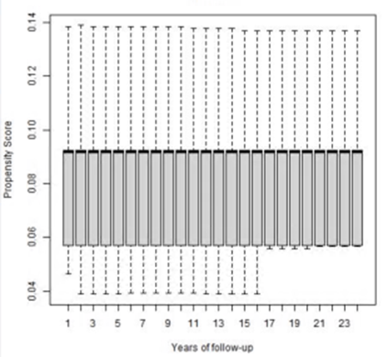 | A
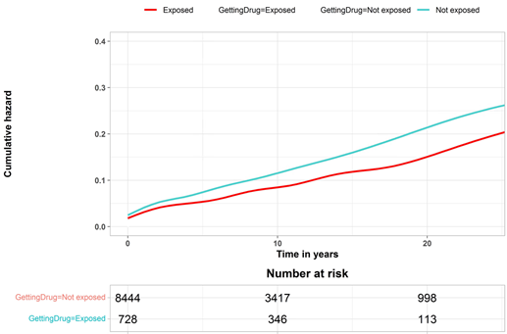 | B
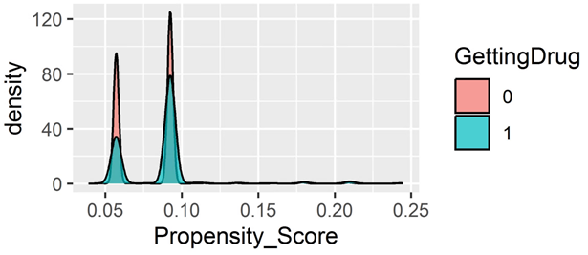 | C
Supplementary Figure 38: Levocabastine - A) Propensity score over time B) Cumulative Hazard C) Propensity score density. GettingDrug = 0 means Not exposed. GettingDrug=1 means Exposed.

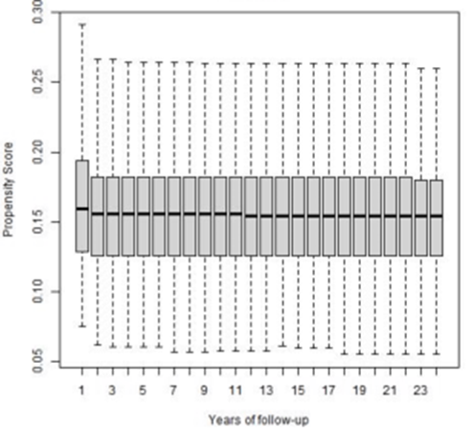 | A
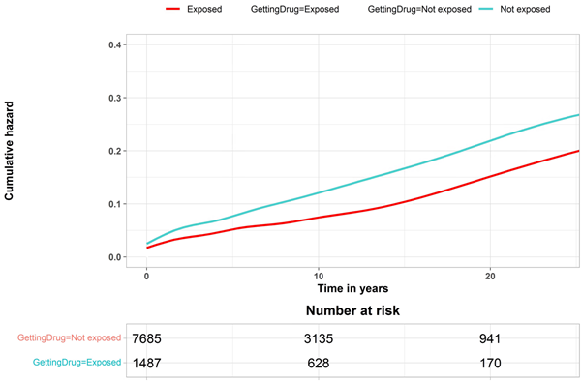 | B
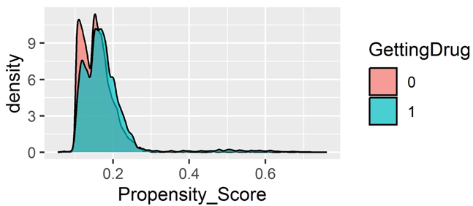 | C
Supplementary Figure 39: Clopidogrel - A) Propensity score over time B) Cumulative Hazard C) Propensity score density. GettingDrug = 0 means Not exposed. GettingDrug=1 means Exposed.

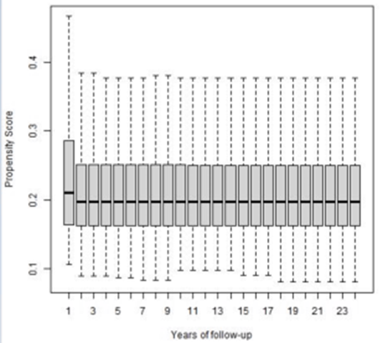 | A
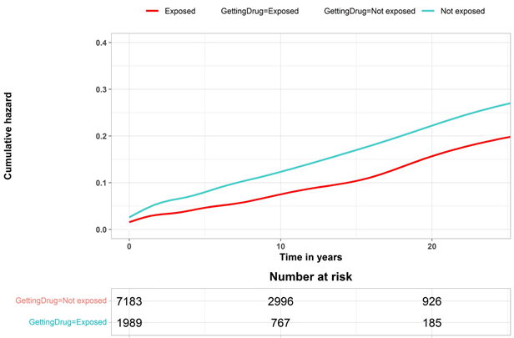 | B
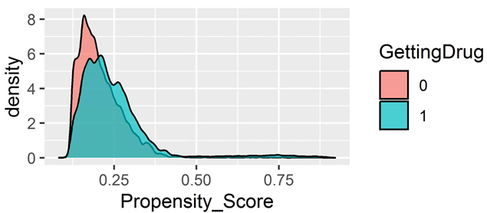 | C
Supplementary Figure 40: Glyceryl trinitrate - A) Propensity score over time B) Cumulative Hazard C) Propensity score density. GettingDrug = 0 means Not exposed. GettingDrug=1 means Exposed.

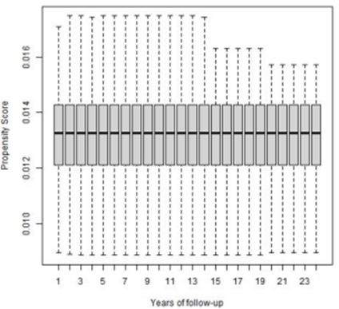 | A
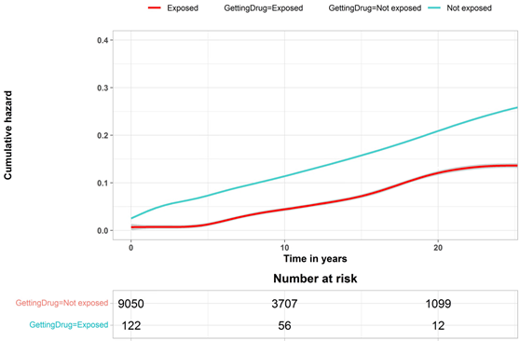 | B
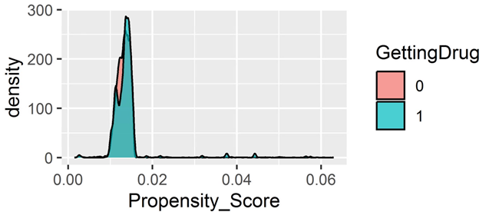 | C
Supplementary Figure 41: Epinephrine- A) Propensity score over time B) Cumulative Hazard C) Propensity score density. GettingDrug = 0 means Not exposed. GettingDrug=1 means Exposed.

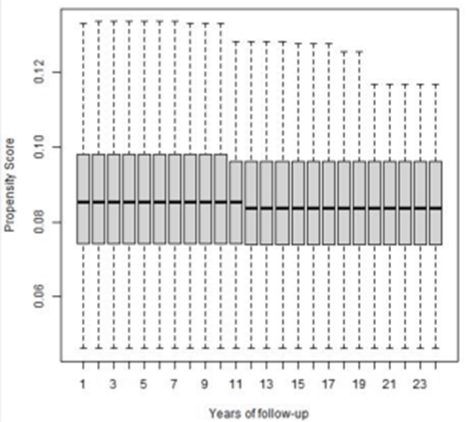 | A
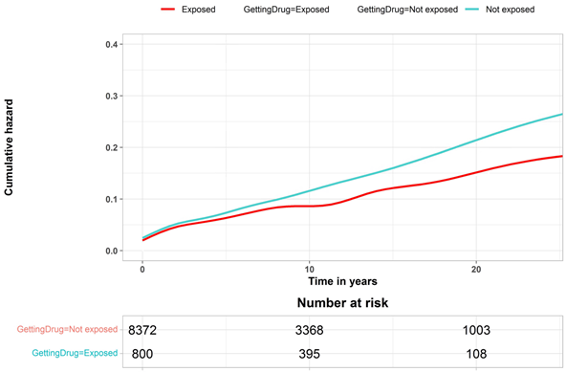 | B
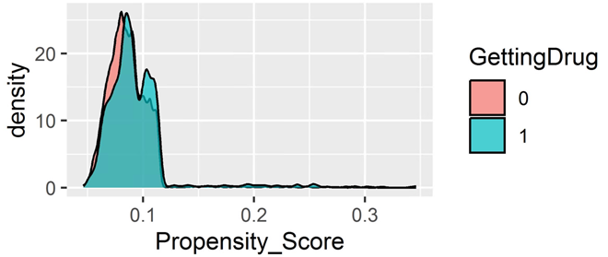 | C
Supplementary Figure 42: Fexofenadine - A) Propensity score over time B) Cumulative Hazard C) Propensity score density. GettingDrug = 0 means Not exposed. GettingDrug=1 means Exposed.

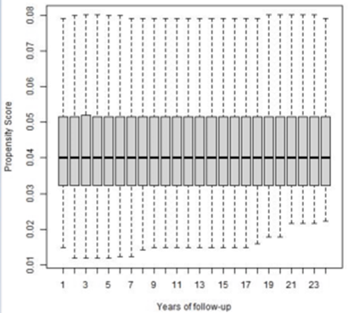 | A
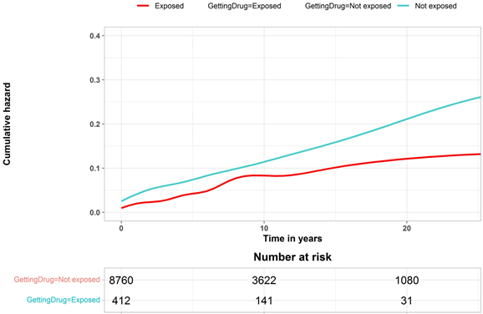 | B
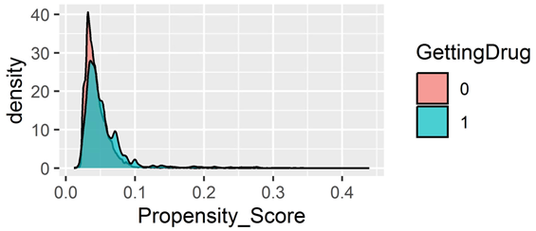 | C
Supplementary Figure 43: Docusate sodium - A) Propensity score over time B) Cumulative Hazard C) Propensity score density. GettingDrug = 0 means Not exposed. GettingDrug=1 means Exposed.

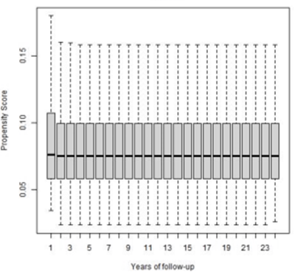 | A
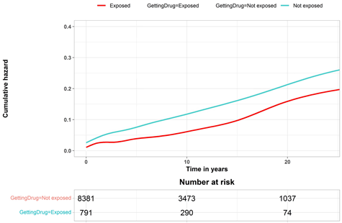 | B
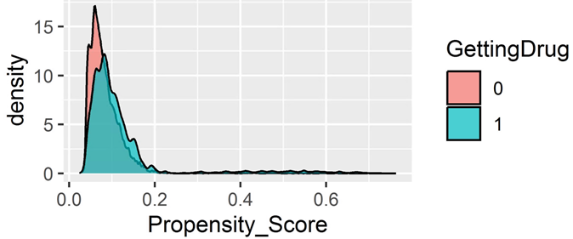 | C
Supplementary Figure 44: Isosorbide - A) Propensity score over time B) Cumulative Hazard C) Propensity score density. GettingDrug = 0 means Not exposed. GettingDrug=1 means Exposed.

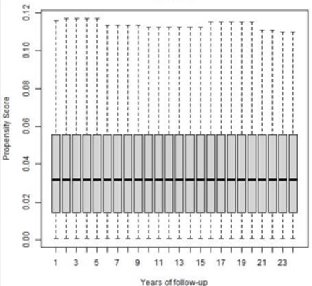 | A
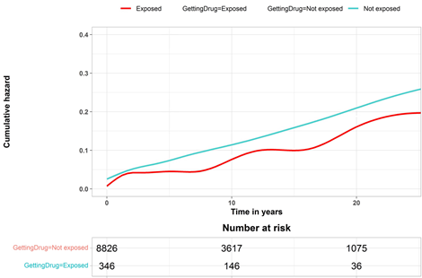 | B
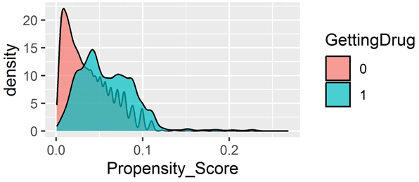 | C
Supplementary Figure 45: Disulfiram - A) Propensity score over time B) Cumulative Hazard C) Propensity score density. GettingDrug = 0 means Not exposed. GettingDrug=1 means Exposed.

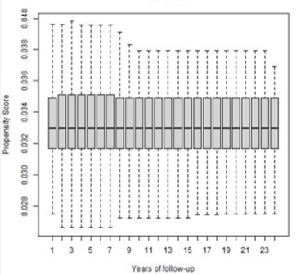 | A
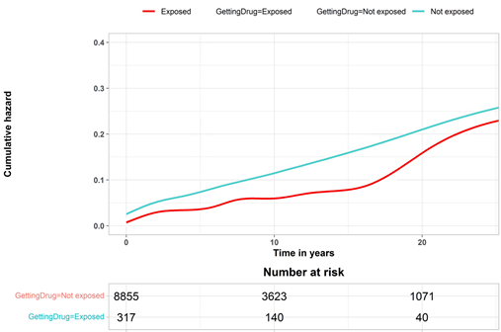 | B
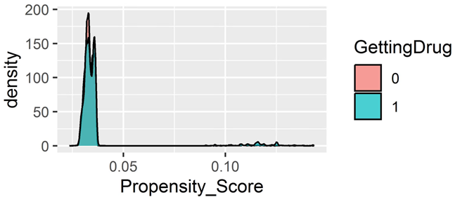 | C
Supplementary Figure 46: Quetiapine- A)Propensity score over time B) Cumulative Hazard C) Propensity score density. GettingDrug = 0 means Not exposed. GettingDrug=1 means Exposed.

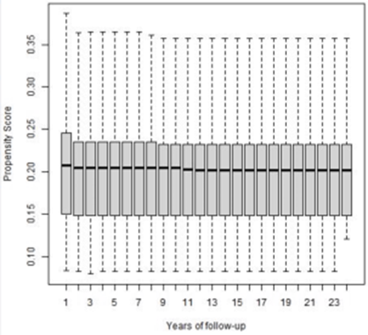 | A
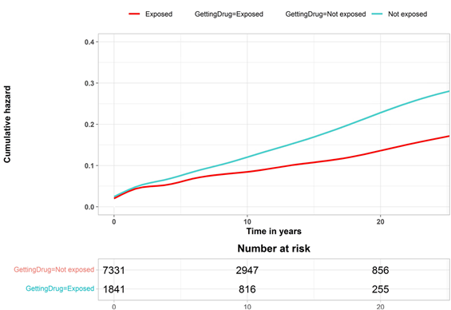 | B
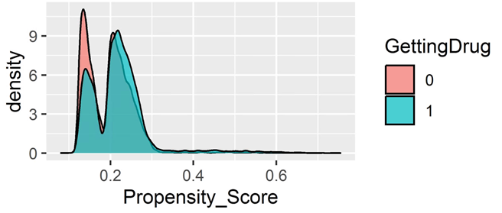 | C
Supplementary Figure 47: Glucosamine - A) Propensity score over time B) Cumulative Hazard C) Propensity score density. GettingDrug = 0 means Not exposed. GettingDrug=1 means Exposed.

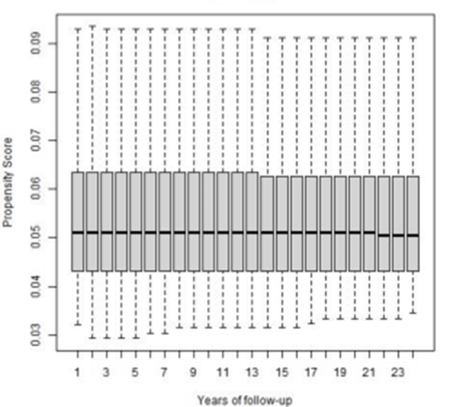 | A
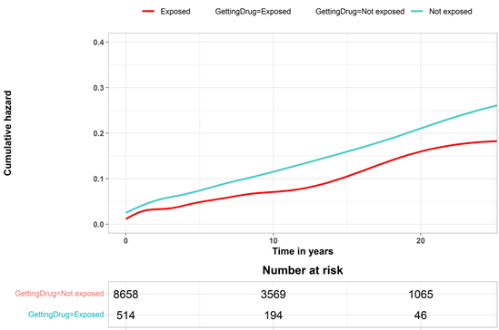 | B
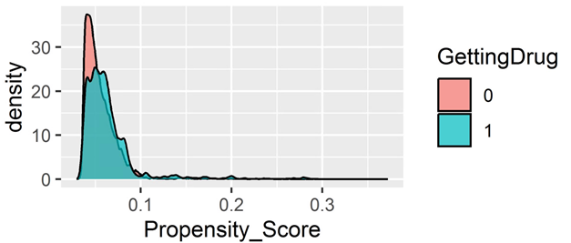 | C
Supplementary Figure 48: Tolterodine - A) Propensity score over time B) Cumulative Hazard C) Propensity score density. GettingDrug = 0 means Not exposed. GettingDrug=1 means Exposed.

Supplementary Material 3

Supplementary Table 1. Median Adherence for drugs associated with increasing or decreasing risk of ileocecal resection
Drug name | Median Adherence (MPR)
Docusate sodium | 82
Epinephrine | 105
Bendroflumethiazide and potassium | 87
Furosemide | 90
Enalapril | 81
Estradiol | 85
Tolterodine | 83
Levothyroxine sodium | 89
Indometacin | 87
Quetiapine | 88
Diazepam | 84
Oxazepam | 83
Zopiclone | 82
Zolpidem | 88
Citalopram | 80
Disulfiram | 103
Fluticasone | 87
Montelukast | 83
Fexofenadine | 87
Levocabastine | 80
MPR = Medication Possession Rate.

Supplementary Material 4

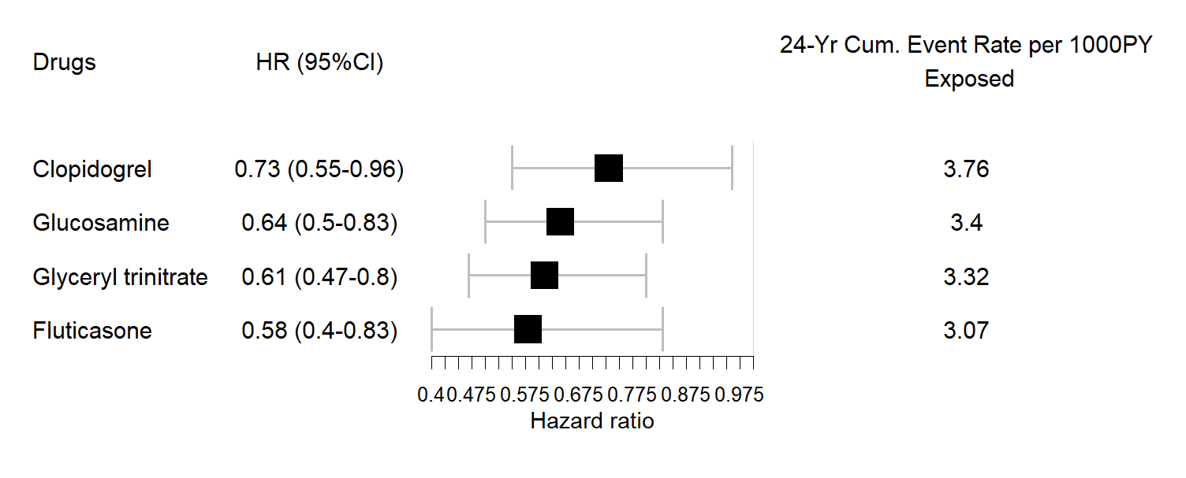
Supplementary Figure 1: Hazard ratio of drugs confirmed with the sensitivity analysis associated with a prolonged time interval from the initial diagnosis of CD to the study outcome.
.

