Work Disability and Return to Work After Acute Lymphoblastic Leukemia: A Danish Nationwide Cohort Study
E.F. Maksten, R.R.K. Jørgensen, M.S. Pedersen, K. Fonager, R.S. Bech, I. Mølle, A.D. Ørskov, C. Schöllkopf, U.M. Overgaard, G.N. Thomsen, T.C. El-Galaly, M.T. Severinsen

Supplementary Table 1
Employment status one, three, and five years after index (corresponding to one year after diagnosis) for patients with ALL and comparators holding a job before diagnosis (or corresponding day for comparators).
Patients with ALL
 | 1 year | 3 years | 5 years
Unemployed/Early retirement pension/  Retirement pension, n (%) | 13 (11.3) | 8 (8.8) | 5 (8.2)
Sick leave/Disability pension/Flexible job, n (%) | 54 (47.0) | 23 (25.3) | 19 (31.1)
Working, n (%) | 48 (41.7) | 60 (65.9) | 37 (60.7)
Comparators
 | 1 year | 3 years | 5 years
Unemployed/Early retirement pension/  Retirement pension, n (%) | 33 (5.8) | 29 (6.0) | 23 (6.1)
Sick leave/Disability pension/Flexible job, n (%) | 10 (1.8) | 21 (4.3) | 22 (5.9)
Working, n (%) | 528 (92.5) | 437 (89.7) | 331 (88.0)

Supplementary Figure 1
Cumulative risk of disability pension for A) female and B) male patients with ALL and their matched comparators.

A)
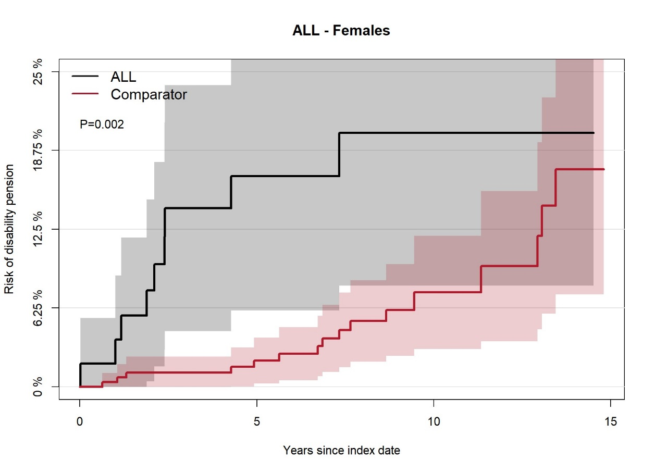
B)
