Supplementary Figure 1: Timetable of week 1. Blue boxes represent theoretical sessions, pink boxes indicate Hands-On sessions, orange boxes represent on-site events, green boxes specify blended learning assignments and brown boxes depict a summary of the overall aim of the day.

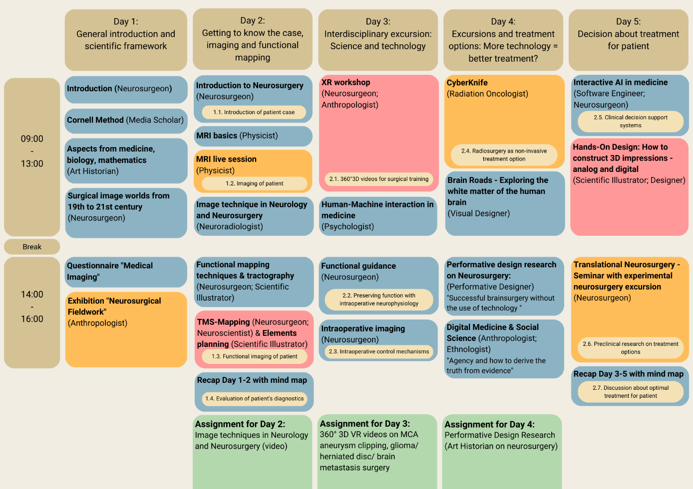

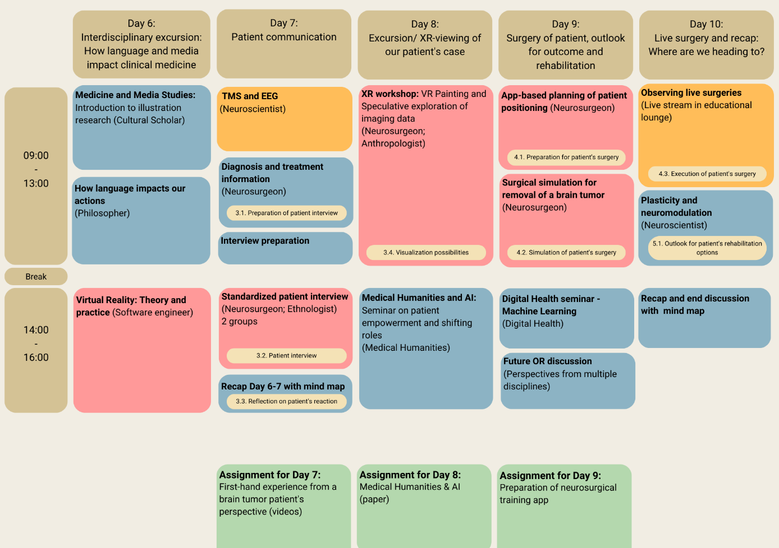
Supplementary Figure 2: Timetable of week 2. Blue boxes represent theoretical sessions, pink boxes indicate Hands-On sessions, orange boxes represent on-site events, green boxes specify blended learning assignments and brown boxes depict a summary of the overall aim of the day.
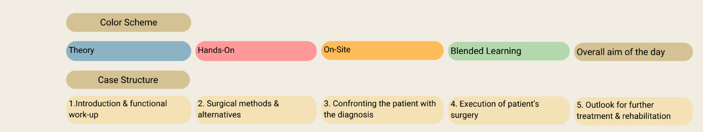
Supplementary Figure 3: Explanatory legend of the color scheme and the case structure.

