Supporting Information

ORIGINAL RESEARCH
Jinyuan Ma et al

Dissolving Microneedle-Based Cascade-activation Nanoplatform for Enhanced Photodynamic Therapy of Skin Cancer
Jinyuan Ma^{1,2}*, Zongguang Tai^{1,2}*, Ying Li^{1,2}*, Yang Li³, Jiandong Wang^{1,2}, Tao Zhou^{1,2}, Min Shen^{1,2}, Rujuan Xin^{1,2}, Cuie Shen^{1,2}, Quangang Zhu^{1,2#}, Zhongjian Chen^{1,2#}

¹Shanghai Skin Disease Hospital, School of Medicine, Tongji University, Shanghai, China
²Shanghai Engineering Research Center for Topical Chinese Medicine, Shanghai, China
³CAS Key Laboratory of Design and Assembly of Functional Nanostructures, Fujian Institute of Research on the Structure of Matter, Chinese Academy of Sciences, Fuzhou, China
# These authors contributed equally.

Jinyuan Ma^{1,2*}
Zongguang Tai^{1,2*}
Ying Li^{1,2*}
*These authors contributed equally to this work

Correspondence: Quangang Zhu
Shanghai Skin Disease Hospital, School of Medicine, Tongji University, 1278 Baode Road, Shanghai 200443, China
Tel +86 21 36803155
Fax +86 21 36803155
Email qgzhu@126.com

Correspondence: Zhongjian Chen
Shanghai Skin Disease Hospital, School of Medicine, Tongji University, 1278 Baode Road, Shanghai 200443, China
Tel +86 21 36803007
Fax +86 21 36803007
Email aajian818@163.com

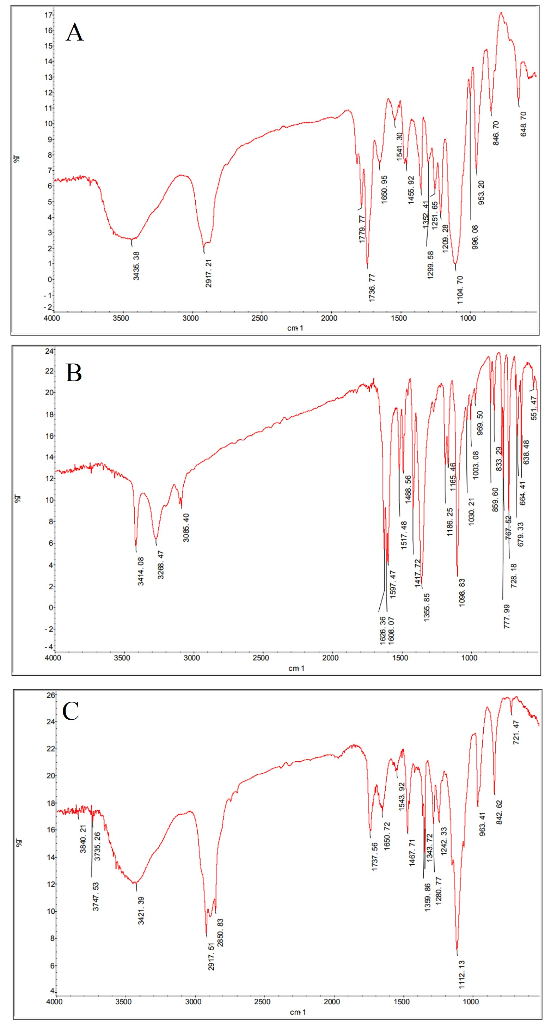
Figure S1 The FT-IR spectrum of (A) DSPE-PEG-NHS, (B) TPZ, and (C) DSPE-PEG-TPZ.

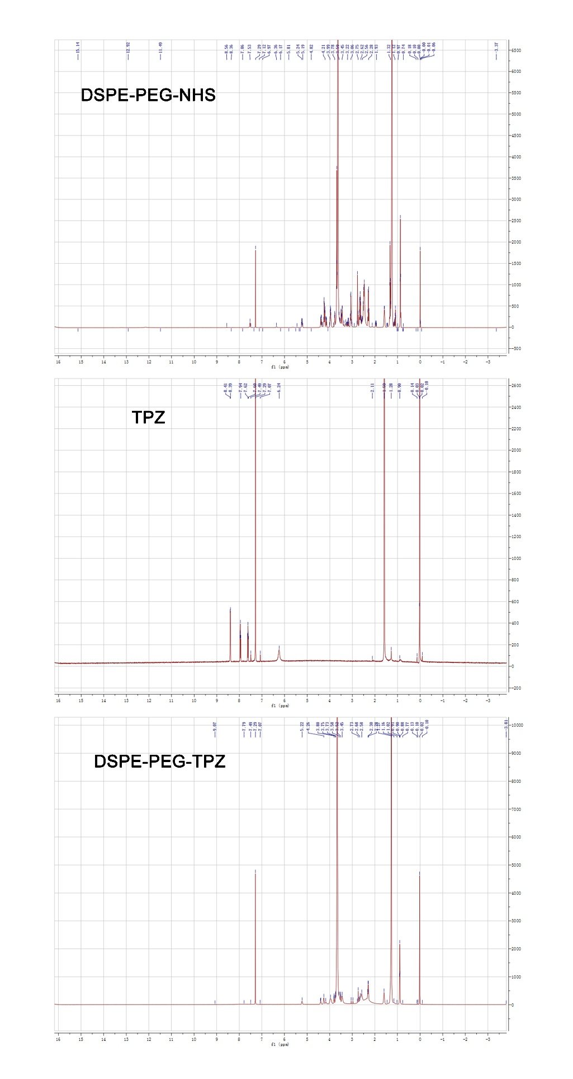
Figure S2 The ¹H-NMR spectra spectrum of DSPE-PEG-NHS, TPZ, and DSPE-PEG-TPZ.

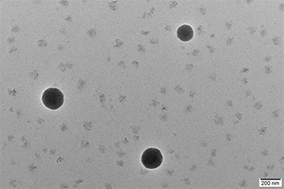
Figure S3 Transmission electron microscopy images of DPC.

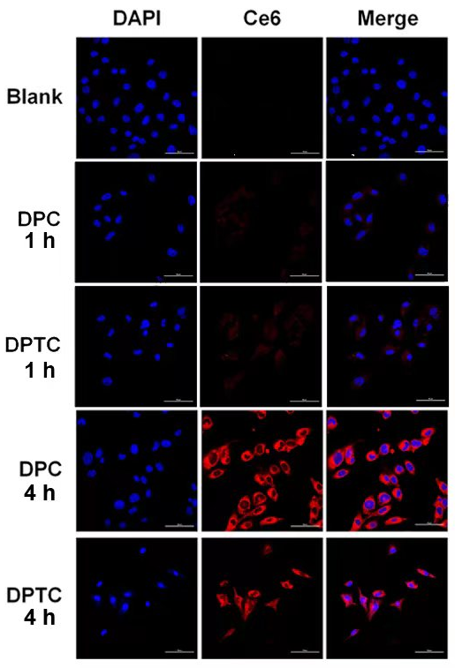
Figure S4 CLSM images of B16 cells treated with DPTC for 1 h and 4 h (×600). Scale bar = 50 μm

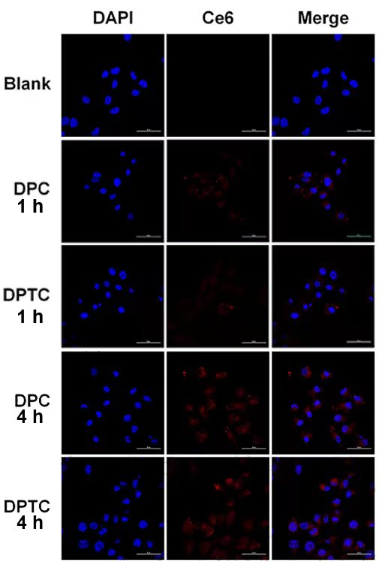
Figure S5 CLSM images of SCL-1 cells treated with DPTC for 1 h and 4 h (×600). Scale bar = 50 μm

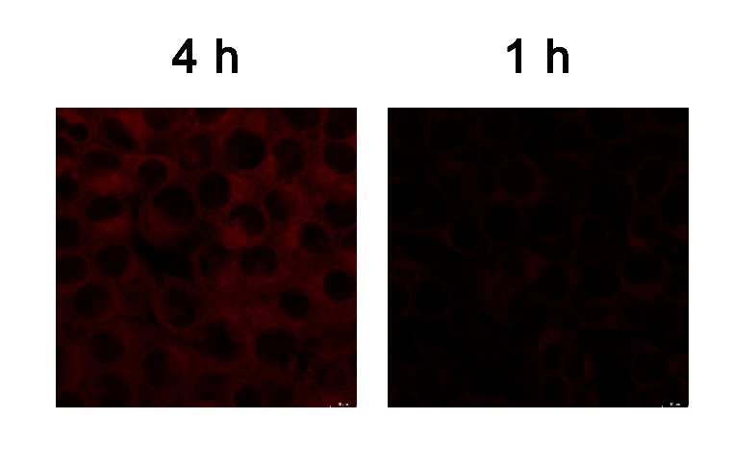
Figure S6 CLSM images of B16 cells treated with Ce6 for 1 h and 4 h (×1000). Scale bar = 10 μm

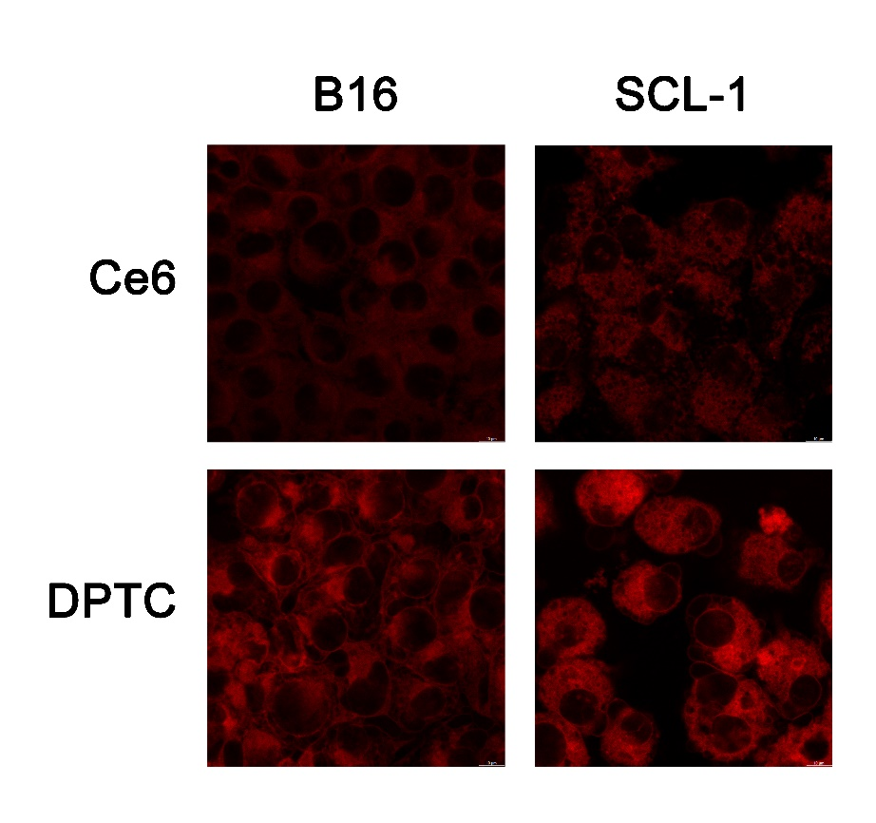
Figure S7 CLSM images of B16 cells treated with DPTC or Ce6 for 4 h (×1000). Scale bar = 10 μm
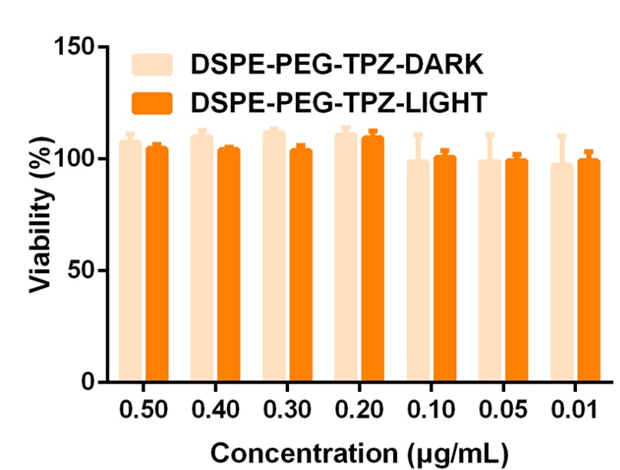
Figure S8 In vitro cytotoxicity of DSPE-PEG-TPZ on B16 cells.

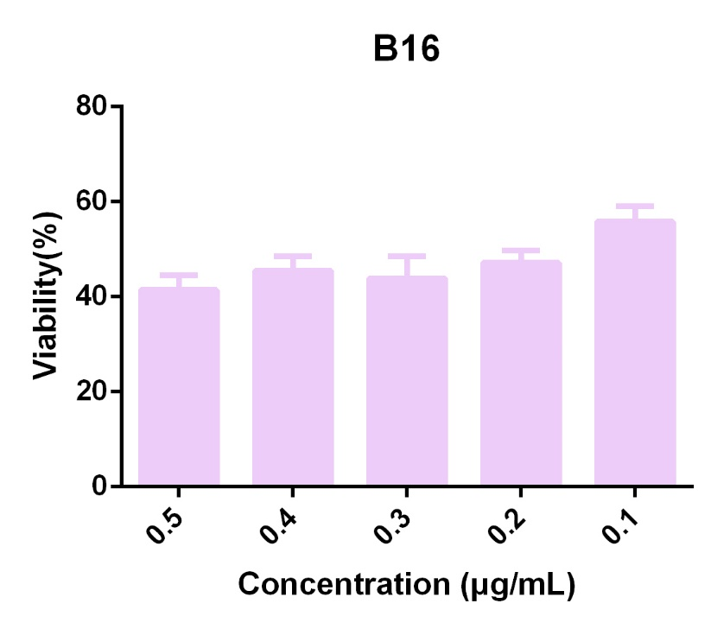
Figure S9 In vitro cytotoxicity of DSPE-PEG-TPZon B16 cells in hypoxia condition.

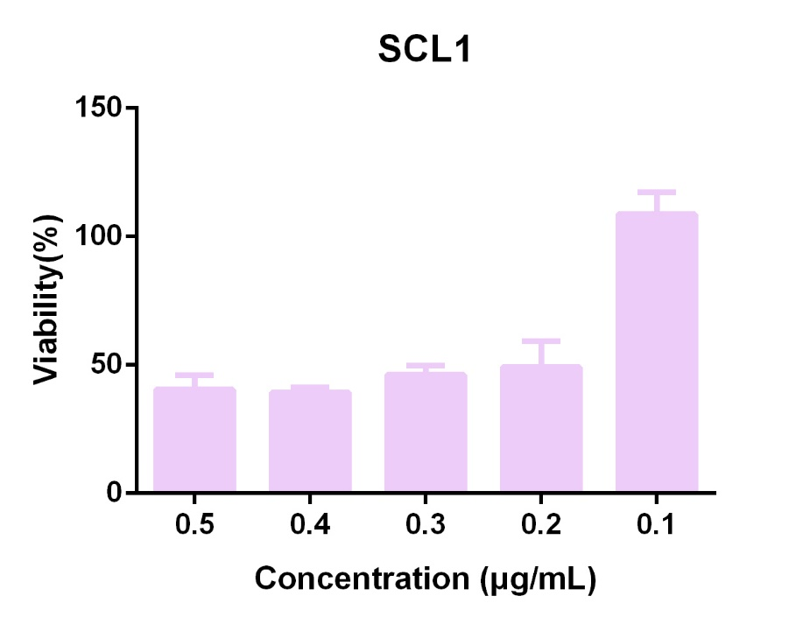
Figure S10 In vitro cytotoxicity of DSPE-PEG-TPZ on SCL-1 cells in hypoxia condition.

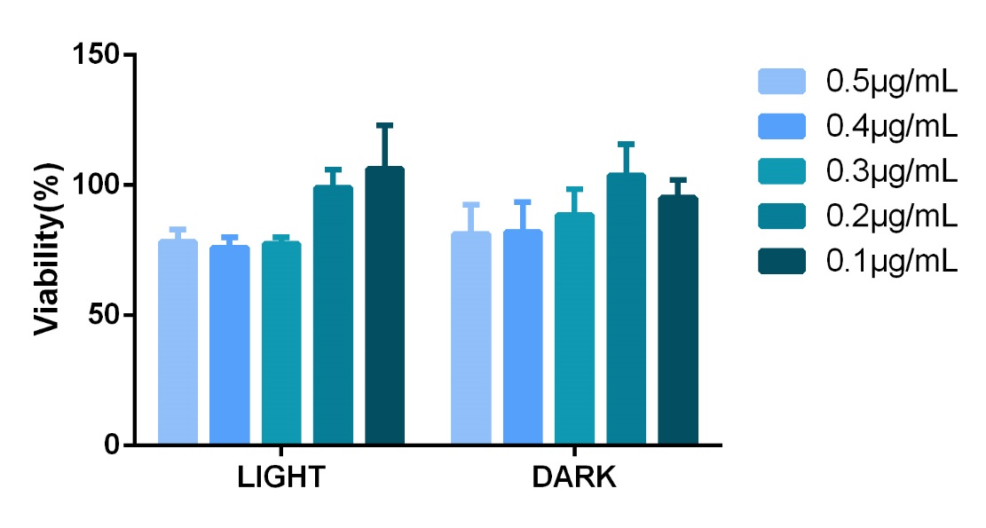
Figure S11 In vitro cytotoxicity of free Ce6 on B16 cells.

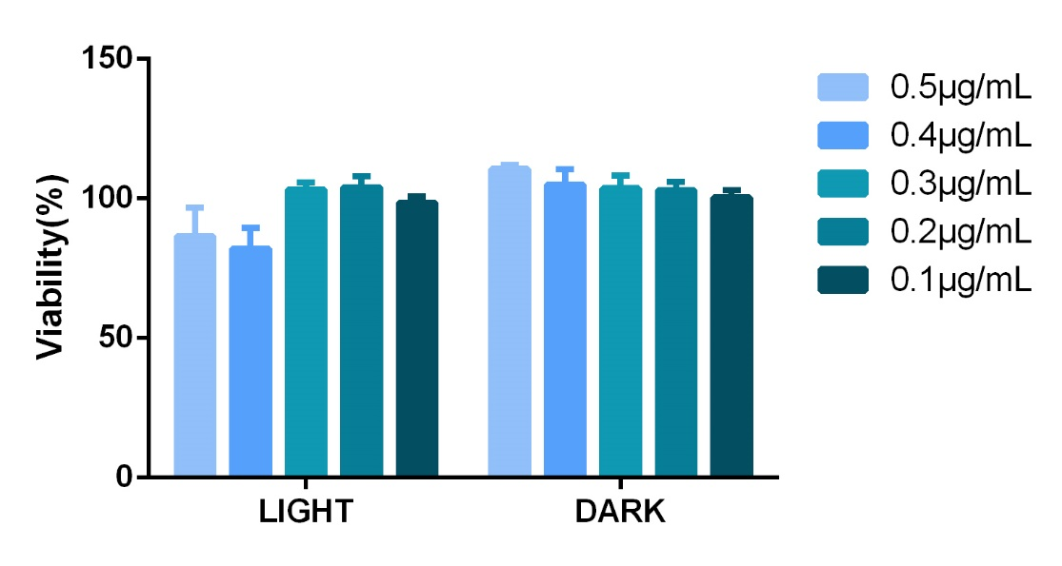
Figure S12 In vitro cytotoxicity of free Ce6 on SCL-1 cells.

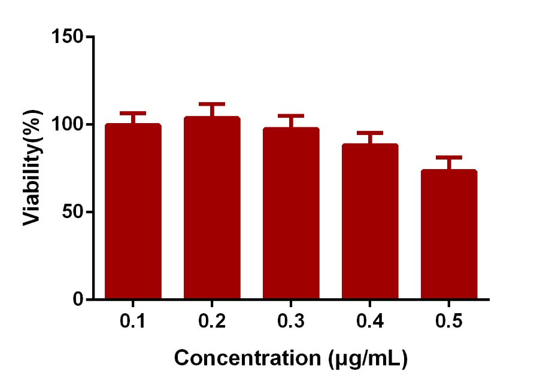
Figure S13 In vitro cytotoxicity of DPTC at dark on HaCat cells.

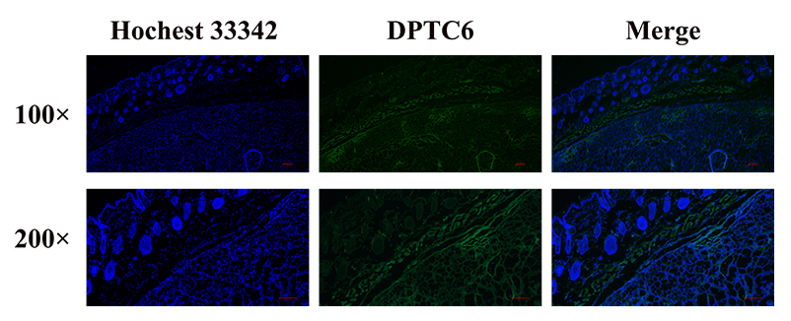
Figure S14 DTPC6 fluorescence signals distribution on SCL-1 xenograft tumors when injected in vein.

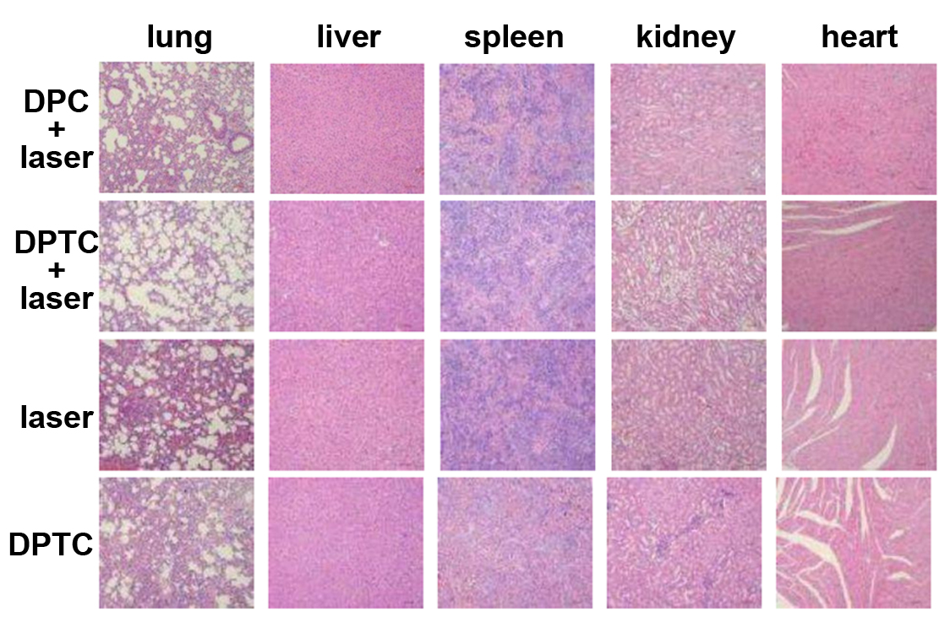
Figure S15 H&E staining images of major organs (heart, liver, spleen, lung, and kidney) slides from different groups after 14-day treatment.

