Appendix E1 CT imaging

All patients underwent four CT scans: unenhanced phase, late arterial phase (AP), portal vein phase (PVP), and delayed phase (DP). CT is performed on a 64-slice CT scanner (GE Healthcare, USA; Tube voltage 120 kV, tube current 250mA; Field of vision (300-500) mm× (300-500) mm, matrix 512×512, layer spacing 5mm, layer thickness 5mm). After the enhanced scan was administered intravenously with a power syringe (Bayer, Germany) at a flow rate of 3.0 to 3.5ml/s. Using the tracking technique, AP images were acquired 18 s after the descending aorta (the level of the celiac trunk) reached 100 HU.

Appendix E2 Transcatheter arterial chemoembolization procedure

Seldinger technique was used to puncture the right femoral artery, insert the 5F artery sheath, and then the 5F/4F RH arteriography catheter was placed in the artery sheath. Abdominal trunk arteriography and superior mesenteric arteriography were performed to determine the blood supply vessels, portal return, and the presence of arteriovenous fistula. In addition, the presence of extrahepatic supplying arteries was determined according to the angiography. After the tumor blood supply vessels were identified, the superselection (segment-level or subsegment-level) method was performed.
The 2.4/2.7F microcatheter was sent to the appropriate position under the guidance of the microfilament. First, raltitrexed was slowly infused (the dose was about 2.5-3 mg/m2), and then lipiodo emulsion (pirirubicin 40 mg+ lipiodo 10 ml fully emulsified) was slowly injected into the blood supply vessels of the tumor. The dosage was calculated according to the tumor diameter (2-3 ml/cm). Observe the tumor staining, if not filled, can add blank iodide, the total amount of iodide is not more than 20ml.
Try to avoid reflux during injection, and then inject the appropriate gelatine sponge /PVA granule type embolization agent. Angiography was performed again 5 minutes later to observe complete embolization. If complete embolization was achieved, the operation was over. If not, the above steps were repeated until complete embolization was achieved.

Appendix E3 Construct a deep learning prognosis model

- Image segmentation
In this study, the arterial phase was selected as the research object, ITK(2.2.0) was used for preprocessing, and the bilinear interpolation and nearest interpolation were used to resample the CT and the mask volume toto 1×1×1 mm³, respectively. Then the CT pixel density was normalized to between 0 and 1. The deep-wise bounding box was used to obtain plaques containing the three-dimensional volume of the tumor.

- Detail
The final deep learning model is the modified resnet101 (PyTorch: 1.7.1) . A computer with a 24 GB Titan 3090Ti graphics card was used. 1000 CT images were randomly selected from the training data set for pre-experiment, and the hyperparameters were determined: The batch is set to 32, the training iteration (epoch) is set to 500, the -Adam optimizer parameter is set to beta and is set to 0.9, the learning rate is set to 1e−4 and calculated by equation (1) below, weight decay is set to 1e−4 and momentum to 0.9. The fully connected layer of the output image prediction scores was modified to accommodate the number of classes in this study. The average time required for a training phase was 167 seconds, while the average time required for a test was only 12 seconds.

$\begin{aligned}v_{t}&=β_{2}^{p}v_{t-1}+\left(1-β_{2}^{p}\right){\left|g_{t}\right|}^{p} \\ &=\left(1-β_{2}^{p}\right)\sum_{i=1}^{t}{ }β_{2}^{p(t-i)}⋅{\left|g_{i}\right|}^{p}\end{aligned}$ （1）

V_{t} is the gradient value obtained by the current batch, V_{T-1} is the gradient value calculated by the previous batch, and g_{t} is the gradient value of the gradient back propagation

- The modified resnet101 model

Resnet is a typical Convolutional Neural Network (CNN) whose goal is to learn the abstract mapping between image data and the desired labels. the most important components of the DL model are the Residual Block and the Fully Connected Layer. The residual block consists of a convolutional layer, activation function, batch normalization, and residual connectivity to learn features from data adaptively. The DL model simulates the process of human brain analysis and extracts high-level semantic features by overlaying multiple residual blocks, and then sends the output values to the fully-connected layer classifier through the global average pooling layer. The residual learning structure can be implemented by forward neural networks combined with residual connectivity. The residual connectivity is similar to the principle of constant mapping in that it neither generates additional parameters nor increases the computational complexity. Moreover, the whole network can still be trained by end-to-end back propagation.

In this study, an end-to-end improved resnet101 model with 101 layers is constructed based on the principle of residual networks with input image size: 224 × 224. The model consists of 33 residual blocks that efficiently propagate gradients and accelerate network convergence through shortcut connections with raw CT images at the input. We also define specialized loss functions to train the model for risk prediction. The model is trained using data enhancement and fine-tuning techniques to avoid overfitting.

Migration learning: Overfitting occurs when we train a DL model using a limited dataset. We perform migration learning on the data from the training set - details of migration learning; the parameters of the model trained on ImageNet (a large-scale dataset of 10 million natural images) are used as the initialization parameters of the deep model in this study, and the parameters of the convolution operation are frozen during subsequent training, and only the parameters in the fully connected layer are fine-tuned.

Fine-tuning: A process used for model optimization to improve model performance and reduce time by freezing shallow model parameters to train the model, allowing deep focused training of the model to obtain problem-specific features. This study builds an improved resnet101 model custom fully connected layer based on this method to improve the model performance.

Loss function: In the DL learning model, the loss function is used to calculate the error between the model output and the actual label, and we define the loss function as：A scalable discrete-time survival model for neural networks

Dropout: When training a complex feedforward neural network with many parameters on a training set with a small sample size, it usually has high accuracy on the training set and poor performance on the validation set, resulting in overfitting. Because we use Dropout to reduce the possibility of overfitting and thus improve the generalization ability of the model, Dropout can randomly and temporarily select some hidden neurons in the intermediate layers to stop working with a certain probability, while keeping the number of neurons in the input and output layers unchanged. In the process of back-propagation and parameter update, the neurons that are not removed update their corresponding weights, while the weights of those neurons that are stopped remain unchanged so that they can be re-selected to participate in the update of weights in the next iteration as the starting point. The probability of Dropout is set to 0.5.

Learning rate: The learning rate controls the speed of adjusting the neural network weights based on the gradient of the loss function, and is a hyperparameter of DL. The smaller the learning rate, the slower the gradient of the loss function decreases and the longer the convergence time; if the learning rate is too small, it will cause the training set model to be easy to overfit and converge slowly, and if the learning rate is too large, it is easy to explode the loss function, easy to oscillate and will cross the optimal value. The initial learning rate in this study is 0.001, while the learning rate is dynamically adjusted by combining the ReduceLROnPlateau strategy, and the learning rate decreases to one-tenth of the initial learning rate when the training set loss does not decrease for 10 consecutive epochs.

The overfitting phenomenon is further suppressed using the early stopping strategy, which is determined with reference to the loss on the validation set, and training is stopped when the validation set loss does not decrease for 20 consecutive epochs. Within the epoch limit, the best model with the lowest loss on the training set is preserved.

Appendix E4 Radiomic model

Images of HCC in the arterial phase of all patients were uploaded to the deepwise platform and sketched by two experts with 7 and 8 years of radiology experience without knowledge of clinical and laboratory information. The ROI was as close to the tumor edge as possible, and the deepwise platform was then used to automatically extract features. Then the correlation coefficients between the classes were calculated to ensure the stability and repeatability of the radiological features. Then, the non-0 coefficient features were selected by LASSO COX to construct radscore and the feature correlation analysis was carried out

Appendix E5 Statistical analysis

Categorical variables were descripted as frequency and percentage. Comparison of clinical features were conducted using Student’s t-test or Wilcoxon rank-sum test and chi-square test or Fisher’s exact test for continuous variables and categorical variables, respectively. LASSO COX was used to screen radiomic signatures related to survival using “glmnet” package in R. Multivariate stepwise Logistic regression was conducted to identify the independent factors associated with survival. ROC curves were plotted using the "pROC" package. Calibration curves and decision curves were plotted using “rms” package and “rmda” package, respectively. All statistical analyses were performed in R software version 3.6.3, and p < 0.05 was considered to be statistically significant. Kaplan-Meier curves were plotted using the "survival" package in R.

Appendix E6 Results of LASSO feature selection

A total of 713 features were extracted from each patient's ROI, of which (88%) had satisfactory intra- and interobserver reproducibility (ICC > 0.8). Subsequently, LASSO features were screened using regularized regression with penalty (α denoted as the weight of the penalty term) and the number of features was reduced to 5. Finally, Radscore was constructed from the 5 features and calculated as follows:

Radscore = 1.628708e-01 + gradient_glszm_ZoneEntropy × 0.062126883 +
log.sigma.2.0.mm.3D_ngtdm_Contrast × -3.097256224 +
log.sigma.4.0.mm.3D_glszm_SmallAreaEmphasis × -0.004368544 +
square_firstorder_Variance × 0.000134998 +
wavelet.HLL_ngtdm_Complexity × 0.000507638

Table S1 Univariate and multifactorial COX analysis of DLOP_{CTR} and clinical factors

Variable | Univariate Analysis |  | Multivariate Analysis
Variable | HR (95%CI) | P | HR (95%CI) | P
Age | 0.98(0.96-0.99) | < 0.05 | 1.00 (0.98-1.00) | 0.72
Gender | 1.00 (0.78-1.40) | 0.78
Portal Hypertension | 0.79 (0.59-1.10) | 0.11
Diabetes | 0.89 (0.65-1.2) | 0.47
Cirrhosis | 0.87 (0.68-1.1) | 0.28
Hepatitis | 0.75 (0.51-1.1) | 0.14
Child-Pugh score | 1.447 (1.078-1.941) | 0.01 | 1.357 (0.995- 1.851) | 0.0537
AFP | 1.59(0.78-3.26) | 0.20
AST | 1.93(0.71-5.26) | 0.20
ALT | 2.58(0.69-9.74) | 0.16
ALB | 0.74(0.36-1.54) | 0.42
TBIL | 1.16(0.48-2.75) | 0.75
Tumor number | 1.12 (0.88-1.43) | 0.35
Tumor size | 1.00 (1.00-1.00) | 0.74
Tumor location
Left | reference
Right | 0.18 (0.86-1.7) | 0.56
Others | 0.18 (0.79-1.8) | 0.56
MVI | 1.742 (1.325-2.290) | <.0001 | 1.43 (1.08-1.90) | 0.0147
ALBI score | 2.125 (1.618-2.791) | <.0001 | 1.57(1.17-2.10) | 0.0027
BCLC B subclassification
reference
2 | 1.347 (1.078-1.941) | 0.0543 | 1.46 (0.89-2.38) | 0.13
3 | 1.866 (1.172-2.971) | 0.0086 | 1.42 (1.04-1.95) | 0.03
4 | 4.704 (2.926-7.562) | <.0001 | 2.66 (1.63-4.33) | <.0001
treatment response | 0.52 (0.37-0.72) | < 0.05 | 0.451 (0.247-0.826) | 0.0099
DLOP_{CTR} | 0.12 (0.08-0.16) | < 0.05 | 0.14 (0.10-0.21) | < 0.01

Table S2 Radiomic features after LASSO COX selection

Features | coefficients
(Intercept) | 1.63E-01
gradient_glszm_ZoneEntropy | 0.062126883
log.sigma.2.0.mm.3D_ngtdm_Contrast | -3.097256224
log.sigma.4.0.mm.3D_glszm_SmallAreaEmphasis | -0.004368544
square_firstorder_Variance | 0.000134998
wavelet.HLL_ngtdm_Complexity | 0.000507638

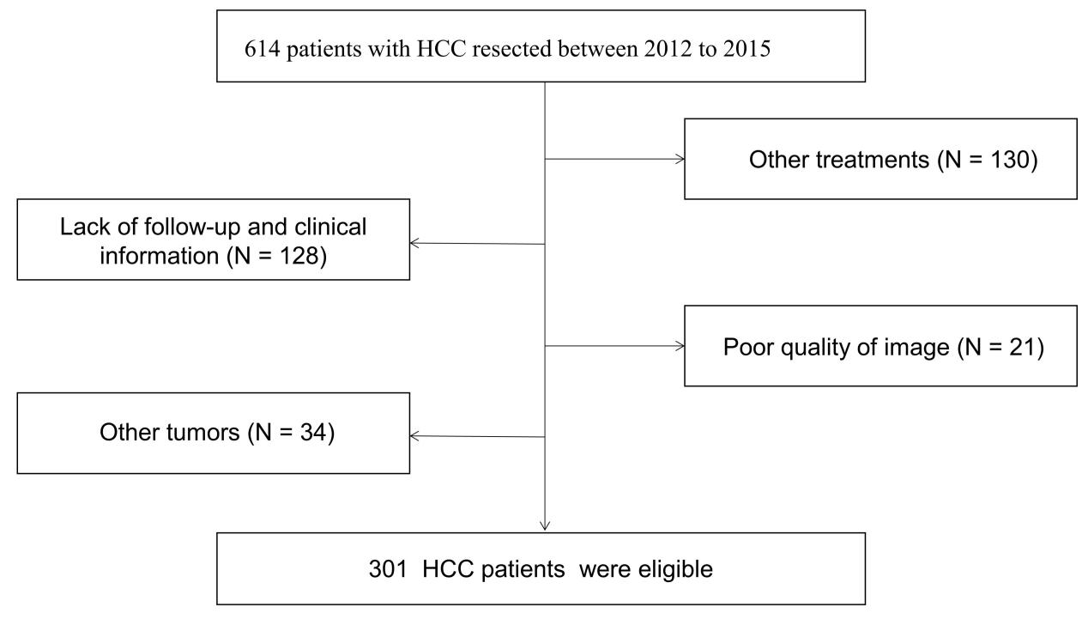
Figure S1 Flowchart of patients for inclusion in the cohorts.
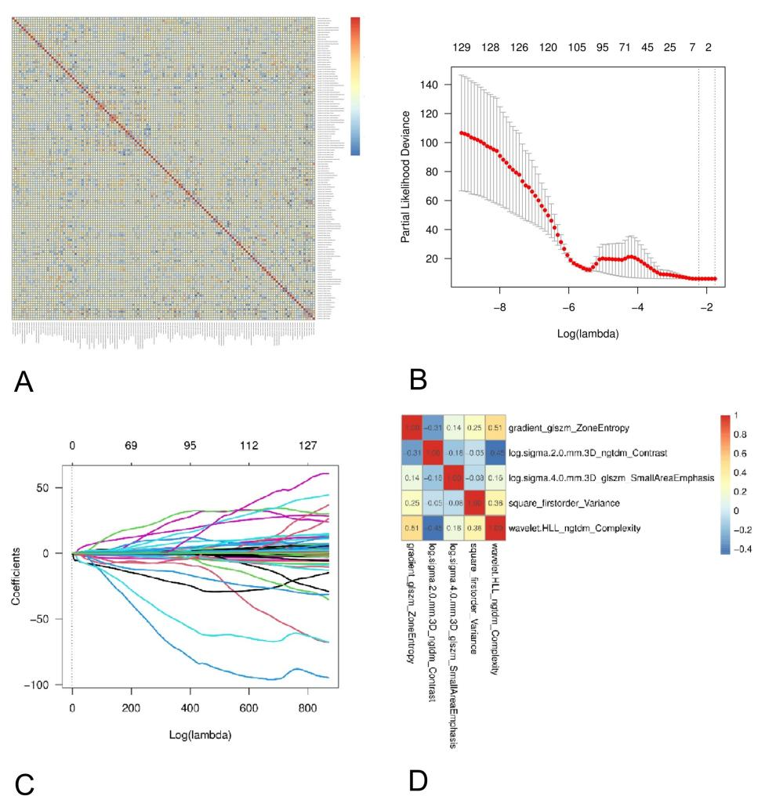
Figure S2 Radiomic features selection (A). Heat maps for all the features. (B) LASSOCOX regression analysis. (C) LASSO coefficient profiles of radiomics features. (D). Heat maps of five radiomic features.

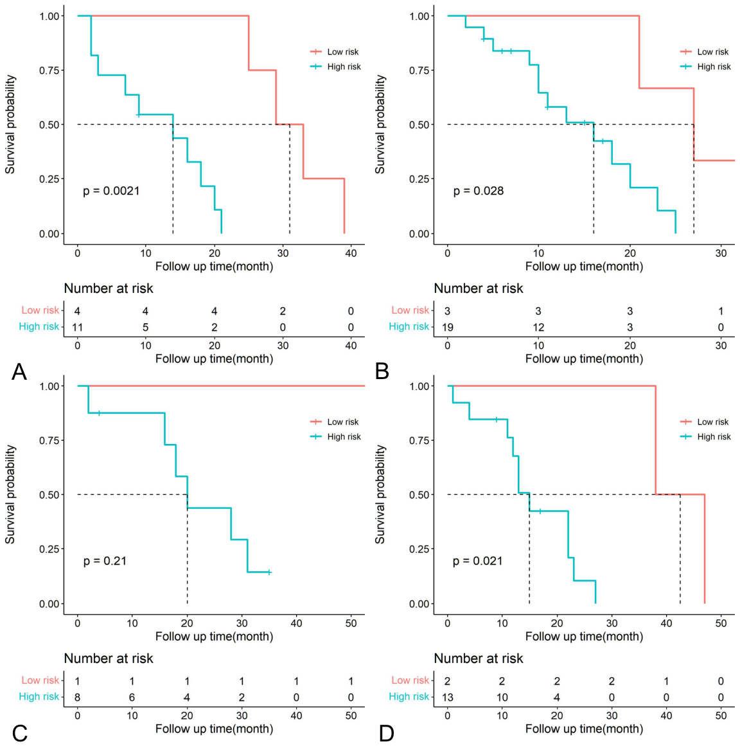
Figure S3 Kaplan–Meier analysis of OS of BCLC substage（B1，B2，B3，B4）

