Supplementary Material
- Supplementary table
Table S1: Non-suicidal self-injury symptoms, each criterion of DSM-5 Non-Suicidal Self-Injury Disorder, variable type and corresponding mnemonic codes
Abbreviation | Criteria | Symptom/survey question | Variable type
NSSI1 | Criterion A | Frequency of non-suicidal self-injury within one year. | 5-point Likert scale ranging from 1 (Never before) to 5 (Once a day)
 | Criterion B | I injure myself …
NSSI2 | Criterion B | To obtain relief from a negative feeling or cognitive state. | 5-point Likert scale ranging from 1 (not at all) to 5 (very much so)
NSSI3 | Criterion B | To resolve interpersonal difficulty.
NSSI4 | Criterion B | To induce a positive feeling state.
 | Criterion C | In the period immediately prior to self-injuring, I experience …
NSSI5 | Criterion C | Negative feelings or thoughts (such as sadness, anxiety, tension, anger and so on). | 5-point Likert scale ranging from 1 (not at all) to 5 (very much so)
NSSI6 | Criterion C | Interpersonal conflicts.
NSSI7 | Criterion C | Preoccupation with the act that I can’t control.
NSSI8 | Criterion C | Frequent thinking about self-injury.
NULL | Criterion D | From the list below, which behavior(s) have you ever engaged in? | A list of behaviors, such as cutting, scratching, obstructing, hitting burning and so on.
NULL | Criterion D | I injure myself for another reason. | Open question, Not included in data analysis
 | Criterion E | Deliberately injuring myself…
NSSI9 | Criterion E | Causes clinically significant stress and pain. | 5-point Likert scale ranging from 1 (not at all) to 5 (very much so)
NSSI10 | Criterion E | Negatively influences my relationships with others.
NSSI11 | Criterion E | Negatively influences my performance (school/work/…)
NSSI12 | Criterion E | Negatively influences other important areas. If yes, describe which ones.
NULL | Criterion F | Do you only injury yourself when you have used drugs or alcohol? | Not included in data analysis
NULL | Criterion F | From the list below, which behavior(s) have you ever engaged in? | Not included in data analysis

Table S2: Edge connection strength between each symptom in the comorbidity network
 | NSSI1 | NSSI2 | NSSI3 | NSSI4 | NSSI5 | NSSI6 | NSSI7 | NSSI8 | NSSI9 | NSSI10 | NSSI11 | NSSI12 | D1 | D2 | D3 | D4 | D5 | D6 | D7 | D8 | D9
NSSI1 | 0.0000 | 0.1161 | 0.1059 | 0.015 | -0.125 | 0.000 | 0.060 | 0.184 | -0.0035 | 0.0000 | 0.0165 | 0.000 | 0.0000 | 0.0000 | 0.000 | 0.000 | 0.0000 | 0.0000 | 0.093 | 0.0000 | 0.060
NSSI2 | 0.1161 | 0.0000 | 0.0347 | 0.299 | 0.278 | 0.000 | 0.000 | 0.085 | -0.0692 | 0.0000 | 0.0000 | 0.000 | 0.0000 | 0.0000 | 0.048 | 0.000 | 0.0000 | 0.0081 | 0.000 | 0.0000 | 0.000
NSSI3 | 0.1059 | 0.0347 | 0.0000 | 0.227 | -0.048 | 0.392 | 0.000 | 0.000 | 0.0000 | 0.0142 | 0.0384 | 0.000 | 0.0000 | 0.0000 | 0.000 | 0.000 | 0.0000 | 0.0084 | 0.000 | 0.0000 | 0.026
NSSI4 | 0.0148 | 0.2993 | 0.2272 | 0.000 | 0.000 | -0.071 | 0.108 | 0.000 | 0.0000 | 0.0000 | 0.0425 | 0.000 | 0.0000 | -0.0328 | 0.000 | 0.000 | 0.0000 | 0.0000 | -0.025 | 0.0000 | 0.000
NSSI5 | -0.1249 | 0.2778 | -0.0476 | 0.000 | 0.000 | 0.221 | 0.246 | 0.057 | 0.0907 | 0.1057 | 0.0319 | 0.011 | 0.0000 | 0.0757 | 0.000 | 0.035 | 0.0000 | 0.0000 | 0.000 | 0.0000 | 0.000
NSSI6 | 0.0000 | 0.0000 | 0.3922 | -0.071 | 0.221 | 0.000 | 0.137 | 0.027 | 0.0223 | 0.0589 | 0.0000 | 0.048 | 0.0000 | 0.0000 | 0.000 | 0.000 | 0.0000 | 0.0193 | 0.000 | 0.0000 | 0.000
NSSI7 | 0.0604 | 0.0000 | 0.0000 | 0.108 | 0.246 | 0.137 | 0.000 | 0.342 | 0.0000 | 0.0000 | 0.0152 | 0.031 | 0.0000 | 0.0000 | 0.000 | 0.000 | 0.0000 | 0.0000 | 0.000 | 0.0000 | 0.000
NSSI8 | 0.1839 | 0.0848 | 0.0000 | 0.000 | 0.057 | 0.027 | 0.342 | 0.000 | 0.0000 | 0.0000 | 0.0000 | 0.000 | -0.0378 | 0.0000 | 0.000 | 0.000 | 0.0000 | 0.1328 | 0.000 | 0.0000 | 0.215
NSSI9 | -0.0035 | -0.0692 | 0.0000 | 0.000 | 0.091 | 0.022 | 0.000 | 0.000 | 0.0000 | 0.1931 | 0.0000 | 0.274 | 0.0000 | 0.0000 | 0.000 | 0.000 | 0.0000 | 0.0000 | -0.023 | 0.0000 | -0.0473
NSSI10 | 0.0000 | 0.0000 | 0.0142 | 0.000 | 0.106 | 0.059 | 0.000 | 0.000 | 0.1931 | 0.0000 | 0.3341 | 0.191 | 0.0000 | 0.0000 | 0.000 | 0.000 | 0.0096 | 0.0000 | 0.000 | 0.0142 | 0.000
NSSI11 | 0.0165 | 0.0000 | 0.0384 | 0.042 | 0.032 | 0.000 | 0.015 | 0.000 | 0.0000 | 0.3341 | 0.0000 | 0.467 | 0.0000 | 0.0061 | 0.000 | 0.000 | 0.0000 | -0.0148 | 0.000 | 0.0503 | 0.000
NSSI12 | 0.0000 | 0.0000 | 0.0000 | 0.000 | 0.011 | 0.048 | 0.031 | 0.000 | 0.2737 | 0.1915 | 0.4671 | 0.000 | 0.0000 | 0.0000 | 0.000 | 0.000 | 0.0167 | 0.0000 | 0.000 | 0.0000 | 0.000
D1 | 0.0000 | 0.0000 | 0.0000 | 0.000 | 0.000 | 0.000 | 0.000 | -0.038 | 0.0000 | 0.0000 | 0.0000 | 0.000 | 0.0000 | 0.4647 | 0.000 | 0.401 | 0.0346 | 0.1263 | 0.083 | 0.0065 | 0.000
D2 | 0.0000 | 0.0000 | 0.0000 | -0.033 | 0.076 | 0.000 | 0.000 | 0.000 | 0.0000 | 0.0000 | 0.0061 | 0.000 | 0.4647 | 0.0000 | 0.000 | 0.075 | 0.1293 | 0.1185 | 0.000 | 0.0000 | 0.211
D3 | 0.0000 | 0.0484 | 0.0000 | 0.000 | 0.000 | 0.000 | 0.000 | 0.000 | 0.0000 | 0.0000 | 0.0000 | 0.000 | 0.0000 | 0.0000 | 0.000 | 0.193 | 0.1352 | 0.1463 | 0.028 | 0.0432 | 0.000
D4 | 0.0000 | 0.0000 | 0.0000 | 0.000 | 0.035 | 0.000 | 0.000 | 0.000 | 0.0000 | 0.0000 | 0.0000 | 0.000 | 0.4012 | 0.0751 | 0.193 | 0.000 | 0.2374 | 0.0000 | 0.000 | 0.1279 | 0.000
D5 | 0.0000 | 0.0000 | 0.0000 | 0.000 | 0.000 | 0.000 | 0.000 | 0.000 | 0.0000 | 0.0096 | 0.0000 | 0.017 | 0.0346 | 0.1293 | 0.135 | 0.237 | 0.0000 | 0.0534 | 0.076 | 0.1472 | 0.000
D6 | 0.0000 | 0.0081 | 0.0084 | 0.000 | 0.000 | 0.019 | 0.000 | 0.133 | 0.0000 | 0.0000 | -0.0148 | 0.000 | 0.1263 | 0.1185 | 0.146 | 0.000 | 0.0534 | 0.0000 | 0.129 | 0.0000 | 0.359
D7 | 0.0929 | 0.0000 | 0.0000 | -0.025 | 0.000 | 0.000 | 0.000 | 0.000 | -0.0235 | 0.0000 | 0.0000 | 0.000 | 0.0830 | 0.0000 | 0.028 | 0.000 | 0.0756 | 0.1290 | 0.000 | 0.3738 | 0.014
D8 | 0.0000 | 0.0000 | 0.0000 | 0.000 | 0.000 | 0.000 | 0.000 | 0.000 | 0.0000 | 0.0142 | 0.0503 | 0.000 | 0.0065 | 0.0000 | 0.043 | 0.128 | 0.1472 | 0.0000 | 0.374 | 0.0000 | 0.158
D9 | 0.0596 | 0.0000 | 0.0263 | 0.000 | 0.000 | 0.000 | 0.000 | 0.215 | -0.0473 | 0.0000 | 0.0000 | 0.000 | 0.0000 | 0.2110 | 0.000 | 0.000 | 0.0000 | 0.3586 | 0.014 | 0.1582 | 0.000

- Supplementary Figure
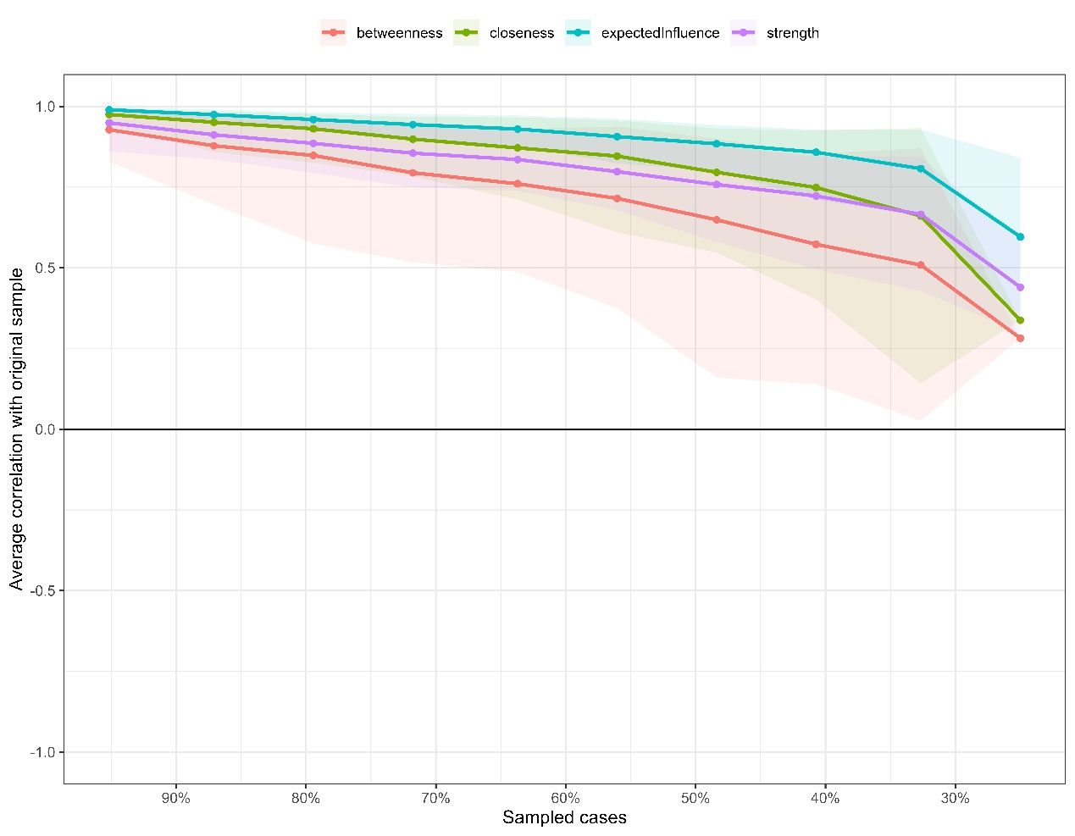
Figure S1: Average correlations between centrality indices of networks sampled with persons dropped and the original sample. Lines indicate the means and areas indicate the range from the 2.5th quantile to the 97.5th quantile
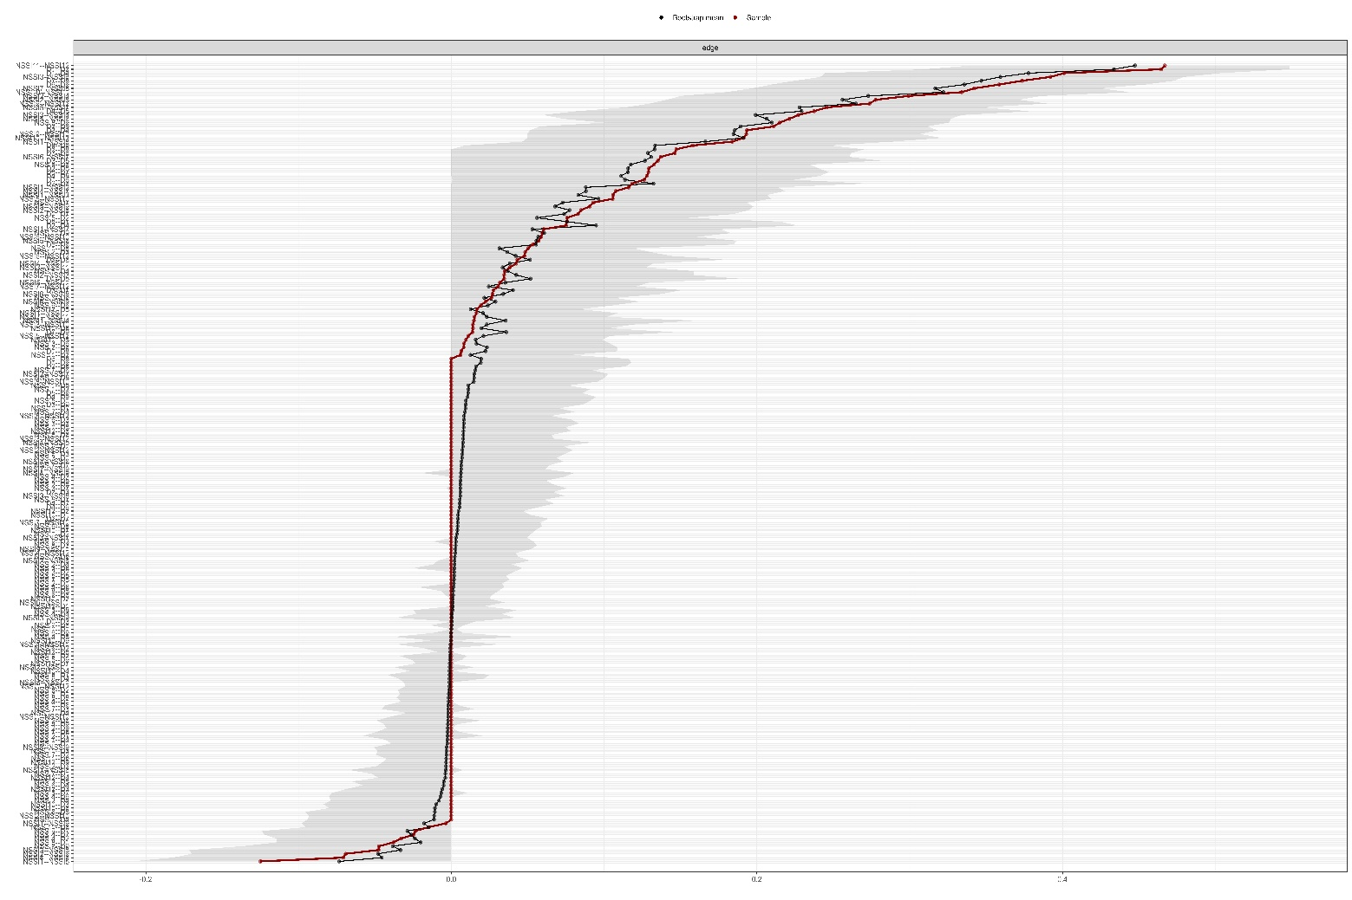
Figure S2: Bootstrapped confidence intervals of estimated edge-weights. The red line indicates the sample values and the gray area the bootstrapped CIs.
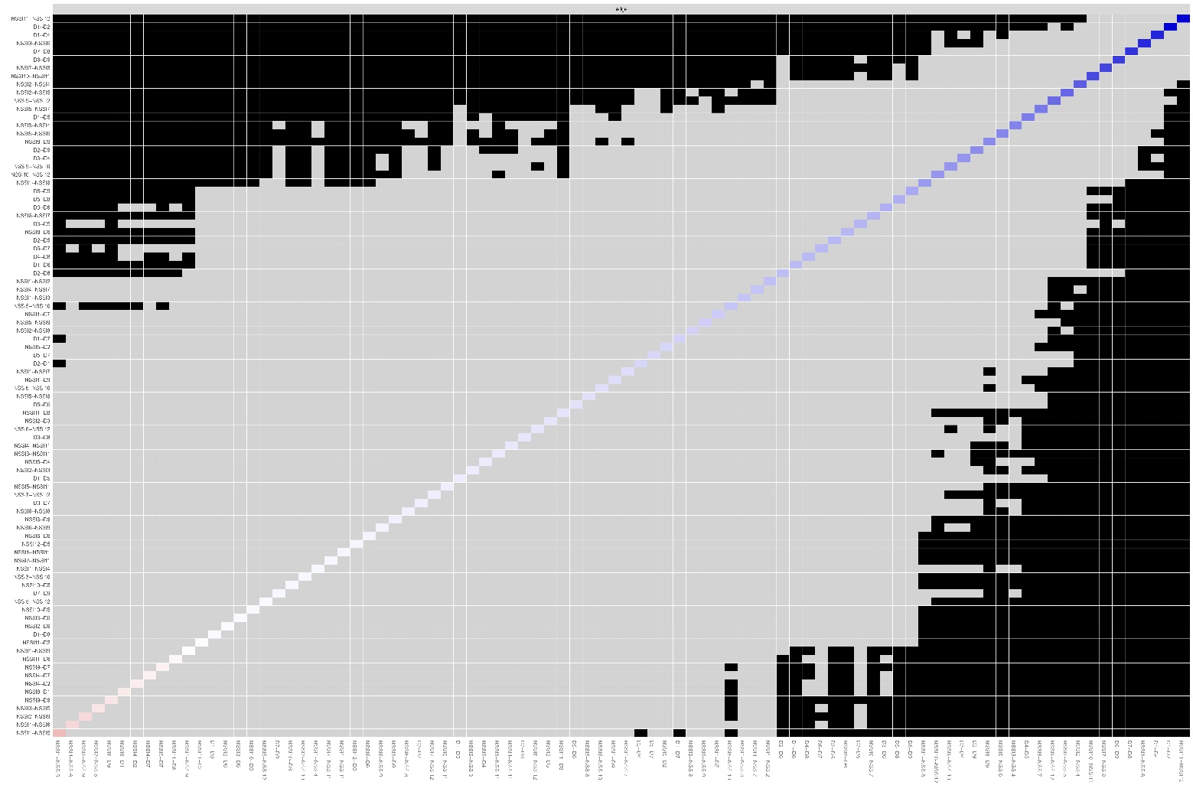

Figure S3: Bootstrapped difference tests (α = 0.05) between edge-weights that were non-zero in the estimated network. Black boxes indicate a significant difference between two edge-weights and grey boxes indicate no significant difference. Colored boxes in the plot correspond to the color of the edge in Figure 2.

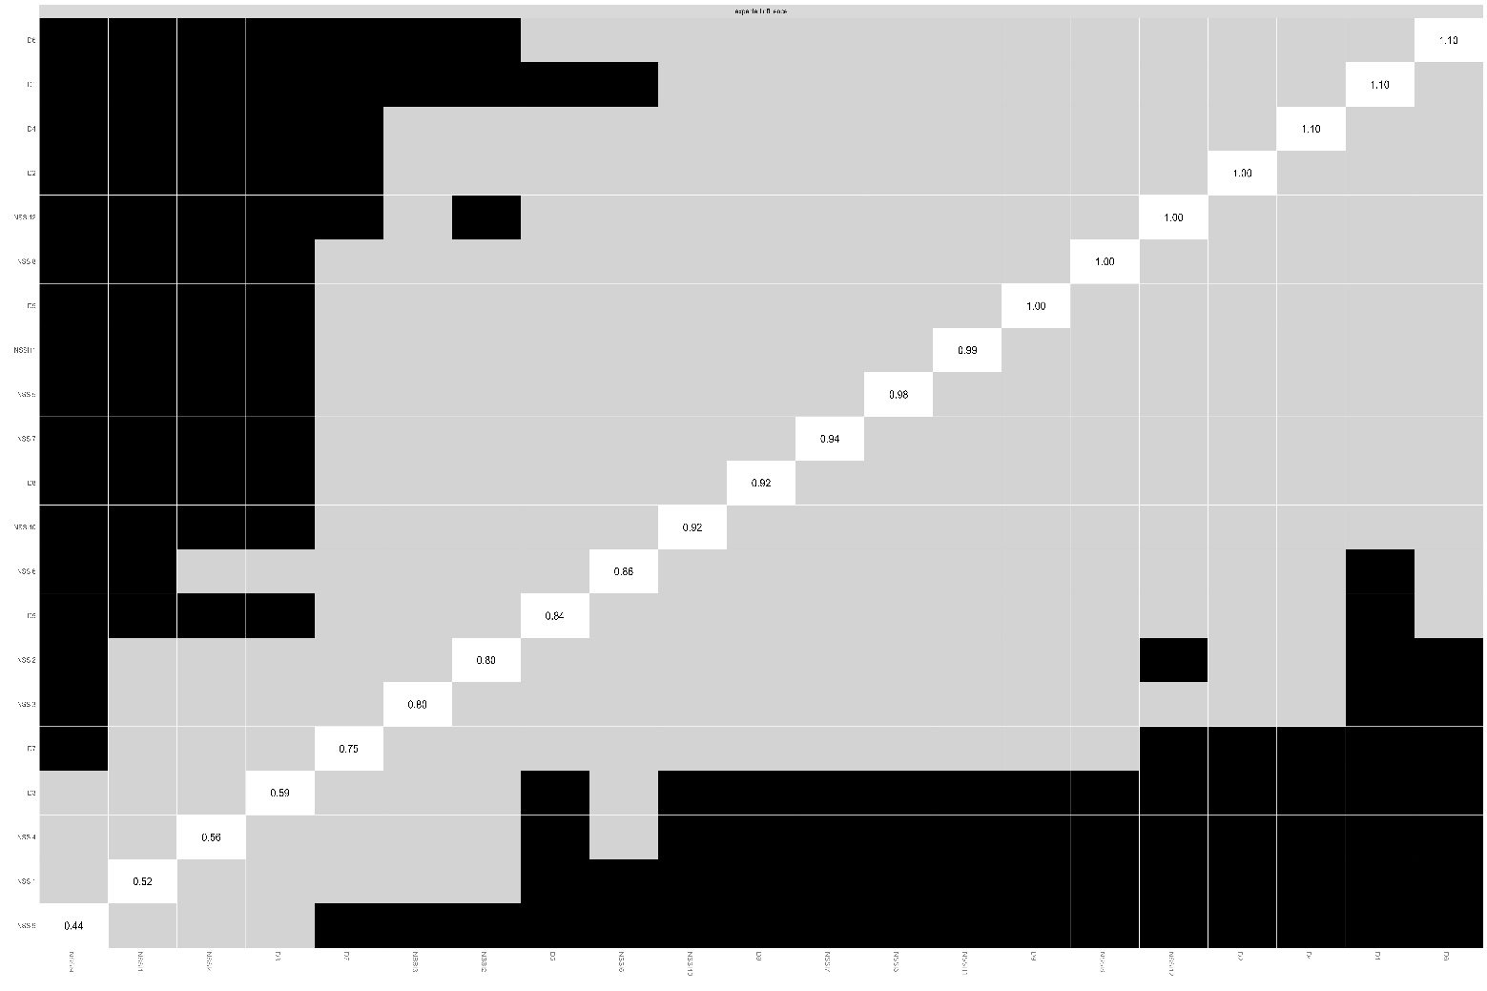

Figure S4: Bootstrapped difference tests (α = 0.05) between node expected influence of the estimated network. Black boxes indicate a significant difference between two node and grey boxes indicate no significant difference. white boxes in the centrality plot show the value of node expected influence.

