SUPPLEMENTARY

SFigure 1. Dr Hasan Sadikin Hospital Screening Protocol for Palliative Care

STable 1: Survival Function on Covariates
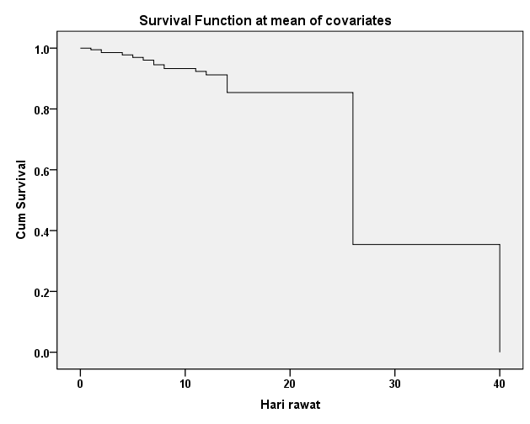

STable 2: Survival Function using Early Warning Score
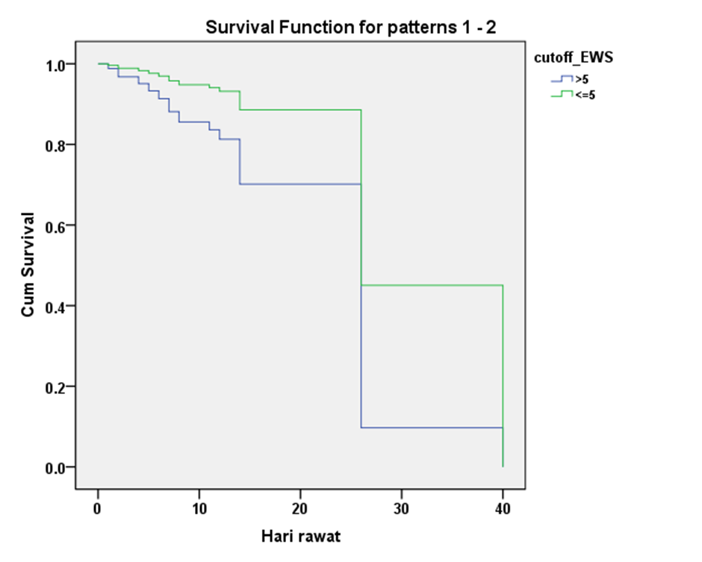
Days of Inpatient Care

