Supplementary Material
Supplementary Figures and Tables

Supplementary Figures

Supplementary Figure 1. Construction of prognostic target-ingredient network. (A) 29 genes with poor prognosis from the up-regulated group. (B) Three genes with good prognosis and two genes with poor prognosis from the down-regulated group. (C) The action network of targets with good prognosis and their related ingredients.
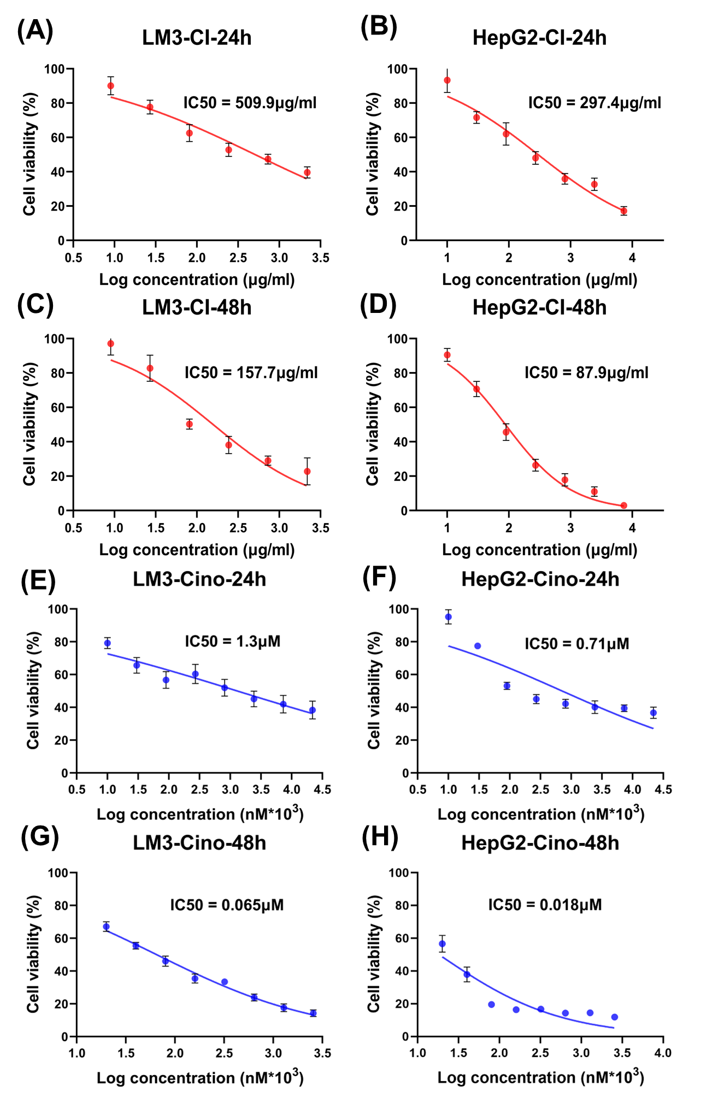
Supplementary Figure 2. Cytotoxicity test of hepatocellular carcinoma cell lines. (A-D) IC₅₀ of 24 hours and 48 hours under different concentrations of CI treatment. (E-H) IC₅₀ of 24 hours and 48 hours under different concentrations of Cinobufagin treatment.
Supplementary Figure 3. Xenograft tumor models of nude mice in different treatment groups.

Supplementary Tables
Supplementary Table 1. Statistics for 38 components. The first column is the component number. The second column is the compound name. The third column is the PubChem serial number. Four to six columns are listed as three topological methods for water-solubility evaluation of compounds, Solubility class (Log S scale): Insoluble (I) < -10 < Poorly (P) < -6 < Moderately (M) < -4 < Soluble (S) < -2 < Very (V) < 0 < Highly (H). The last column is listed as druglikeness evaluation, with a total of five indicators, and each indicator means "yes" or "no". The number represents the count of "yes" of the five metrics.
No. | Ingredient_names | PubChem CID | Water Solubility Class |  |  | Druglikeness
No. | Ingredient_names | PubChem CID | ESOL | Ali | SILICOS-IT | Druglikeness
Ing1 | 12beta-Hydroxycinobufagin | 15513542 | S | M | M | 5
Ing2 | 19-Hydroxydesacetylcinobufagin | 15513543 | S | S | S | 5
Ing3 | 19-Oxodesacetylcinobufagin | 11144140 | S | S | S | 5
Ing4 | 20S,21-Epoxyresibufogenin-3-formate | 101157014 | M | M | S | 5
Ing5 | 3beta-Formyloxyresibufogenin | 10916635 | M | M | M | 5
Ing6 | 5beta-Hydroxybufotalin | 15513540 | S | M | M | 5
Ing7 | 6alpha-Hydroxycinobufagin | 10939450 | S | M | M | 5
Ing8 | Racepinephrine hydrochloride | 5924 | V | V | S | 5
Ing9 | Adrenaline | 838 | V | H | S | 4
Ing10 | Arenobufagin | 12305198 | S | S | M | 5
Ing11 | Bufalin | 9547215 | M | M | M | 5
Ing12 | Bufarenogin | 167607 | S | S | M | 5
Ing13 | Bufotalin | 12302120 | M | M | M | 5
Ing14 | Bufotalinin | 11225 | S | S | M | 5
Ing15 | Bufotenidine | 3083591 | S | S | M | 5
Ing16 | Bufotenine | 10257 | S | S | S | 5
Ing17 | N,N,N-Trimethylserotonin | 656705 | S | S | M | 5
Ing18 | Cinobufagin | 11969542 | M | M | M | 5
Ing19 | Cinobufaginol | 12303266 | S | M | M | 5
Ing20 | Cinobufotalin | 259776 | S | M | M | 5
Ing21 | Desacetylcinobufotalin | 15513544 | S | S | S | 5
Ing22 | Gamabufotalin | 259803 | S | S | M | 5
Ing23 | gamma-Aminobutyric acid | 119 | H | S | S | 3
Ing24 | Marioside | 10411827 | S | S | S | 2
Ing25 | Morphine | 5288826 | S | V | S | 5
Ing26 | Morroniside | 11228693 | V | V | S | 1
Ing27 | Resibufogenin | 6917974 | M | M | M | 5
Ing28 | Serotonin | 5202 | S | S | S | 4
Ing29 | Serpentine | 73391 | M | S | M | 5
Ing30 | Suberic acid | 10457 | V | S | S | 4
Ing31 | Suberogorgin | 57357334 | S | S | S | 5
Ing32 | Telocinobufagin | 259991 | S | M | M | 5
Ing33 | Tryptamine | 1150 | V | V | S | 4
Ing34 | Tryptanthrin | 73549 | S | S | M | 5
Ing35 | Hellebrigenol | 10432170 | S | S | M | 5
Ing36 | Bufotalidin | 259577 | S | S | M | 5
Ing37 | 19-Oxocinobufotalin | 102093790 | S | S | M | 5
Ing38 | 19-Oxocinobufagin | 102093791 | S | S | M | 5

Supplementary Table 2. Statistics for 34 prognostic related targets. The first column is the target-related gene name. The second column is the expression grouping, "Up" is the high expression group, and "Down" is the low expression group. The third column is the prognosis grouping. The fourth column is Hazard Ratio (HR), which is used to evaluate the prognosis of the gene. The fifth column shows the P value, and the P value of all targets is 0.01 or less. In the sixth and seventh columns, "yes" or "no" indicates whether or not the gene belongs to a cell cycle pathway or 15 hub genes.
Gene | Group | Prognosis | HR | p(HR) | Cell cycle | Hub genes
SORD | Down | Good | 0.61 | 6.3E-03 | no | no
FOLH1 | Down | Good | 0.61 | 5.7E-03 | no | no
ESR1 | Down | Good | 0.55 | 8.4E-04 | no | no
PNP | Down | Poor | 1.7 | 5.4E-03 | no | no
CA9 | Down | Poor | 1.7 | 2.1E-03 | no | no
ACKR3 | Up | Poor | 1.7 | 2.2E-03 | no | no
ATP1A1 | Up | Poor | 1.8 | 8.3E-04 | no | no
AURKA | Up | Poor | 1.9 | 2.8E-04 | no | yes
CCNA2 | Up | Poor | 1.7 | 4.1E-03 | yes | yes
CCNB1 | Up | Poor | 2 | 2.0E-04 | yes | yes
CCNE1 | Up | Poor | 1.7 | 2.2E-03 | yes | yes
CDC25A | Up | Poor | 1.7 | 2.4E-03 | yes | yes
CDK1 | Up | Poor | 2 | 2.2E-04 | yes | yes
CDK4 | Up | Poor | 1.7 | 2.4E-03 | yes | yes
CHEK1 | Up | Poor | 2.1 | 4.4E-05 | yes | yes
EZH2 | Up | Poor | 2.1 | 7.8E-05 | no | no
FABP5 | Up | Poor | 1.8 | 1.3E-03 | no | no
GNA12 | Up | Poor | 1.6 | 5.9E-03 | no | no
GSK3A | Up | Poor | 1.6 | 5.2E-03 | no | no
KIF11 | Up | Poor | 1.8 | 7.2E-04 | no | yes
LGALS3 | Up | Poor | 1.7 | 4.1E-03 | no | no
MMP1 | Up | Poor | 2 | 3.0E-04 | no | no
MMP9 | Up | Poor | 1.6 | 5.9E-03 | no | no
PLK1 | Up | Poor | 1.8 | 9.7E-04 | yes | yes
POLA1 | Up | Poor | 1.6 | 9.3E-03 | no | no
PPP1CC | Up | Poor | 1.7 | 2.2E-03 | no | no
PRKDC | Up | Poor | 1.6 | 1.0E-02 | yes | no
SLC7A11 | Up | Poor | 1.8 | 1.2E-03 | no | no
TK1 | Up | Poor | 1.7 | 4.3E-03 | no | no
CCNE2 | Up | Poor | 1.6 | 7.8E-03 | yes | yes
TKT | Up | Poor | 1.7 | 4.0E-03 | no | no
TTK | Up | Poor | 1.8 | 1.7E-03 | yes | yes
G6PD | Up | Poor | 2 | 9.7E-05 | no | no
NUDT1 | Up | Poor | 1.7 | 2.8E-03 | no | no

Supplementary Table 3. Parameters related to molecular docking by Autodock Vina.
Receptor | PDB_ID | Ligand | center_x | center_y | center_z | size_x | size_y | size_z
CDK1 | 4Y72 | ex_ligand | 30.317 | -72.137 | 184.638 | 11.628 | 10.111 | 10.617
CDK1 | 4Y72 | Ingredients | 23.684 | -67.342 | 186.194 | 20.000 | 20.000 | 16.000
CDK4 | 7SJ3 | ex_ligand | 12.440 | -39.381 | 10.040 | 15.000 | 9.750 | 10.500
CDK4 | 7SJ3 | Ingredients | 13.308 | -39.381 | 10.040 | 19.500 | 15.750 | 15.000
PLK1 | 3THB | ex_ligand | -44.473 | 10.395 | 10.256 | 8.000 | 12.000 | 9.000
PLK1 | 3THB | Ingredients | -43.438 | 10.395 | 11.963 | 12.000 | 16.000 | 16.000
CHEK1 | 2HOG | ex_ligand | 16.987 | -2.482 | 9.861 | 16.139 | 9.222 | 9.683
CHEK1 | 2HOG | Ingredients | 12.185 | -0.107 | 17.246 | 23.550 | 17.444 | 25.294
TTK | 5N84 | ex_ligand | 37.397 | 42.329 | 39.534 | 8.500 | 14.000 | 9.000
TTK | 5N84 | Ingredients | 39.164 | 37.126 | 35.911 | 17.444 | 17.444 | 20.933

