Supplementary Table 1: The primers used for analysis of gene expression using qPCR.
Gene of interest | Primers
ULK1 | FP: 5’ GGCAAGTTCGAGTTCTCCCG 3’  RP: 5’ CGACCTCCAAATCGTGCTTCT 3’
ATG3 | FP: 5’ GGCGGATGGGTAGATACATAT 3’  RP: 5’ GCTTCTCCTTCATCTTCATCTTC 3’
ATG5 | FP: 5’ GATACCAGAGGGCGGAAGTG 3’  RP: 5’GTAGCAGGACTCCAGGAAGC 3’
LC3II | FP: 5’ CCGCCACCTTTTTGGGTAGA 3’  RP: 5’ CCGTTTACCCTGCGTTTGTG 3’
NF-κB1 | FP: 5’ AACAGAGAGGATTTCGTTTCCG 3’  RP: 5’ TTTGACCTGAGGGTAAGACTTCT 3’
NF-κB2 | FP: 5’ ATGAAGATTGAGCGGCCTGT 3’  RP: 5’ GCACCTCTTCCTTGTCTTCCA 3’
p53 | FP: 5’ GCTGCTCAGATAGCGATGGTC 3’  RP: 5’ CTCCCAGGACAGGCACAAACA 3’
E-cadherin | FP: 5’ CCAGTGAACAACGATGGCATT 3’  RP: 5’ TGCTGCTTGGCCTCAAAAT 3’
SNAIL | FP: 5’ CCCCAATCGGAAGCCTAACT 3’  RP: 5’ GCTGGAAGGTAAACTCTGGATTAGA 3’
Vimentin | FP: 5’ TCCAAACTTTTCCTCCCTGAAC 3’  RP: 5’ GGGTATCAACCAGAGGGAGTGA 3’
β-actin | FP: 5’ GGTCATCACCATTGGCAATGAG 3’  RP: 5’ TACAGGTCTTTGCGGATGTCC 3’

Supplementary Table 2A: The drug release at varying time intervals at pH 5.5 are as follows:
Time (Hours) | Release (%)
18 | 3.003003
18.5 | 7.132132
19 | 15.39039
19.5 | 23.27327
20 | 31.15616
20.5 | 46.54655
21 | 53.67868
21.5 | 62.68769
22 | 69.44444
22.5 | 75.45045
23 | 82.95796
23.5 | 87.08709
24 | 88.58859

Supplementary Table 2B: The drug release at varying time intervals at pH 7.4 are as follows:
Time (Hours) | Release (%)
72 | 1.97366
75 | 9.21058
78 | 15.46067
81 | 25.65809
84 | 35.19744
87 | 43.75009
90 | 57.5659
93 | 67.76329
96 | 75.65784
97 | 79.93427
98 | 84.53981
99 | 88.81575
100 | 90.78941
101 | 91.11852
102 | 91.44762

Supplementary Figure 1A: UPLC based determination of standard rutin.
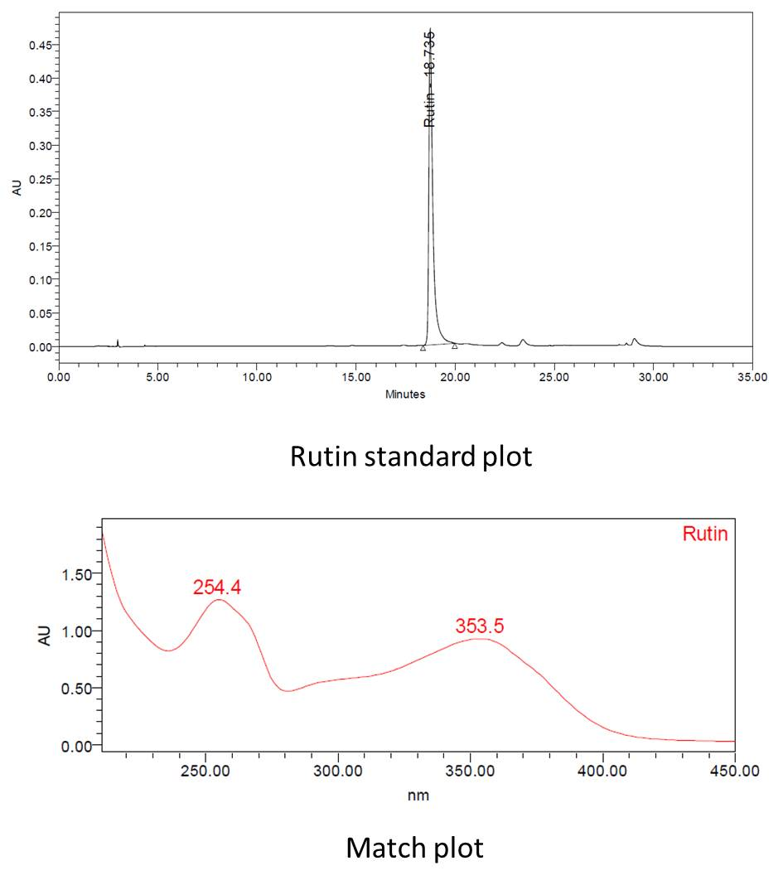

Supplementary Figure 1B: UPLC based quantification of rutin load on CNPs.
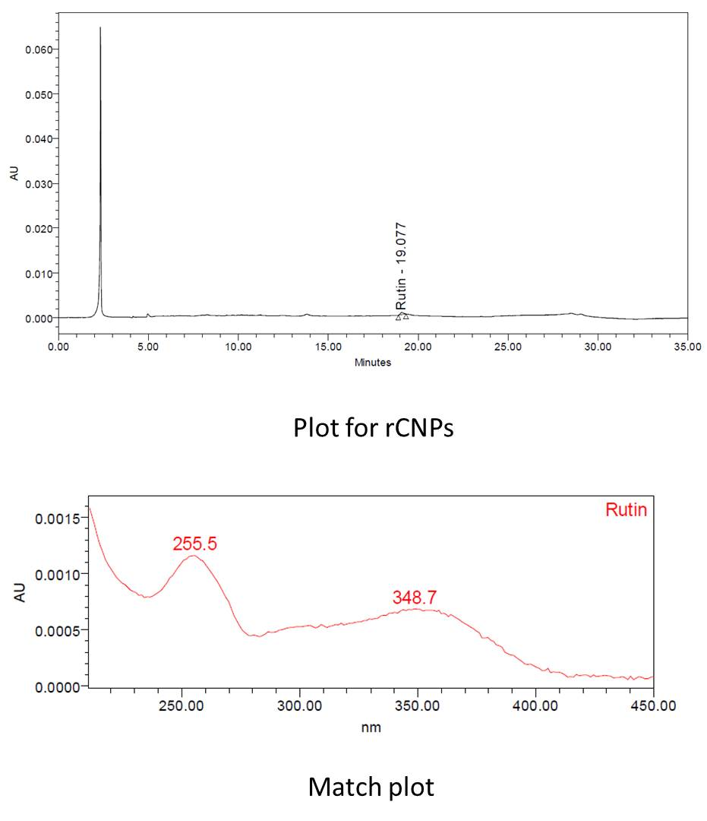

Supplementary Figure 2A: Microscopic observations of the cytotoxic effects of rCNPs filtered using a 0.22 micron filter on Hep3B cells.
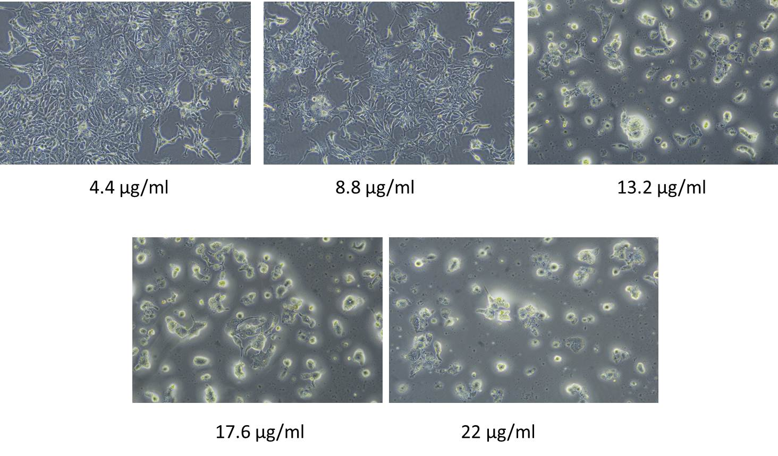
Supplementary Figure 2B: Microscopic observations of the cytotoxic effects of the pCNPs on Hep3B cells.
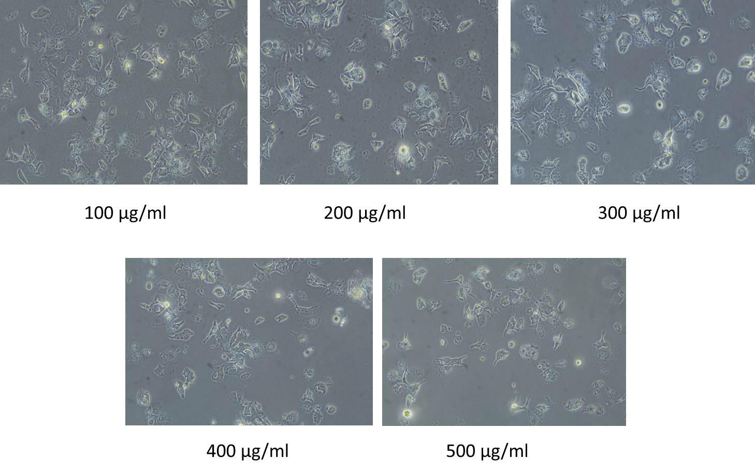
Supplementary Figure 3: Microscopic observations of interactions between rCNPs and L929 fibroblasts.
