Supplementary Material
Supplementary Figure 1. Fundoscopic examination of the child revealing pale optic disc; A – Left Eye, B – Right Eye; arrow points at the optic disc
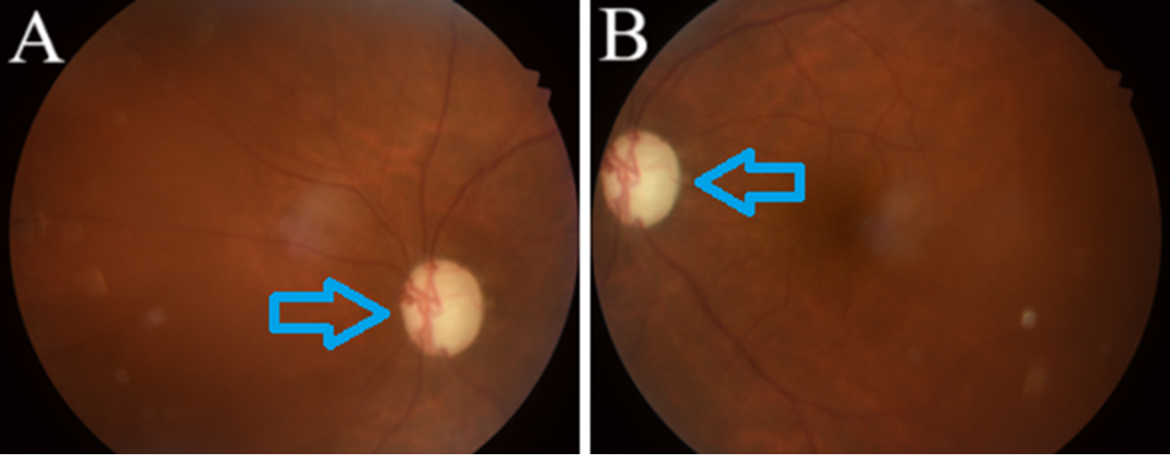
Supplementary Table 1. Developmental Quotient Assessment of the boy
Developmental Domain | Developmental Quotient | Inference
Gross Motor Skills | 75% (Stood without support at 16 Months) | Moderate Delay
Fine Motor Skills | 65% (Grasps were delayed) | Severe Delay
Language Skills | 81% (Said Mama at 11 months) | Mild Delay
Social & Adaptive Skills | 90% (Waved hands at 10 months) | Normal
Supplementary Table 2. Boy’s Anthropometric Measurements and Deviations
Parameter | Observed | Ideal | Standard Deviation
Weight | 26 kg | 32.5 kg | Less than 25th Percentile
Height | 123 cm | 137 cm | Less than 3rd Percentile
Head Circumference | 53 cm | -
Body Mass Index | 17.18 kg/m² | 18.5 to 24.9 kg/m² | 50th to 23rd adult equivalent

