Supporting Information

Integrin avb3 and LHRH Receptor double Directed Nano-analogue Effective Against Ovarian Cancer in Mice Model
Na Qi ^{1,2#}，Xiantai Zhou^{2#}， Ningzhu Ma²， Jianguo Zhang²，Zhenlin Wang ²，Xin Zhang¹*，Aimin Li¹*
1 Cancer Center, Integrated Hospital of Traditional Chinese Medicine, Southern Medical University, Guangzhou, 510315, China;
2 Department of Pharmacy, Guilin Medical University, Guilin, 541004, China;

#These authors contribute equally to this work.
*Corresponding author: Aimin Li; Xin Zhang, Cancer Center, Integrated Hospital of Traditional Chinese Medicine, Southern Medical University, Guangzhou, 510315, China; Email: liaimin2005@163.com； Email: 252089553@qq.com.

Supporting Information Figure of Contents

Figure. S1 Time-of-Flight Mass Spectrometry of DSPE-PEG₂₀₀₀-LHRHa S-2
Figure.S2 HE staining of HE staining of heart, liver, spleen, lung and kidney S-3
tissue. Magnification X200.

Figure S1 Time-of-Flight Mass Spectrometry of DSPE-PEG₂₀₀₀-LHRHa.

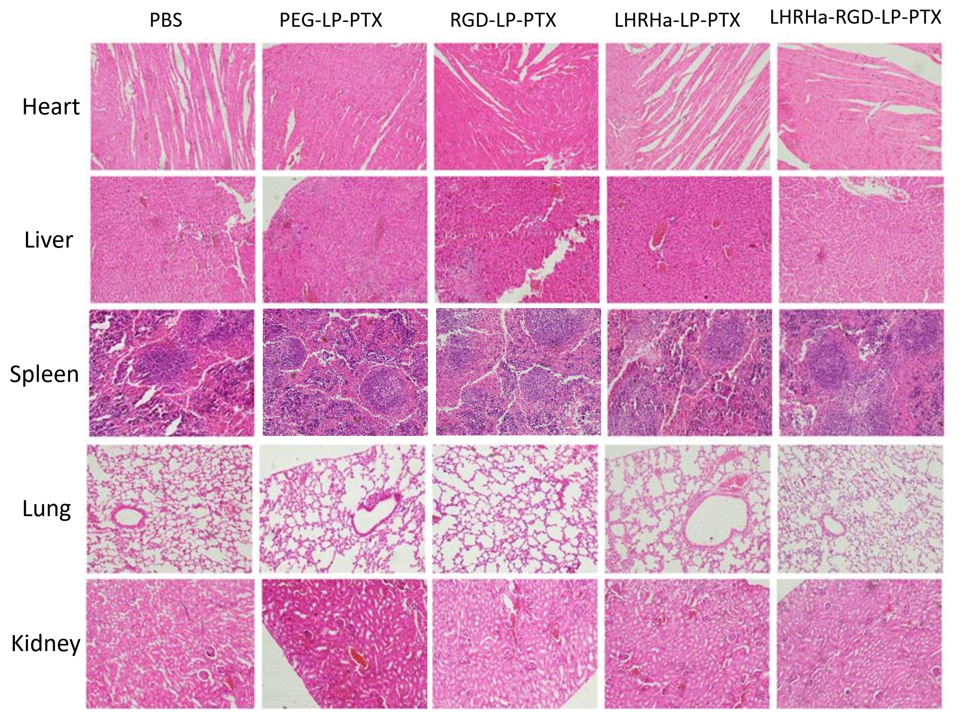
Figure.S2 HE staining of heart, liver, spleen, lung and kidney tissue. Magnification X200

