Supplementary Materials
Coordinated ASBT and EGFR Mechanisms for Optimized Liraglutide Nanoformulation Absorption in the GI Tract

Authors’ names and affiliations:
Seho Kweon^{1,2}, Seong Jin Park³, Ha Kyeong Lee¹, Seo Hee Kang⁴, Kwan-Young Chang⁴, Jeong Uk Choi⁵, Jooho Park⁶, Jung-Hyun Shim⁷, Jin Woo Park⁷, Youngro Byun^{1,3}

¹Department of Molecular Medicine and Biopharmaceutical Science, Graduate School of Convergence Science and Technology, Seoul National University, Seoul 08826, Republic of Korea
²College of Pharmacy, Chonnam National University, Gwangju 61186, Republic of Korea
³College of Pharmacy, Seoul National University, Seoul 08826, Republic of Korea
⁴Global R&D Center, IcureBNP, Seoul 06170, Republic of Korea
⁵College of Pharmacy, Kyung Hee University, Seoul 02447, Republic of Korea
⁶Department of Biomedical & Health Science, Konkuk University, Chungju 27478, Republic of Korea
⁷College of Pharmacy and Biomedical and Healthcare Research Institute, Mokpo National University, Jeonnam 58554, Republic of Korea

Correspondence: Jin Woo Park; Youngro Byun, Tel +82 61 450 2704; +82 2 880 7866, E-mail jwpark@mokpo.ac.kr; yrbyun@snu.ac.kr

Running title: Enhanced bioavailability and efficacy of oral liraglutide nanoformulation

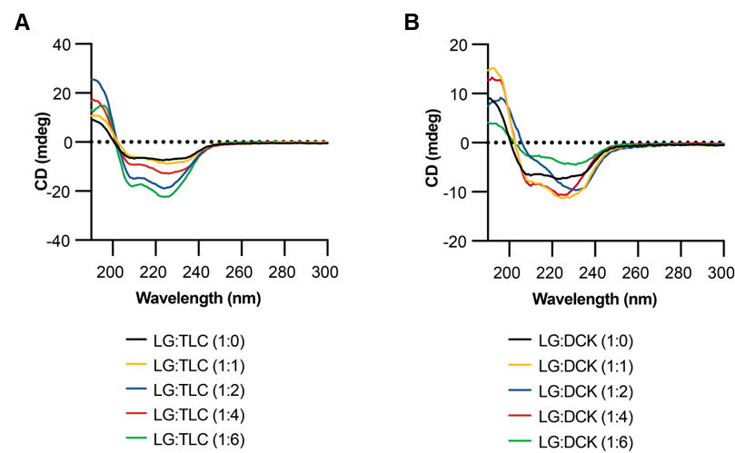
Figure S1 (A) CD spectra of LG/TLC nanoparticles and (B) LG/DCK nanoparticles on various molar ratios (1:0, 1:1, 1:2, 1:4, and 1:6).
Abbreviations: CD, circular dichroism; LG, liraglutide; TLC, taurolithocholate; DCK, lysine conjugated deoxycholate.

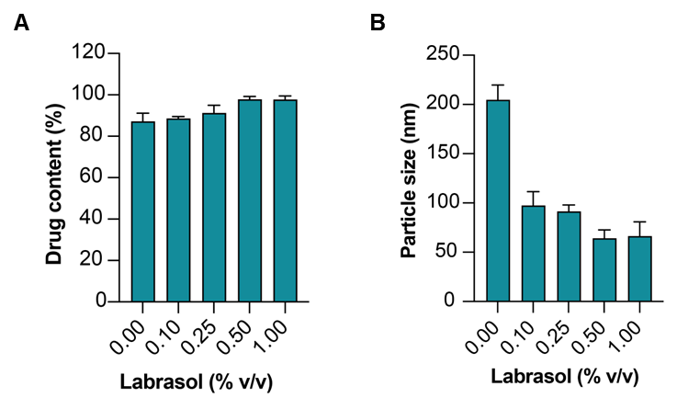
Figure S2 (A) Drug content and (B) particle size of LG formulations by various Labrasol concentrations (0.0 to 1.0% [v/v]).
Notes: Data are presented with a mean ± standard deviation with n=4 for all group. Abbreviations: LG, liraglutide.

Figure S3. In vitro cytotoxic effects after incubation of Caco-2 cells with free LG, LG/TD-NF without LG, or LG/TD-NF at concentrations ranged from 0 to 100 µM based on LG.
Notes: Each value represents the mean ± standard deviation (n=4).
Abbreviations: LG, liraglutide; LG/TD-NF without LG, all excipients mixture except LG in LG nanoformulation; LG/TD-NF, oral nanoformulation

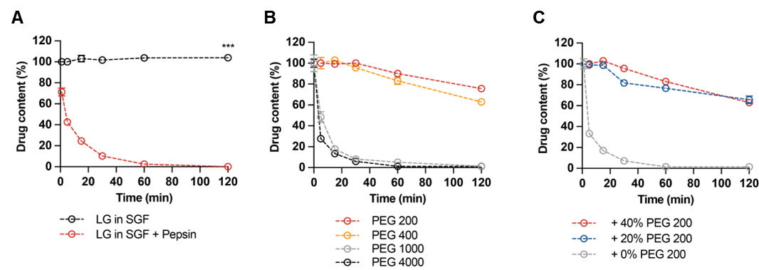
Figure S4 Drug content of various LG formulations against degradation effects by (A) pepsin, (B) molecular weight of PEGs (PEG 200, PEG 400, PEG 1000, and PEG 4000), and (C) PEG concentrations (0%, 20%, and 40%) (right).
Notes: Data are presented with a mean ± standard deviation with n=4 for all group. ***P < 0.001 compared to the LG in SGF with pepsin.
Abbreviations: SGF, simulated gastric fluid; LG, liraglutide; PEG, polyethylene glycol.

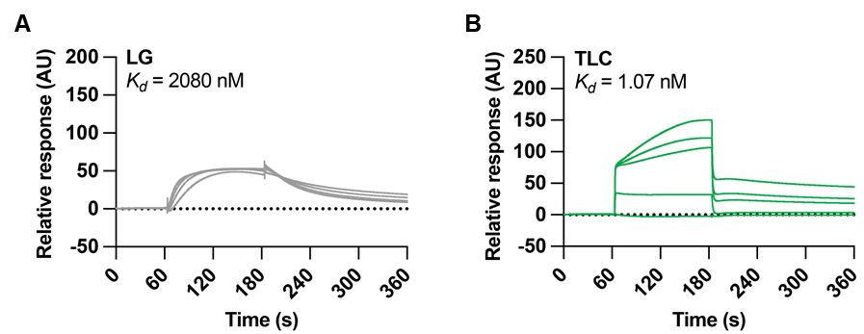
Figure S5 SPR analysis of (A) LG and (B) TLC on an ASBT-immobilized CM5 sensor chip for binding affinity (K_{d}).
Abbreviations: SPR, surface plasmon resonance; LG, liraglutide; TLC, taurolithocholate.

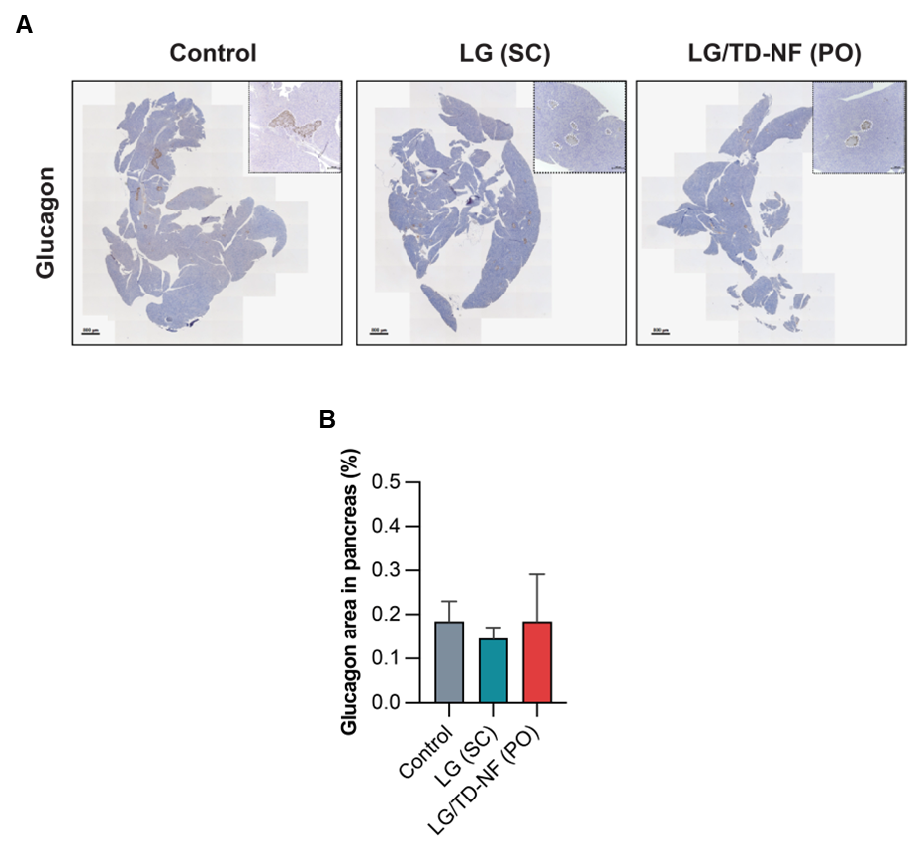
Figure S6 (A) Immunofluorescence staining of glucagon on pancreas and (B) quantification of the area on last day.
Abbreviations: LG, liraglutide; SC, subcutaneous; PO, per oral.

