Supporting Information

Supplementary Material 1. Experimental Methods
1.1 In vitro detection methodology of Dex and Dsp
The in vitro analysis methods of Dex and Dsp were established by the following steps: (1) Detection wavelength determination: Dex and Dsp were dissolved in methanol to prepare their standard solutions (100 µg/mL). Then, their maximum absorption wavelengths were determined by scanning with an ultraviolet-visible spectrophotometer (UV-vis, UV-2550, Shimadzu, Japan) in the wavelength range of 200 - 400 nm, which was then used as the detection wavelength of the methodological research. (2) Determination conditions and specificity of high-performance liquid chromatography (HPLC): the drug concentration was detected by HPLC, and the detection conditions were listed as follows: C18 BDS Hypersil, KH₂PO₄-methanol (40:60, v/v), column temperature 25℃, flow rate 1 mL/min. For the specificity inspection, the solvent, Dsp, and Dex mixed solution, blank LCaP NPs breaking the emulsion, blank LCaP NPs breaking emulsion with Dsp and Dex, and L_{d}CaP_{d} NPs breaking emulsion were detected by HPLC to collect their chromatograms. (3) Development of the standard curve: Dsp and Dex methanol solutions were prepared with a concentration range of 0.3125 - 50 μg/mL, respectively. The absorbance of different concentrations of Dsp or Dex solution was measured by HPLC. The standard curve was obtained by plotting the peak area of each analyte versus Dsp or Dex concentration. (4) Recovery, precision, and stability evaluation: For the precision evaluation, Dsp or Dex solutions of three different concentrations (1.25, 10, and 50 µg/mL) were processed and detected 5 times within a day (intra-day) and five days (inter-day) by HPLC, respectively. For the spiked recovery evaluation, Dsp or Dex solutions with concentrations of 1.25, 10, and 50 µg/mL were prepared. Dsp or Dex solutions equivalent to 80%, 100%, and 120% of the initial content were added to these samples. Then, the content of Dsp or Dex in each sample was detected to calculate the recovery rate. For the stability evaluation, three groups of mixed standard solutions of Dex and Dsp (0.05 mg/mL) were incubated in the water bath at 25 ℃. Samples were taken at 0, 2, 4, 8, 12, and 24 h and analyzed by HPLC to evaluate the stability of the mixed standard solutions.
1.2 In vivo methodological HPLC study
The in vivo methodological HPLC study was performed according to the following parts: (1) Processing of plasma samples: The collected blood sample was immediately centrifuged (12,000 rpm, 10 min), followed by the collection of supernatant plasma (200 μL). Methanol (800 mL) was added to the plasma samples and stirred vigorously to precipitate protein. The mixture was centrifuged (12,000 rpm, 15 min), then transferred supernatant (400 mL) to another tube and evaporated to dryness at 40 ℃ under nitrogen. The resulting extract was dissolved in methanol (150 mL) and centrifuged (12,000 rpm, 15 min), then the supernatant (100 mL) was taken for HPLC analysis. (2) Determination conditions and specificity of HPLC: detection conditions: C18 BDS Hypersil, KH₂PO₄ (0.02 mol/L)-methanol (40:60, v/v), column temperature 25℃, flow rate 1 mL/min, wavelength 242 nm. For the specificity inspection, the blank plasma sample and plasma sample containing Dsp or Dex (50 μg/mL) were treated according to the plasma samples processing method, and then detected by HPLC to collect their chromatograms. (3) Development of the standard curve: The linearity of Dex or Dsp was assessed by a calibration curve that was obtained by plotting the peak area of each analyte versus Dex or Dsp concentration. The detected concentrations were in the range of 0.2-50 μg/mL. (4) Recovery and precision: The absolute recoveries of Dex and Dsp were determined at different standard concentrations (0.5, 10, and 50 μg/mL) by spiking the corresponding sample of fresh, untreated plasma. The percentage recovery was obtained by comparing the peak area of the extracted samples with samples in which the same amounts of compounds were diluted with the mobile phase and injected directly. To evaluate the precision, these extracted samples at three concentrations (0.5, 10, and 50 μg/mL) were processed and injected five times within a day (intra-day) and within five days (inter-day) for calculating the relative standard deviation (RSD).
1.3 Histological scoring criteria
The histological scoring criteria were developed as described previously.¹ All data were measured and recorded by two independent experimenters. The standards for epithelium (E) are listed as follows: 0, normal morphology; 1, loss of goblet cells; 2, loss of goblet cells in large areas; 3, loss of crypts; and 4, loss of crypts in large areas. The infiltration (I) was evaluated by the following standard scores: 0, no infiltrate; 1, infiltrate around the crypt basis; 2, infiltrate reaching the muscularis mucosae; 3, extensive infiltration reaching the muscularis mucosae and thickening of the mucosa with abundant edema; 4, infiltration of the submucosa. The total histological score was the sum of E and I.
Supplementary Material 2.Results
2.1 In vitro detection methodology of Dex and Dsp
In establishing determination methods for Dsp and Dex, their maximum absorption wavelengths detected by UV-vis spectra analysis were 242 nm and 240 nm, respectively (Fig. S3). Therefore, 242 nm is used as the detection wavelength. The chromatographic peaks of Dsp and Dex could be effectively separated under the adopted HPLC determination conditions, and the components of L_{d}CaP_{d} NPs did not affect the detection of Dsp and Dex (Fig. S4). The linear relationships within the 0.3125 - 50 μg/mL range were found between peak areas of each concentration and theoretical concentrations (Fig. S5). For precision detection, the intra- and inter-day RSDs of Dsp and Dex were less than 5% in three concentrations (Table S4). For recovery detection, the spiked recovery of different Dsp and Dex concentrations ranged from 99.25% to 102.45% (Dsp) and 99.81% to 100.84% (Dex), and no noticeable difference occurred among the three concentrations (Table S5). Moreover, the stability evaluation results indicated that the RSDs of Dsp and Dex were less than 2% in three concentrations during the incubation for 24 h (Table S6). These results suggested that the reproducibility, recovery, and stability of Dsp and Dex were acceptable over the studied concentration range.
2.2 In vivo methodological HPLC study
In the in vivo methodological HPLC study, Dsp, Dex, and blank plasma chromatographic peaks could be separated under the selected HPLC conditions (Fig. S13). The linear relationships within the 0.2 - 50 μg/mL range were found between Dsp or Dex peak areas and concentrations (Fig. S14). For the precision test, the intra- and inter-day RSD of blood assay was less than 10% in three different concentrations. For recovery detection, the absolute recoveries of dexamethasone in blood ranged from 98.8% to 109.8%, and no noticeable difference occurred among the three concentrations (Table S7 and S8).

References
- Sun X, Somada S, Shibata K, et al. A critical role of CD30 ligand/CD30 in controlling inflammatory bowel diseases in mice. Gastroenterology. 2008;134(2):447-458.

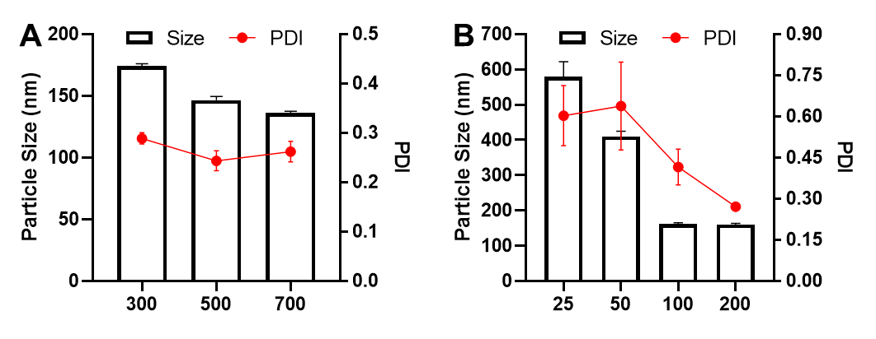
Figure S1 Effects of stirring speed (A) and calcium/phosphorus mol ratio (B) on the particle size, Zeta potential, and PDI of CaP_{d} NPs. Mean ± SD, n = 3.

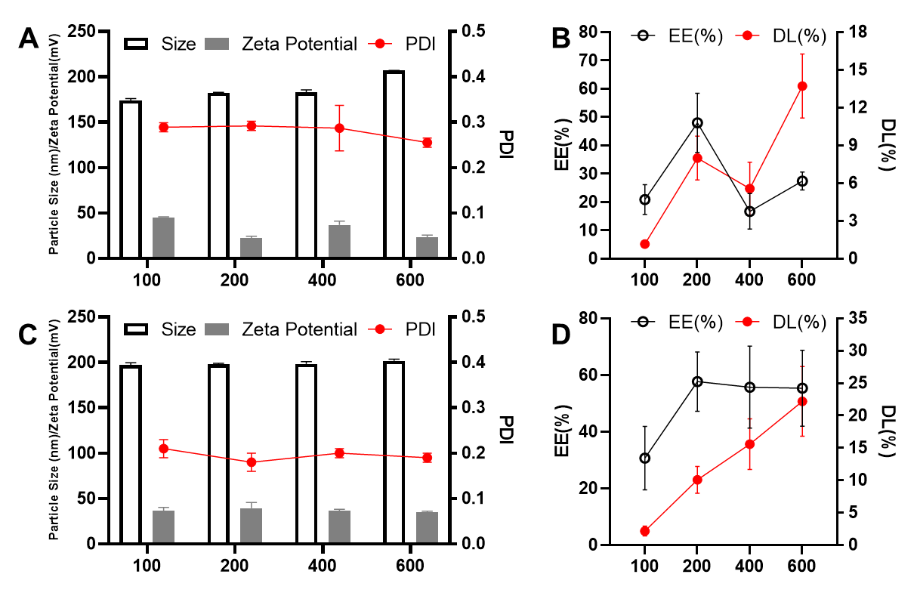
Figure S2 A and B. Effect of the loading amount of Dsp on the surface morphology (A) and drug-loading efficiency (B) of CaP_{d} NPs. C and D. Effect of the loading amount of Dex on the surface morphology (C) and drug-loading efficiency (D) of L_{d}CaP_{d} NPs. Mean ± SD, n = 3.

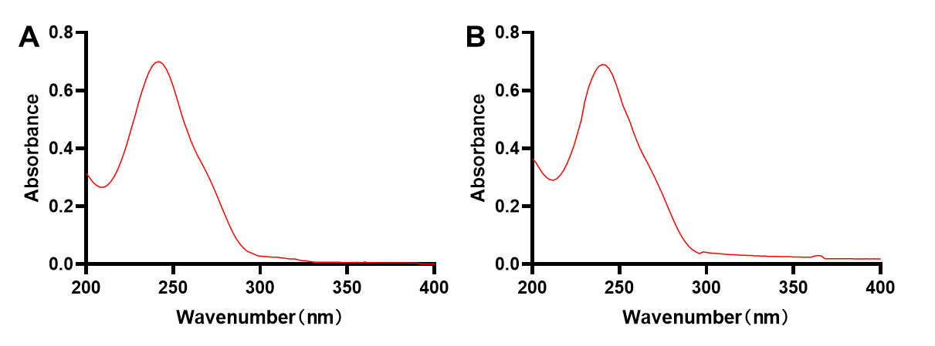
Figure S3 UV-Vis absorption spectra of Dsp (A) and Dex (B).

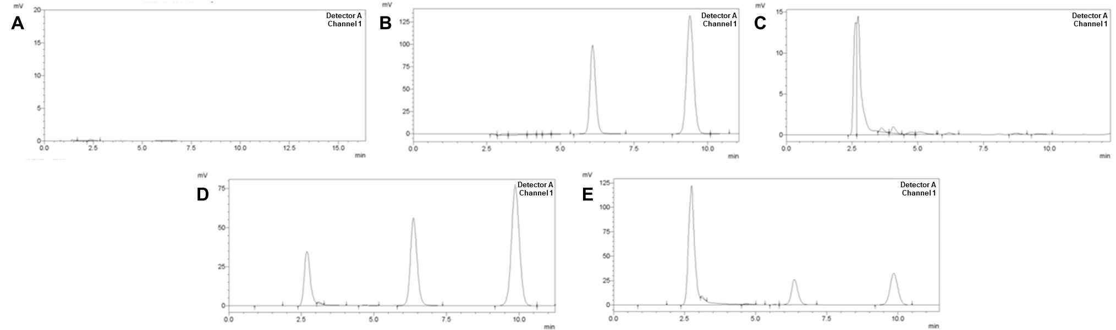
Figure S4 Method specificity investigation of simultaneous detection of Dex and Dsp by HPLC. A. Blank solvent. B. Dex and Dsp mixed solution. C. Blank-LCaP NPs solution. D. Mixed solution of Blank-LCaP NPs, Dex, and Dsp. E. L_{d}CaP_{d} NPs solution.

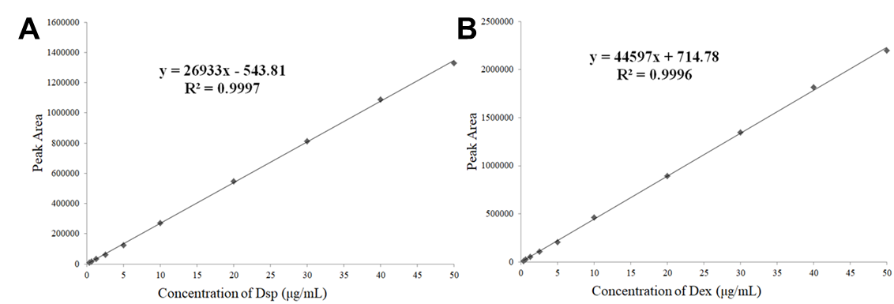
Figure S5 Standard curve for Dsp (A) and Dex (B).

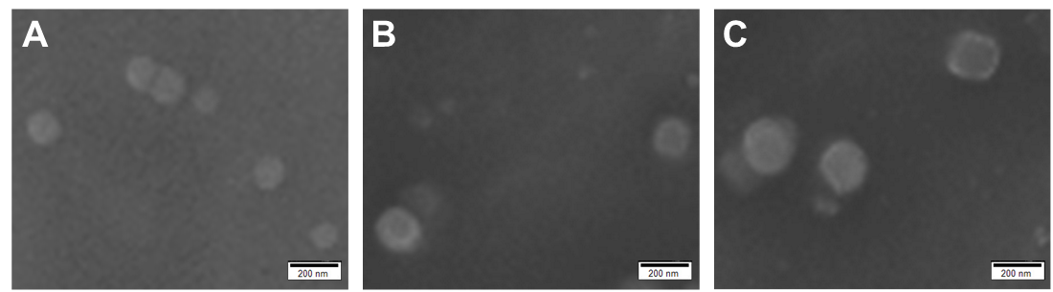
Figure S6 SEM images of CaP_{d} NPs (A), LCaP_{d} NPs (B), and L_{d}CaP_{d} NPs (C).

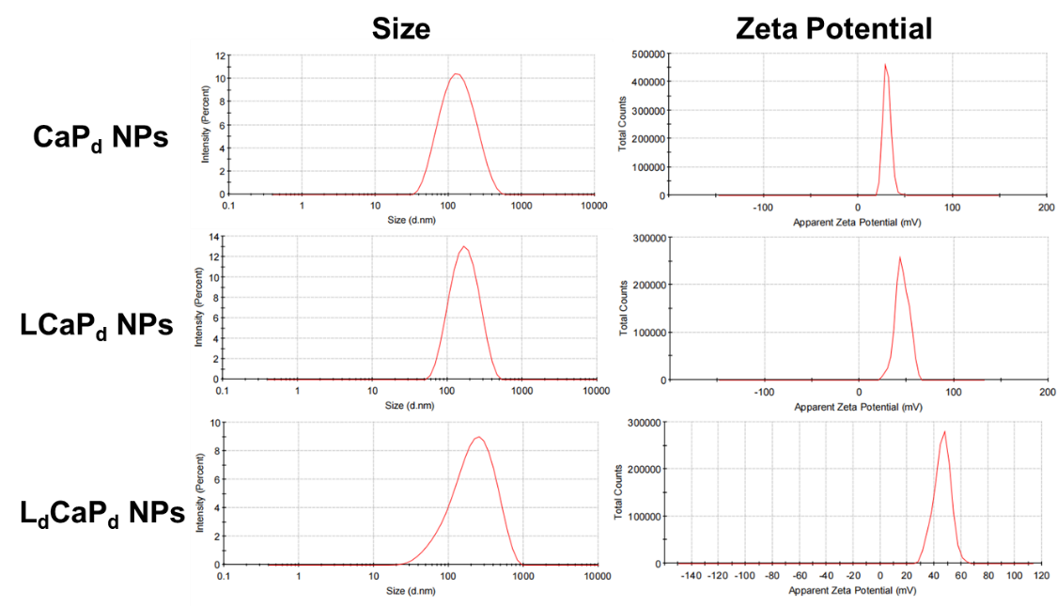
Figure S7 Particle size and Zeta potential of CaP_{d} NPs, LCaP_{d} NPs, and L_{d}CaP_{d} NPs.

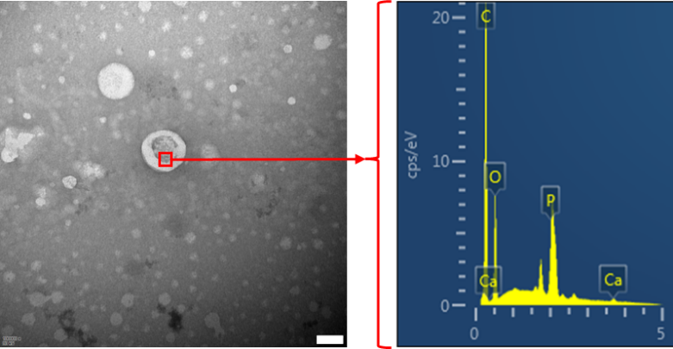
Figure S8 EDS analysis of L_{d}CaP_{d} NPs. Scale bar: 100 nm.

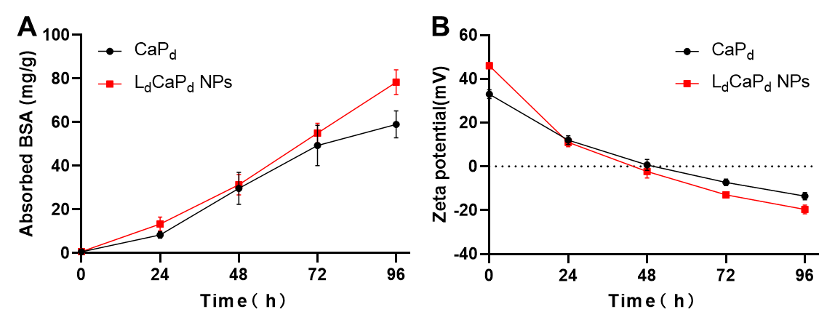
Figure S9 Protein adsorption experiment results. A. BSA adsorption amounts of CaP_{d} NPs and L_{d}CaP_{d} NPs at different time points; B. Zeta-potential of BSA adsorbed CaP_{d} NPs and L_{d}CaP_{d} NPs at different time points. Mean ± SD, n = 3.

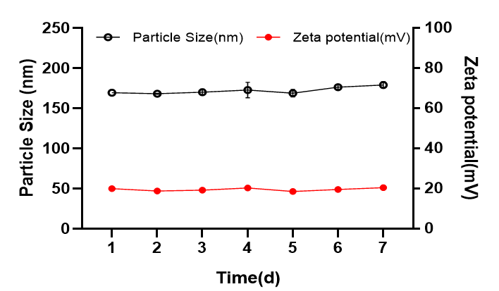
Figure S10 Changes of particle and size potential of L_{d}CaP_{d} NPs within 7 days at room temperature. Mean ± SD, n = 3.

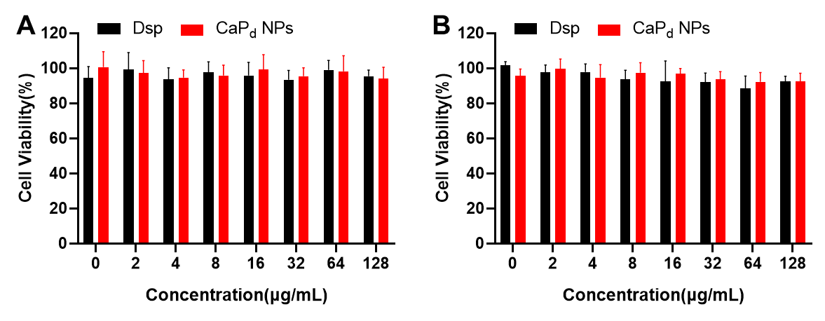
Figure S11 Cytotoxicity of CaP_{d} NPs in RAW 264.7 (A) and HT-29 cells (B). Mean ± SD, n = 3.

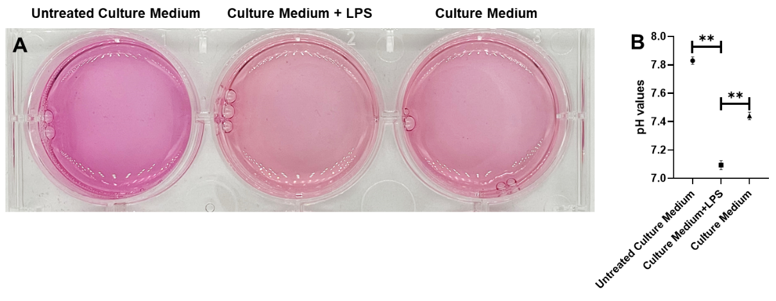
Figure S12 The LPS-induced M1 polarization of macrophage leading to the acidification of DMEM culture medium. A. Photos of different culture media. From left to right: unused DMEM medium, DMEM medium with LPS (100 ng/mL) and incubated with cells for 24 h, DMEM medium without LPS and incubated with cells for 24 h. B. The pH detection results of each culture medium. The above medium was supplemented with fetal bovine serum (10%, v/v). **P < 0.01: significantly different from the culture media with LPS. Mean ± SD, n = 3.

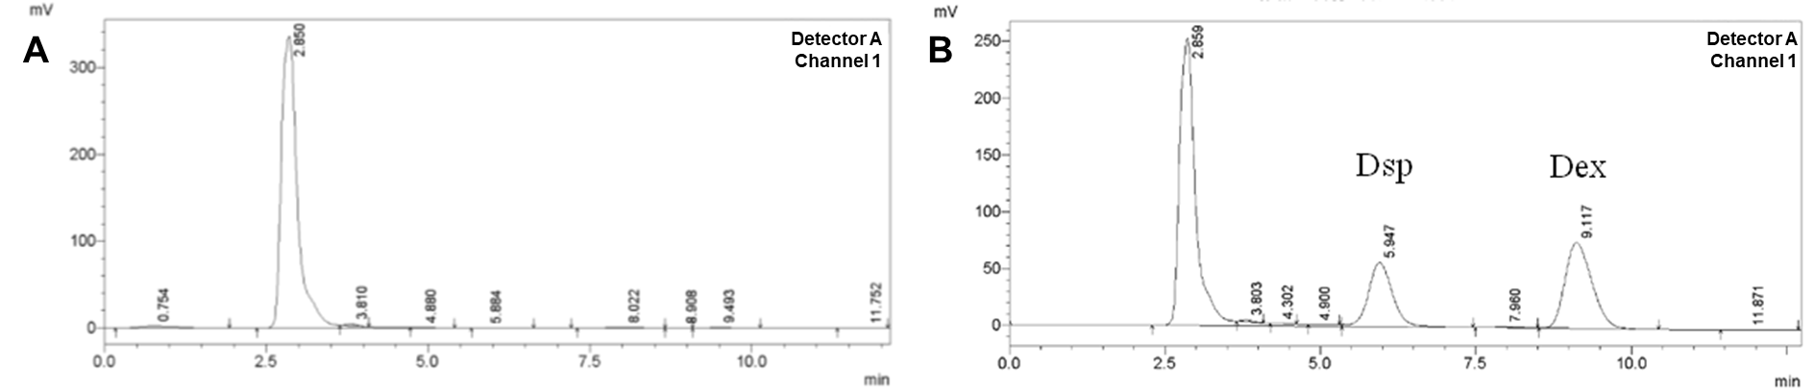
Figure S13 Method specificity investigation of Dex and Dsp in plasma. A. HPLC chromatographic image of blank plasma. B. HPLC chromatographic image of Dex/Dsp mixed standard solution in the blank plasma.

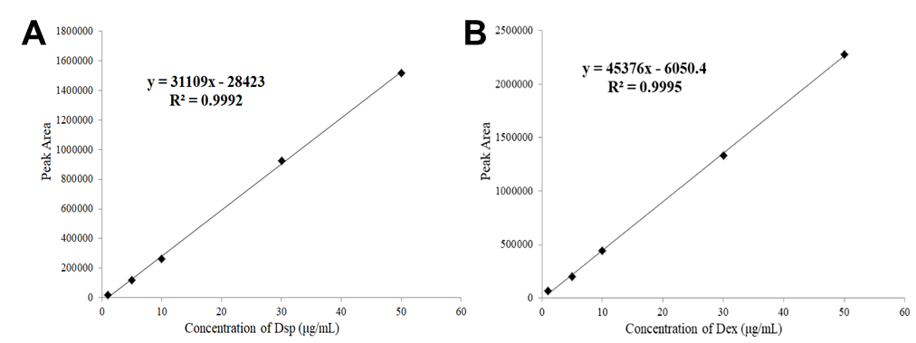
Figure S14 Linear relationship between peak area and concentration of Dex (A) and Dsp (B) in plasma.

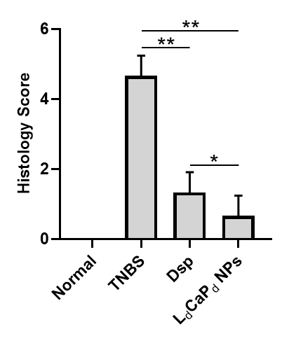
Figure S15 The histology score of colitis in the models after different treatments. *P < 0.05, **P < 0.01, means ± SD, n = 10.

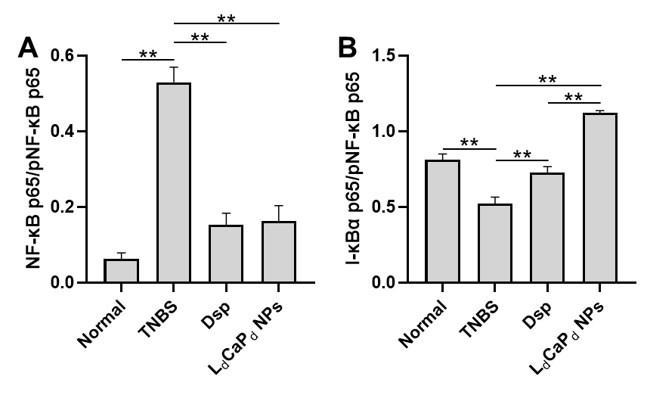
Figure S16 The protein blotting statistics of NF-κB p65/p-NF-κB p65 (A) and I-κBα/p-NF-κB p65 (B) from Fig. 6I. **P < 0.01, mean ± SD, n = 10.

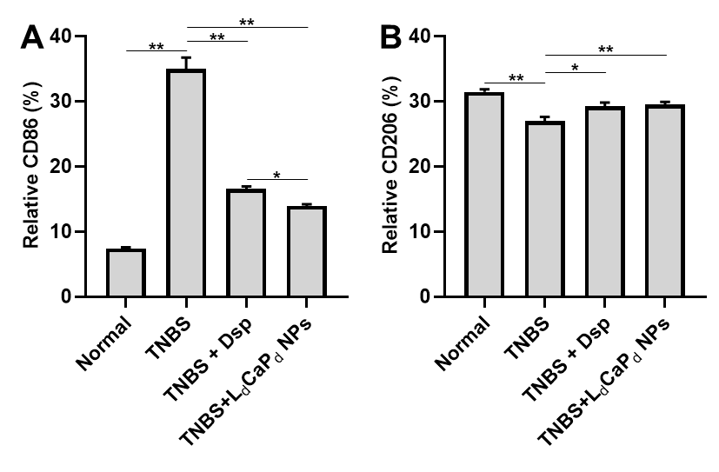
Figure S17 Effects of Dsp and L_{d}CaP_{d} NP on the expression of immunohistochemical markers in mouse colon tissue, A. CD86; B. CD206. **P < 0.01, *P < 0.05, mean ± SD, n = 10.

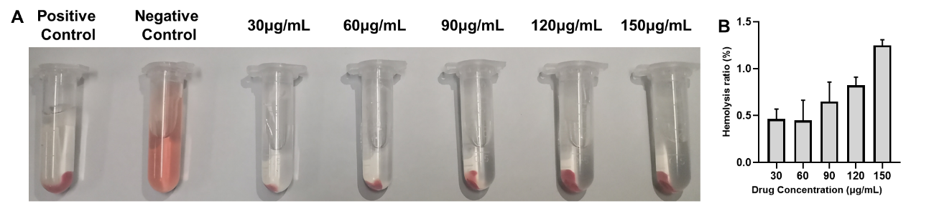
Figure S18 Hemolysis test of L_{d}CaP_{d} NPs. A. Effects of L_{d}CaP_{d} NPs solution with different concentrations on the integrity of rats’ erythrocyte membrane. B. Hemolysis ratio of L_{d}CaP_{d} NPs solutions with different concentrations. Mean ± SD, n = 3.

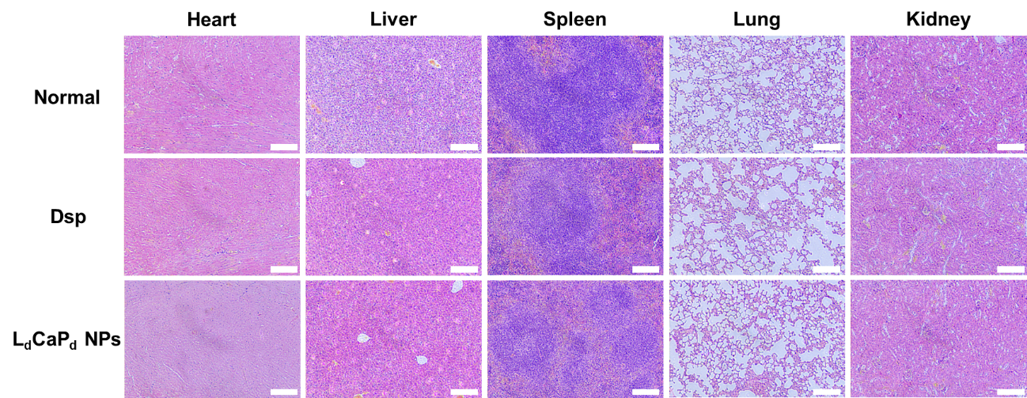
Figure S19 Histological study of heart, liver, spleen, lung, and kidney tissues of healthy mice after treatment using hematoxylin and eosin (H&E) staining, scale bars: 100 μm.

Table S1 Primers information for qRT-PCR assay
Name | Sequence (5’-3’)
NF-κB
Forward | TCCAGGCATACCTACCAGACCAAG
Reverse | GGCGGAGTCTTGAACACTATGGC
I-κBα
Forward | TGCCACAAATCTGAACCTCCACAAG
Reverse | CAAGCAAGCATCGCACATCATTACC

Table S2 The assay criteria of o-benzidine to determine the fecal occult blood of mice
Results | Phenomenon
normal | No color occurred after adding reagents for 2 min
Occult blood | Green or light green appears after adding reagent for 2min
Occult blood+ | Blue-green or dark green appears after adding reagent for 10s
Occult blood++ | Blue or blue-green appears after adding reagent for 5-20s
Occult blood+++ | Dark blue appears immediately after the reagent is added

Table S3 Disease activity index (DAI) scoring criteria
Weight loss | Character of Faeces | Occult Blood | Score
＜0% | normal | normal | 0
1%-5% | loose | Occult blood+ | 1
5%-10% | loose | Occult blood++ | 2
10%-15% | Diarrhea | Occult blood+++ | 3
＞15% | Diarrhea | Visible blood in the stool | 4

Table S4 Precision for Dsp and Dex determination by HPLC (n = 5)
Concentration | Intra-day precision RSD (%) |  | Inter-day precision RSD (%)
(µg/mL) | Dsp | Dex | Dsp | Dex
1.25 | 1.55 | 2.93 | 1.14 | 2.22
10 | 3.63 | 3.40 | 0.83 | 2.20
50 | 2.28 | 2.86 | 2.94 | 2.92

Table S5 Spiked recovery for Dsp and Dex determination by HPLC (Mean ± SD, n = 3)
Concentration  (µg/mL) | Adding sample  (%) | Dsp |  |  | Dex
Concentration  (µg/mL) | Adding sample  (%) | Mean±SD | Recovery | RSD | Mean±SD | Recovery | RSD
Concentration  (µg/mL) | Adding sample  (%) | (µg/mL) | (%) | (%) | (µg/mL) | (%) | (%)
1.25 | 80 | 2.25±0.03 | 100.26±1.55 | 1.54 | 2.25±0.06 | 100.00±2.63 | 2.63
1.25 | 100 | 2.50±0.08 | 100.12±3.19 | 3.19 | 2.50±0.01 | 99.81±0.33 | 0.33
1.25 | 120 | 2.82±0.01 | 102.45±0.29 | 0.27 | 2.75±0.04 | 100.10±1.92 | 1.46
10 | 80 | 18.25±0.35 | 101.38±1.97 | 1.94 | 17.98±0.55 | 99.88± 3.03 | 3.04
10 | 100 | 20.26±0.20 | 101.30±0.99 | 0.98 | 20.00±0.78 | 100.00±3.88 | 3.88
10 | 120 | 22.23±0.52 | 101.05±2.34 | 2.32 | 22.08±0.21 | 100.36±0.95 | 0.95
20 | 80 | 36.09±0.32 | 100.25±0.88 | 0.88 | 35.98±1.32 | 99.96± 3.68 | 3.68
20 | 100 | 40.36±1.03 | 100.89±2.57 | 2.54 | 40.23±0.42 | 100.56±1.05 | 1.04
20 | 120 | 43.67±0.61 | 99.25 ± 1.40 | 1.40 | 44.37±0.67 | 100.84±1.51 | 1.50

Table S6 The stability of mixed solution analyzed by HPLC (n = 5)
Sample | No. | Concentration (µg/mL) |  |  |  |  |  |  | RSD
Sample | No. | 0 h | 2 h | 4 h | 8 h | 12 h | 24 h | (%)
Dsp | 1 | 49.46 | 51.83 | 50.86 | 50.31 | 49.72 | 49.19 | 1.98
Dsp | 2 | 49.74 | 50.47 | 50.75 | 51.15 | 51.79 | 49.81 | 1.56
Dsp | 3 | 51.02 | 50.63 | 50.00 | 50.01 | 50.66 | 49.77 | 0.97
Dex | 1 | 49.28 | 50.54 | 50.82 | 50.29 | 50.00 | 50.69 | 1.13
Dex | 2 | 50.66 | 50.15 | 50.37 | 50.67 | 51.20 | 49.21 | 1.33
Dex | 3 | 51.62 | 50.37 | 49.74 | 50.29 | 50.75 | 50.42 | 1.24

Table S7 Precision for Dsp and Dex in plasma detected by HPLC (n = 5)
Concentration | Intra-day precision RSD (%) |  | Inter-day precision RSD (%)
(µg/mL) | Dsp | Dex | Dsp | Dex
1 | 3.10 | 3.62 | 3.15 | 4.31
5 | 4.30 | 4.96 | 3.23 | 3.39
10 | 4.67 | 3.35 | 4.87 | 4.66

Table S8 Average recovery for Dsp and Dex in plasma detected by HPLC (Mean ± SD, n = 3)
Concentration  (µg/mL) | Dsp |  |  | Dex
Concentration  (µg/mL) | Measured | Recovery | RSD | Measured | Recovery | RSD
Concentration  (µg/mL) | (µg/mL) | (%) | (%) | (µg/mL) | (%) | (%)
1 | 1.09 ± 0.07 | 109.87 ± 7.57 | 6.89 | 1.09 ± 0.06 | 109.87 ± 2.63 | 6.37
5 | 5.05 ± 0.26 | 101.03 ± 5.25 | 5.19 | 4.94 ± 0.27 | 98.87 ± 5.51 | 5.57
10 | 10.24 ± 0.69 | 102.43 ± 6.90 | 6.74 | 10.31 ± 0.76 | 103.14 ± 7.69 | 7.45

Table S9 Pharmacokinetic parameter of Dsp (i.v. administration of 6 mg/kg) and L_{d}CaP_{d} NPs
(i.v. administration of NPs containing 6 mg/kg Dsp) in rats (Mean ± SD, n = 6).
Parameters | Dsp | L_{d}CaP_{d} NPs
t_{1/2} (min) | 271.84 ± 23.77 | 317.21 ± 33.48
C_{max} (mg/L) | 4.63 ± 1.05 | 16.02 ± 3.95##
AUC₀₋₁₂ (min·mg/L) | 1014.47 ± 106.12 | 4638.41 ± 532.60##
AUC_{0-∞} (min·mg/L) | 1270.83 ± 81.78 | 5509.42 ± 746.65##
MRT (min) | 414.91 ± 55.96 | 456.53 ± 53.02
CL (mL/min) | 0.95 ± 0.06 | 0.22 ± 0.03##
Compared with Dsp, ##P < 0.01

