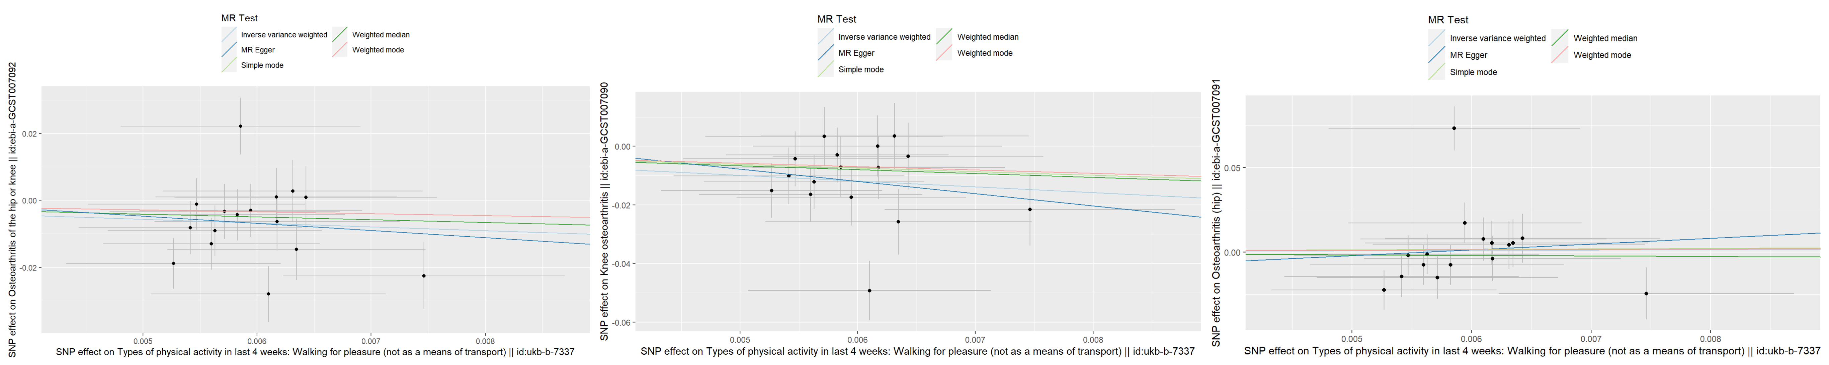
Supplementary Figure 1：Scatter plot

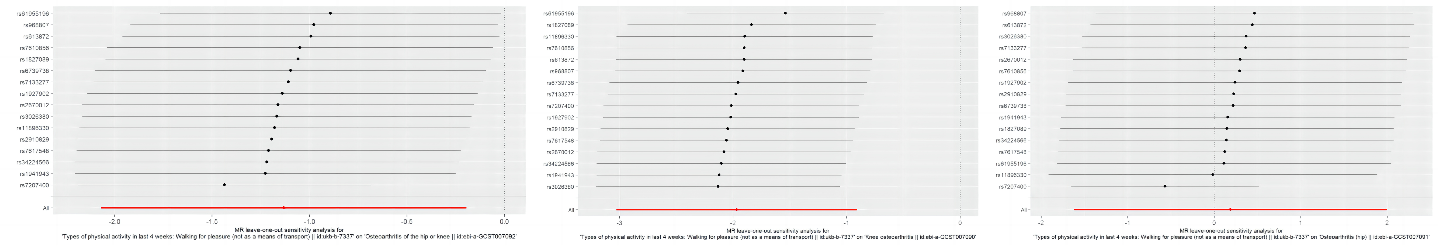
Supplementary Figure 2：Leave one out analysis plot

Supplementary Table 1 The MR result after removing heterogeneity

Outcomes | MR result | OR | L-95%CI | U-95%CI | P value
Osteoarthritis  (Knee or Hip)  SNP=15 | MR Egger | 0.1824 | 1.37E-05 | 2427.2094 | 0.7311
Osteoarthritis  (Knee or Hip)  SNP=15 | Weighted median | 0.3966 | 0.1513 | 1.0397 | 0.0600
Osteoarthritis  (Knee or Hip)  SNP=15 | IVW | 0.2377 | 0.1121 | 0.5040 | 0.0002
Osteoarthritis  (Knee or Hip)  SNP=15 | Simple mode | 0.5699 | 0.0946 | 3.4326 | 0.5492
Osteoarthritis  (Knee or Hip)  SNP=15 | Weighted mode | 0.5699 | 0.1102 | 2.9465 | 0.5133
Knee osteoarthritis  SNP=16 | MR Egger | 0.0152 | 1.64E-08 | 14124.8144 | 0.5600
Knee osteoarthritis  SNP=16 | Weighted median | 0.2672 | 0.0803 | 0.8892 | 0.0314
Knee osteoarthritis  SNP=16 | IVW | 0.1396 | 0.0484 | 0.4026 | 0.0003
Knee osteoarthritis  SNP=16 | Simple mode | 0.292 | 0.0383 | 2.2262 | 0.2534
Knee osteoarthritis  SNP=16 | Weighted mode | 0.3186 | 0.0484 | 2.0958 | 0.2525
Osteoarthritis (hip)  SNP=15 | MR Egger | 91.5105 | 0.0002 | 52393932.77 | 0.5160
Osteoarthritis (hip)  SNP=15 | Weighted median | 0.7126 | 0.1617 | 3.1403 | 0.6543
Osteoarthritis (hip)  SNP=15 | IVW | 0.5674 | 0.1915 | 1.6808 | 0.3064
Osteoarthritis (hip)  SNP=15 | Simple mode | 1.4748 | 0.0949 | 22.9219 | 0.7854
Osteoarthritis (hip)  SNP=15 | Weighted mode | 1.3677 | 0.0783 | 23.8927 | 0.8332

Note: IVW: Inverse variance weighting, OR: Odds Ratio, L-95%CI: Lower 95% confidence interval, U-95%CI: Upper 95% confidence interval, SNP:Single nucleotide polymorphism, MR: Mendelian randomization

Supplementary Table 2: Heterogeneity and pleiotropy test after removing heterogeneity

Outcome |  | OA | KOA | HOA
IVW  (heterogeneity) | p value | 0.3273 | 0.0672 | 0.5713
IVW  (heterogeneity) | Q | 15.7755 | 23.8771 | 12.0409
MR Egger  (heterogeneity) | p value | 0.2617 | 0.0497 | 0.6030
MR Egger  (heterogeneity) | Q | 15.7719 | 23.7068 | 11.4724
MR Egger  (pleiotropy) | p value | 0.9571 | 0.7558 | 0.4643
MR Egger  (pleiotropy) | intercept | 0.0016 | 0.0132 | -0.0303

Note: OA: Osteoarthritis, KOA: Knee osteoarthritis, HOA: Hip osteoarthritis, MR: Mendelian randomization, IVW: Inverse variance weighting.

