ORIGINAL RESEARCH
Nicole M.D. van der Burg et al
Bronchodilator responsiveness measured by spirometry and impulse oscillometry in patients with asthma after short acting antimuscarinic and/or beta-2-agonists inhalation

Supplementary figure 1: Patient characteristics of non-responders plotted against responders. Of the 34 patients that underwent BDR testing, 23 presented with >7% change in FEV1 (ΔFEV1%), called responders, and 11 presented with a <7% change, called non-responders. The non-responders consisted of 7 women and 4 men, with a mean (SD, min-max) age of 30.3 (9.4, 21-49) years. None were currently smoking nor had any history of smoking previously. The average BMI was 25.3 ± 3.1, the average ACT was 21.3 ± 2.5 and the baseline predicted percentage (%p) of FEV1 was 102.1 ± 12.8 (plotted on the right axis). Comparing all characteristics between responders and non-responders (adjusting for multiple comparisons) only found significant differences between ΔFEV1%, p = <0.000001, as expected.
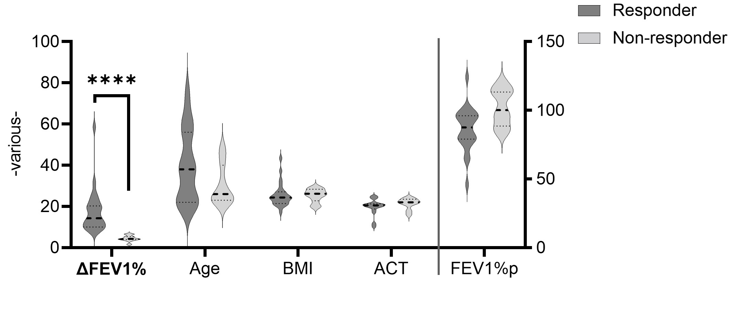
Supplementary figure 2: Statistical analysis of the change over time for spirometry readings with each bronchodilator test. Plots reflect the same data as seen in Figure 1 but with alternative statistical analysis over time per bronchodilator test. Graph only depicts changes between 5 – 60 minutes, not changes from the baseline (of which there was no changes from baseline for SABA alone and SAMA alone in FVC). Statistics: 2-way RM ANOVA with Geisser-Greenhouse correction for the variability and Sídák correction for multiple comparisons, n=23, *p<0.05, **p<0.01, ***p<0.001, ****p<0.0001.
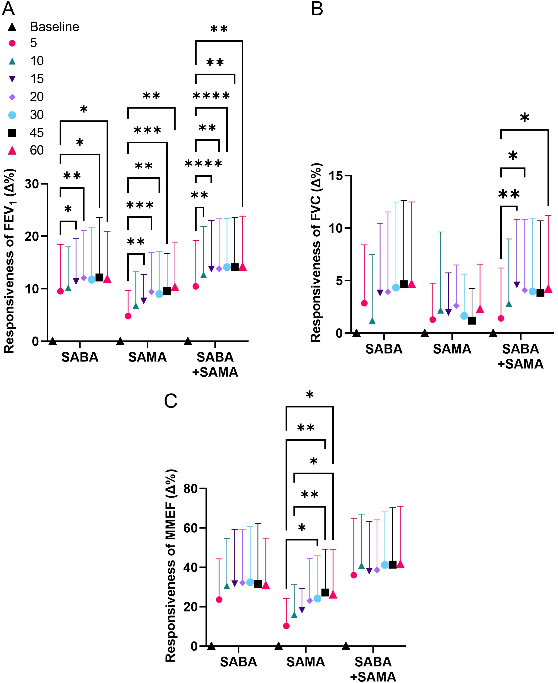

Supplementary figure 3: Statistical analysis of the change over time for impulse oscillometry readings with each bronchodilator test. Plots reflect the same data as seen in Figure 3 but with alternative statistical analysis over time per bronchodilator test. Graph only depicts changes between 5 – 60 minutes, not changes from the baseline (of which there was no changes from baseline for SABA alone and SAMA alone in R5-R20). Statistics: 2-way RM ANOVA with Geisser-Greenhouse correction for the variability and Šídák correction for multiple comparisons, n=23. *p<0.05, **p<0.01, ***p<0.001, ****p<0.0001.
