Supplementary Material

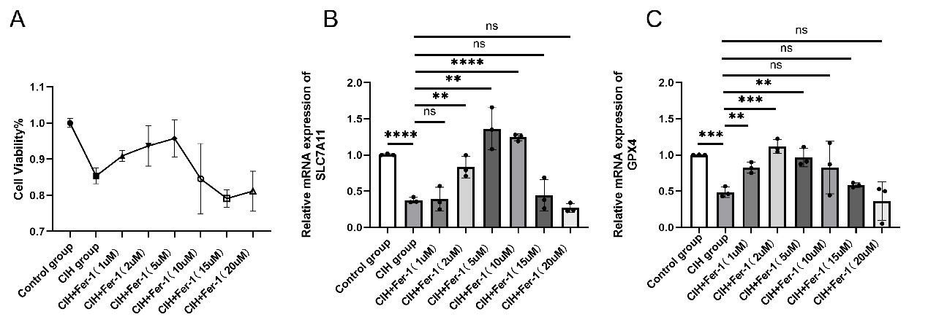
Figure S1. A, CCK-8 was used to screen the optimal concentration of Fer-1; B, The mRNA level of SLC7A11 was detected by qRT-PCR, used to screen the optimal concentration of Fer-1. C, The mRNA level of GPX4 was detected by qRT-PCR, used to screen the optimal concentration of Fer-1.

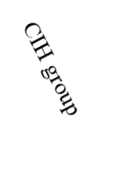
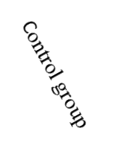
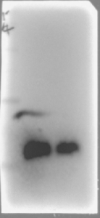
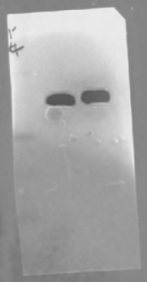
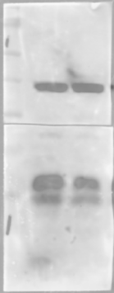
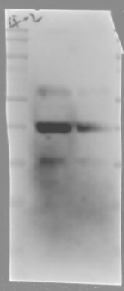
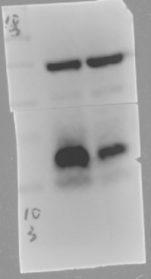
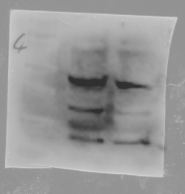
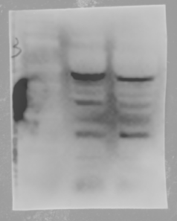
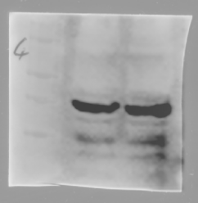
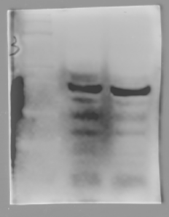
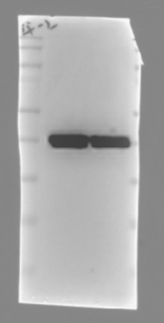
β-ACTIN
SLC7A11
Figure S2. Western blot images of Fig. 1F. The WB legends of ROAEC. The blots were cut prior to hybridisation with antibodies during blotting. The images show all blots and replicates of SLC7A11, GPX4, and β-actin. The inner black rectangles are the representative blots.
Second Repetition
First Repetition
Third
Repetition
42KD
55KD
17KD
β-ACTIN
GPX4

Third
Repetition
100
75
60
35
45
KD
15
25
First Repetition
Second Repetition
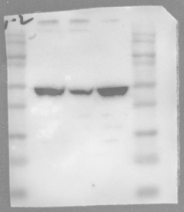
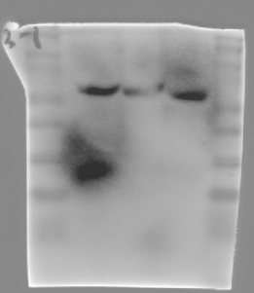
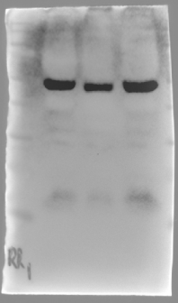
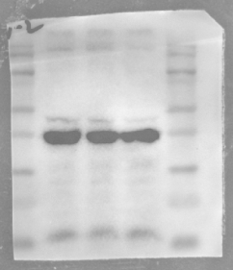
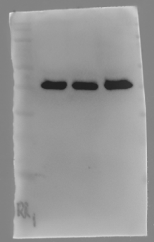
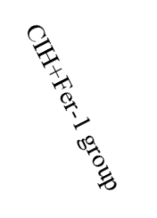
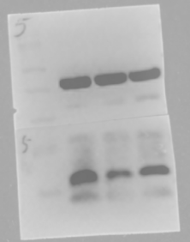
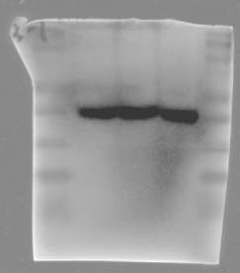
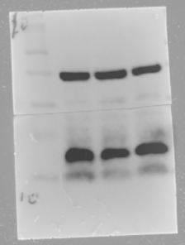
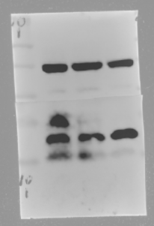
55KD
β-ACTIN
SLC7A11
GPX4

β-ACTIN
42KD
17KD
42KD
Third
Repetition
Third
Repetition
First Repetition
Second Repetition
First Repetition
Second Repetition
Figure S3. Western blot images of Fig.2F. The WB legends of ROAEC. The blots were cut prior to hybridisation with antibodies during blotting. The images show all blots and replicates of SLC7A11, GPX4, and β-actin. The inner black rectangles are the representative blots.

