SUPPLEMENTARY DATA

Table of Contents
1. Figure S1. Flow chart on the selection of study population. 2
2. Figure S2. Directed acyclic graph showing selection of covariates for confounding control. 3
3. Figure S3. Cumulative incidence rate for all-cause death among hypertensive patients stratified by age group 4
4. Figure S4. Exposure-response curves for the independent effects of BMI and age among hypertensive patients stratified by gender. 5
5. Figure S5. Different angles of exposure-response surface plots of the joint effect of BMI and age on all-cause mortality among males with hypertension. 6
6. Figure S6. Different angles of exposure-response surface plots of the joint effect of BMI and age on all-cause mortality among females with hypertension. 7
7. Figure S7. Exposure-response curves for the independent effects of BMI and age among hypertensive patients. 8
8. Figure S8. Different angles of exposure-response surface plots of the joint effect of BMI and age on all-cause mortality among hypertensive patients. 9

Figure S1. Flow chart on the selection of study population.
Abbreviations: BMI, body mass index; EHR, electronic health record.

Figure S2. Directed acyclic graph showing selection of covariates for confounding control.
Abbreviation: SBP, systolic blood pressure; DBP, diastolic blood pressure; CVD, cardiovascular disease.

Figure S3. Cumulative incidence rate for all-cause death among hypertensive patients stratified by age group.
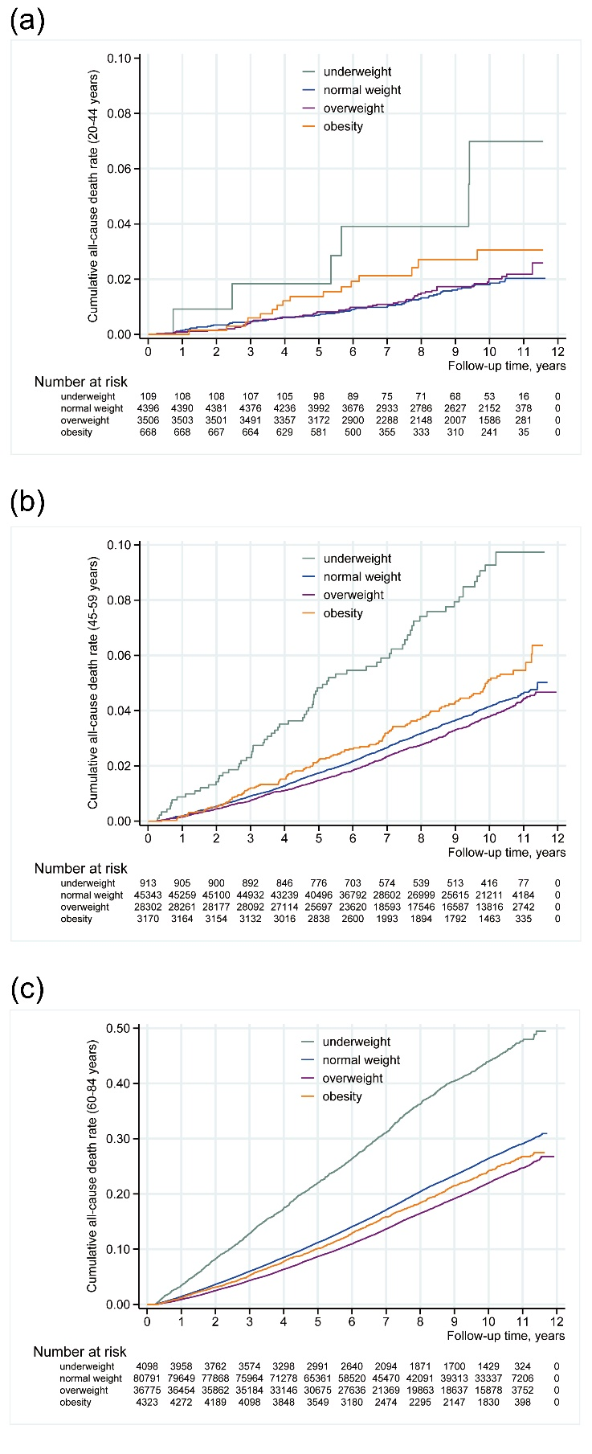
(a) 20-44 years old; (b) 45-59 years old; (c) 60-85 years old.
BMI (kg/m²) was calculated by weight (kg)/height² (m²); Underweight: <18.5 kg/m²; Normal weight: 18.5-24.9 kg/m²; Overweight: 25.0-29.9 kg/m²; Obesity: ≥30.0 kg/m².

Figure S4. Exposure-response curves for the independent effects of BMI and age among hypertensive patients stratified by gender.
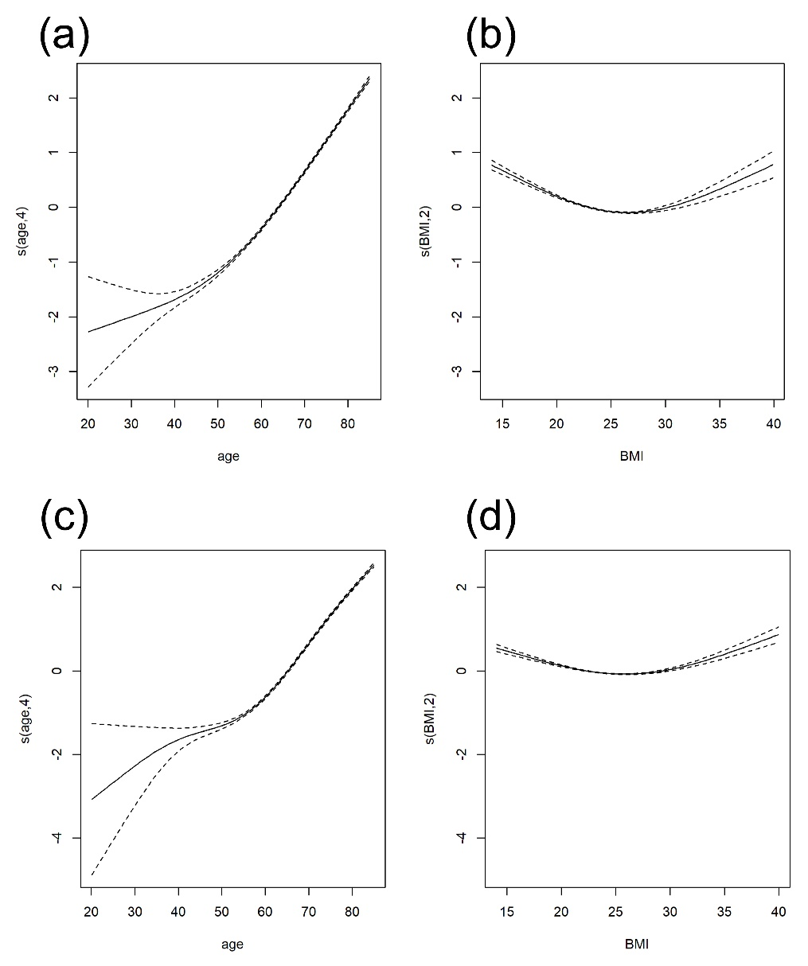
(a) Independent effect of age among males with hypertension; (b) Independent effect of BMI among males with hypertension; (c) Independent effect of age among females with hypertension; (d) Independent effect of BMI among females with hypertension.
Adjusting for systolic blood pressure, diastolic blood pressure, physical exercise, smoking, drinking, diabetes mellitus, family history of hypertension, family history of diabetes mellitus, family history of cardiovascular disease, and family history of stroke.

Figure S5. Different angles of exposure-response surface plots of the joint effect of BMI and age on all-cause mortality among males with hypertension.
The plots (a), (b), (c), and (d) represent the different angles.
Adjusting for systolic blood pressure, diastolic blood pressure, physical exercise, smoking, drinking, diabetes mellitus, family history of hypertension, family history of diabetes mellitus, family history of cardiovascular disease, and family history of stroke.

Figure S6. Different angles of exposure-response surface plots of the joint effect of BMI and age on all-cause mortality among females with hypertension.
The plots (a), (b), (c), and (d) represent the different angles.
Adjusting for systolic blood pressure, diastolic blood pressure, physical exercise, drinking, family history of hypertension, family history of diabetes mellitus, family history of cardiovascular disease, and family history of stroke.

Figure S7. Exposure-response curves for the independent effects of BMI and age among hypertensive patients.
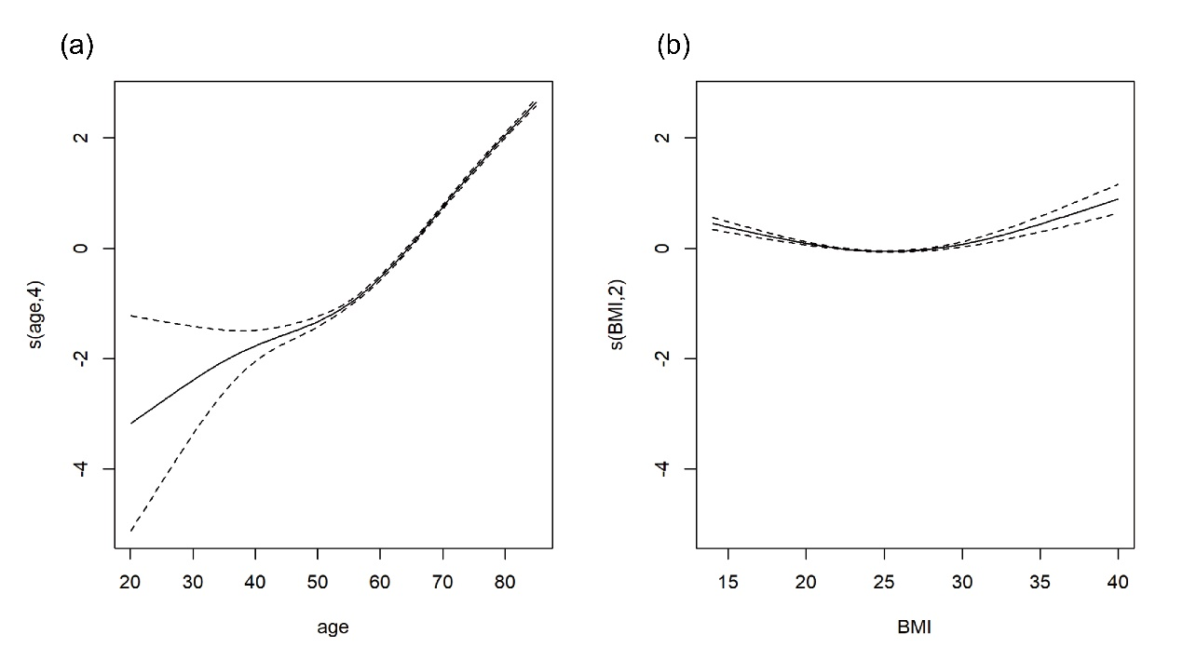
(a) Independent effect of age; (b) Independent effect of BMI.
Adjusting for systolic blood pressure, diastolic blood pressure, physical exercise, drinking, family history of hypertension, family history of diabetes mellitus, family history of cardiovascular disease, and family history of stroke.
Excluding patients who smoked, were diagnosed with diabetes, or had less than 5 years of follow-up.

Figure S8. Different angles of exposure-response surface plots of the joint effect of BMI and age on all-cause mortality among hypertensive patients.
The plots (a), (b), (c), and (d) represent the different angles.
Adjusting for gender, systolic blood pressure, diastolic blood pressure, physical exercise, drinking, family history of hypertension, family history of diabetes mellitus, family history of cardiovascular disease, and family history of stroke.
Excluding patients who smoked, were diagnosed with diabetes, or had less than 5 years of follow-up.

