Table S1. 5-year relative survival rates for all cancers combined and ten major cancers by age
 | 2011-13 | 2014-15 | 2016-18 | 2019-21
All
<45 | 52.1(50.6-53.6) | 60.4(59.0-61.8) | 68.9(67.8-69.9) | 73.4(72.4-74.3)
45-54 | 40.8(39.5-42.1) | 48.2(47.0-49.5) | 58.3(57.4-59.3) | 61.8(60.9-62.7)
55-64 | 33.3(32.2-34.3) | 37.6(36.6-38.6) | 43.9(43.0-44.8) | 47.5(46.7-48.3)
65-74 | 25.6(24.5-26.7) | 26.8(25.8-27.8) | 32.4(31.4-33.3) | 35.1(34.3-36.0)
≥75 | 19.0(17.9-20.2) | 17.5(16.4-18.6) | 19.1(18.2-20.2) | 18.9(18.0-19.8)
Lung
<45 | 18.4(13.7-23.7) | 31.8(26.3-37.5) | 51.5(46.8-56.0) | 57.5(52.9-61.8)
45-54 | 15.7(13.1-18.6) | 23.0(20.2-26.0) | 38.1(35.4-40.9) | 44.5(41.8-47.2)
55-64 | 14.9(13.2-16.8) | 19.3(17.6-21.1) | 28.6(26.8-30.4) | 33.7(31.9-35.5)
65-74 | 12.5(10.7-14.3) | 14.6(12.9-16.3) | 18.6(17.0-20.3) | 21.4(19.8-23.0)
≥75 | 10.4(8.6-12.5) | 6.6(5.3-8.3) | 8.5(7.1-10) | 7.1(6.0-8.3)
Liver
<45 | 13.2(10.9-15.8) | 14.2(11.7-17.0) | 15.3(12.9-18.0) | 16.8(14.4-19.4)
45-54 | 12.6(10.6-14.9) | 15.4(13.2-17.8) | 18.2(16.0-20.5) | 19.5(17.5-21.7)
55-64 | 13.8(12.0-15.9) | 14.9(13.0-16.9) | 18.1(16.2-20.1) | 18.0(16.2-19.8)
65-74 | 12.8(10.5-15.3) | 9.9(8.1-12.0) | 14.4(12.4-16.6) | 14.5(12.6-16.5)
≥75 | 7.5(5.3-10.3) | 7.2(5.2-9.6) | 7.2(5.4-9.5) | 6.9(5.3-8.7)
Stomach
<45 | 34.2(28.3-40.3) | 42.6(36.1-48.8) | 49.3(43.2-55.1) | 49.8(43.9-55.4)
45-54 | 36.8(32.7-40.9) | 39.8(35.4-44.0) | 44.7(40.8-48.5) | 45.7(42.0-49.3)
55-64 | 38.5(35.7-41.2) | 38.4(35.5-41.3) | 40.3(37.6-43.0) | 42.2(39.7-44.8)
65-74 | 29.2(26.6-31.9) | 29.2(26.6-31.9) | 31.0(28.6-33.5) | 33.9(31.5-36.2)
≥75 | 17.3(14.7-20.2) | 14.4(12.1-17.0) | 12.4(10.4-14.6) | 11.6(9.9-13.5)
Oesophagus
<45 | 22.5(14.9-31.0) | 26.4(14.7-39.6) | 38.9(27.0-50.6) | 41.5(28.1-54.3)
45-54 | 22.0(18.5-25.7) | 22.9(18.9-27.3) | 28.2(24.4-32.2) | 28.8(25.1-32.6)
55-64 | 22.7(20.3-25.3) | 23.0(20.2-25.9) | 27.8(25.2-30.5) | 28.5(25.9-31.1)
65-74 | 13.8(11.3-16.5) | 19.1(16.2-22.3) | 19.2(16.6-22.0) | 22.2(19.7-24.8)
≥75 | 10.3(7.9-13.1) | 7.6(5.6-10) | 7.7(5.8-10) | 6.7(5.1-8.6)
Colon-rectum
<45 | 52.6(46.8-58.0) | 51.9(46.1-57.4) | 57.0(51.6-62.0) | 59.2(54.5-63.6)
45-54 | 51.5(46.8-56.0) | 56.0(51.6-60.2) | 61.7(58.4-64.9) | 63.9(60.8-66.8)
55-64 | 50.9(47.3-54.5) | 55.4(52.1-58.6) | 57.7(54.9-60.4) | 60.8(58.3-63.3)
65-74 | 43.3(39.4-47.1) | 45.0(41.4-48.6) | 51.8(48.9-54.8) | 53.8(51.2-56.5)
≥75 | 30.0(26.0-34.1) | 32.2(28.4-36.1) | 37.1(33.6-40.7) | 38.4(35.2-41.6)
Breast
<45 | 81.0(77.0-84.4) | 78.1(74.5-81.2) | 84.4(81.8-86.7) | 87.0(84.8-88.9)
45-54 | 72.6(68.5-76.3) | 75.1(71.7-78.2) | 84.3(82.0-86.3) | 85.6(83.6-87.4)
55-64 | 67.2(62.1-71.9) | 72.1(67.5-76.2) | 77.8(74.3-80.9) | 81.3(78.3-83.9)
65-74 | 66.7(57.8-74.4) | 64.7(57.1-71.5) | 74.0(67.8-79.3) | 78.2(72.8-82.8)
≥75 | 49.3(36.9-61.8) | 49.3(35.8-62.9) | 67.3(56.4-77.4) | 62.8(52.9-72.2)
Cervix
<45 | 76.3(70.3-81.3) | 77.8(71.8-82.6) | 81.6(77.0-85.3) | 82.5(78.2-86.1)
45-54 | 65.6(59.8-70.8) | 67.1(62.3-71.4) | 78.1(74.7-81.2) | 79.1(75.8-82.1)
55-64 | 65.0(57.3-71.8) | 57.6(51.0-63.7) | 70.9(66.0-75.3) | 73.5(68.9-77.5)
65-74 | 51.2(35.6-65.3) | 42.3(31.8-52.7) | 56.0(47.8-63.6) | 55.8(47.9-63.2)
≥75 | 24.7(7.7-49.4) | 29.2(15.6-45.4) | 23.1(13.5-34.8) | 22.7(14.0-33.1)
Thyroid
<45 | 97.9(95.9-99.0) | 96.3(94.8-97.4) | 99.4(98.7-99.8) | 99.6(99.2-99.9)
45-54 | 95.8(92.1-98.0) | 93.6(91.2-95.4) | 99.6(98.6-100.2) | 99.9(99.2-100.4)
55-64 | 90.2(84.9-94.1) | 92.7(89.3-95.3) | 98.3(96.3-99.7) | 98.8(97.2-99.9)
65-74 | 80.4(67.5-89.8) | 79.9(70.8-87.2) | 92.9(86.5-97.4) | 94.7(89.7-98.3)
≥75 | 69.8(40.3-96.3) | 61.7(39.4-82.8) | 55.8(32.9-78.2) | 70.8(51.2-88.0)
Brain
<45 | 44.8(38.1-51.3) | 52.1(45.2-58.4) | 61.3(55.8-66.4) | 61.9(56.7-66.6)
45-54 | 49.3(41.2-56.9) | 55.8(48.6-62.5) | 65.7(59.8-70.9) | 68.7(63.3-73.4)
55-64 | 33.6(26.1-41.4) | 45.6(38.7-52.2) | 59.1(53.5-64.3) | 60.8(55.4-65.8)
65-74 | 37.7(27.9-47.8) | 31.2(24.0-38.9) | 47.6(41.3-53.6) | 46.6(40.7-52.4)
≥75 | 29.4(19.2-41.1) | 21.8(14.6-30.2) | 35.8(27.1-45.1) | 34.1(26.2-42.6)
Lymphoma
<45 | 69.0(60.2-76.2) | 62.9(54.5-70.2) | 68.9(62.3-74.5) | 71.6(65.6-76.8)
45-54 | 47.6(37.7-56.8) | 54.0(45.5-61.8) | 64.0(56.5-70.6) | 65.3(58.6-71.2)
55-64 | 42.5(34.8-50.2) | 45.9(39.1-52.4) | 45.7(39.5-51.8) | 52.3(46.6-57.7)
65-74 | 32.0(24.4-40.1) | 32.4(24.9-40.4) | 37.7(31.4-44.1) | 40.3(34.4-46.1)
≥75 | 21.4(12.3-32.8) | 21.2(13.4-30.9) | 21.4(14.3-29.9) | 22.0(15.7-29.4)

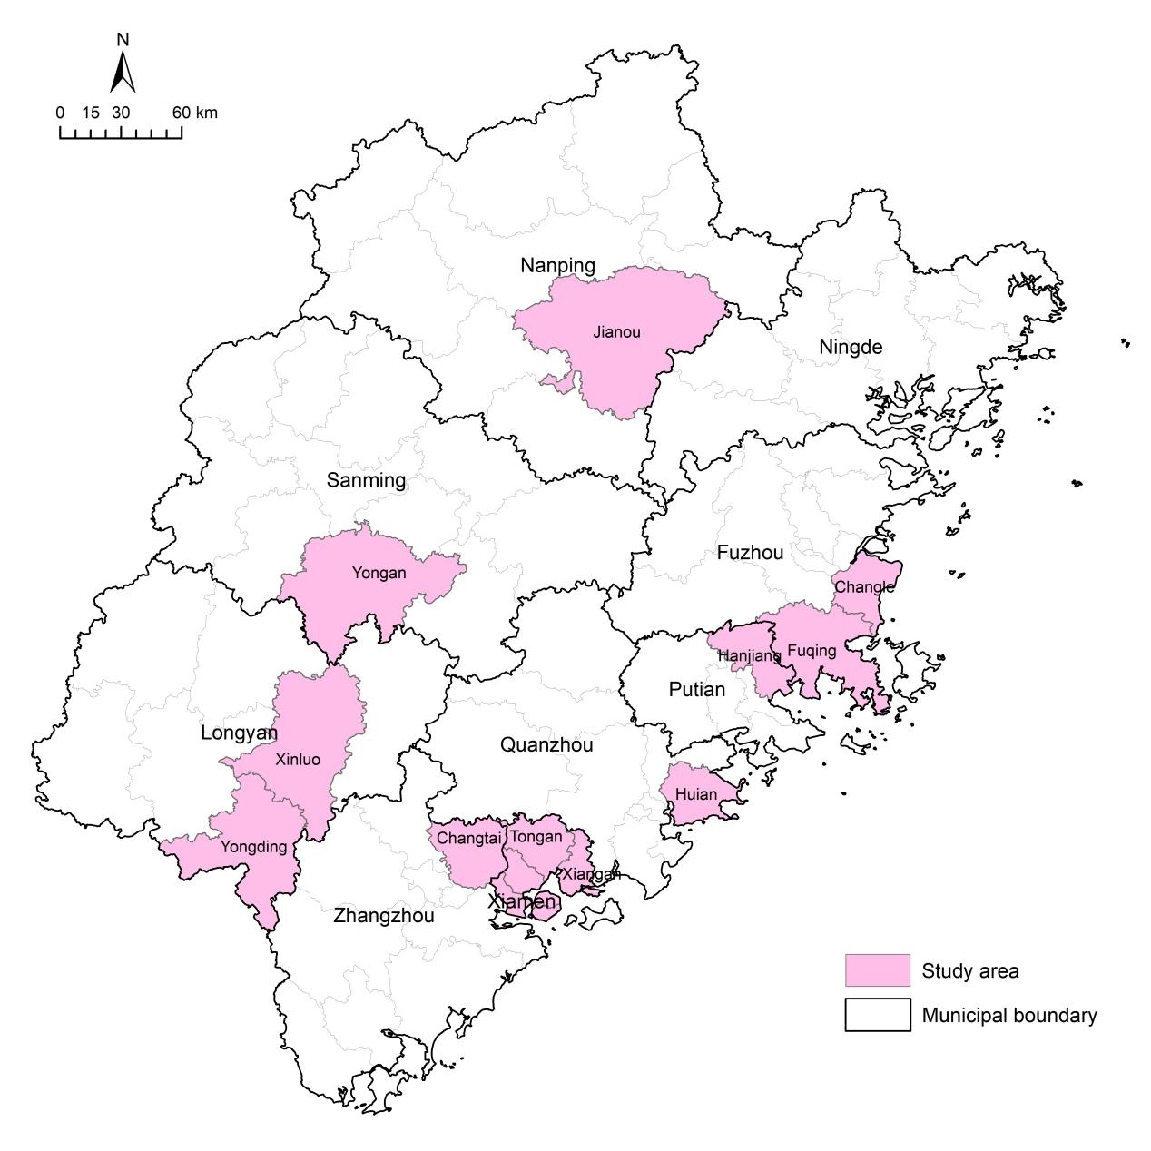
Figure S1 Geographical distribution of cancer registration areas.

Figure S2 Number of patients included in the analyses by sex and type of cancer. (A) All patients; (B) Male patients; (C) Female patients.

