Supplementary Information for
Lipid-based self-microemulsion of niclosamide achieved enhanced oral delivery and anti-tumor efficacy in orthotopic patient-derived xenograft of hepatocellular carcinoma in mice

Yi Liu¹, David Quintanar Guerrero², David Lechuga-Ballesteros³, Mingdian Tan¹, Faiz Ahmad¹, Bilal Aleiwi⁴, Edmund Ellsworth⁴, Bin Chen⁴, Mei-Sze Chua¹, Samuel So¹

¹Department of Surgery, School of Medicine, Stanford University, Stanford, CA, USA.
²Laboratorio de Investigación y Posgrado en Tecnologías Farmacéuticas, Facultad de Estudios Superiores Cuautitlán, Universidad Nacional Autónoma de México, Cuautitlán Izcalli CP 54745, Mexico
³AstraZeneca Pharmaceuticals, Ltd. 4222 Emperor Boulevard, Durham, NC, USA.
⁴Department of Pharmacology and Toxicology, Michigan State University, East Lansing, MI, USA.

Corresponding author:
Mei-Sze Chua, PhD
Senior Scientist
Email: mchua@stanford.edu
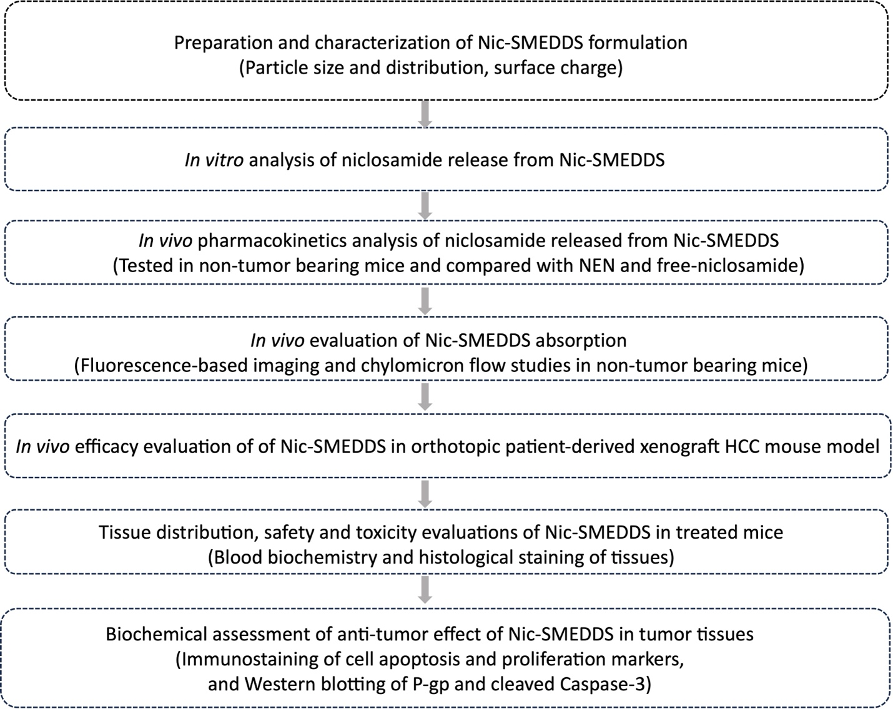

Schematics. Flow chart of experimental processes in the evaluation of Nic-SMEDDS for its physicochemical and absorption characteristics, and anti-tumor effects.
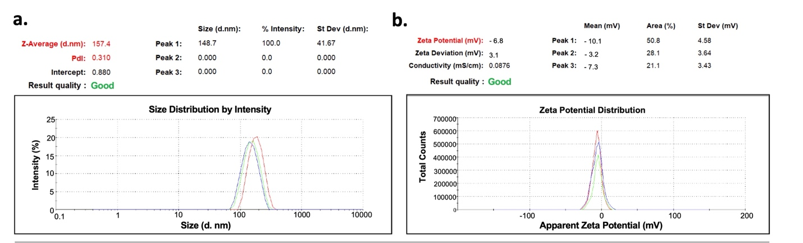

Figure S1. Characterization of Nic-SMEDDS particles by Dynamic Light Scattering. (a) Particle size of Nic-SMEDDS is an average 157.4 nm; (b) Surface charge (ζ potential) of Nic-SMEDDS is -6.8mV. The Nic-SMEDDS formulation was diluted 1:100 (%v/v) with deionized water before measurements.

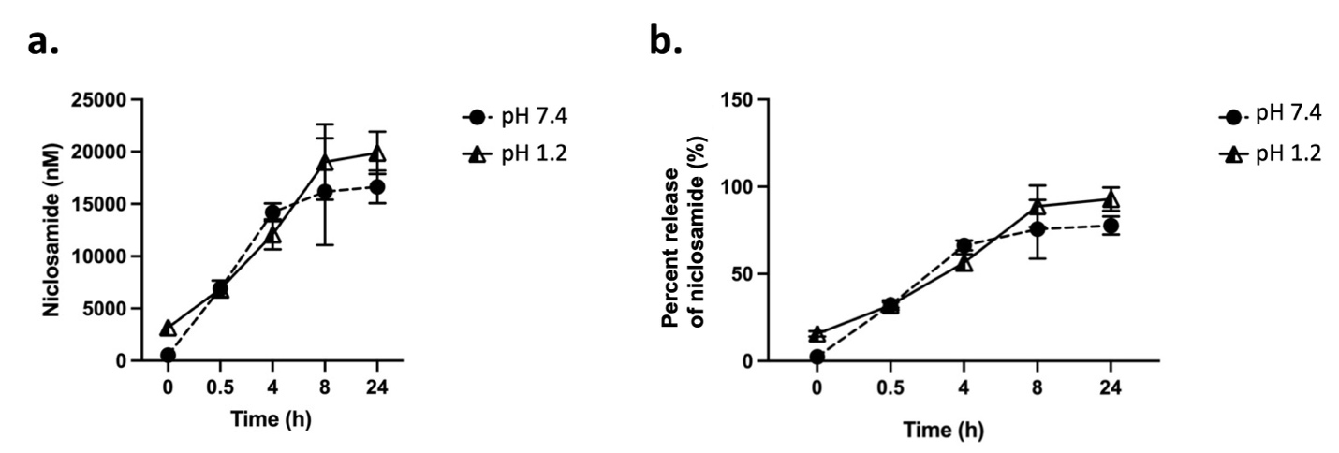

Figure S2. In vitro release of niclosamide from Nic-SMEDDS. (a). Niclosamide concentrations detected from the release media and its cumulative release profile over time from Nic-SMEDDS at pH 7.4 and pH 1.2 (n = 3, data were plotted as mean ± SEM). (b). The total amount of niclosamide released, expressed as percentage of the total amount loaded in the Nic-SMEDDS: 77.7 ± 5.16% (pH 7.4), and 92.89 ± 6.68% (pH 1.2) within 24 h.

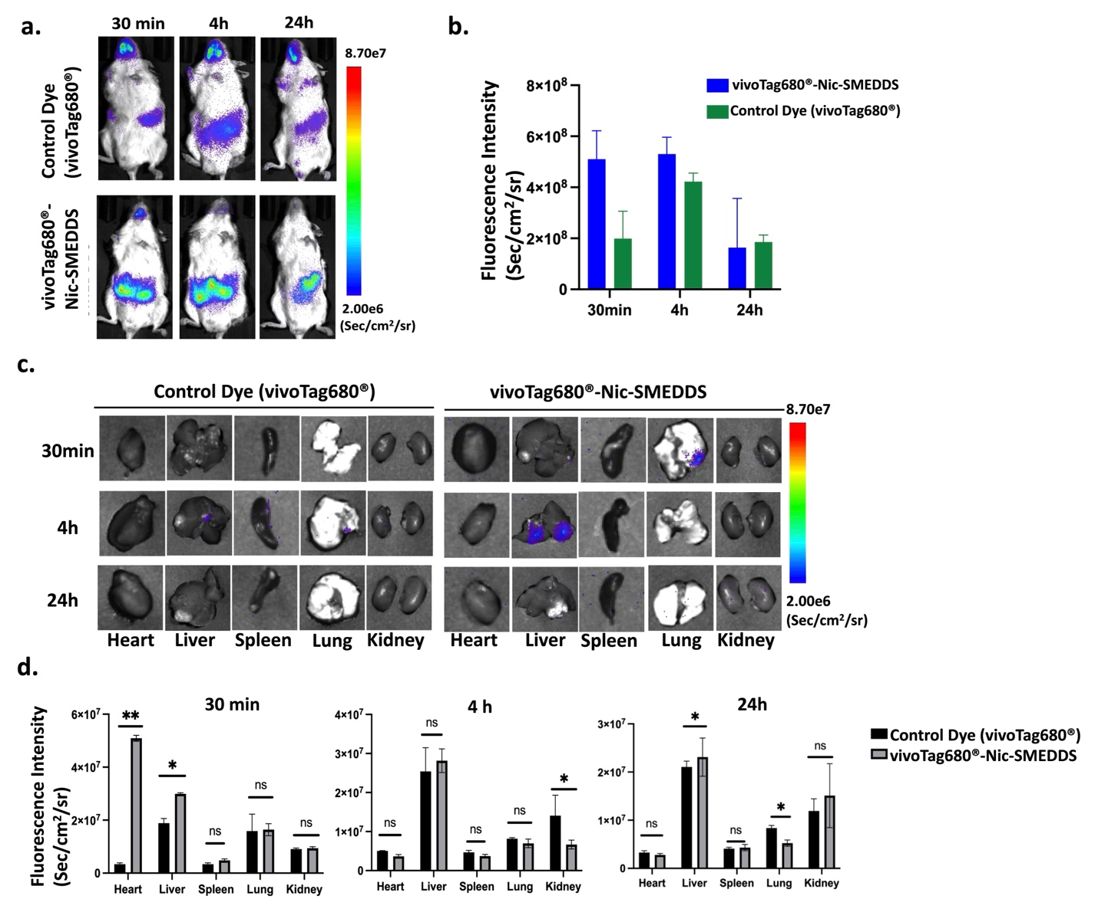

Figure S3. In vivo biodistribution and organ accumulation of Nic-SMEDDS. (a) vivoTag680®-Nic-SMEDDS was orally administered to NSG mice, and IVIS imaging was done at 30 min, 4 h, and 24 h after. (b) Quantitative analysis of vivoTag680® fluorescence signals from (a). (c) Ex vivo images of mouse organs and tumors were taken by the IVIS imaging 48 hours post-injection of vivoTag680®-labeled-Nic-SMEDDS. (d) vivoTag680® fluorescence signals quantified from (c). Data were plotted as mean ± SEM (n = 3), one-way ANOVA was used for statistical analysis; * denotes p < 0.05; ** denotes p < 0.01; ns denotes no significance.

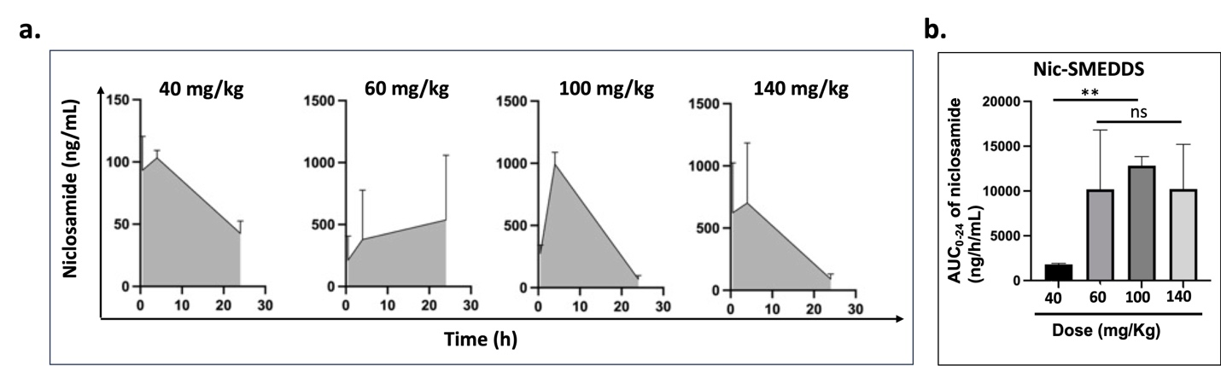

Figure S4. In vivo pharmacokinetics of Nic-SMEDDS at multiple dosages. (a) Plasma concentration of niclosamide following oral administration of Nic-SMEDDS at a single dose of 40, 60, 100, or 140 mg/kg (equivalent to molecular weight of NEN). (b) Analysis of the niclosamide AUC (0–24) achieved by different doses of Nic-SMEDDS (median ± SEM): 1803.1 ± 127.3 ng/h/mL for the 40 mg/kg group; 10193.2 ± 6622.1 ng/h/mL for the 60 mg/kg; 12818.6 ± 1023.4 ng/h/mL for 100 mg/kg group; and 10233.5 ± 4971.7 ng/h/mL for the 140 mg/kg group. Data were plotted as mean ± SEM (n = 3), ** denotes p < 0.01; ns denotes no significance.

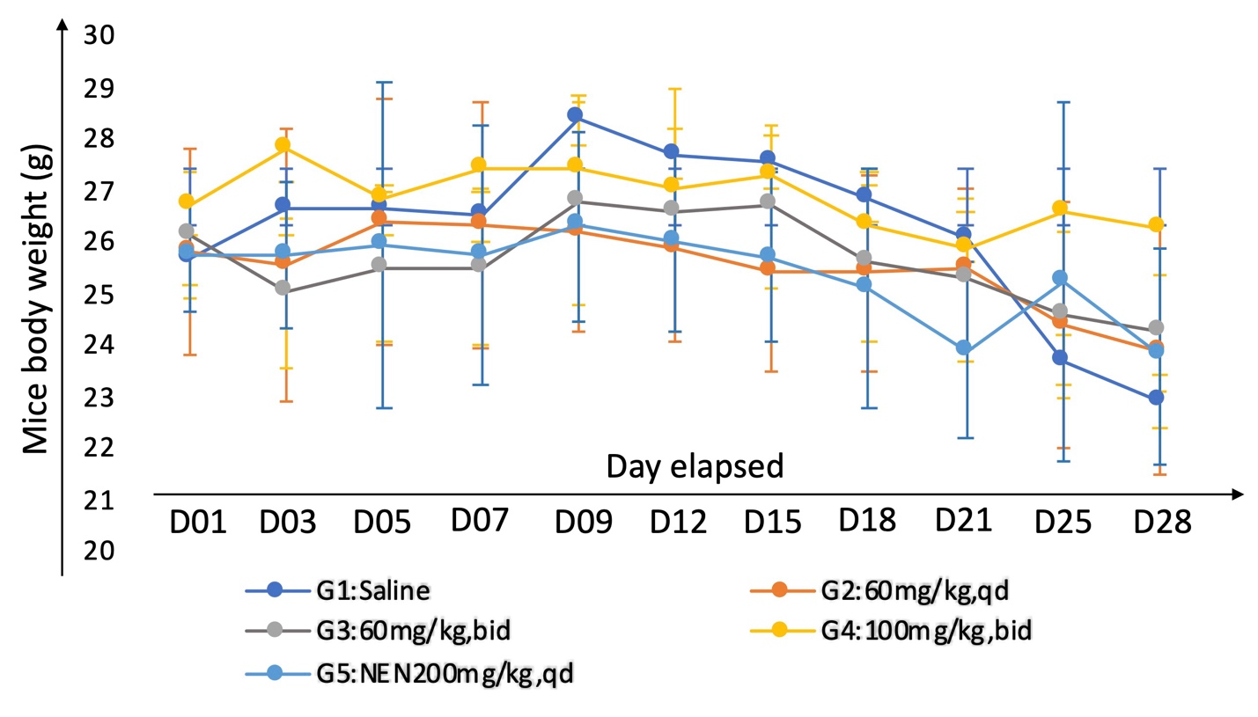

Figure S5. Mice body weight changes throughout the treatment period. Data were plotted as mean ± SD, n = 6.

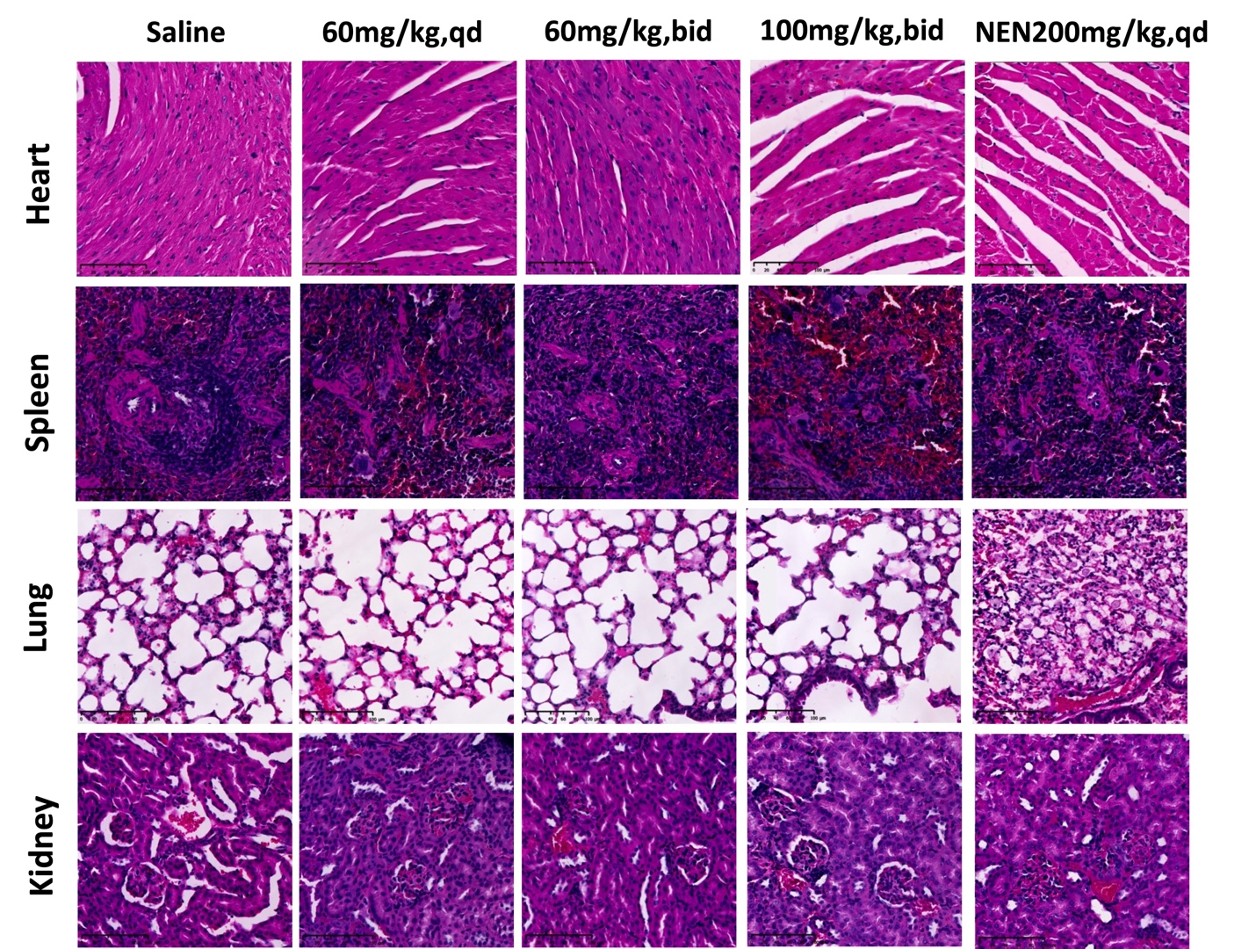

Figure S6. Histologic H&E-stained sections of major organs harvested from mice in each group at the end of the treatment period. While NEN at 200 mg/kg was associated with changes in the lung alveoli, no other discernible effects were observed in the Nic-SMEDDS treatment groups in any organ.

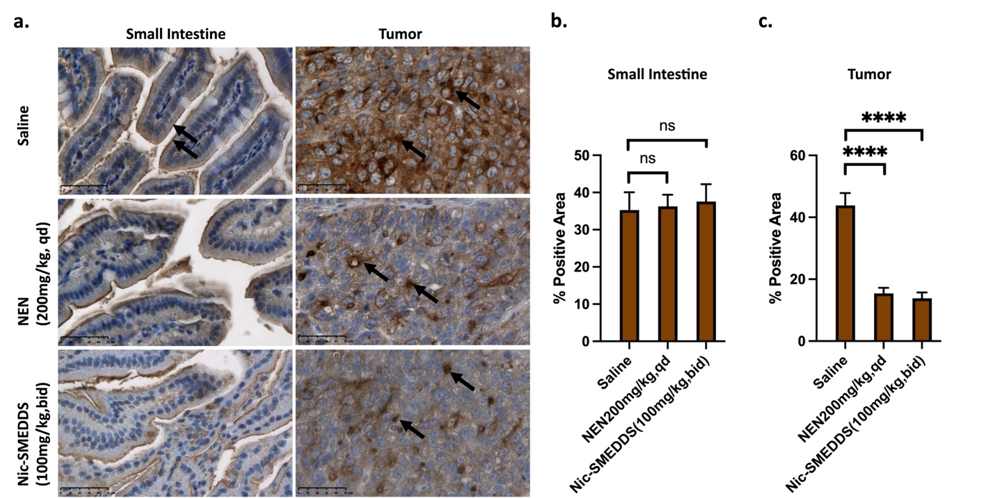

Figure S7. Representative immunohistochemical (IHC) staining of P-gp protein. (a) Expression and localization of P-gp in the small intestinal mucosa, and PDX tissue from the Nic-SMEDSS (100mg/kg, bid) and NEN (200mg/kg, equivalent to niclosamide, qd) groups. Saline-treated mice were used as the negative control. Black arrows indicate positive stains. Magnification: 40x, Scale: 50 µm). Quantitative analysis of positive P-gp staining in (b) small intestine (Threshold 115/158, detected area 739,689), and (c) PDX (Threshold 0/90, detected area 739,689) was performed using the Image J software. Data were plotted as mean ± SEM, n = 3. Statistical analysis using one-way ANOVA; **** denotes p < 0.0001; ns denotes no significance.

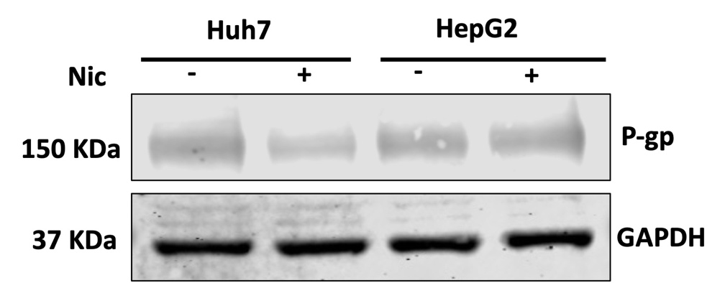

Figure S8. Detection of P-gp protein expression in HCC cell lines, Huh7 and HepG2. Cells were treated with 1 µM of niclosamide (Nic) for 48 h. GAPDH served as the internal loading control for immunoblotting analysis.

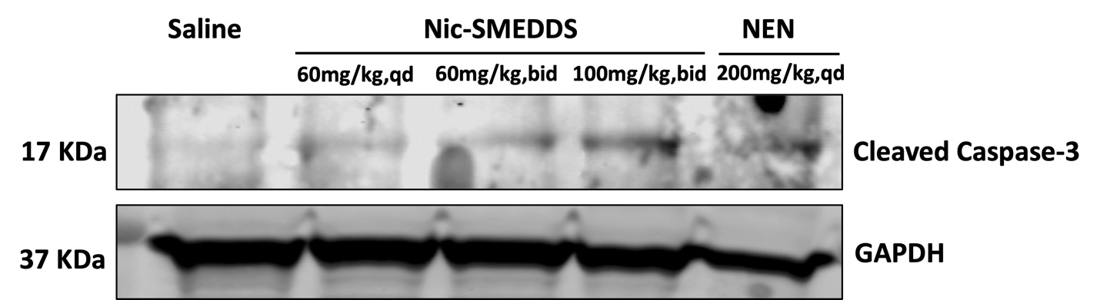

Figure S9. Detection of cleaved Caspase-3 protein expression in tumor tissues after different treatment conditions. Tumor tissues were harvested from in vivo efficacy study, and whole cell lysates extracted for immunoblotting analysis of cleaved Caspase-3 protein levels. GAPDH was used as the internal loading control.

