Supplementary materials
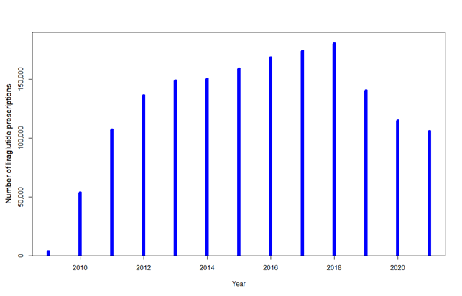
Figure S1. Number of prescriptions with liraglutide per year during the study period. Prescriptions are not unique per individual.
Table S1. Number of individuals with the SeHCAT test followed by a prescription with colestyramine, colestipol, or colesevelam within different time periods after the SeHCAT test
Time period | n
SeHCAT test + prescription within 1 month | 2,694
SeHCAT test + prescription within 3 months | 4,515
SeHCAT test + prescription within 6 months | 4,981
SeHCAT test + prescription within 1 year | 5,230
SeHCAT test + prescription with no time constraint | 6,379
SeHCAT, ⁷⁵selenium-homotaurocholic acid
Table S2. Liraglutide (ATC code: A10BJ02) prescriptions among individuals suffering from BAD (individuals diagnosed with ICD10 code K90.8B or a SeHCAT test followed by a prescription of bile acid sequestrant within 365 days). Individuals suffering from BAD may have bile acid sequestrant prescriptions before liraglutide prescription.
 | n
Individuals suffering from BAD with prescriptions of liraglutide both before and after the SeHCAT test, no time limit | 190
Individuals suffering from BAD with a prescription of liraglutide after the SeHCAT test, with no prior prescription of liraglutide | 248
Liraglutide prescriptions after SeHCAT test and after prescription with bile acid sequestrants, with no prescription of liraglutide before SeHCAT in non-unique individuals with BAD | 226
Liraglutide prescriptions after SeHCAT test and after prescription with colestyramine, with no prescription of liraglutide before SeHCAT in individuals with BAD | 161
Liraglutide prescriptions after the SeHCAT test and after prescription with colesevelam, with no prescription of liraglutide before SeHCAT in individuals with BAD | 58
Liraglutide prescriptions after SeHCAT test and after prescription with colestipol, with no prescription of liraglutide before SeHCAT in individuals with BAD | 7
ICD10, International Classification of Diseases Version 10; SeHCAT, ⁷⁵selenium-homotaurocholic acid

