Supplementary Materials for

Cold Exposure Alleviates T2DM Through Plasma-derived Extracellular Vesicles

Fu-Xing-Zi Li et al.

Corresponding author: Ling-Qing Yuan, allenylq@csu.edu.cn

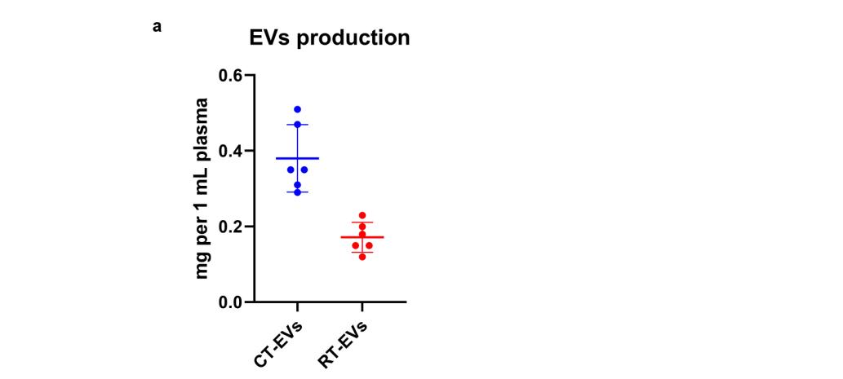

Fig S1. EVs prodution of 1 mL plasma from six different batches (P1, P2, P3, P4, P5 and P6). EVs production in CT-EVs or RT-EVs detected by BCA method.

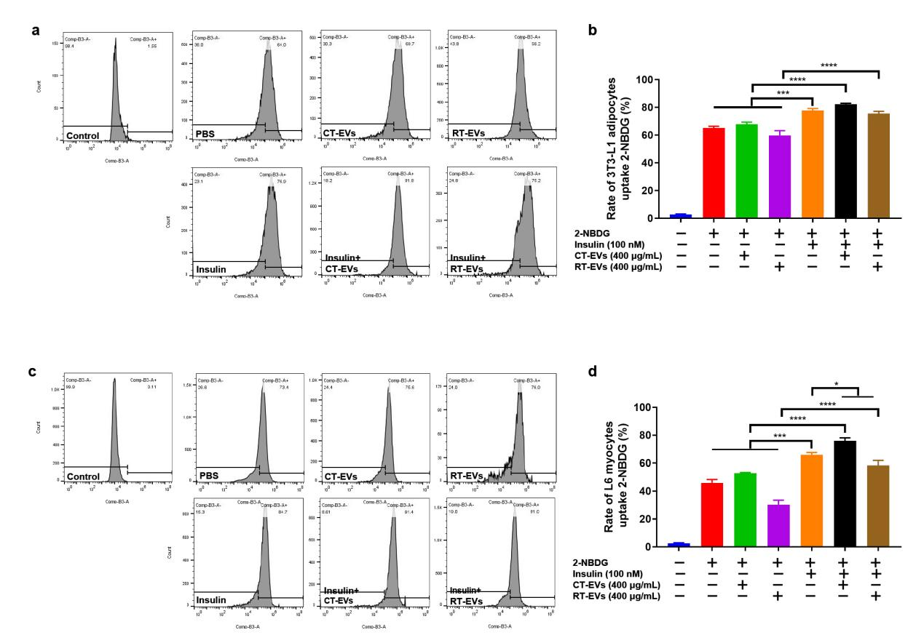

Fig S2. CT-EVs improved cellular insulin sensitivity in vitro. (a and c) Effects of CT-EVs on glucose uptake of 3T3-L1 adipocytes and L6 myocytes detected by flow cytometry. (b and d) Rate of cell uptake of 2-NBDG in different groups of 3T3-L1 adipocytes and L6 myocytes (n = 3). Statistical significance was calculated by a one-way ANOVA (c and d). ns > 0.05, *p < 0.05; **p < 0.01; ***p < 0.001; ****p < 0.0001.

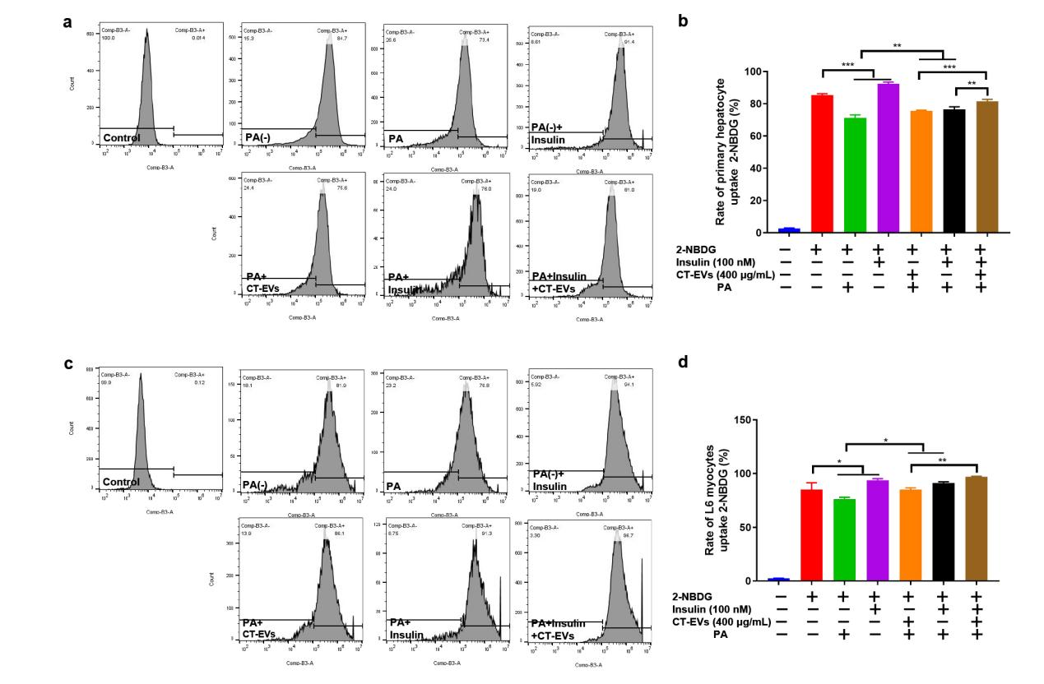

Fig S3. CT-EVs increased insulin sensitivity in a PA-induced insulin-resistant cell model. (a and c) Effects of CT-EVs on glucose uptake of PA-induced insulin-resistant primary hepatocytes and L6 myocytes model detected by flow cytometry. (b and d) Rate of cell uptake of 2-NBDG in different groups of PA-induced insulin-resistant primary hepatocytes and L6 myocytes (n = 3). Statistical significance was calculated by a one-way ANOVA (b and d). *p < 0.05; **p < 0.01; ***p < 0.001; ****p < 0.0001..

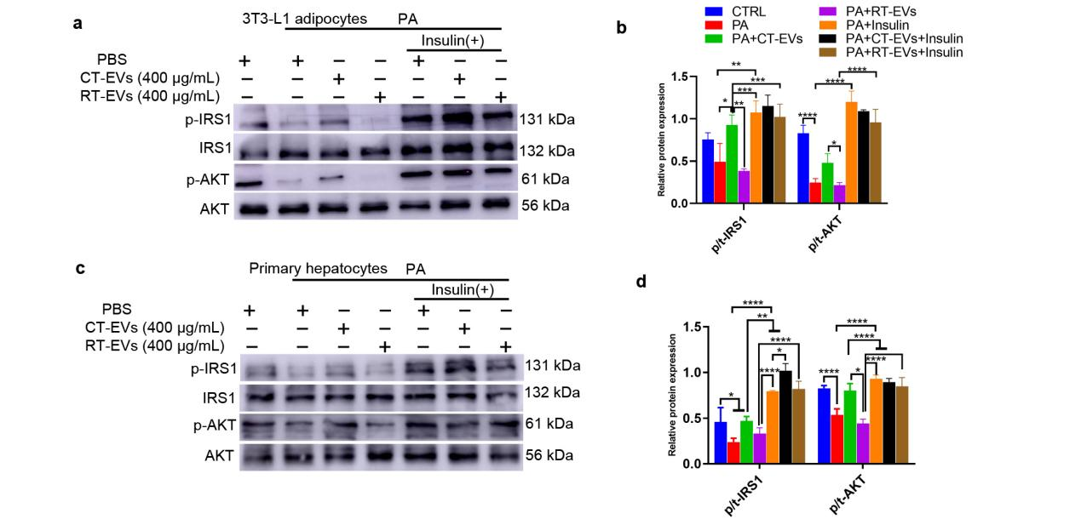

Fig S4. CT-EVs activated insulin/AKT signaling to promote insulin sensitivity. (a to d) Insulin stimulated IRS1 and AKT phosphorylation in PA-induced 3T3-L1 adipocytes and PA-induced primary hepatocytes treated with RT-EVs/CT-EVs as indicated (left, representative pictures of Western blot; right, quantitative measurements of p/t-IRS1 and p/t-AKT) (n = 3). Statistical significance was calculated by a one-way ANOVA (b and d). *p < 0.05; **p < 0.01; ***p < 0.001; ****p < 0.0001.

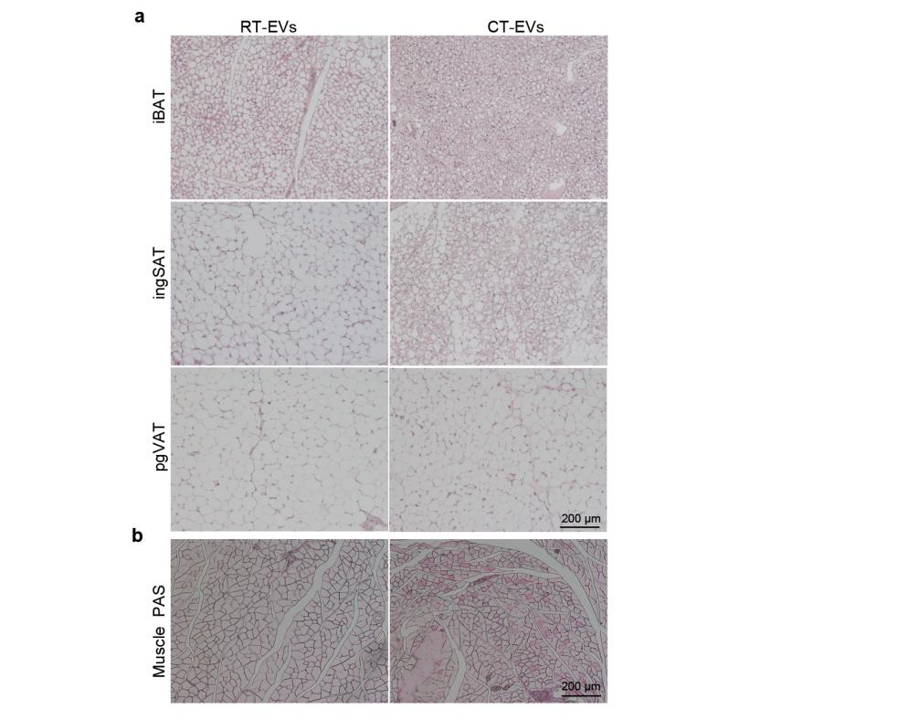

Fig S5. BAT/VAT HE staining and muscle PAS staining in RT-EVs or CT-EVs treated T2DM mice. (a) H&E staining on paraffin sections from iBAT, ingSAT, and pgVAT of RT-EVs or CT-EVs-administrated mice (n = 6, scale bar = 200 μm). (b) Representative images of PAS-stained muscle sections were observed under light microscopy (n = 4, scale bar = 200 μm).

