The Supplementary Information
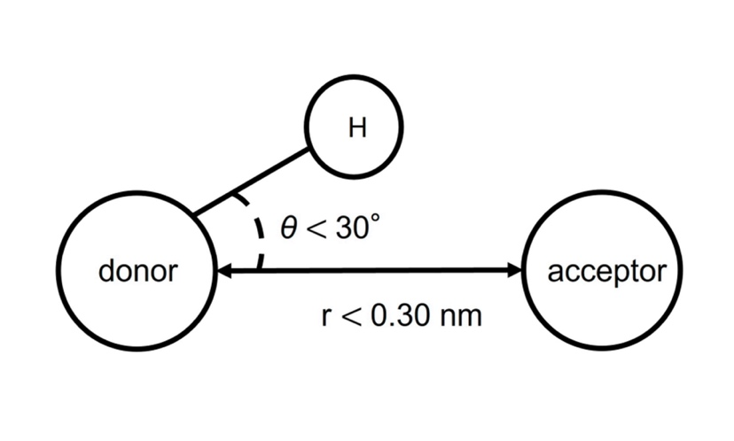
Supplementary Figure 1. Conditions for Calculating Hydrogen Bonding

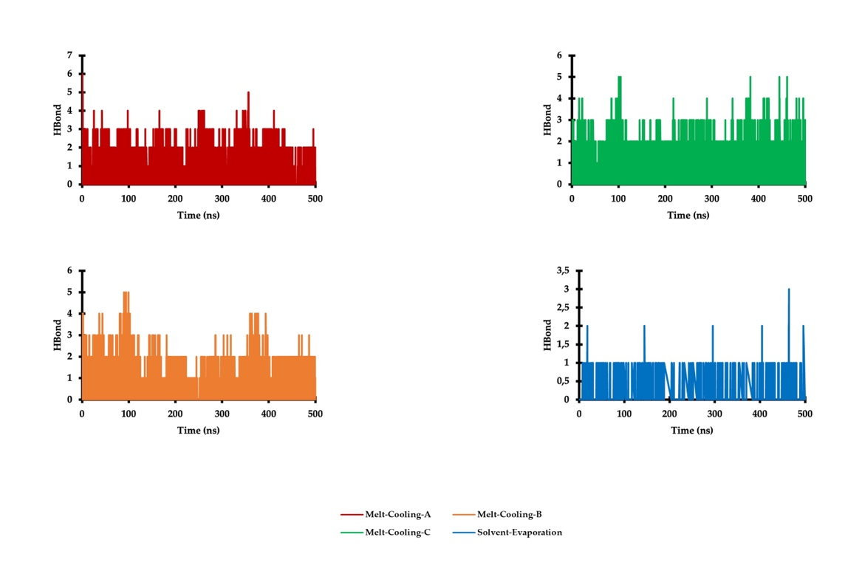
Supplementary Figure 2. Comparison of the Hydrogen Bond (H-bond) Graphs of the Complex System During Molecular Dynamics Simulations

Supplementary Table 1. The Molecular Docking Interaction between Ritonavir and Polymers
No | Polymer | Binding Energy (kcal/mol) | Hydrogen bond distance (Å)
1 | Hypromellose (HPMC) | -5.28 | 2.03
2 | Hypromellose phthalate (HPMCP) | -2.75 | 2.16
3 | Hypromellose acetate succinate (HPMCAS) | -2.25  -5.11 | 2.20  2.02
4 | Polyvinylpyrrolidone (PVP) | -4.16 | 2.03
5 | Polyvinyl acetate (PVA) | -5.84 | 1.99
6 | Co-povidone (PVPVA) | -3.28 | 2.00
7 | Eudragit | -5.06 | 2.07
8 | Polyvinyl acetate phthalate (PVAP) | -0.38  -4.78 | 2.00  2.14
9 | Methyl cellulose | -5.91  -3.53 | 1.99  1.99
10 | Ethyl cellulose | -3.05 | 2.16
11 | Natrium alginate | -5.59  -2.30 | 2.05  2.17
12 | Carbomer | -2.55 | 2.09
13 | PEG | -6.61 | 1.93
14 | Chitosan | -2.55  -3.28  -4.14  -0.60 | 2.20  1.86  2.07  2.17
15 | Water soluble chitin | -6.06 | 1.99
16 | Soluplus | -5.44 | 2.06
17 | Locust bean gum | -5.21 | 2.10
18 | Cellulose acetate phthalate (CAP) | -4.64 | 2.13
19 | Poloxamer 188 | -5.64  -5.58 | 2.10  1.98
20 | D-ɑ-tocopheryl polyethylene glycol succinate (TPGS) | -3.36 | 2.11
21 | 5-carboxypentyl hydroxypropyl cellulose (5-CHC) | -2.06  -7.84 | 2.13  1.78

Supplementary Table 2. Interaction Dynamics of the RTV and PLX During Molecular Dynamics Simulations
Melt-Cooling-A | Interaction | Category | Distance
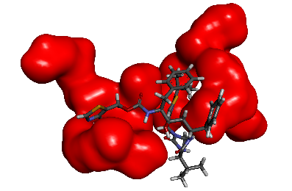  0 ns  Temperature: 0ºC  Hydrogen Bond: 7 interactions  Poloxamer: 4 molecules | RIT - POL9:O3  RIT - POL9:O3  POL15:H29 - RIT  POL23:H29 - RIT1:O6  RIT - POL23:O2  RIT - POL24:O3  POL23:H22 - RIT | Hydrogen Bond  Hydrogen Bond  Hydrogen Bond  Hydrogen Bond  Hydrogen Bond  Hydrogen Bond  Hydrogen Bond | 2.05 Å  3.02 Å  2.04 Å  1.89 Å  2.61 Å  2.89 Å  2.40 Å
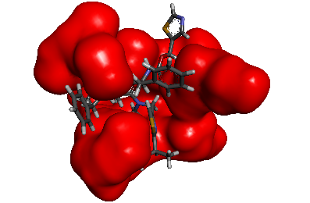  250 ns  Temperature: 140ºC  Hydrogen Bond: 15 interactions  Poloxamer: 7 molecules | RIT - POL9:O3  RIT - POL3:O3  POL3:H29 - RIT  POL13:H29 - RIT  POL20:H29 - RIT  RIT - POL20:O3  RIT - POL15:O3  RIT - POL11:O1  RIT - POL3:O2  POL11:H13 - RIT  POL11:H22 - RIT  POL13:H15 - RIT  POL18:H27 - RIT  POL18:H28 - RIT  POL20:H23 - RIT | Hydrogen Bond  Hydrogen Bond  Hydrogen Bond  Hydrogen Bond  Hydrogen Bond  Hydrogen Bond  Hydrogen Bond  Hydrogen Bond  Hydrogen Bond  Hydrogen Bond  Hydrogen Bond  Hydrogen Bond  Hydrogen Bond  Hydrogen Bond  Hydrogen Bond | 2.15 Å  2.13 Å  1.72 Å  2.27 Å  1.86 Å  2.27 Å  2.76 Å  2.98 Å  2.44 Å  2.59 Å  2.75 Å  2.64 Å  3.03 Å  2.97 Å  2.90 Å
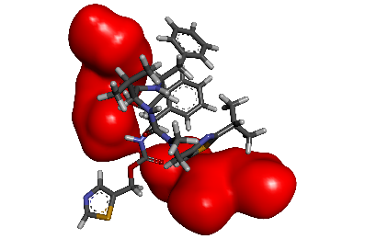  500 ns  Temperature: 0ºC  Hydrogen Bond: 2 interactions  Poloxamer: 2 molecules | POL11:H29 - RIT  POL26:H29 - RIT | Hydrogen Bond  Hydrogen Bond | 2.12 Å  2.34 Å

Supplementary Table 2. Interaction Dynamics of the RTV and PLX During Molecular Dynamics Simulations (Cont.)
Melt-Cooling-A | Interaction | Category | Distance
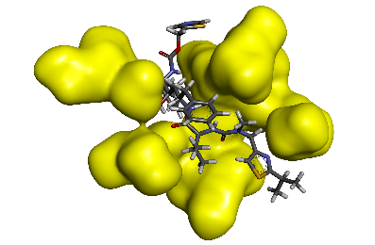  0 ns  Temperature: 0ºC  Hydrogen Bond: 11 interactions  Poloxamer: 7 molecules | RIT - POL26:O3  POL20:H29 - RIT  POL24:H29 - RIT  RIT - POL24:O3  RIT - POL14:O2  RIT - POL4:O3  POL14:H12 - RIT  POL20:H23 - RIT  POL22:H22 - RIT  POL25:H22 - RIT  POL26:H14 - RIT | Hydrogen Bond  Hydrogen Bond  Hydrogen Bond  Hydrogen Bond  Hydrogen Bond  Hydrogen Bond  Hydrogen Bond  Hydrogen Bond  Hydrogen Bond  Hydrogen Bond  Hydrogen Bond | 2.16 Å  2.04 Å  2.07 Å  2.55 Å  2.85 Å  2.74 Å  2.63 Å  2.56 Å  2.64 Å  2.79 Å  2.64 Å
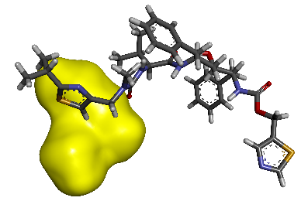  250 ns  Temperature: 140ºC  Hydrogen Bond: 1 interaction  Poloxamer: 1 molecule | POL8:H13 - RIT | Hydrogen Bond | 2.67 Å
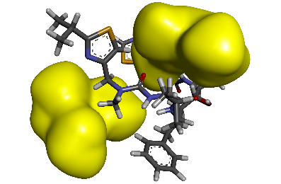  500 ns  Temperature: 0ºC  Hydrogen Bond: 7 interactions  Poloxamer: 2 molecules | RIT - POL4:O3  POL4:H29 - RIT  RIT - POL18:O1  RIT - POL18:O3  POL4:H14 - RIT  POL4:H27 - RIT  POL4:H28 - RIT | Hydrogen Bond  Hydrogen Bond  Hydrogen Bond  Hydrogen Bond  Hydrogen Bond  Hydrogen Bond  Hydrogen Bond | 1.99 Å  2.01 Å  2.52 Å  2.75 Å  2.45 Å  2.91 Å  2.99 Å

Supplementary Table 2. Interaction Dynamics of the RTV and PLX During Molecular Dynamics Simulations (Cont.)
Melt-Cooling-A | Interaction | Category | Distance
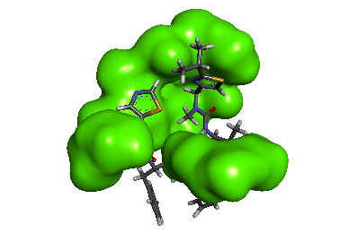  0 ns  Temperature: 0ºC  Hydrogen Bond: 13 interactions  Poloxamer: 6 molecules | RIT - POL20:O3  RIT - POL10:O2  RIT - POL3:O3  POL2:H29 - RIT  POL10:H29 - RIT  POL19:H29 - RIT  RIT - POL10:O2  RIT - POL3:O3  RIT - POL9:O1  RIT - POL2:O3  POL3:H28 - RIT  POL19:H28 - RIT  POL20:H23 - RIT | Hydrogen Bond  Hydrogen Bond  Hydrogen Bond  Hydrogen Bond  Hydrogen Bond  Hydrogen Bond  Hydrogen Bond  Hydrogen Bond  Hydrogen Bond  Hydrogen Bond  Hydrogen Bond  Hydrogen Bond  Hydrogen Bond | 1.89 Å  1.97 Å  2.11 Å  2.68 Å  1.98 Å  1.75 Å  2.58 Å  2.60 Å  2.49 Å  2.57 Å  2.49 Å  2.80 Å  2.33 Å
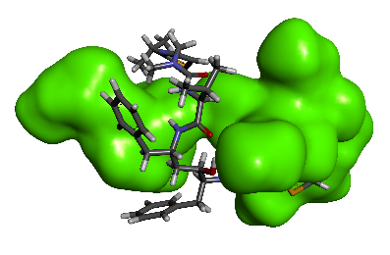  250 ns  Temperature: 140ºC  Hydrogen Bond: 7 interactions  Poloxamer: 5 molecules | RIT - POL7:O3  POL17:H29 - RIT  RIT - POL20:O2  X: POL17:H16 - RIT  X: POL17:H28 - RIT  X: POL21:H22 - RIT  X: POL18:H29 - RIT | Hydrogen Bond  Hydrogen Bond  Hydrogen Bond  Hydrogen Bond  Hydrogen Bond  Hydrogen Bond  Hydrogen Bond | 2.37 Å  1.84 Å  2.40 Å  2.98 Å  2.82 Å  2.66 Å  2.81 Å
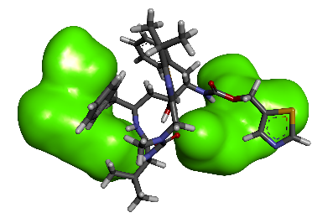  500 ns  Temperature: 0ºC  Hydrogen Bond: 6 interactions  Poloxamer: 2 molecules | RIT - POL17:O2  POL17:H29 - RIT  RIT - POL17:O3  POL17:H12 - RIT  POL17:H27 - RIT  POL21:H27 - RIT | Hydrogen Bond  Hydrogen Bond  Hydrogen Bond  Hydrogen Bond  Hydrogen Bond  Hydrogen Bond | 2.67 Å  1.76 Å  2.62 Å  2.69 Å  2.85 Å  2.96 Å

Supplementary Table 2. Interaction Dynamics of the RTV and PLX During Molecular Dynamics Simulations (Cont.)
Melt-Cooling-A | Interaction | Category | Distance
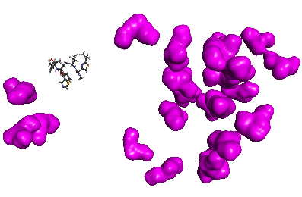  0 ns  Temperature: 0ºC  Hydrogen Bond: 0 interaction  Poloxamer: 0 molecule | - | - | -
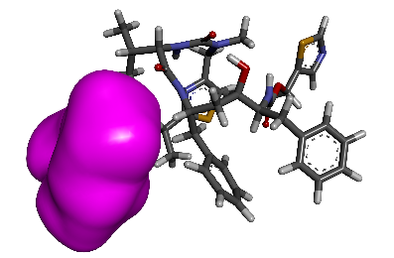  50 ns  Temperature: 20ºC  Hydrogen Bond: 1 interaction  Poloxamer: 1 molecule | POL741:H27 - RIT | Hydrogen Bond | 2.66 Å
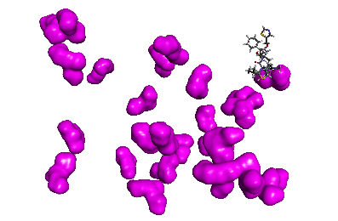  200 ns  Temperature: 80ºC  Hydrogen Bond: 0 interaction  Poloxamer: 0 molecule | - | - | -

