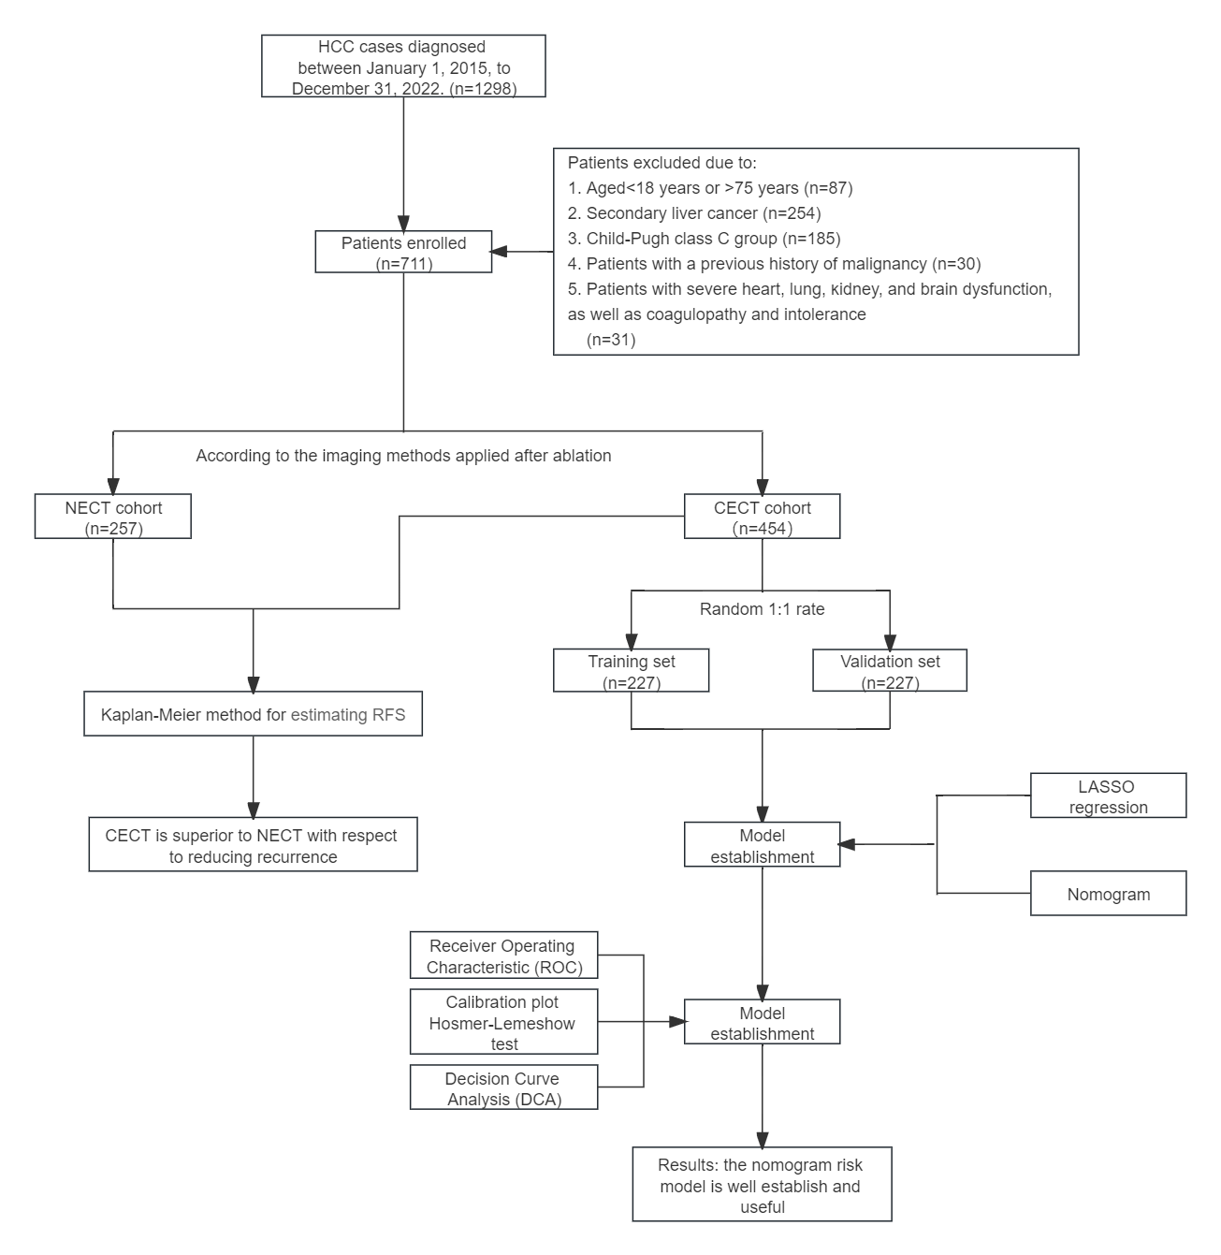

Figure S1 Flow chart of the patients included in the study.
Abbreviations: HCC, hepatocellular carcinoma; CECT, contrast-enhanced computed tomography; NECT, non-enhanced computed tomography; KM, Kaplan-Meier curve; RFS, recurrence-free survival;

