Supporting Information

Supplementary Figure S1. Characterization of HUVECs. （A）The morphology of endothelial cells. Scale bar=200 μm. (B) Flow cytometry analysis of marker of endothelial cells, CD31.
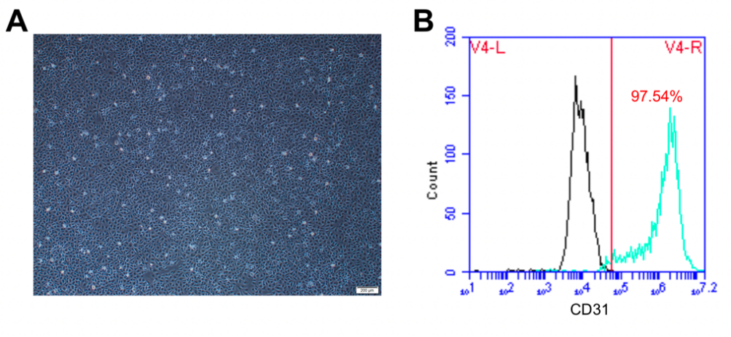
Supplementary Table S1. Primers for qRT-PCR.
Target cDNA | Primer sequence (5’-3’)
human-GAPDH | CTTTGGTATCGTGGAAGGACTC  GTAGAGGCAGGGATGATGTTCT
human-CD31 | TCGTGGTCAACATAACAGAACT  TTGAGTCTGTGACACAATCGTA
human-VEGF | AGGGAAGAGGAGGAGATGAG  GCTGGGTTTGTCGGTGTT
human-angiogenin | ACCCTCACAGAGAAAACCTAAG
human-angiogenin | GACGACGGAAAATTGACTGATC
human-Col 1 | AACATGGAGACTGGTGAGACCT  CGCCATACTCGAACTGGAATC
human-Col 3 | CTTCTCTCCAGCCGAGCTTC  TGTGTTTCGTGCAACCATCC

