SUPPLEMENTARY MATERIALS
PEGylated SOCS3 mimetics encapsulated into PLGA-NPs as selective inhibitors of JAK/STAT pathway in TNBC cells
Sara La Manna¹, Alessia Cugudda¹, Flavia Anna Mercurio², Marilisa Leone², Sara Fortuna³, Concetta Di Natale⁴, Elena Lagreca⁴, Paolo Antonio Netti⁴, Valeria Panzetta⁴ and Daniela Marasco¹

¹Department of Pharmacy, CIRPEB: Research Center on Bioactive Peptides- University of Naples Federico II, 80131, Naples, Italy; ²Institute of Biostructures and Bioimaging (CNR), Via Pietro Castellino 111, 80131, Naples, Italy; ³Italian Institute of Technology (IIT), Via Melen 83, B Block, 16152, Genova, Italy; ⁴Department of Ingegneria Chimica del Materiali e della Produzione Industriale (DICMAPI), University of Naples Federico II, 80125, Naples, Italy.

Correspondence: Daniela Marasco
Tel +39-081-2532043
Email daniela.marasco@unina.it

Table S1: Names and sequences of KIRCONG chim analogues and dissociation constants (K_{D}) values of the affinity of SOCS3 peptidomimetics toward JAK2. Residues belonging to different SOCS3 regions are colored in blue (restKIR), and orange (CONG). Control sequences are also reported.
Name | Sequence | K_{D} (µM)
KIRCONG chim | KβAlaF²⁵SSKSEYQL³³-βAlaβAla-F⁴⁶YWSAVT⁵² | 11±3*
KIRCONG chim PEG | KβAlaF²⁵SSKSEYQL³³-PEG-F⁴⁶YWSAVT⁵² | (4±2)*10
Ctrl PEG | βAla-G-βAla-QL-PEG-AAFAARA
Ctrl PEG-Val | βAla-G-βAla-QL-PEG-AAFAARAV
*¹

Table S2: Deconvolution of CD spectra reported in Figure 1 E, obtained with BESTSEL software.
TFE % | Helix | βETA | Turn | Others
0 | 1.8 | 29.4 | 13.9 | 54.9
5 | 1.1 | 30.3 | 14.7 | 53.9
15 | 0.3 | 38.7 | 12.8 | 48.2
25 | 0.0 | 39.9 | 15.0 | 45.0
35 | 0.0 | 41.1 | 13.5 | 45.4
45 | 2.9 | 42.3 | 13.9 | 40.9
55 | 4.8 | 35.7 | 13.5 | 46.0
65 | 4.9 | 31.4 | 13.0 | 50.7

Table S3: ¹H chemical shifts of KIRCONG chim PEG peptide in sodium phosphate buffer/TFE (50/50, v/v) and t=25°C. BAL refers to β-Alanine residue. N.D. stands for not determined.
Residue | HN | Hα | Hβ | Hγ | Others
1K | 7.88 | 4.26 | 1.79 | 1.44 | δ 1.72  ε 3.00
2BAL | 7.93 | 2.44-2.51 | 3.42
3F | 7.98 | 4.62 | 3.03-3.18 |  | δ 7.26  ε 7.35
4S | N.D. | N.D. | N.D.
5S | N.D. | N.D. | N.D.
6K | N.D. | 4.41 | 1.93 | 1.48 | δ 1.71  ε 3.01
7S | N.D. | N.D. | N.D.
8E | 8.65 | 4.24 | 1.94-1.99 | 2.19
9Y | 7.84 | 4.64 | 2.96 |  | δ 7.13  ε 7.24
10Q | 8.15 | 4.41 | 1.84 | 2.08-2.25 | ε 6.63-7.30
11L | 7.89 | 4.39 | 1.61 | 1.60 | 0.85
12PEG | 8.03 |  |  |  | 3.07-3.11-3.50-3.58-3.90
13F | 7.84 | 4.63 | 2.93-3.07 |  | δ 7.05-7.07  ε 6.83
14Y | 7.84 | 4.76 | 2.88-2.92 |  | δ 6.92  ε 6.75
15W | 7.99 | 4.69 | 3.30 |  | Hε₁ 9.71  Hδ₁ 7.13  Hη₂ 7.22  Hε₃ 7.52  Hζ₃ 7.14  Hζ₂ 7.41
16S | 7.71 | 4.31 | 4.13
17A | 8.00 | 4.30 | 1.44
18V | 7.76 | 4.13 | 2.18ev | 0.97-1.01
19T | 7.71 | 4.35 | 4.30 | 1.20 | CONH₂  6.97-7.26

Figure S1. NMR studies of KIRCONG chim PEG peptide in sodium phosphate buffer H₂O/D₂O 90/10 v/v. (A) H_{N}-aromatic/aliphatic regions of 2D [¹H,¹H] TOCSY (left panel) and NOESY 300 (right panel) spectra. (B) A detail of the KIRCONG chim PEG peptide NOESY 300 spectrum where the Trp HE1 region and contacts with the nearest Trp aromatic protons can be seen.

Figure S2. NMR studies of KIRCONG chim PEG in sodium phosphate buffer/TFE mixture. (A) Comparison of 1D [¹H] NMR spectra of KIRCONG chim (lower spectrum) (H₂O/TFE 60/40 v/v); and its PEGylated analogue (upper spectrum) (H₂O/TFE 50/50 v/v); backbone H_{N} and aromatic proton regions are evidenced by rectangles. (B) 2D [¹H,¹H] TOCSY (left panel) and ROESY (right panel) spectra of KIRCONG chim PEG: the H_{N}-aromatic/aliphatic regions are shown. (C) ROE pattern obtained from 2D ROESY analysis; “d_{xy}(i,i+z)” indicates a cross-peak between "x" and "y" protons in residues “i” and “i+z”, respectively; the thickness of the bars is proportional to the distance between protons. In the amino acid sequence shown on top X indicates the PEG moiety and B the β-Alanine residue.

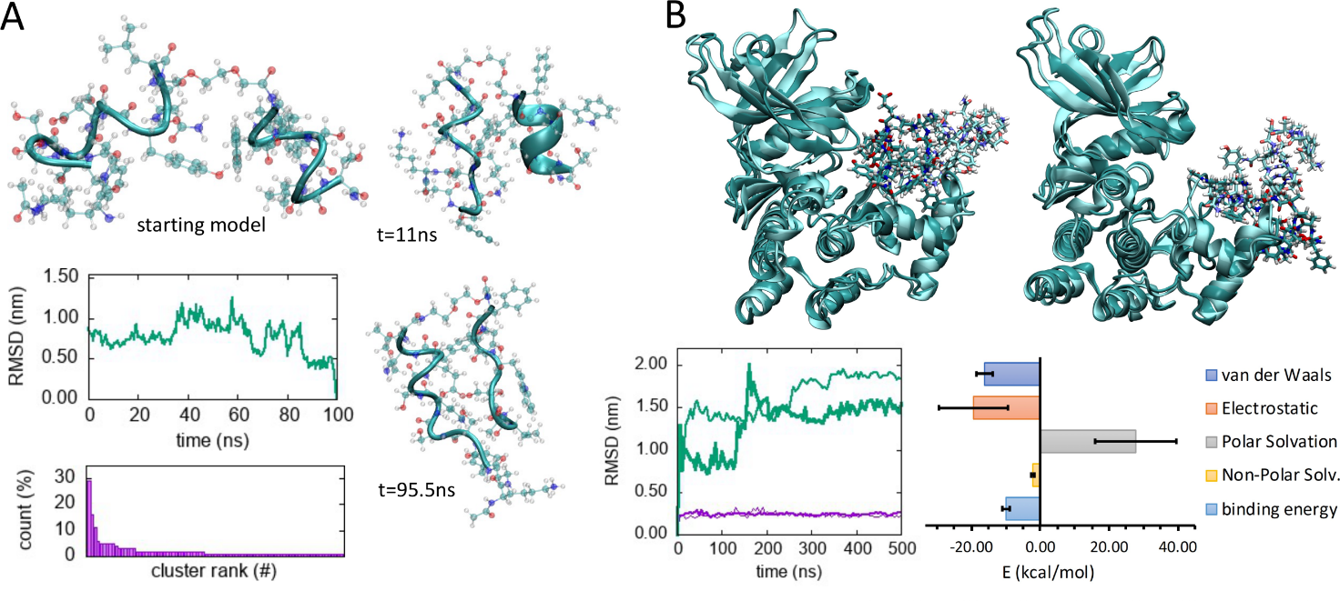
Figure S3. Simulation results. (A) free KIRCONG chim PEG peptide: starting model; peptide root mean squared deviation (RMSD) calculated over a 100ns long molecular dynamics (MD) trajectory; conformational clustering; and two conformations representing the largest conformational cluster (t=11ns) and the second larger conformational cluster (t=95.5ns). (B) KIRCONG chim PEG peptide docked to JAK2: comparison between two equilibrated conformations (lighter color) and those obtained after 500ns of MD; RMSD calculated over the two 500ns long MD runs for the peptides (this/fine green line) and protein (thick/fine purple line); average MMPBSA based free energy of binding split into its components, averages and error bars have been calculated over the two independent MD runs. In all snapshots, water molecules and ions have been removed for ease of interpretation.

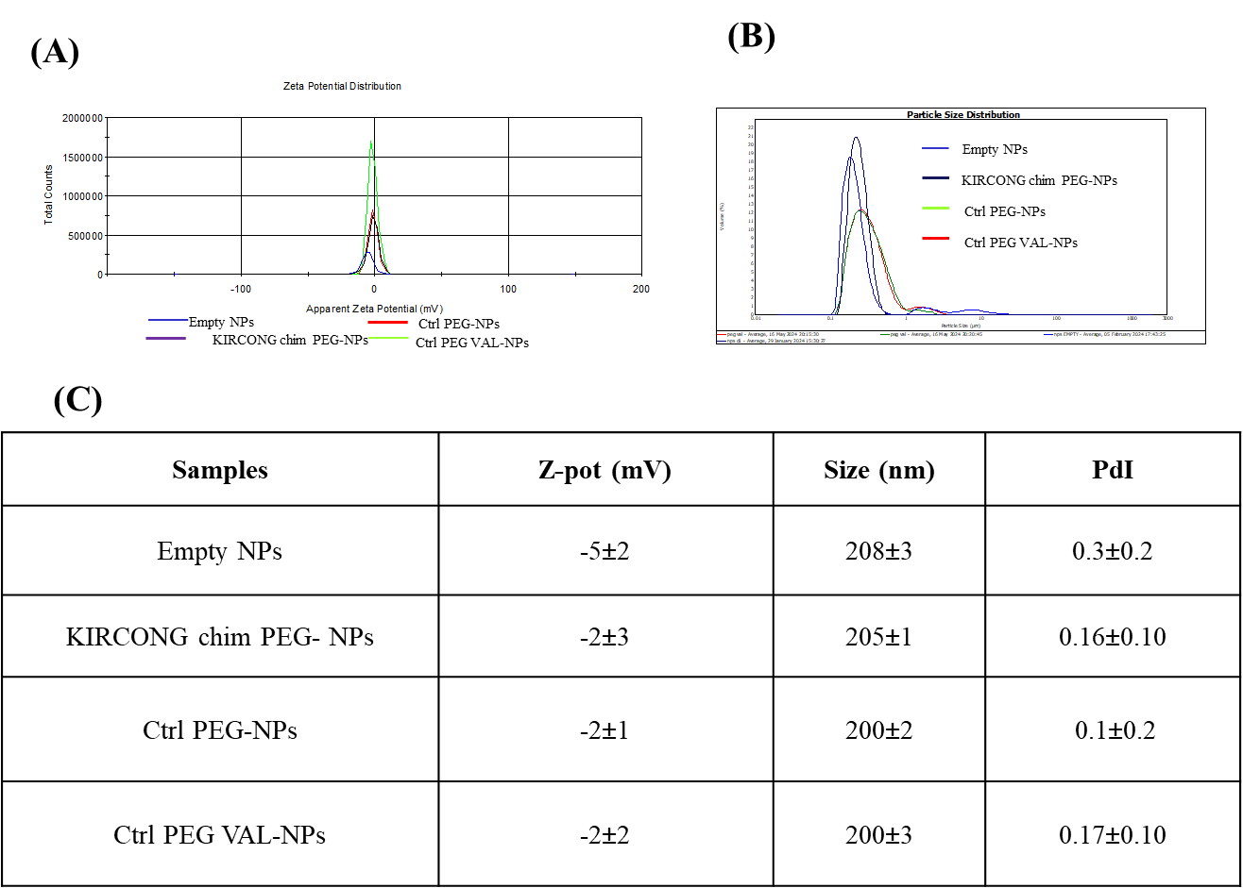
Figure S4. Chemical physical characterization of peptide-NPs by Static Light Scattering. A) zeta potential distribution, B) size distribution obtained by light scattering, C) Summary of all parameters obtained by SLS.

Figure S5. In vitro releases of KIRCONG chim PEG and Controls PEG from PLGA-NPs at different time points.

Figure S6. Representative confocal images KIRCONG chim PEG (red, A), lysosomes (green, B) and merged red and green channels (yellow, C) in MDA-MB-231 cells. Colocalization between red and green channels is calculated as percentage of yellow region (KIRCONG chim PEG contained into lysosomes) respect to lysosomes area per cell. Data are reported as mean ± standard deviation.

1. La Manna S, Lopez-Sanz L, Mercurio FA, et al. Chimeric peptidomimetics of SOCS 3 able to interact with JAK2 as anti-inflammatory compounds. ACS medicinal chemistry letters. 2020;11(5):615-623.

