Supporting Information

Iron-based nanovehicle delivering Fin56 for hyperthermia-boosted ferroptosis therapy against osteosarcoma

Yiran Zhang^{1,2,3,6*}, Qingcheng Song^{2,3*}, Yueyao Zhang^{2,3*}, Jiheng Xiao⁴, Xiangtian Deng⁵, Xin Xing^{2,3}, Hongzhi Hu^{4#}, Yingze Zhang^{1,2,3#}

¹School of Medicine, Nankai University, Tianjin, 300071, China.
²Department of Orthopaedic Surgery, Third Hospital of Hebei Medical University, Shijiazhuang, 050051, Hebei, China
³NHC Key Laboratory of Intelligent Orthopaedic Equipment, Third Hospital of Hebei Medical University, Shijiazhuang, Hebei, China.
⁴Department of Orthopaedics, Union Hospital, Tongji Medical College, Huazhong University of Science and Technology, Wuhan 430022, China
⁵Orthopaedics Research Institute, Department of Orthopaedics, West China Hospital, Sichuan University
⁶HeBei Ex&Invivo Biotechnology Co. Ltd, Shijiazhuang, 050051, Hebei, China

*These authors contributed equally to this work
#Correspondence:
Yingze Zhang, E-mail: yzling_liu@163.com
(First Corresponding author);
Hongzhi Hu, E-mail: 13720105746@163.com

Figure S1 Characterizations of as-prepared NPs. (A) Zeta potential of Fe₃O₄, FS, FSR and FSR-Fin56 NPs; (B) FT-IR spectra of Fe₃O₄, RGD, FS and FSR. Black arrow indicates the stretching vibration peak of Si-O-Si at 1085 cm⁻¹. Blue arrow indicates the peak of surface-bound hydroxyl groups at 3300cm-1. Red arrow indicates the characteristic amide peak of RGD. (C) Hydrodynamic size of GCMMR NPs in various media over 7 days. (D) Photothermal stability curve of FSR NPs following on/off NIR laser irradiation (1.0 W cm⁻²) for 5 cycles.

Figure S2 The Biosafety evaluation by biochemical indexes of healthy mice (A, C) and mice after treatment of FSR-Fin56 (B, D). The aminotransferase (ALT) and aminotransferase (AST) reflect the liver function of the mice. The blood urea nitrogen (BUN) and creatinine (CREA) reflect the kidney function of the mice.

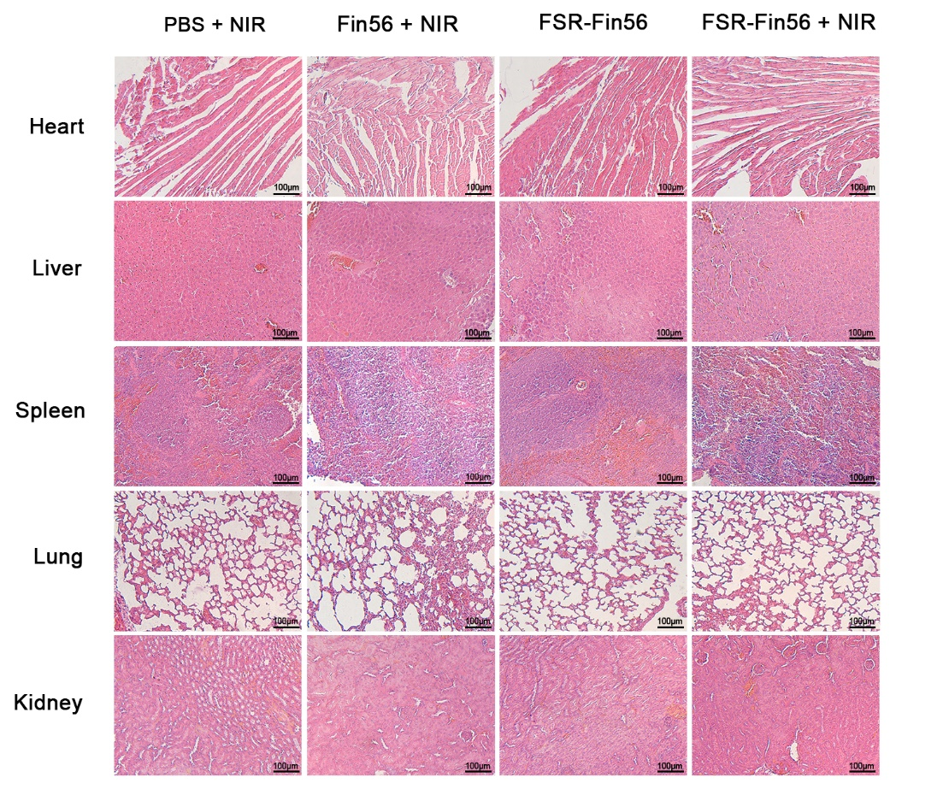
Figure S3 H&E staining images of dissected major organs (heart, liver, spleen, lung, kidney) of MNNG/HOS tumor-bearing mice after corresponding treatments.

