Supporting information

Glutathione depletion-induced ROS/NO generation for cascade breast cancer therapy and enhanced anti-tumor immune response

Jing Wang^{1#}, Yanxiang Sang^{2,#}, Weijian Chen³, Liang Cheng², Wenxiang Du², Hongjie Zhang², Benyan Zheng²,Lei Song², Yuan Hu^{2*}and Xiaopeng Ma^{1*}

1 Department of General Surgery, The First Affiliated Hospital of USTC, Division of Life Sciences and Medicine, University of Science and Technology of China, Hefei, Anhui, 230001, P.R. China.
2 State Key Laboratory of Fire Science, University of Science and Technology of China, Hefei, Anhui, 230006, P.R. China.
3 Technology Center, China Tobacco Anhui Industrial Co.,Ltd., Hefei, Anhui, 230088, P.R. China.

# These authors contributed equally to this study.

*Corresponding Authors:
Yuan Hu, Email: yuanhu@ustc.edu.cn
Xiaopeng Ma, Email: XiaopengMa@fsyy.ustc.edu.cn

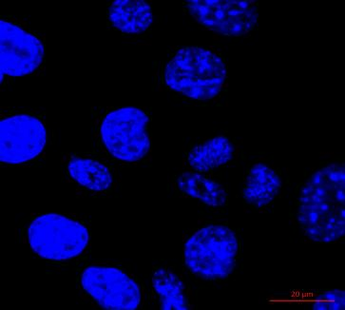
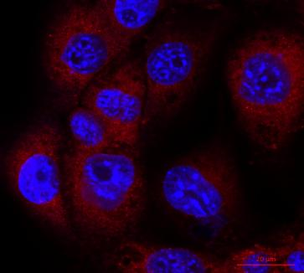
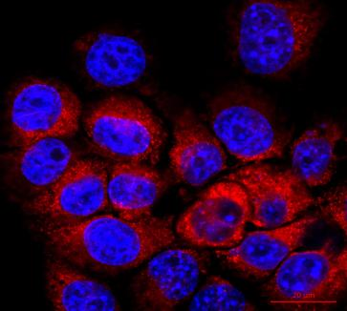
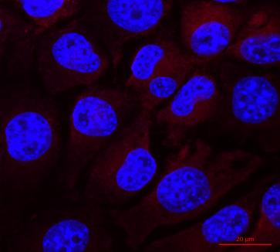
0h
1h
2h
4h

DAPI/Rho-6G

Figure S1 Confocal microscopy images of 4T1 cells treated with Rho-6G loaded BP NSs (5μg/ml) for 1h, 2h, 4h, respectively. Red and blue indicate Rho6G fluorescence and DAPI-stained nuclear fluorescence. (scale bars, 20μm).

Figure S2 The quantitative analysis of cellular internalization of Rhodamine 6G loaded BP NSs in 4T1 cells at 1 h, 2 h, and 4 h respectively.

Figure S3 The quantitative analysis of ROS fluorescence intensity in control, BP, BC, BCL, BCL plus US groups. Data are shown as mean ± SD (n = 3). ****p < 0.0001.
Figure S4 The quantitative analysis of NO fluorescence intensity in control, BP, BC, BCL, BCL plus US groups. Data are shown as mean ± SD (n = 3). ***p < 0.001. ****p < 0.0001.

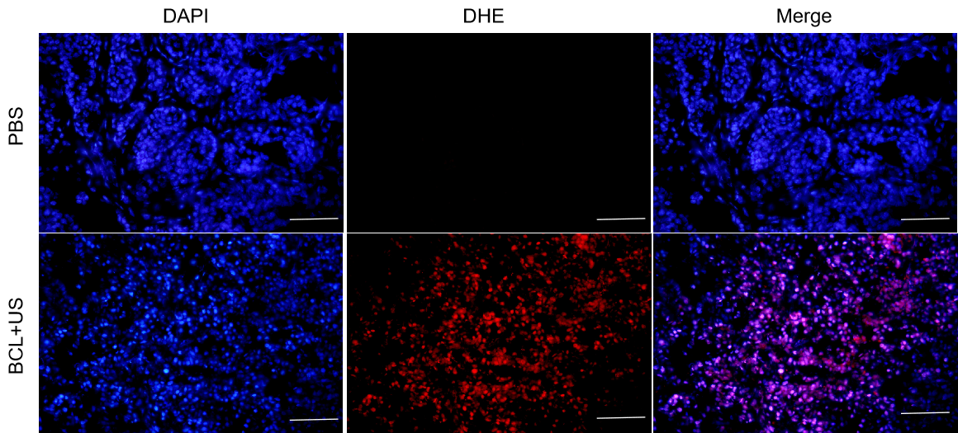
Figure S5 DHE staining of tumors sections in indicated treatment groups. Scale bar: 100 μm

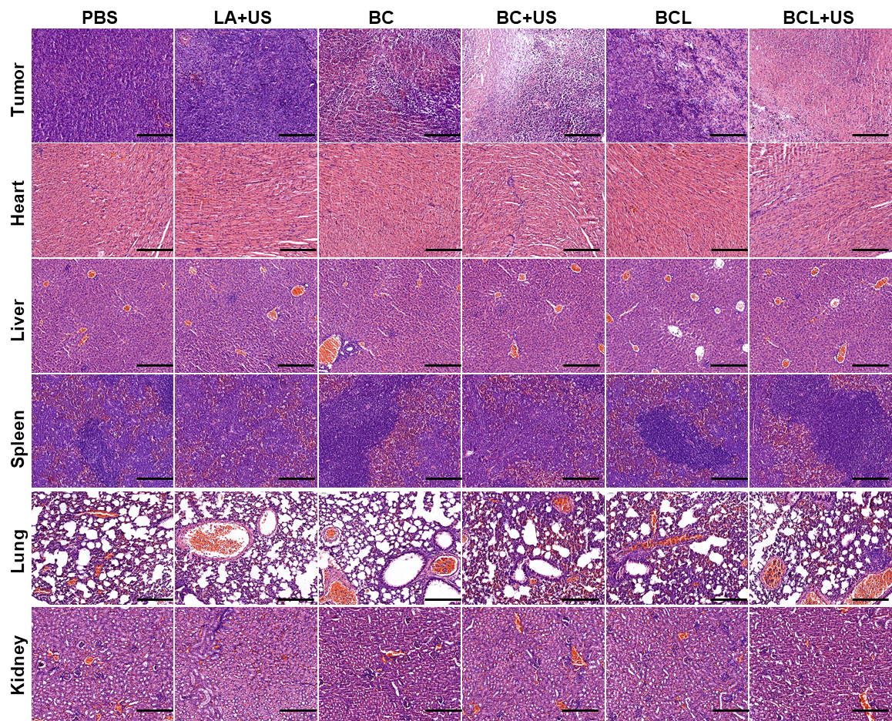
Figure S6 H&E staining of tumors and main organs (heart, liver, spleen, lung, kidney) in indicated treatment groups. Scale bar: 200 μm.

Figure S7 Gating strategy

Figure S8 The quantification of immune cell subpopulations treated with BCL+US. Data are means ± SD (n = 3). ns no significance, **p < 0.01 and ****p < 0.0001.

