Table S1 Histopathological Summary of Study Animals.
Group | 1 |  | 2 |  | 3 |  | 4 |  | 5
α-PD-L1 | – |  | + |  | + |  | + |  | +
Au@SiO₂ NPs | – |  | + |  | – |  | + |  | –
XR | – |  | – |  | + |  | + |  | –
Hematoxylin and eosin (H&E) stains
Mitotic GL261 cells | 4 | 0 |  | 4 |  | 0 |  | 4
Lysed GL261 cells | 0 | 2 |  | 0 |  | 3 |  | 0
Inflammatory cell infiltration | 0 | 0 |  | 0 |  | 2 |  | 0
Microgliosis (repair process) | 0 | 1 |  | 0 |  | 3 |  | 0
Mitotic rate (per 400X) | >15 | 3-5 |  | >15 |  | 3-5 |  | >15
Immunohistochemistry (IHC) stains
PD1 | + |  | + |  | + |  | + |  | +
CD8 | – |  | + |  | – |  | + |  | –
CD4 | – |  | – |  | – |  | + |  | –
+ = present, – = none;
severity grading: 0 = within normal limits, 1 = minimal, 2 = mild, 3 = moderate, 4 = severe.
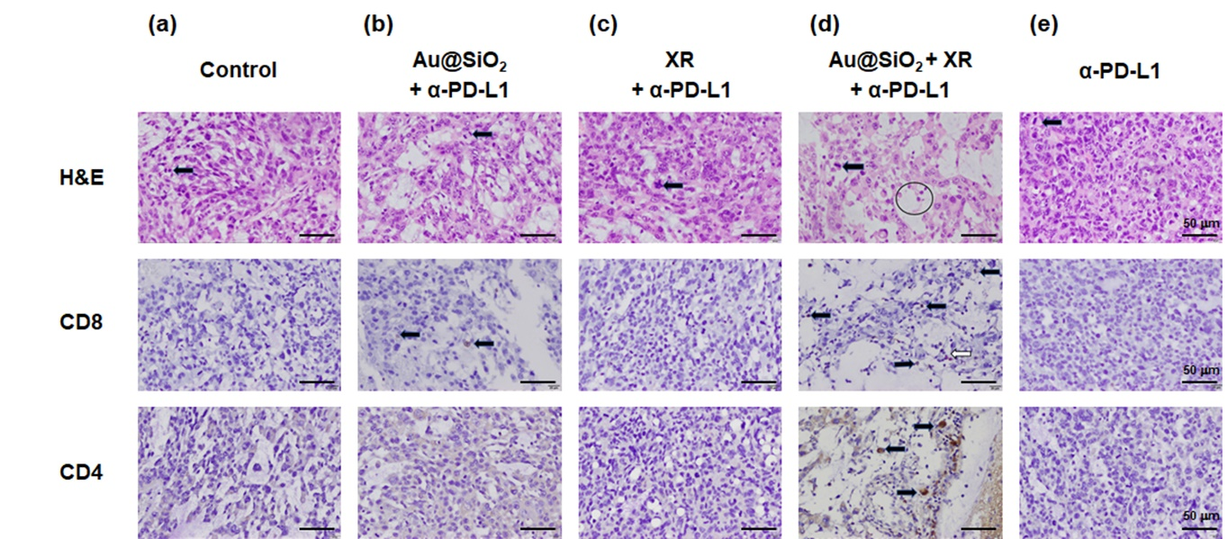
Figure S1 Histopathological assessment of brain tissue obtained from mice receiving different treatments. (a) Control; (b) Au@SiO₂ NPs + α-PD-L1; (c) XR+ α-PD-L1; (d) Au@SiO₂ NPs + XR + α-PD-L1; (e) α-PD-L1. α-PD-L1 at a dose of 10 mg/kg, Au@SiO₂ NPs at a dose of 1 mg/kg, and X-ray irradiation (XR) with a single fraction of 6 MeV photons at a dose of 2 Gray. Rows depict H&E (first row), CD8 (second row), and CD4 stains (third row). Black arrows in each row signify tumor cells with mitotic features, CD8+ cells, and CD4+ cells, respectively. A black circle in the first row marks inflammatory cell infiltration, while a white arrow in the second row denotes Au@SiO2 NPs. Scale bar: 50 μm.
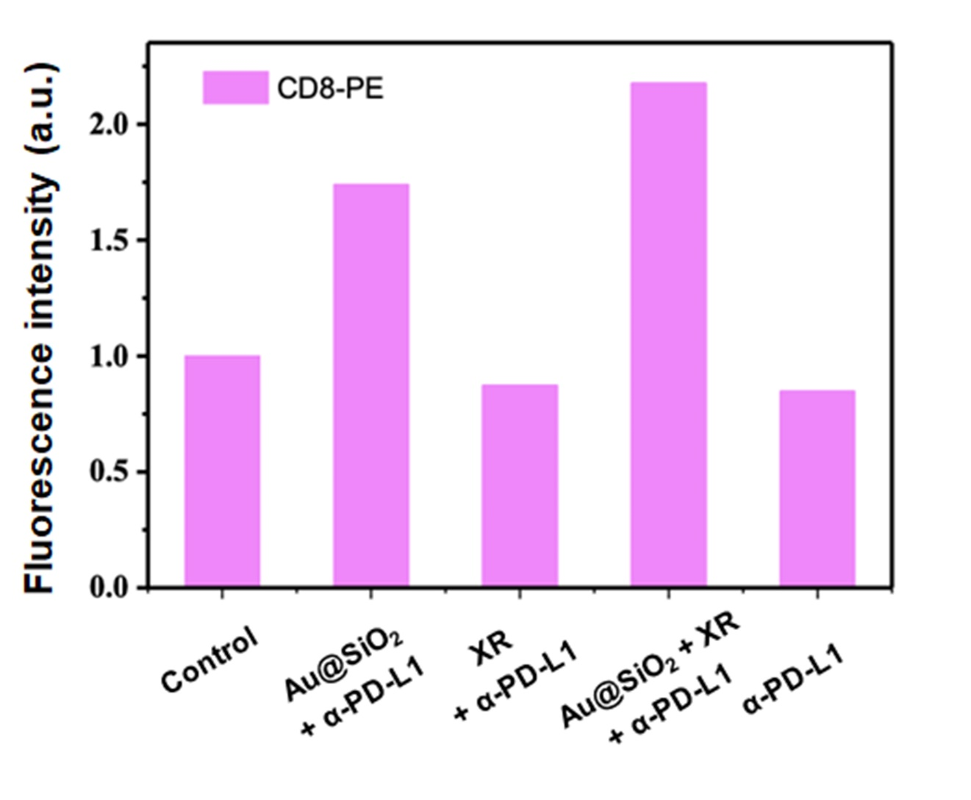
Figure S2 Flow cytometry quantification of splenic CD8⁺ T Cells in mice receiving different treatments. α-PD-L1 at a dose of 10 mg/kg, Au@SiO₂ NPs at a dose of 1 mg/kg, and X-ray irradiation (XR) with a single fraction of 6 MeV photons at a dose of 2 Gray.

