ORIGINAL RESEARCH
Mei-Yu Lv et al
Abhd2, a candidate gene regulating airway remodeling in COPD via TGF-β
Mei-Yu Lv^{1, 2}, Ling-Ling Jin^{2, 3}, Xi-Qiao Sang², Wen-Chao Shi², Li-Xia Qiang², Qing-Yan Lin⁴, and Shou-De Jin^{2,} *

¹Department of Respiratory Medicine, Harbin Medical University Cancer Hospital, Harbin, 150001, China.
²Department of Respiratory Medicine, the Fourth Affiliated Hospital of Harbin Medical University, Harbin, 150001, China.
³Department of Critical care medicine，The Second Affiliated Hospital of Xi 'an Jiaotong University.
⁴Department of Respiratory Medicine, Heilongjiang Provincial Hospital, Harbin, 150001, China.

Correspondence: Shou-De Jin.
Department of Respiratory Medicine, The Fourth Affiliated Hospital of Harbin Medical University, No. 37 Yiyuan Street, Nangang District, Harbin 150001, China.

Tel [+86 0451-85939123]
Fax [+86 0451-85939123]
Email [jinshoude@163.com]
Table S1. Primer sequences of inflammatory factors in mouse lung tissue
Target genes | Primer | Sequences
IL-1α | forward | 5′-TTGTTTGATGTTGCTGACACC-3′
 | Reverse | 5′-CCTCTCAAGCAGAGCACAGA-3′
IL-1β | forward | 5′-GCAACTGTTCCTGAACTCA-3′
 | Reverse | 5′-CTCGGAGCCTGTAGTGCAG-3′
IL-8 | forward | 5′-CGGCAATGAAGCTTCTGTAT-3′
 | Reverse | 5′-CCTTGAAACTCTTTGCCTCA-3′
NF-κB | forward | 5′-GGGGCCTGCAAAGGTTATC-3′
 | Reverse | 5′-TGCTGTTACGGTGCATACCC-3′
TGF-β | forward | 5′-TACAGGGCTTTCGATTCAGC-3′
 | Reverse | 5′-CGCACACAGCAGTTCTTCTC-3′
TNF-α | forward | 5′-CCAGACCCTCACACTCAGAT-3′
 | Reverse | 5′-AACACCCATTCCCTTCACAG-3′
GAPDH | forward | 5′-GGGCTCTCTGCTCCTCCCTGTT-3′
 | Reverse | 5′-AGGCGTCCGATACGGCCAAA-3′
Table S2. Measurement of clinical airway diameter and airway wall thickness
Groups | Overall | COPD | Control | P value
Participants (n) | 83 | 53 | 30 | /
TD | 17.70 ± 3.94 | 17.73 ± 4.30 | 17.65 $\text{±}$ 3.28 | 0.929
AD | 17.36 ± 3.09 | 17.82 ± 3.36 | 16.55 $\text{±}$ 2.38 | 0.071
RTD | 15.13 ± 2.81 | 15.12 $\text{±}$ 3.13 | $$\text{15.16 ± 2.20}$$ | 0.944
RAD | 13.37 ± 2.55 | 13.71 $\text{± 2.62}$ | $$\text{12.78 ± 2.35}$$ | 0.109
TWT | 2.20 ± 0.49 | 2.38 $\text{± 0.43}$ | $$\text{1.87 ± 0.42}$$ | ＜0.001
BWT | 1.36 ± 0.45 | 1.45$\text{± 0.47}$ | 1.19 $\text{± 0.37}$ | 0.010
Note: Data presented as mean ± SD, and t-test was used for comparison between groups (P < 0.05).
Abbreviation: AD, anteroposterior diameter; BWT, bronchial wall thickness; RAD, right anteroposterior diameter; RTD, right tracheal transverse diameter; TD, tracheal transverse diameter; TWT, tracheal wall thickness.

Table S3. Body weight changes in mice after cyclic injection of CSE (g)
Groups | CSE1 | CSE2 | CSE3 | CSE4 | CSE5
N | 8/8 | 8/7 | 8/5 | 8/5 | 7/5
WTSM | 19.34 ± 2.15 | 22.16 $\text{±}$ 2.99 | 23.69 ± 3.14 | 25.20 ± 3.06 | 27.00 ± 2.62
ABSM | 18.23 $\text{±}$ 1.36 | 20.54 ± 1.37 | 21.69 ± 1.47 | 22.84 ± 1.98 | 23.84 ± 1.91
P value | 0.235 | 0.199 | 0.214 | 0.156 | 0.046
Note: Data were shown as mean ± SD. N referred to the number of remaining C57BL6 and Abhd2^{Gt/Gt} mice surviving at the corresponding cycle.
Abbreviation: WTSM, wild-type+ CSE group; ABSM, Abhd2^{Gt/Gt} + CSE group.

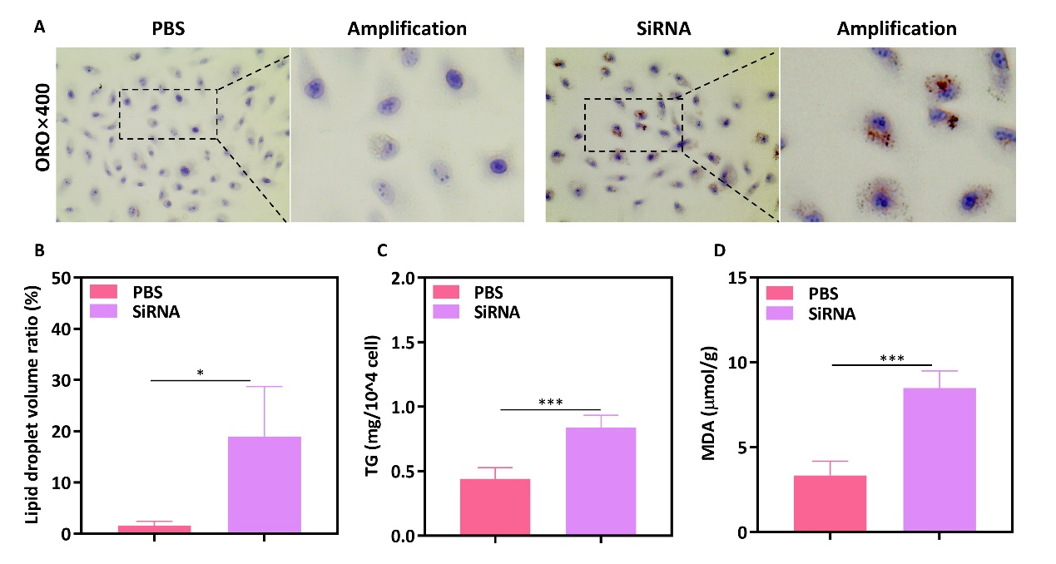
Figure S1. Measurement of lipid metabolism. (A) Oil red staining results confirmed fat deposition in cells with Abhd2 gene silencing (Magnification×400). (B) Increased lipid droplet volume ratio in cells with Abhd2 gene silencing. (C) Triglyceride deposition in Abhd2 gene silencing group. (D) Increased malondialdehyde in Abhd2 gene silencing group.
*P < 0.05, ***P < 0.001.

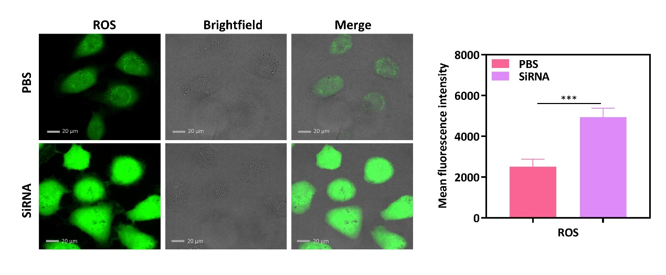
Figure S2. Increased ROS in cells with Abhd2 gene silencing (Magnification×400).
***P < 0.001

