Supplementary Material
for
Chitosan-Rapamycin Carbon Dots Alleviate Glaucomatous Retinal Injury by Inducing Autophagy to Promote M2 Microglial Polarization
Qi Wang^{1,2,3,*}, Jiaxin Dong^{4,*}, Mengxian Du^{1,3,*}, Xinna Liu^{1,2,3}, Shiqi Zhang¹, Di Zhang^{1,3}, Wanyun Qin^{1,3}, Xikun Xu^{1,2}, Xianghui Li^{1,3}, Ruidong Su^{1,2}, Leyi Qiu^{1,2}, Baoqiang Li^{4,5}, Huiping Yuan¹

¹Department of Ophthalmology, The Second Affiliated Hospital of Harbin Medical University, Harbin, People’s Republic of China; ²The Key Laboratory of Myocardial Ischemia, Harbin Medical University, Ministry Education, Harbin, People’s Republic of China; ³Future Medical Laboratory, the Second Affiliated Hospital of Harbin Medical University, Harbin, People’s Republic of China; ⁴Institute for Advanced Ceramics, State Key Laboratory of Urban Water Resource and Environment, Harbin Institute of Technology, Harbin, People’s Republic of China; ⁵Laboratory of Dynamics and Extreme Characteristics of Promising Nanostructured Materials, Saint Petersburg State University, St. Petersburg, Russia

*These authors contributed equally to this work

Supplementary Tables
Supplementary Table 1. Primer sequences.
Gene | Forward | Reverse
TNF-α | CTGAACTTCGGGGTGATCGG | GGCTTGTCACTCGAATTTTGAGA
IL-1a | TCTATGATGCAAGCTATGGCTCA | CGGCTCTCCTTGAAGGTGA
IL-1β | GCAACTGTTCCTGAACTCAACT | ATCTTTTGGGGTCCGTCAACT
IL-6 | TAGTCCTTCCTACCCCAATTTCC | TTGGTCCTTAGCCACTCCTTC
IL-4 | GCCGATGATCTCTCTCAAGTGAT | GCCGATGATCTCTCTCAAGTGAT
TGF-β | CTCCCGTGGCTTCTAGTGC | GCCTTAGTTTGGACAGGATCTG
IL10 | GCTCTTACTGACTGGCATGAG | CGCAGCTCTAGGAGCATGTG
β-actin | GGCTGTATTCCCCTCCATCG | CCAGTTGGTAACAATGCCATGT

Description | GeneRatio (%) | P value | Count
inflammatory response | 4.92040521 | 5.12343E-23 | 102
response to lipopolysaccharide | 3.714423541 | 4.75291E-16 | 77
positive regulation of tumor necrosis factor production | 2.170767004 | 5.33135E-15 | 45
positive regulation of inflammatory response | 1.881331404 | 6.08343E-13 | 39
positive regulation of interleukin-6 production | 1.833092137 | 6.71155E-11 | 38
positive regulation of interleukin-1 beta production | 1.302460203 | 1.37084E-10 | 27
positive regulation of superoxide anion generation | 0.771828268 | 1.29972E-09 | 16
lipopolysaccharide-mediated signaling pathway | 0.964785335 | 7.82058E-09 | 20
positive regulation of cytokine production | 1.302460203 | 1.0759E-07 | 27
positive regulation of chemokine production | 0.868306802 | 5.49354E-06 | 18
response to hypoxia | 2.653159672 | 6.39827E-06 | 55
response to hydrogen peroxide | 1.061263869 | 5.47274E-05 | 22
positive regulation of microglial cell migration | 0.241196334 | 0.001302801 | 5
positive regulation of microglial cell mediated cytotoxicity | 0.192957067 | 0.003774948 | 4
regulation of reactive oxygen species metabolic process | 0.434153401 | 0.00402231 | 9
Supplementary Table 2. Gene ontology enrichment analysis results of biological processes.

Supplementary Figures
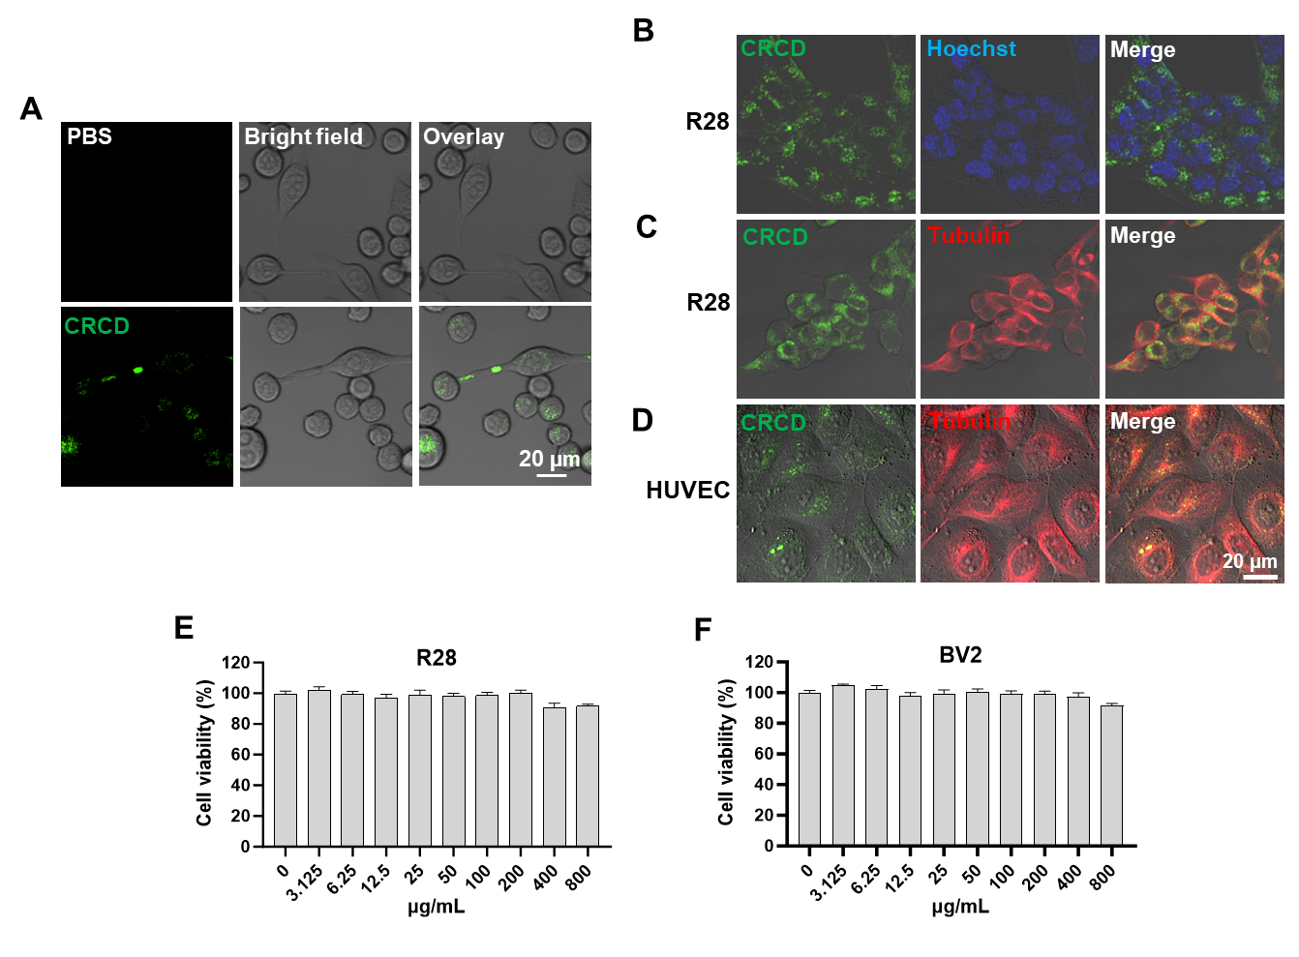
Figure S1 (A) Confocal laser scanning microscopy (CLSM) images of phosphate-buffered saline (PBS) or chitosan-rapamycin carbon dots (CRCD) uptake by murine microglia (BV2), with green fluorescence excitation at 405 nm. (B) CLSM images of CRCD uptake and live nuclei staining by Hoechst 33342, indicating that CRCD did not localize to the nucleus, in rat retinal cell line (R28). CLSM images of CRCD uptake (overlaid on brightfield) and cytoplasmic tubulin staining for (C) R28 cells and (D) human umbilical vein endothelial cells (HUVECs), indicating cytoplasmic localization of CRCD. Cell viability for (E) R28 and (F) BV2 cells, upon exposure to different CRCD concentrations for 24 h, as determined by the CCK-8 assay. n=4-6/group.

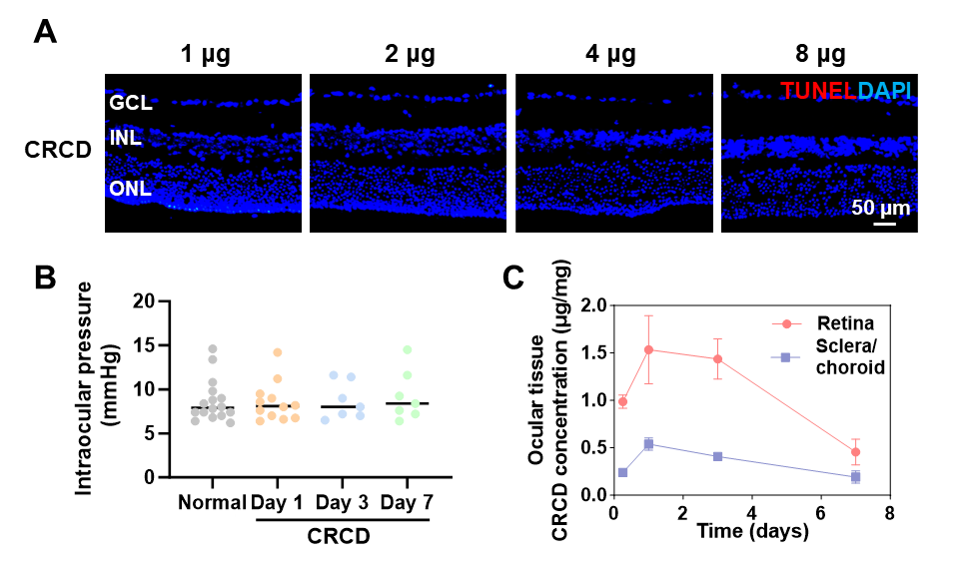
Figure S2 (A) Representative immunofluorescence images of apoptotic terminal deoxynucleotidyl transferase dUTP nick end labeling (TUNEL)⁺ cells among mice retinas intravitreally injected with 1, 2, 4, or 8 µg (in 1 µL PBS) of CRCD. (B) Intraocular pressure quantification from mice intravitreally injected with CRCD, at days 1, 3, and 7 post-injection. (C) Ultra-performance liquid chromatography measurements of CRCD concentrations in retina and choroid/sclera tissues, at different time points post-injection. n=7-16/group for (B), n=3-6/group for (C).

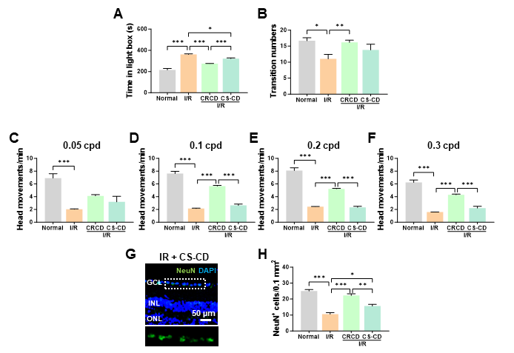
Figure S3 Chitosan-rapamycin carbon dots (CRCD) was more effective than chitosan-carbon dots (CS-CD) for improving visual function and preserving RGCs post-I/R injury. (A) Time spent in the light chamber among Normal, I/R, I/R+CRCD, and I/R+CS-CD mouse groups. (B) Number of transitions between the light and dark chambers among the 4 groups. Number of head movements elicited under the OMR test for (C) 0.05, (D) 0.1, (E) 0.2, and (F) 0.3 cycles per degree (cpd), among the 4 groups. (G) Immunofluorescence staining images for I/R+CS-CD retinas. (H) Quantification of NeuN⁺ cells within the granular cell layer (GCL) among the 4 groups. n=5/group for (A-F), n=4/group for (G-H). *P<0.05, **P<0.01, ***P<0.001.

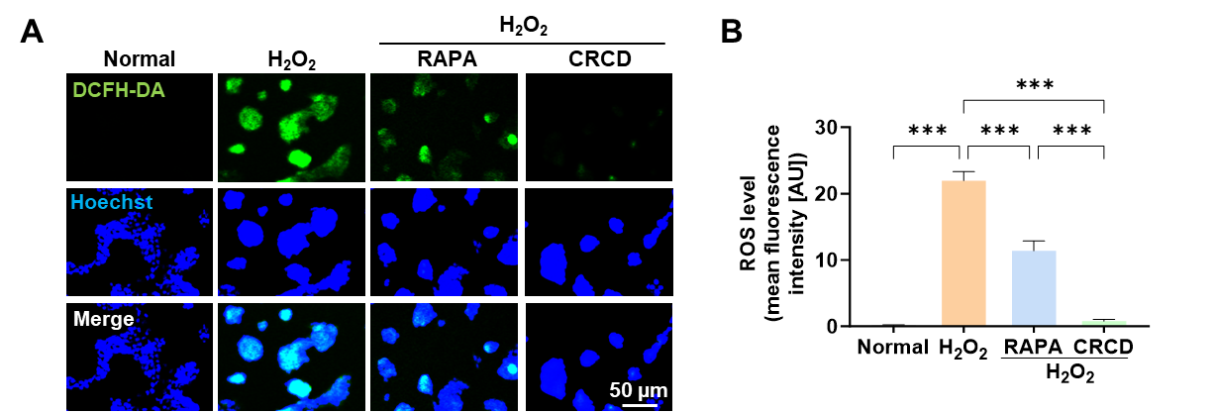
Figure S4 (A) Representative diacetyldichlorofluorescein (DCFH-DA) fluorescence images and (B) reactive oxygen species (ROS) quantification among untreated control (Normal) R28 cells, as well as those treated with H₂O₂ (H₂O₂), H₂O₂ with rapamycin (RAPA; H₂O₂+RAPA), and H₂O₂ with CRCD (H₂O₂+CRCD) for 2 h. Fluorescence was measured in terms of arbitrary units (AU). n=7-13/group. ***P<0.001.

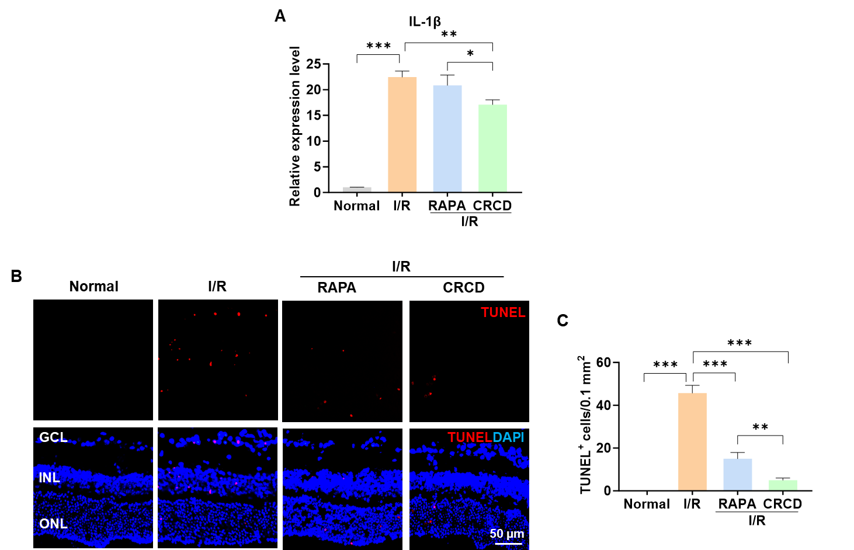
Figure S5 (A) Quantification of relative gene expression levels for IL-1β. (B) Representative immunofluorescence images and (C) quantification of TUNEL⁺ cells among Normal, I/R, I/R+RAPA, and I/R+CRCD mouse retinal groups. n=3/group. *P<0.05, **P<0.01, ***P<0.001.

