Supplementary material
Supplementary Figure 1
- Sensitivity analysis: Changes to the environmental footprint in percent assuming that all electricity consumed at the reprocessing plant in Florida is 100% renewable (wind and solar energy in equal measures)
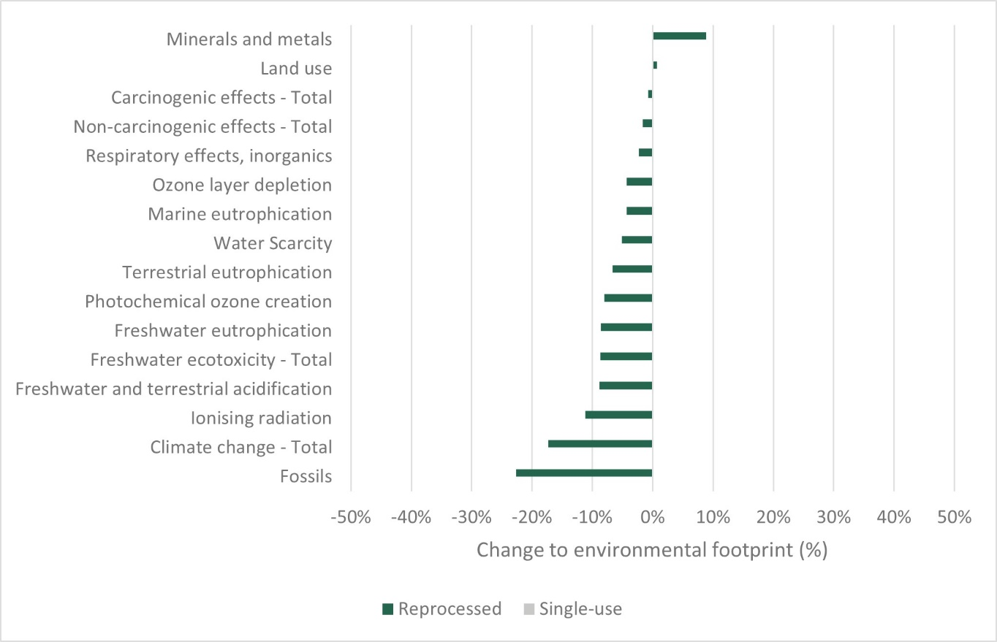

- Sensitivity analysis: Changes to the environmental footprint in percent assuming that all ethylene oxide used in high-level disinfection during IPC sleeve reprocessing is emitted into the air
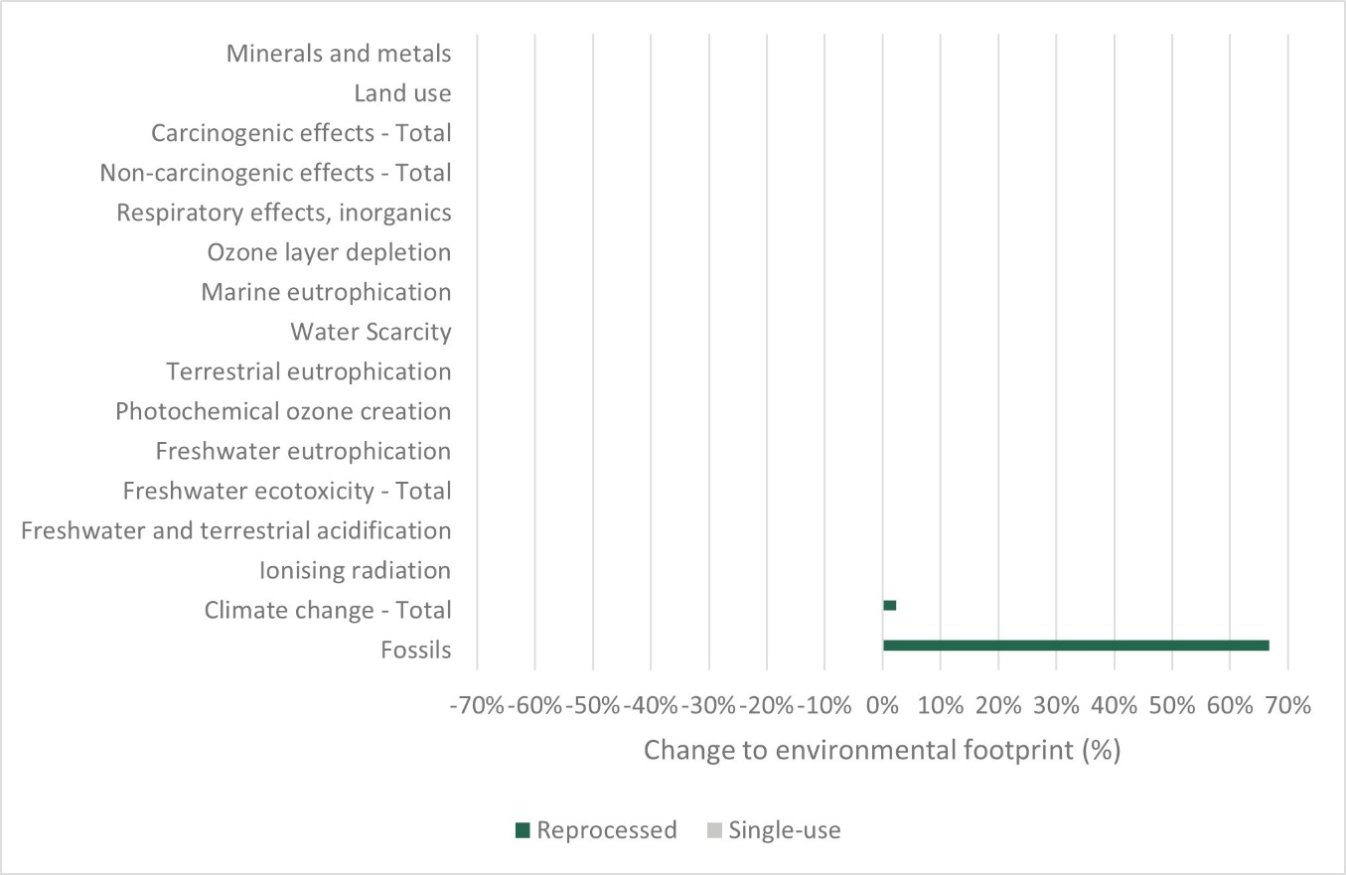

- Sensitivity analysis: Changes to the environmental footprint in percent assuming that 50% more transports are required (for both single-use and reprocessed IPC sleeves)
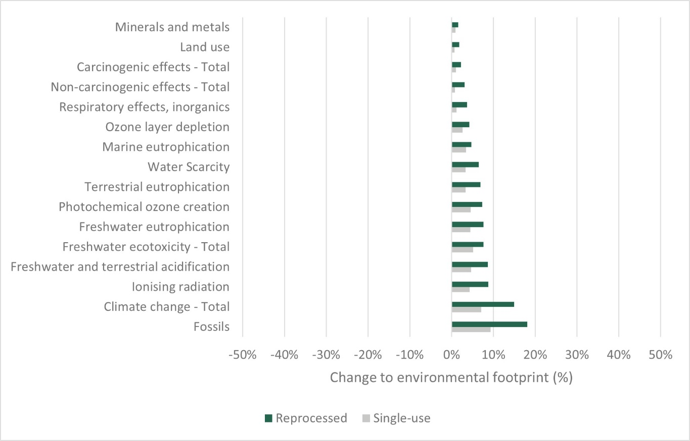

- Sensitivity analysis: Changes to the environmental footprint in percent assuming that transport distances are 50% shorter for reprocessing IPC sleeves
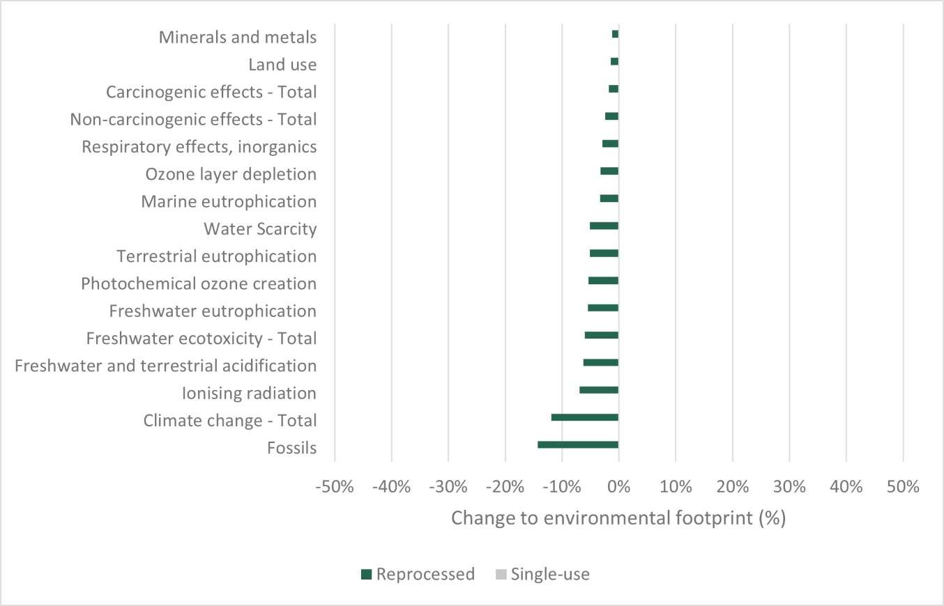

Supplementary Table 1 Main drivers of most relevant normalized impact categories
Single-use IPC sleeve | Reprocessed IPC sleeve
Freshwater ecotoxicity
- Sheet production (polyester laminated with polyester)  - Cardboard box (IPC product packaging)  - Cardboard box (packaging of pre-component hot stamp) | - Cardboard box (IPC product packaging)  - Deionized water (reprocessing facility)  - Sheet production (polyester laminated with polyester)
Fossils
- Sheet production (polyester laminated with polyester)  - Loop sheet production (nylon)  - Cardboard box (IPC product packaging) | - Cardboard box (IPC product packaging)  - Electricity (reprocessing facility)  - Sheet production (polyester laminated with polyester)
Climate change
- Sheet production (polyester laminated with polyester)  - Waste disposal cardboard box (landfill)  - Loop sheet production (nylon) | - Waste disposal cardboard box (landfill)  - Cardboard box (IPC product packaging)  - Waste disposal cardboard box (landfill)

