SUPPLEMENTARY MATERIAL

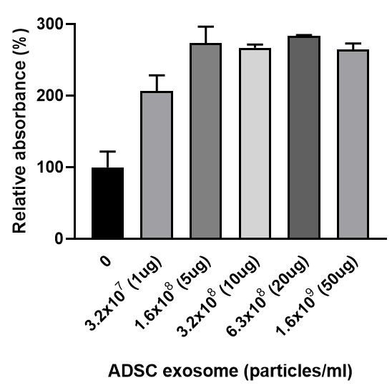
Supplementary Figure 1. The efficacy of ADSC exosomes on the proliferation of human dermal fibroblasts. Human dermal fibroblasts (Biosolution Ltd., Nowon, Seoul, Korea) were treated with exosomes by concentration during 48 h. After then, cells were treated with 0.5 mg/mL MTT (3-[4,5 dimethylthioazole-2-yl]-2,5-diphenyl tetrazolium bromide) (M2129; Sigma-Aldrich, St. Louis, MO, USA) reagent. The results were then measured at 570 nm using an ELISA reader (Versamax, Molecular device, San Jose, CA, USA). The results were expressed as sample/control(0)*100.

Supplementary Table 1.

mRNA Primers Used for RT-qPCR
Antibody name | TaqMan Assay ID
IL1B | Hs1555410_m1
IL6 | Hs00174131_m1
TNFA | Hs 00174128_m1
NOX2 | Hs00166163_m1
NOX4 | Hs00418356_m1
Nrf2 | Hs00975961_g1
GAPDH | Hs 02758991_m1

Supplementary Table 2

Antibodies used for western blot analyses and immunoprecipitation Antibody
Antibody | Host | Dilution | Company | CaT.No | MW
CD63 | Rabbit | 1:1000 | Abcam | ab134045 | 65 kDa
CD9 | Rabbit | 1:1000 | Abcam | ab236630 | 25 kDa
ATG5 | Rabbit | 1:1000 | Abcam | ab108327 | 45 kDa
P62 | Rabbit | 1:1000 | Abcam | ab155686 | 47 kDa
Beclin1 | Rabbit | 1:1000 | Abcam | NB500-249 | 50 kDa
LC3Bll | Rabbit | 1:1000 | Abcam | ab51520 | 15 kDa
P65 | Rabbit | 1:1000 | Abcam | ab16502 | 64 kDa
Phosphor-P65 | Rabbit | 1:1000 | Abcam | ab86299 | 60 kDa
P38 | Rabbit | 1:1000 | Abcam | ab31828 | 41 kDa
Phosphor-P38 | Rabbit | 1:1000 | Abcam | ab4822 | 38 kDa
GAPDH | Rabbit | 1:1000 | Abcam | ab9485 | 37 kDa

