Supplemental Table 1: aOR of Engagement in IHM Modalities for Pain
Group | Comparison | aOR | 95% CI Low | 95% CI High
(Intercept) | (Intercept) | 0.187 | 0.116 | 0.299
Age | Age +10yrs | 0.858 | 0.820 | 0.899
Sex | Male v. Female | 0.804 | 0.692 | 0.934
Race/Ethnicity | Hispanic v. NH White | 0.938 | 0.728 | 1.209
Race/Ethnicity | NH Black v. NH White | 0.683 | 0.531 | 0.879
Race/Ethnicity | Other v. NH White | 0.702 | 0.503 | 0.980
Education | HS/GED v. < HS | 1.516 | 1.163 | 1.975
Education | Some College v. < HS | 2.193 | 1.661 | 2.896
Education | Assoc/Bach v. < HS | 2.868 | 2.197 | 3.744
Education | Masters/PhD v. < HS | 4.043 | 2.815 | 5.806
Family income | Fam income +$10,000 | 1.037 | 1.021 | 1.053
Proximity to metro area | M/S metro v. Non-metro | 1.067 | 0.859 | 1.324
Proximity to metro area | L fringe metro v. Non-metro | 1.301 | 1.027 | 1.648
Proximity to metro area | L central metro v. Non-metro | 1.590 | 1.261 | 2.004
Number of pain locations | Pain locations +1 | 1.198 | 1.130 | 1.271
Pain limiting life or work | Pain limit some days v. Never | 1.388 | 1.147 | 1.680
Pain limiting life or work | Pain limit most days v. Never | 1.508 | 1.186 | 1.916
Pain limiting life or work | Pain limit every day v. Never | 1.604 | 1.268 | 2.029
Opioid use past 3 mo | Opioids some days v. Never | 1.150 | 0.827 | 1.599
Opioid use past 3 mo | Opioids most days v. Never | 1.175 | 0.692 | 1.996
Opioid use past 3 mo | Opioids every day v. Never | 0.708 | 0.533 | 0.942
PHQ-8 | PHQ-8 +5 units | 1.074 | 0.998 | 1.156
Bold covariates contain 95% confidence intervals that do not cross 1 (null). Abbreviations: Assoc, associate’s; aOR, adjusted odds ratio; Bach, bachelor’s; CI, confidence interval; fam, family; GED, general equivalency diploma; HS, high school; L, large; M, medium; metro, metropolitan; NH, mo, months; Non-Hispanic; PHQ-8, Patient Health Questionnaire-8; S, small; v., versus; yrs, years

Supplemental Table 2: Relative Change in Count of IHM Modalities Used for Pain
Group | Comparison | Relative change | 95% CI Low | 95% CI High
(Intercept) | (Intercept) | 0.749 | 0.427 | 1.315
Age | Age +10yrs | 0.866 | 0.825 | 0.910
Sex | Male v. Female | 0.775 | 0.663 | 0.907
Race/Ethnicity | Hispanic v. NH White | 0.829 | 0.634 | 1.084
Race/Ethnicity | NH Black v. NH White | 0.908 | 0.692 | 1.193
Race/Ethnicity | Other v. NH White | 0.736 | 0.513 | 1.057
Education | HS/GED v. < HS | 1.270 | 0.844 | 1.913
Education | Some College v. < HS | 1.894 | 1.275 | 2.814
Education | Assoc/Bach v. < HS | 1.772 | 1.199 | 2.619
Education | Masters/PhD v. < HS | 1.913 | 1.236 | 2.959
Family income | Fam income +$10,000 | 1.010 | 0.997 | 1.024
Proximity to metro area | M/S metro v. Non-metro | 1.069 | 0.838 | 1.364
Proximity to metro area | L fringe metro v. Non-metro | 1.058 | 0.817 | 1.371
Proximity to metro area | L central metro v. Non-metro | 1.241 | 0.971 | 1.587
Number of pain locations | Pain locations +1 | 1.102 | 1.041 | 1.167
Pain limiting life or work | Pain limit some days v. Never | 1.209 | 0.991 | 1.476
Pain limiting life or work | Pain limit most days v. Never | 1.315 | 1.034 | 1.672
Pain limiting life or work | Pain limit every day v. Never | 1.180 | 0.916 | 1.520
Opioid use past 3 mo | Opioids some days v. Never | 0.888 | 0.623 | 1.265
Opioid use past 3 mo | Opioids most days v. Never | 1.265 | 0.746 | 2.147
Opioid use past 3 mo | Opioids every day v. Never | 0.767 | 0.529 | 1.111
PHQ-8 | PHQ-8 +5 units | 0.901 | 0.834 | 0.973
Bold covariates contain 95% confidence intervals that do not cross 1 (null). Abbreviations: Assoc, associate’s; aOR, adjusted odds ratio; Bach, bachelor’s; CI, confidence interval; fam, family; GED, general equivalency diploma; HS, high school; L, large; M, medium; metro, metropolitan; mo, months; PHQ-8, Patient Health Questionnaire-8; NH, Non-Hispanic; S, small; v., versus; yrs, years

Supplemental Figure 1: Observed vs. Predicted Values in the Weighted Hurdle Poisson Model

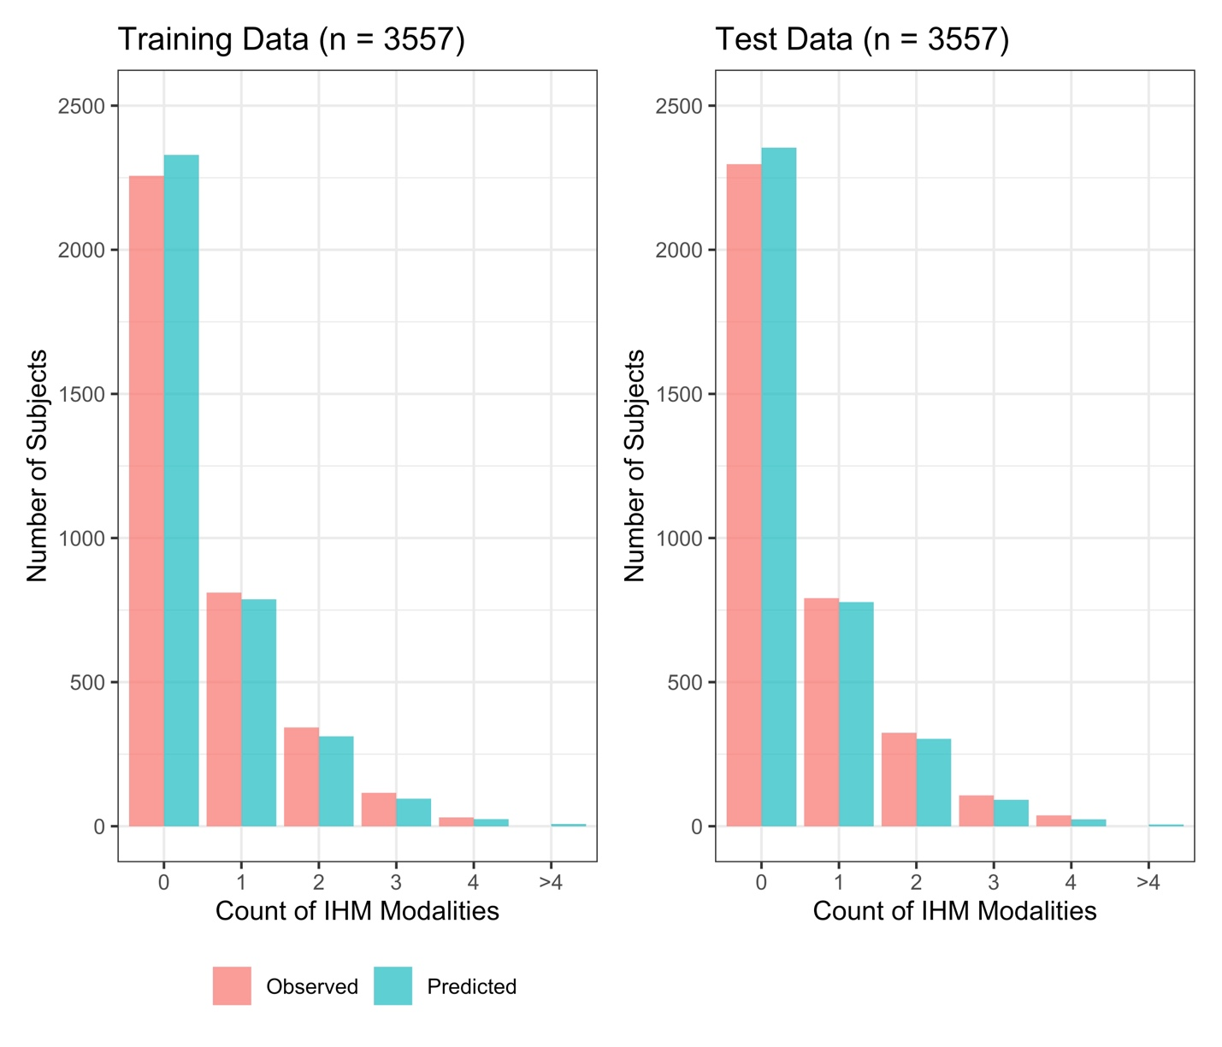
Supplemental Table 3: aOR of Engagement in Nonpharmacologic Only vs. Opioids Only
Group | Comparison | aOR | 95% CI Low | 95% CI High
Age | Age 69 v. 46 | 0.614 | 0.530 | 0.711
Sex | Male v. Female | 0.831 | 0.678 | 1.018
Race/Ethnicity | Hispanic v. NH White | 1.337 | 0.942 | 1.897
Race/Ethnicity | NH Black v. NH White | 0.868 | 0.630 | 1.196
Race/Ethnicity | Other v. NH White | 1.594 | 0.974 | 2.607
Education | HS/GED v. < HS | 1.639 | 1.232 | 2.179
Education | Some College v. < HS | 2.094 | 1.522 | 2.881
Education | Assoc/Bach v. < HS | 3.176 | 2.301 | 4.383
Education | Masters/PhD v. < HS | 3.943 | 2.325 | 6.687
Family income | Family income $85k v. $22k | 1.596 | 1.352 | 1.883
Proximity to metro area | M/S metro v. Non-metro | 1.327 | 1.016 | 1.734
Proximity to metro area | L fringe metro v. Non-metro | 1.864 | 1.356 | 2.562
Proximity to metro area | L central metro v. Non-metro | 1.449 | 1.075 | 1.954
Number of pain locations | 4 pain locations v. 2 | 1.001 | 0.852 | 1.176
Pain limiting life or work | Pain limit some days v. Never | 0.541 | 0.390 | 0.750
Pain limiting life or work | Pain limit most days v. Never | 0.493 | 0.341 | 0.713
Pain limiting life or work | Pain limit every day v. Never | 0.363 | 0.256 | 0.513
PHQ-8 | PHQ-8 score 8 v. 1 | 0.952 | 0.834 | 1.088
Bold covariates contain 95% confidence intervals that do not cross 1 (null). Abbreviations: Assoc, associate’s; aOR, adjusted odds ratio; Bach, bachelor’s; CI, confidence interval; fam, family; GED, general equivalency diploma; HS, high school; L, large; M, medium; metro, metropolitan; NH, Non-Hispanic; PHQ-8, Patient Health Questionnaire-8; S, small; v., versus; yrs, years

