Supplemental figure 1

Supplemental figure 1. GO/PCL scaffold at concentration of (A) 0%, (B) 0.1%, (C) 0.3%, (D) 0.5%, (E) 1.0%.
Abbreviations: GO, Graphene oxide; PCL, Polycaprolactone.

Supplemental figure 2

Supplemental figure 2. Water contact angle of (A) PCL, (B) 0.1%GO/PCL, (C) 0.3%GO/PCL, (D) 0.5%GO/PCL, (E) 1.0%GO/PCL.
Abbreviations: GO, Graphene oxide; PCL, Polycaprolactone.

Supplemental figure 3

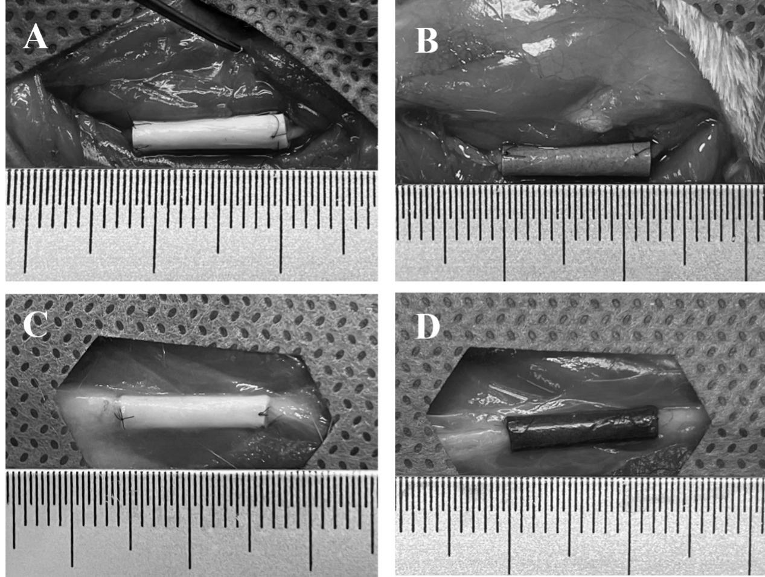

Supplemental figure 3. General observation of regenerated nerve tissues after surgical implantation.
Notes: (A, B) 0 day following repair and (C, D) 12 weeks following repair. (A, C) PCL scaffold. (B, D) GO/PCL scaffold.
Abbreviations: GO, Graphene oxide; PCL, Polycaprolactone.

