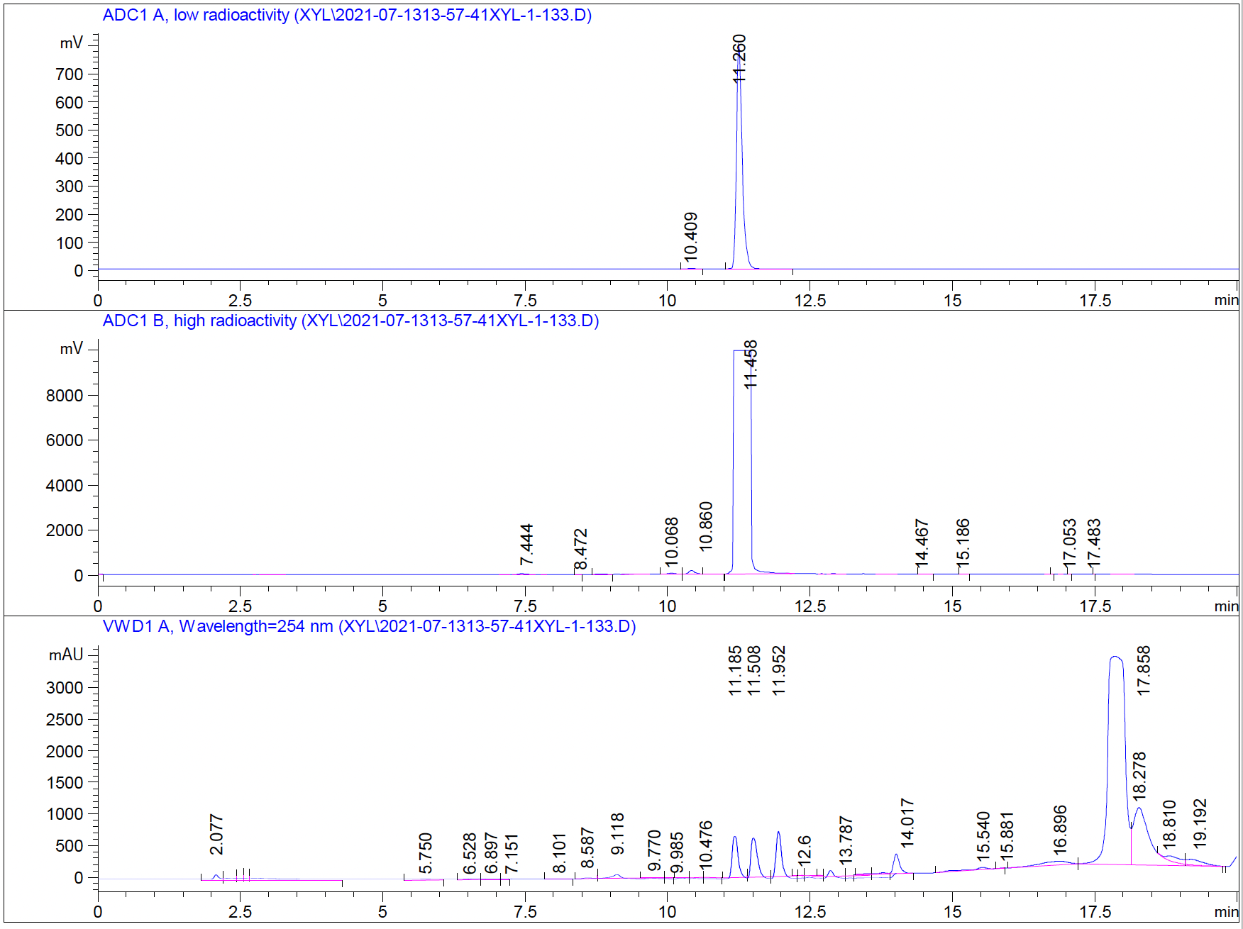
Fig. S1. Semipreparative purification HPLC chromatogram of [¹¹C]1.

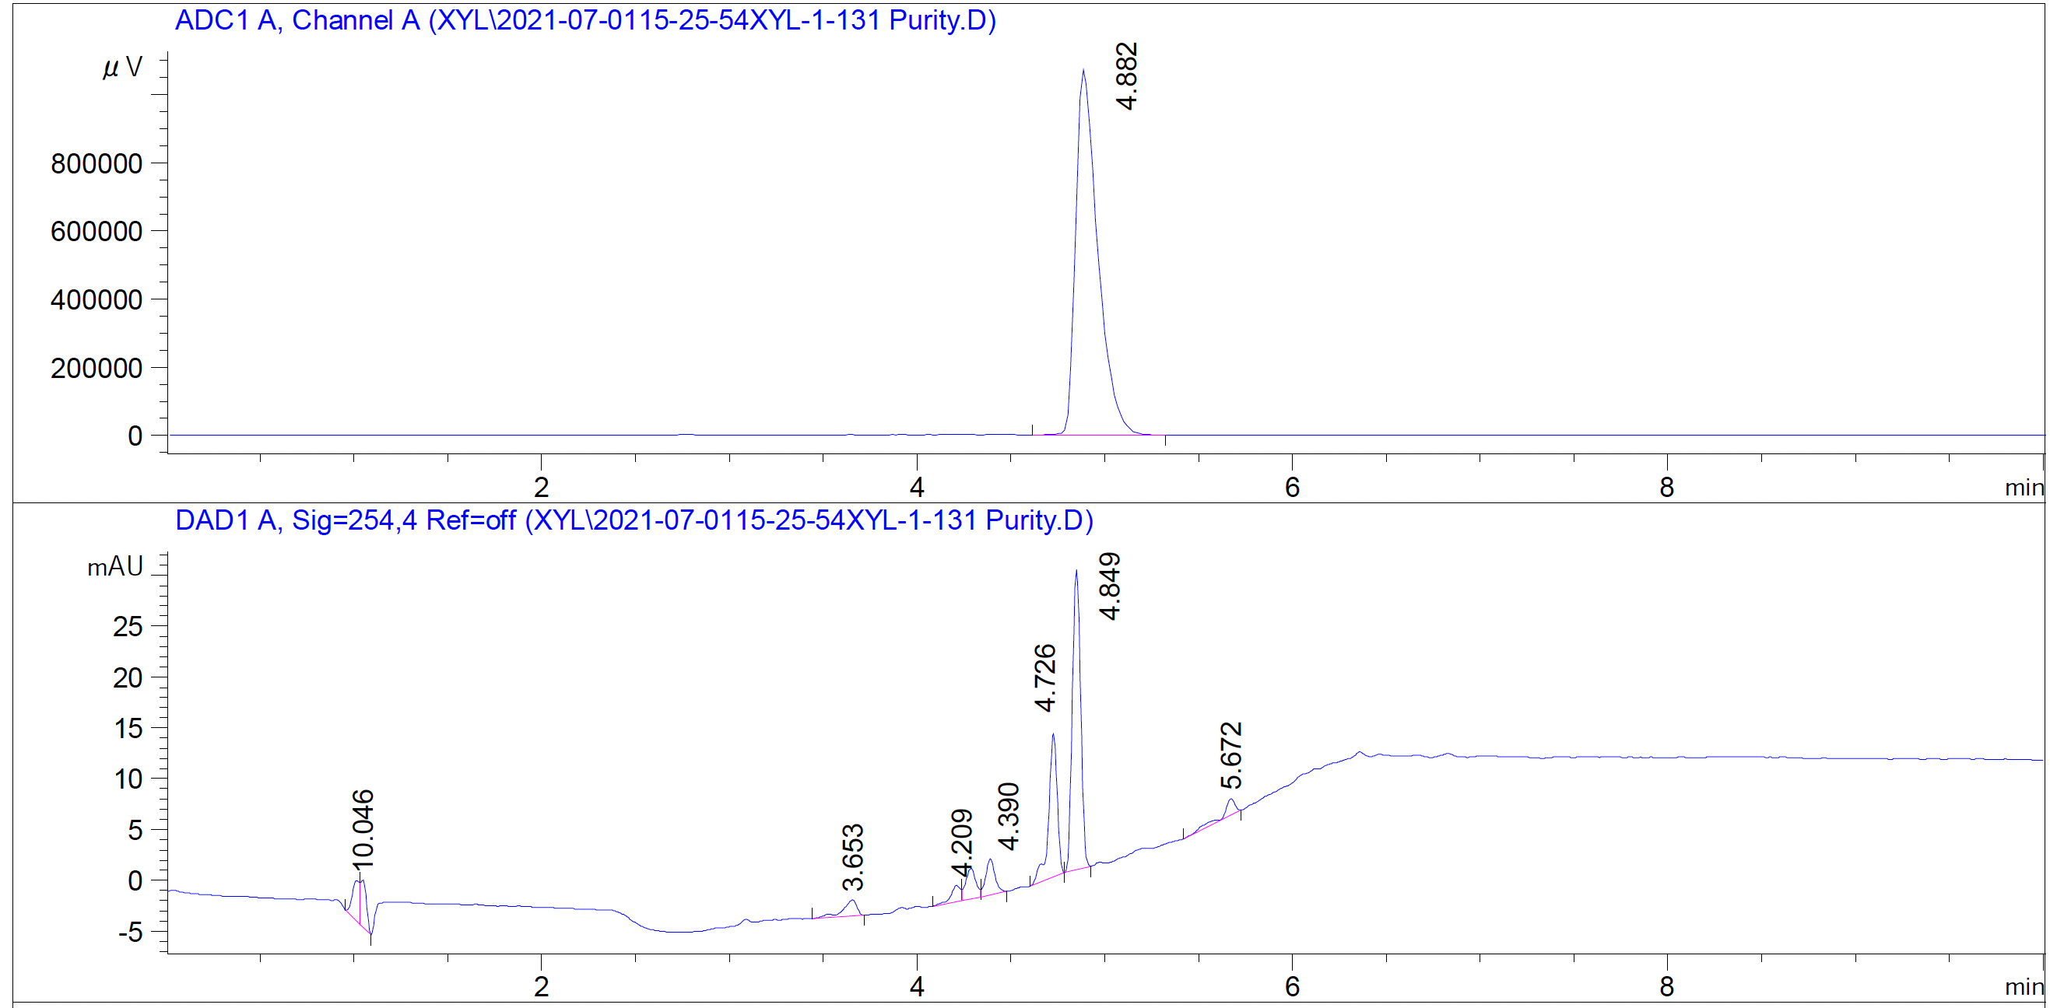
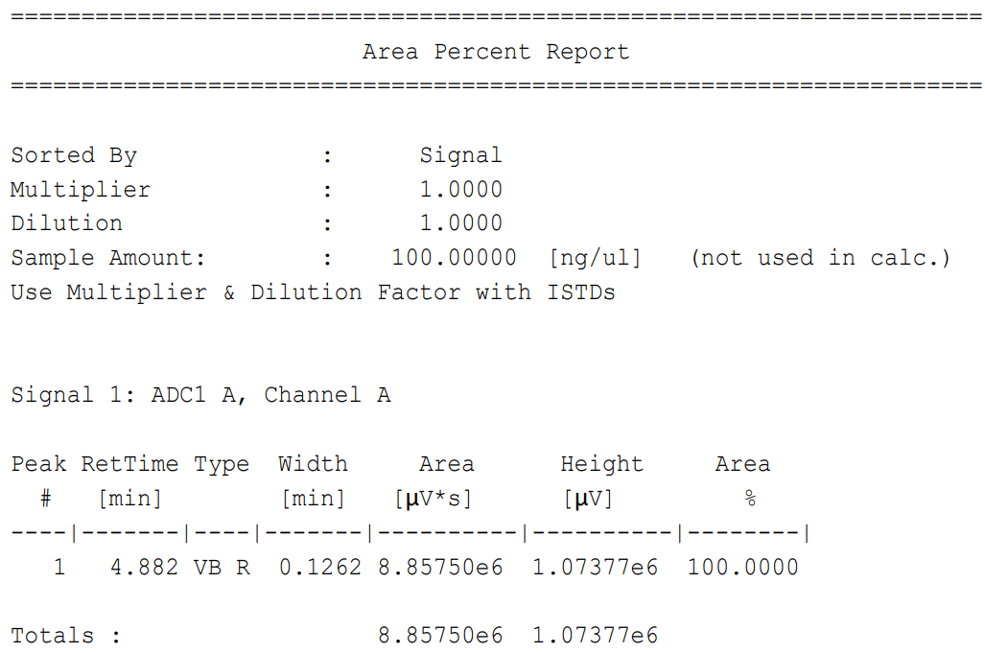
Fig. S2. Purity analysis HPLC chromatogram of [¹¹C]1.

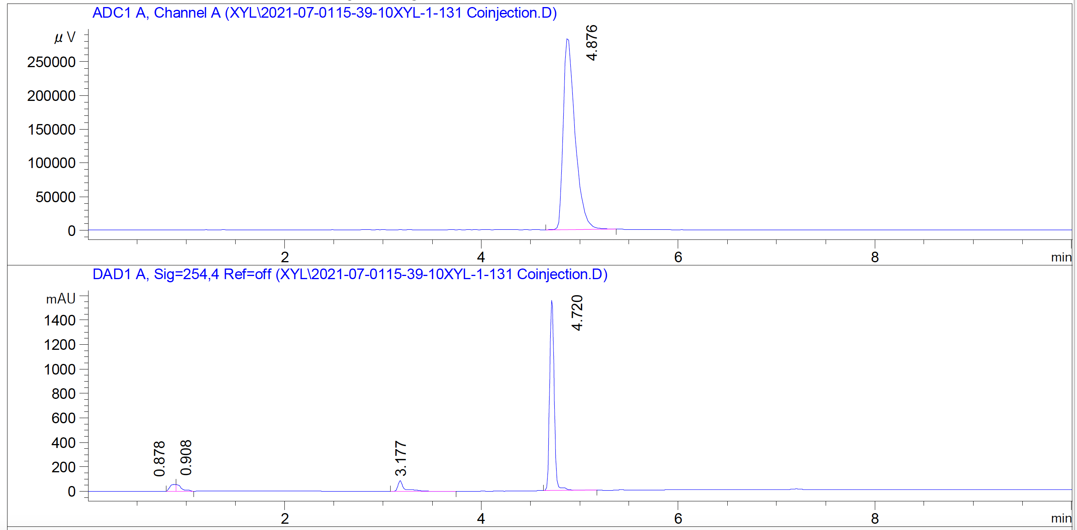
Fig. S3. HPLC chromatogram of co-injection of [¹¹C]1 and compound 1.

