Supplemental Figure S1: Prisma Flow Chart

Supplemental Table S1: Baseline Characteristics Table of the participants

Study | Study Duration  Weeksª | Blinding Status | Study Arms^{b} | No. of Participants Randomized | HbA1c  Mean  (SD) | Body weight kg  Mean  (SD) | Diabetes duration Years  Mean (SD) | Age  Years  Mean  (SD) | FPG  mg/dl  Mean  (SD) | BMI  Kg.m⁻²  Mean  (SD)
Saxena et al.  2023  Jama | 16 | Double-blind | Danuglipron 2.5mg  10mg  40mg  80mg  120mg  Placebo | 68  68  71  67  71  66 | 8.10(1.03)  8.01(0.91)  8.00(0.89)  8.07(0.95)  8.05(0.86)  8.24(0.90) | 90.0(20.13)  92.3(16.44)  90.2(18.74)  91.3(16.64)  93.1(17.95)  90.1(17.54) | 8.8(6.31)  8.5(6.85)  8.0(5.82)  9.7(6.20)  8.7(7.89)  8.8(6.90) | 58.9(9.30)  58.1(9.43)  59.6(8.58)  58.4(9.18)  58.8(9.43)  57.9(10.27) | 169.3(42.4)  165.4(39.0)  166.0(39.3)  172.8(45.4)  169.5(40.7)  173.0(43.7) | 32.5(5.17)  33.0(5.34)  32.3(5.25)  32.9(5.06)  33.3(5.70)  32.5(5.08)
Saxena et al.  2023 Wiley | 12 | Double-blind | Danuglipron  80mg-LS  80mg-HS  120mg-LF  120mg-HF  200mg-HF  Placebo | 20  22  22  22  21  16 | 8.14(1.02)  8.25(1.01)  8.05(0.88)  8.56(1.16)  8.24(1.16)  7.83(0.93) | 96.41(20.43)  91.11(14.22)  101.8(24.54)  95.15(17.01)  86.36(13.64)  101.0(18.44) | 9.3(5.16)  10.3(6.4)  9.15(5.7)  10.2(9.8)  7.87(4.8)  8.15(7.5) | 59.5(9.5)  60.9(8.6)  58.3(7.1)  57.2(11.8)  59.0(9.3)  53.9(9.1) | 178.3(38.0)  177.5(44.3)  159.8(48.5)  182.9(57.5)  167.7(53.9)  162.6(44.6) | 35.1(5.96)  32.8(5.51)  35.1(6.89)  33.9(4.47)  31.5(3.76)  35.5(5.93)
Ono et al. 2022 Wiley | 8 | Double-blind | Danuglipron  40mg  80mg  120mg  Placebo | 10  9  9  9 | 8.2(1.1)  8.6(1.0)  8.4(1.2)  8.3(1.3) | 79.7(13.6)  79.6(10.0)  81.5(10.4)  73.3(9.9) | 2.9(2.2)  9.1(5.8)  5.7(7.7)  5.5(4.1) | 55.9(10.0)  58.0(6.7)  50.7(7.5)  58.6(8.8) | 173.3(29.7)  175.5(32.7)  163.7(47.5)  182.9(36.3) | 28.6(4.1)  28.2(3.6)  28.6(3.4)  25.9(2.7)
Saxena et al.  2021  Nature | 4 | Double-blind | Danuglipron  10mg  15mg  50mg  70mg  120mg BID  120mg BID ST  120mg QD  200mg QD  Placebo | 9  9  10  9  9  9  8  10  25 | 8.2(0.6)  8.6(0.6)  8.3(0.9)  8.3(0.6)  8.5(1.0)  8.2(0.7)  8.2(1.0)  8.6(0.9)  8.0(0.8) | 99.6(12.7)  92.9(22.5)  87.8(13.8)  86.9(18.6)  101.6(17.4)  87.9(19.7)  84.9(15.3)  92.4(18.0)  94.3(17.7) | 11.7(6.1)  8.1(4.2)  9.1(5.1)  11.6(4.6)  10.8(4.7)  9.2(5.9)  9.2(7.4)  8.7(7.8)  8.5(6.8) | 54.0(6.22)  56.1(9.53)  60.2(7.97)  58.3(5.32)  55.8(7.68)  58.6(6.69)  58.3(3.81)  57.6(8.30)  57.6(7.71) | 158.3(23.3)  198.4(33.1)  168.1(34.9)  186.3(32.0)  196.9(26.1)  176.3(44.0)  179.9(28.5)  195.3(37.5)  167.6(32.5) | 33.9(3.4)  35.3(5.1)  32.6(3.6)  31.9(4.3)  35.0(4.7)  30.7(4.5)  31.3(3.3)  31.9(3.6)  33.2(4.5)

Data for HbA1c, body weight, diabetes duration, age, FPG and BMI are presented as mean values
a) Time point at which the primary endpoint was assessed in each study
b) Data for trial arms that used different dose regimens with Danuglipron

Supplemental Table S2: Quality Assessment Table

Study | D1 | D2 | D3 | D4 | D5 | Overall
Saxena et al. 2023 Jama (10) | + | + | + | + | + | +
Saxena et al. 2023 Wiley (12) | + | ! | + | ! | + | +
Ono et al. 2022  Wiley (15) | + | ! | ! | ! | + | +
Saxena et al. 2021 Nature (2) | + | + | + | + | + | +

D1 = Randomization process; D2 = Deviations from the intended interventions; D3 = Missing outcome data; D4 = Measurement of the outcome; D5 = Selection of the reported result
“+” = Low Risk
“!” = Unclear Risk
“-” = High Risk

Supplemental Figure S2: Diarrhea outcomes forest plot

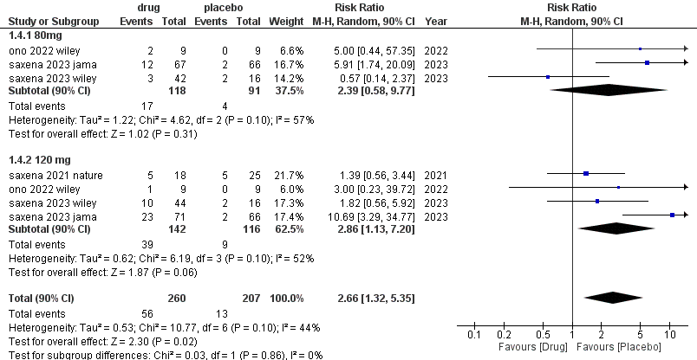

Supplemental Figure S3: Diarrhea outcome forest plot (after Sensitivity Analysis)

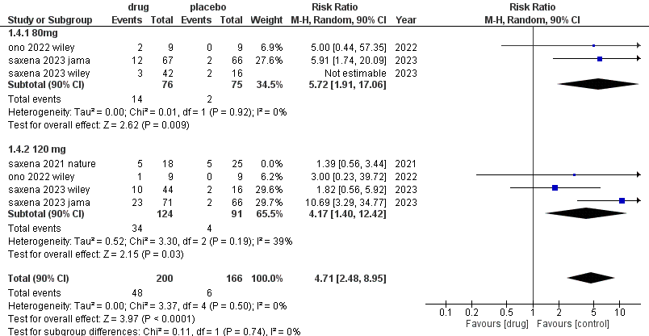

Supplemental Figure S4: Headache outcome forest plot

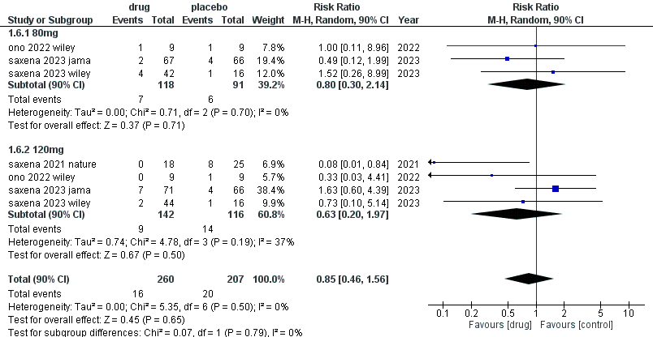

Supplemental Figure S5: Nausea outcome forest plot

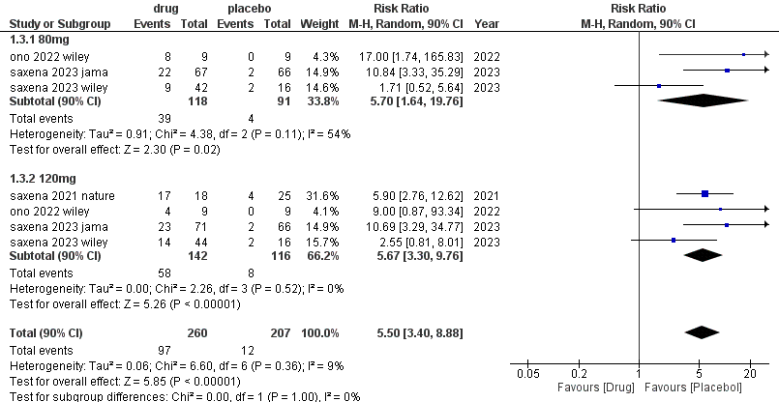

Supplemental Figure S6: Nausea outcome forest plot (after Sensitivity Analysis)

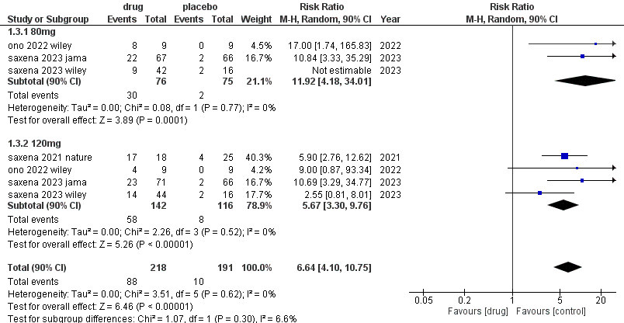

Supplemental Figure S7: Vomiting outcome forest plot (after Sensitivity Analysis)

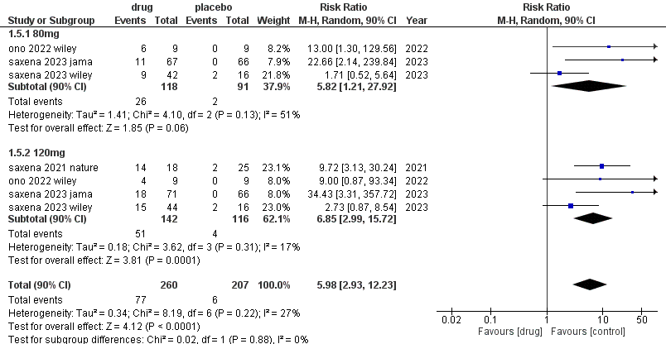

Supplemental Figure S8: Vomiting outcome forest plot (after Sensitivity Analysis)

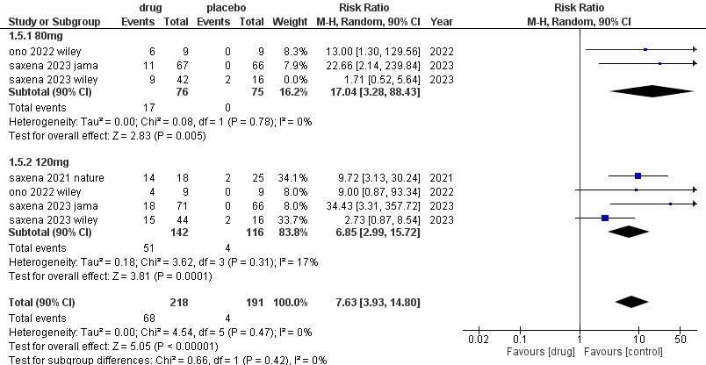

Supplemental Figure S9: Decreased Appetite outcome forest plot

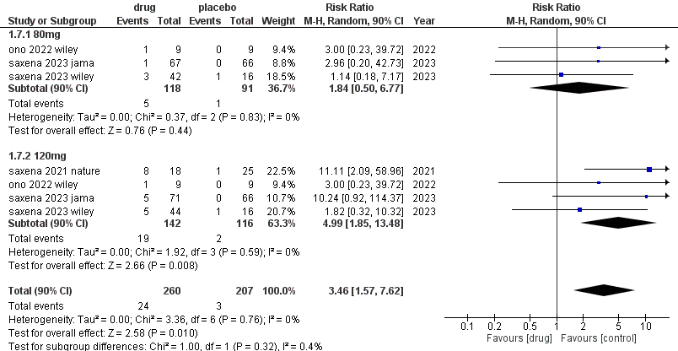

Supplemental Figure S10: Dyspepsia, Abdominal distension, Hypoglycemia and Dizziness outcomes forest plot
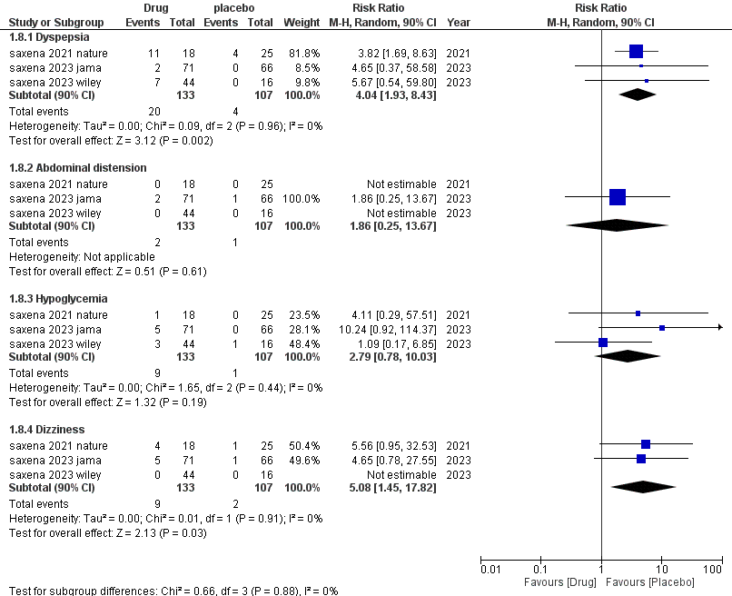

Supplemental Figure S11: Reduction in HBA1C from baseline forest plot

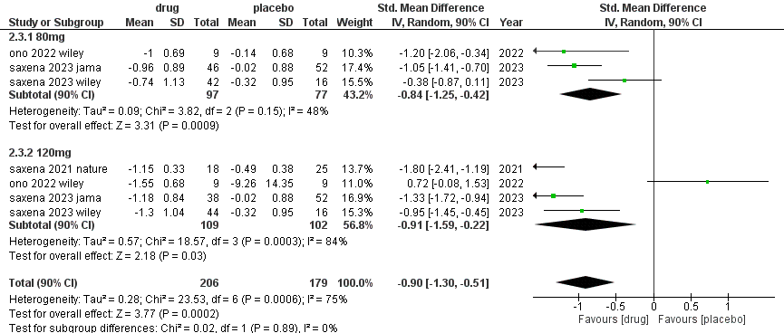

Supplemental Figure S12: Reduction in HBA1C from baseline after sensitivity analysis forest plot

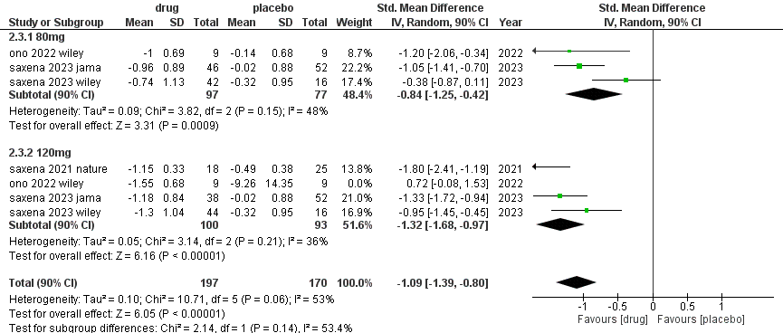

Supplemental Figure S13: Change in fasting plasma glucose (FPG) forest plot

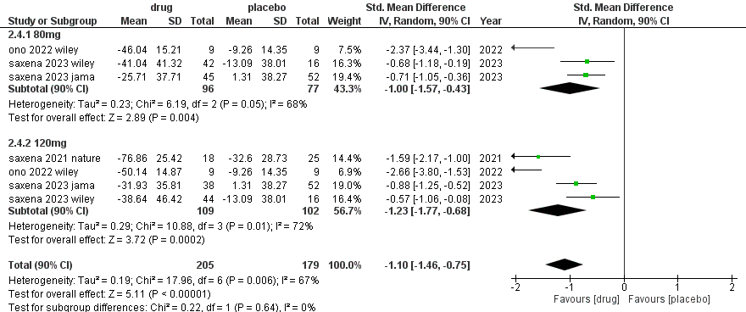

Supplemental Figure S14: Change in fasting plasma glucose (FPG) forest plot after sensitivity analysis

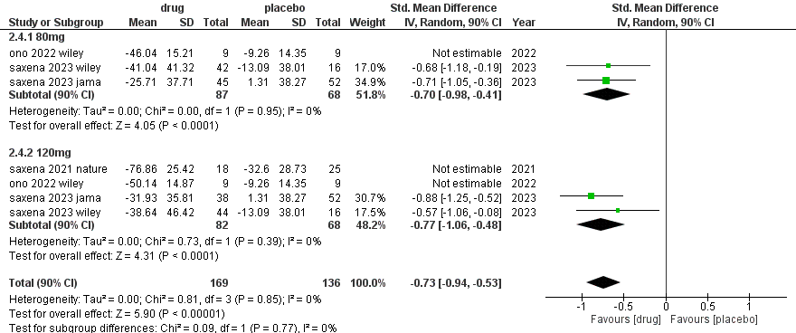

Supplemental Figure S15: Change in Body weight forest plot

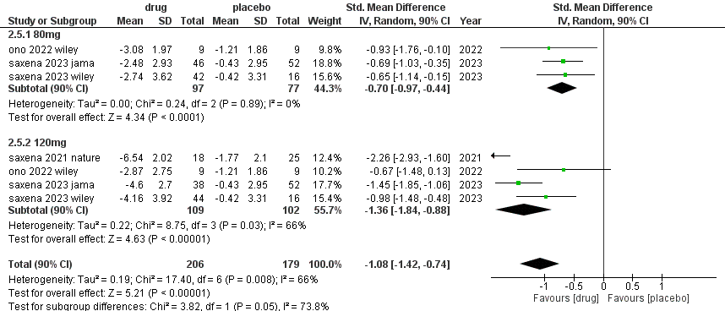

Supplemental Figure S16: Change in Body weight after sensitivity analysis

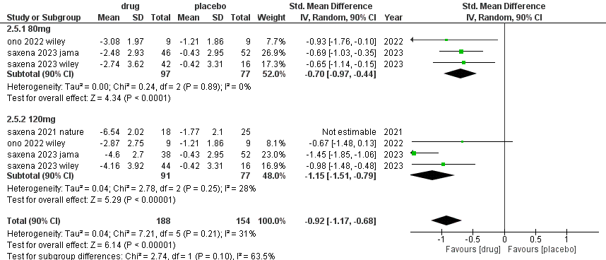

Supplemental Figure S17: Changes in Fasting Plasma Insulin(FPI), Homo-IR and Fasting Glucagon forest plots
