Supplementary data

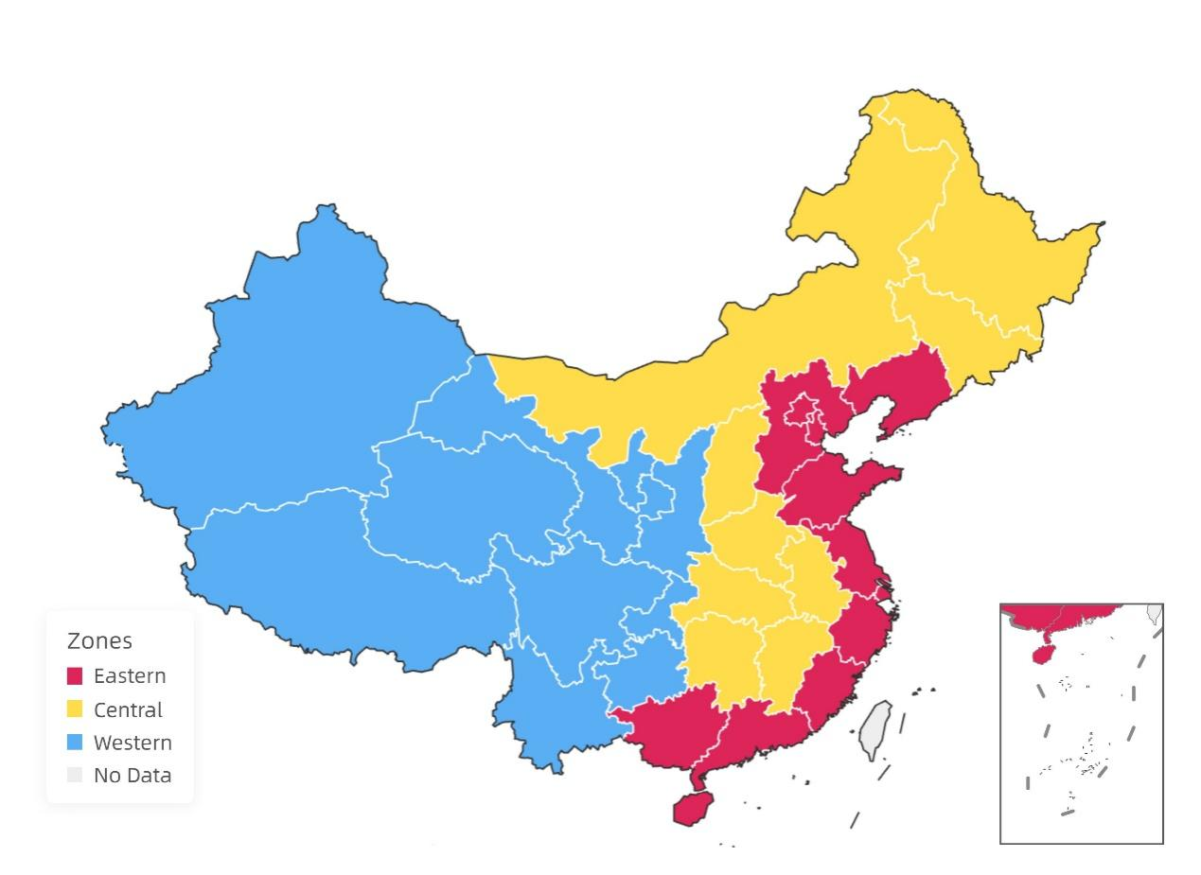
Note: The eastern zone comprises 12 provinces, including Beijing, Tianjin, Hebei, Liaoning, Shanghai, Jiangsu, Zhejiang, Fujian, Shandong, Guangdong, Guangxi, and Hainan. The central zone consists of 9 provinces, including Shanxi, Inner Mongolia, Jilin, Heilongjiang, Anhui, Jiangxi, Henan, Hubei, and Hunan. The western zone comprises10 provinces, including Sichuan, Chongqing, Guizhou, Yunnan, Tibet, Shaanxi, Gansu, Ningxia, Qinghai, and Xinjiang.

Figure S1: China's three major economic zones

