Pioneering Astaxanthin-Tumor Cell Membrane Nanoparticles for Innovative Targeted Drug Delivery on Melanoma
Supplementary data
Cell culture
The immortalized skin keratinocytes (HaCaT).
Fig. S1a showed the cell viability of HaCaT under the treatment of ANPs (0.42 and 0.84 mM). It illustrated that there was no distinguished difference in the survival rate of HaCaT between 100 ~ 200 𝜇M ANPs (0.42 and 0.84 mM), and the survival rate was above 70%. Fig. S1b and 1c demonstrated that ANPs do not enter into non-melanoma cells since there was no fluorescence in the HaCaT cells, and the drug was suspended above the HaCaT keratinocytes rather than enter into the cells, nor cellular debris was found on the culture dish.
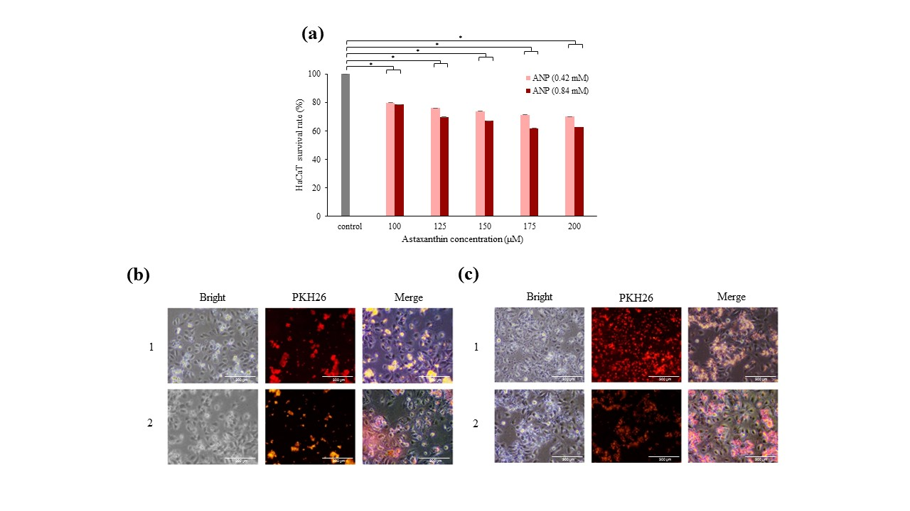
Fig. S1. Cell viability test and fluorescence stain (a) The cell survival rate in HaCaT after conducting different concentrations of ANPs (0.42 and 0.84 mM). (b, c) The HaCaT was co-incubated for 24 hours with PKH26-stained ANPs (0.42 and 0.84 mM). * P < 0.05 vs the control group.

Table S1. Primers used in qRT-PCR

p21
Forward: 5′-TCTGAGCGGCCTGAAGATTC-3′
Reverse: 5′-CAATCTGCGCTTGGAGTGATAG-3′
p27
Forward: 5′-AGCAGTGTCCAGGGATGAGGAA-3′
Reverse: 5′-TTCTTGGGCGTCTGCTCCACAG-3′
Bax
Forward: 5′-GAGAGGTCTTTTTCCGAGTGG-3′
Reverse: 5′-GGAGGAAGTCCAATGTCCAG-3′
Bcl-2
Forward: 5′-GTATTGGTGAGTCGGATTGCAA-3′
Reverse: 5′-TGCTGCATTGTTCCCGTAGAG-3′

