SUPPLEMENTARY MATERIALS

Cell line-dependent adhesion and inhibition of proliferation on carbon-based nanofilms
Barbara Wójcik¹, Katarzyna Zawadzka¹, Ewa Sawosz¹, Malwina Sosnowska¹, Agnieszka Ostrowska¹, Mateusz Wierzbicki¹

¹ Department of Nanobiotechnology, Institute of Biology, Warsaw University of Life Sciences, Ciszewskiego 8, 02-786 Warsaw, Poland

Correspondence: Mateusz Wierzbicki
Department of Nanobiotechnology, Institute of Biology, Warsaw University of Life Sciences, Ciszewskiego 8, 02-786 Warsaw, Poland
Tel +48 22 5936676
Email mateusz_wierzbicki@sggw.edu.pl

Morphological analysis
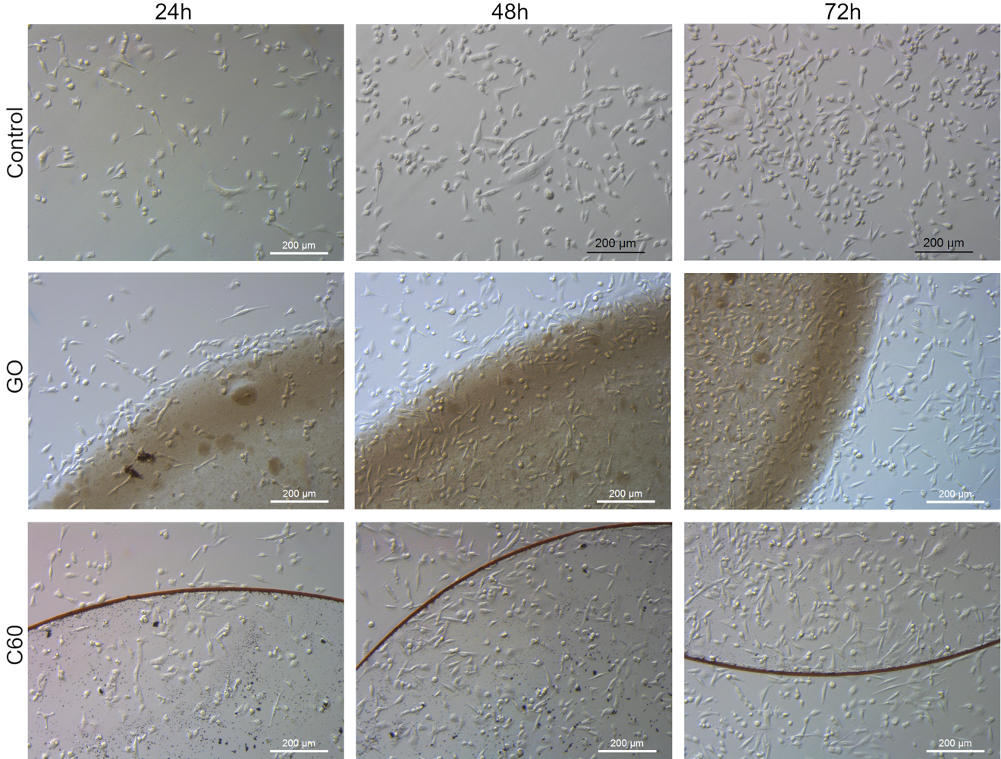
FIGURE S1 Morphological characterization of MDA.MB.231 human breast adenocarcinoma, seeded on GO and C60 nanofilms after 24 hours, 48 hours, and 72 hours.
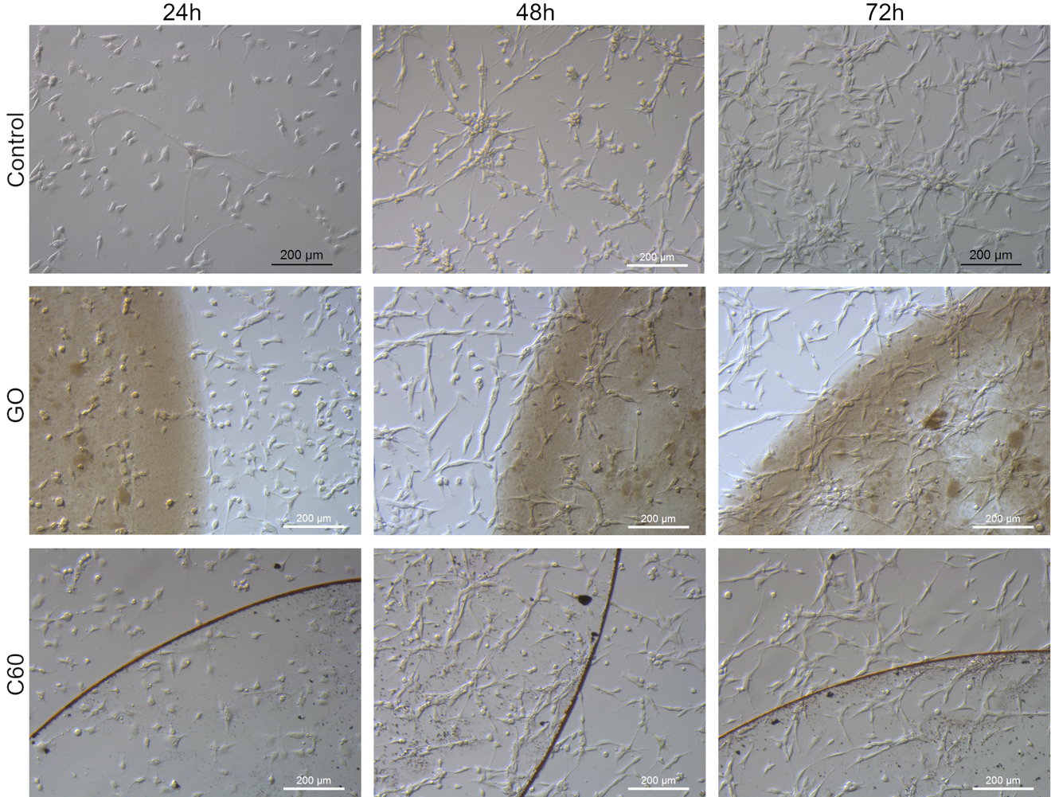
FIGURE S2 Morphological characterization of U-87 MG glioblastoma grade IV cells seeded on GO and C60 nanofilms after 24 hours, 48 hours, and 72 hours.

Interference analysis
In order to avoid false results of the analysis based on the lactate dehydrogenase (LDH) measurements for nanofilms made of graphene (GN), graphene oxide (GO), fullerene (C60), and diamond nanoparticles (ND) used in the experiments, an interference test was performed. The analysis revealed no significant influence of the tested nanofilms compared with the control (Figure 3S).
In order to perform interference analysis, 50 µL of colloidal suspensions of tested nanomaterials were placed at the bottom of a 96-well plate (Nunc, Thermo Fisher Scientific) and dried under sterile conditions. After nanomaterials were fully dried, 100 µL of cell culture medium - EMEM (ATCC, Manassas, VA, USA) was added to a triplicate of wells that were not covered with nanofilm (control group), the same amount of EMEM was added to the wells with nanofilms and incubated for 24 hours in humanified atmosphere. Subsequently, a lactate dehydrogenase activity assay (Thermo Fisher Scientific, Waltham, MA, USA) was performed. 50 µl of cell culture media was transferred into a new plate, followed by mixing with 100 µl of LDH reaction mixture. Spectrophotometer reading was performed after 30 minutes at 490 nm (reference wavelength: 690 nm) using a microplate reader (Tecan Group Ltd., Männedorf, Switzerland). The results are presented as the percentage of the control. Each group consisted of three replicates.
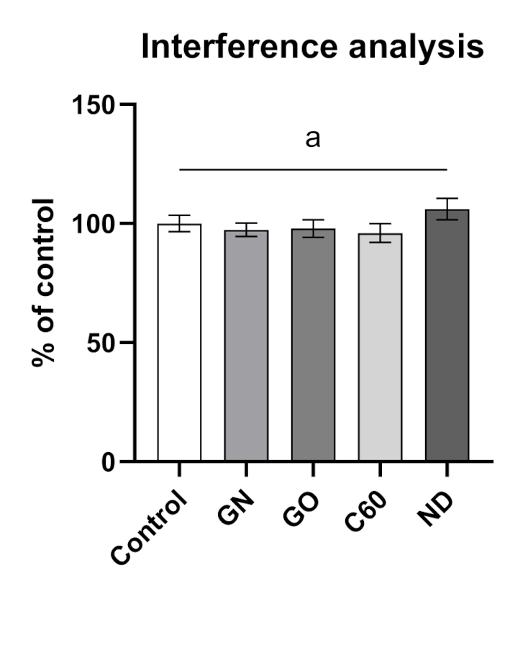
FIGURE S3 LDH interference analysis. Interactions of LDH reagent and nanomaterials are presented as the percentage of control from three replicates with the standard deviation. Different letters above the columns indicate statistically significant differences between the groups (p ≤ 0.05).

