Appendix 1

Table S1. Comparative Analysis of Clinical Characteristics across Training and Verification Cohorts
Variable | Training cohort (n=432) | Verification cohort (n=186) | T/χ²/Z value | P value
Age, years | 50.51±8.78 | 51.16±8.73 | 0.844 | 0.399ª
Male gender, n(%) | 245 (56.7%) | 97 (52.2%) | 1.095 | 0.295^{b}
Hypertension, n(%) | 209 (48.4%) | 92 (49.5%) | 0.061 | 0.805^{b}
Smoking, n(%) | 108 (25.0%) | 43 (23.1%) | 0.249 | 0.618^{b}
BMI, kg/m² | 29.23±4.85 | 29.45±4.94 | 0.522 | 0.602ª
Waist circumference, cm | 97.06±14.61 | 96.61±14.79 | 0.352 | 0.725ª
FBG, mmol/L | 5.3 (3.7, 7.3) | 5.3 (3.7, 7.5) | 0.321 | 0.749^{c}
HbA1c, % | 7.05±1.94 | 7.21±1.84 | 0.935 | 0.350ª
Triglycerides, mmol/L | 1.69 (1.23, 2.62) | 1.68 (1.18, 2.55) | 0.561 | 0.575^{c}
TC, mmol/L | 3.98±1.33 | 3.97±1.29 | 0.126 | 0.900ª
HDL-C, mmol/L | 1.05±0.41 | 1.08±0.40 | 1.077 | 0.282ª
LDL-C, mmol/L | 2.50±0.81 | 2.50±0.86 | 0.106 | 0.916ª
AST, IU/L | 19 (12, 35) | 19 (13, 34) | 0.053 | 0.958^{c}
ALT, IU/L | 31 (14, 49) | 28 (15, 47) | 0.579 | 0.562^{c}
ALB, IU/L | 39.60±6.78 | 40.46±6.46 | 1.470 | 0.142ª
PLT, ×10⁹/L | 246.41±49.34 | 245.24±48.90 | 0.271 | 0.786ª
HOMA-IR | 1.87±0.62 | 1.88±0.62 | 0.297 | 0.766ª
LSM, kPa | 5.5 (4.4, 6.2) | 5.6 (4.5, 5.9) | 0.511 | 0.609^{c}
ªfor independent sample t-test, ^{b}for chi-square test, and ^{c}for Mann-Whitney U test.

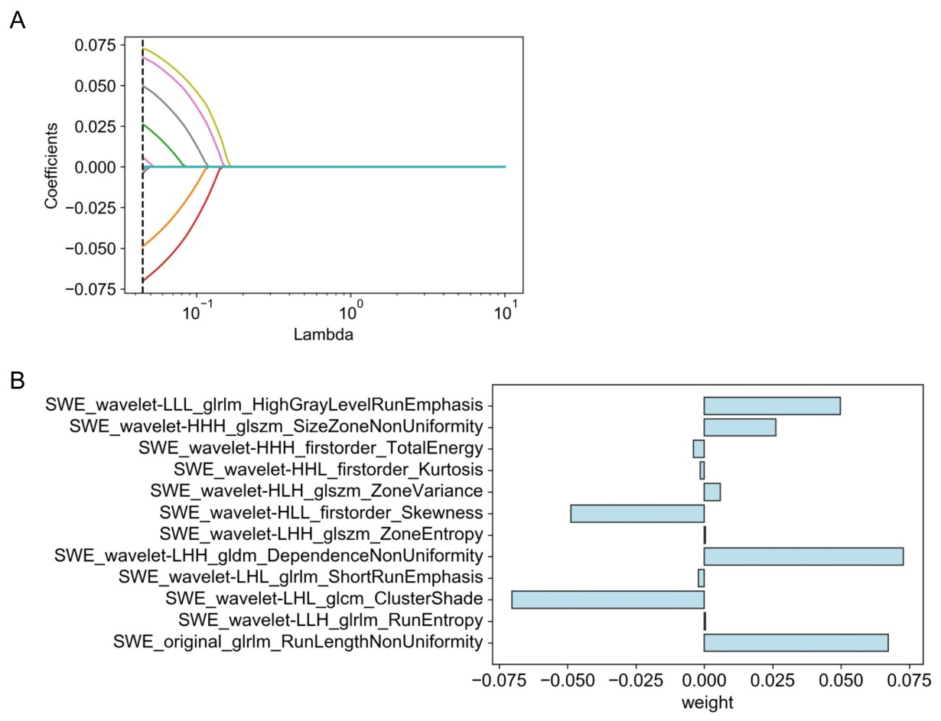
Figure S1. LASSO Regression-Guided Radiomics Feature Selection in SWE Segmentation. Figure A delineates the distribution of features filtered through LASSO, while Figure B presents the retained features alongside their respective weights. In the wavelet-transformed images, the low and high-frequency coefficient blocks are denoted as L and H, respectively.

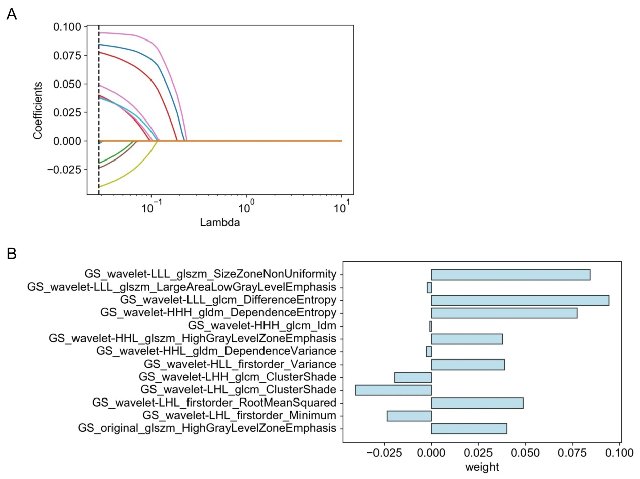
Figure S2. LASSO Regression-Driven Radiomics Feature Selection in Grayscale Segmentation. Figure A provides the distribution of LASSO-selected features, and Figure B illustrates the chosen features with their corresponding weights. GS: grayscale. In the wavelet-transformed images, the low and high-frequency coefficient blocks are denoted as L and H, respectively.

Abbreviations in Appendix

ALB: Albumin, ALT: Alanine Aminotransferase ratio, AST: Aspartate Aminotransferase, BMI: Body Mass Index, FBG: Fasting Blood Glucose, GS: Grayscale, HbA1c: Hemoglobin A1c, HDL-C: High Density Lipoprotein Cholesterol, HOMA-IR: Homeostasis Model Assessment of Insulin Resistance, LASSO: Least Absolute Shrinkage and Selection Operator, LDL-C: Low Density Lipoprotein Cholesterol, PLT: Platelet Counts, SWE: Shear Wave Elastography, TC: Total Cholesterol.

