Patterns, Risk factors, and Outcomes of Recurrence After Hepatectomy for Hepatocellular Carcinoma With and Without Microvascular Invasion
Yang Yu1*, Xiao-Hui Wang2*, Wen-Jie Hu1, De-Hua Chen1, Zi-Li Hu3, Shao-Qiang Li1†
¹ Hepatic Pancreatobiliary Surgery Center, The First Affiliated Hospital, Sun Yat-sen University, Guangzhou 510080, China;
²Department of Liver Surgery, Sun Yat-Sen University Cancer Center, Guangzhou, Guangdong, 510060, P. R. China.
³Department of Hepatobiliary Surgery, Hunan Provincial People's Hospital (The First Affiliated Hospital of Hunan Normal University) Changsha, 410005, Hunan province, China.
†Correspondence
Shao-Qiang Li, Hepatic Pancreatobiliary Surgery Center, the First Affiliated Hospital, Sun Yat-sen University, Guangzhou 510080, China. E-mail: lishaoq@mail.sysu.edu.cn. Tel: +86-020-87755766-8214, Fax: +86-020-87755766-8661
*These authors contributed equally to this work

Supplementary Figure 1. Distribution of the propensity score after matching.
Supplementary Figure 2. Standardized differences in mean or proportion of variables before and after propensity score matching
Supplementary Figure 3. Tumor recurrence at different time points. *P<0.001
Supplementary Table 1. Occurrence rates of extrahepatic organs metastasis
Supplementary Table 2. Univariate analysis of risk factors associated with early and late recurrence in the entire cohort.
Supplementary Table 3. Univariate analysis of risk factors associated with early and late recurrence in the MVI⁽⁺⁾ group
Supplementary Table 4. Univariate analysis of risk factors associated with early and late recurrence in the MVI⁽⁻⁾ group

Supplementary Figure 1. Distribution of the propensity score after matching.
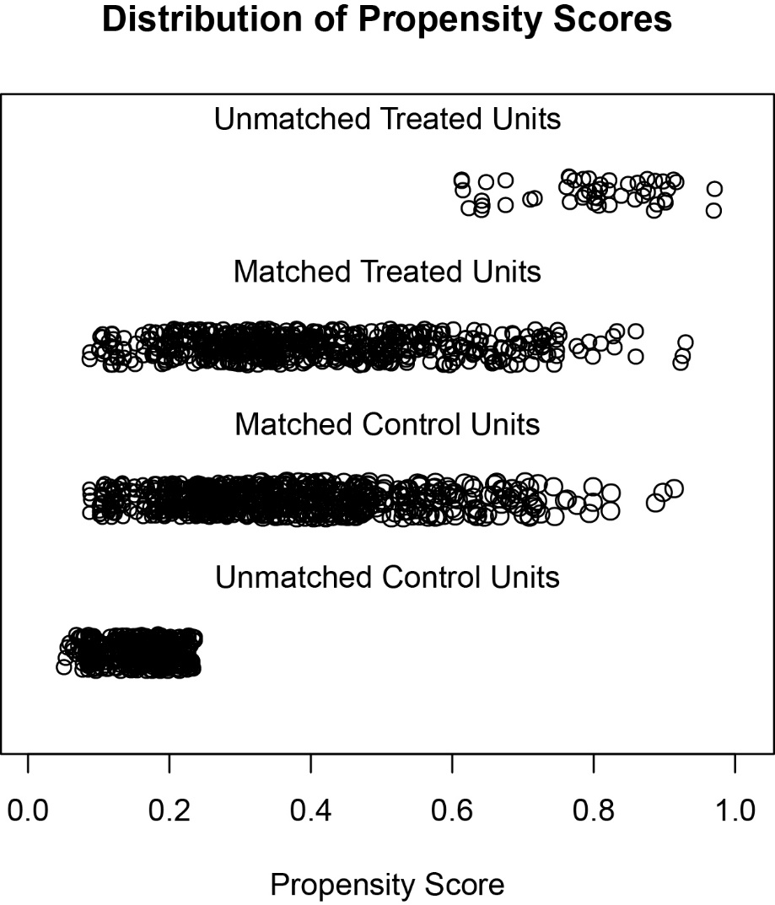

Supplementary Figure 2. Standardized differences in mean or proportion of variables before and after propensity score matching
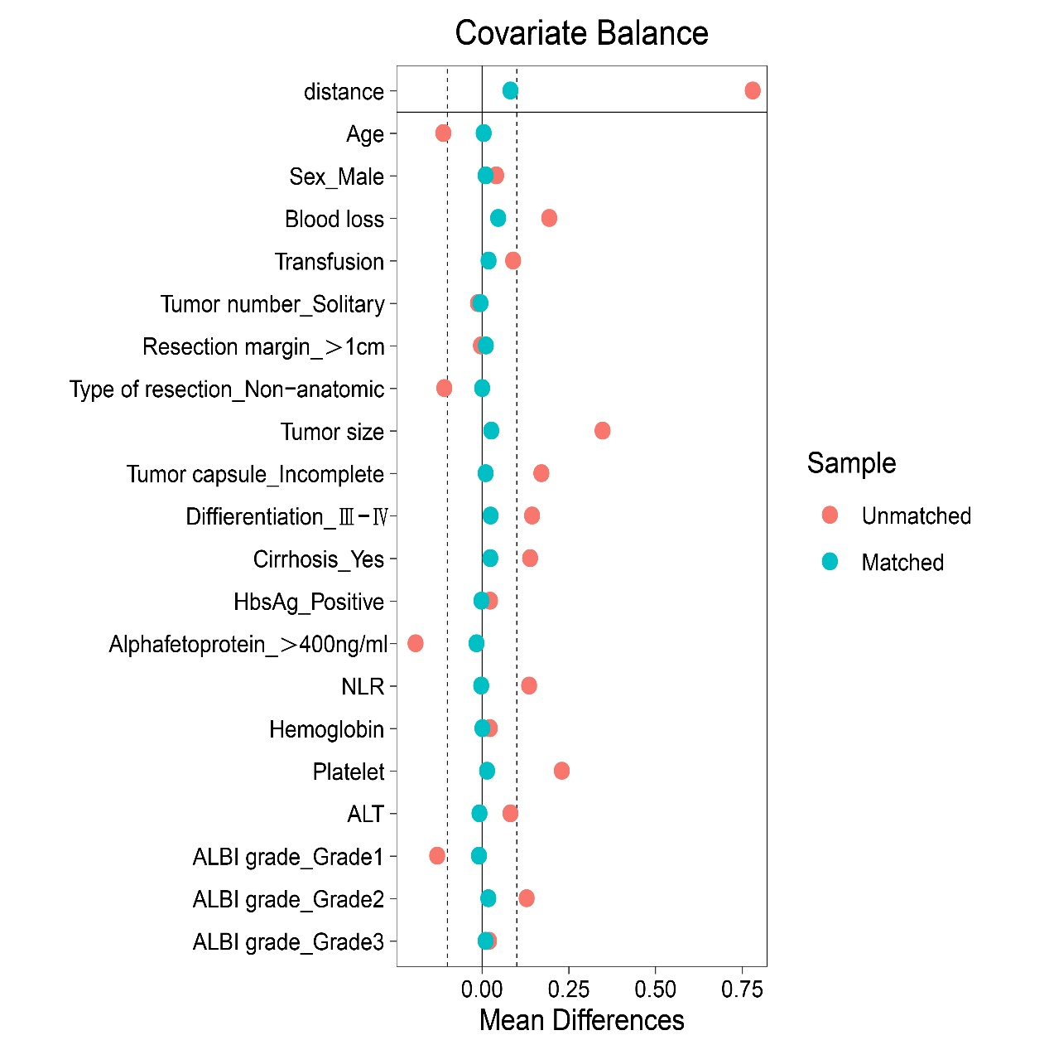

Supplementary Figure 3. Tumor recurrence at different time points. *P<0.001

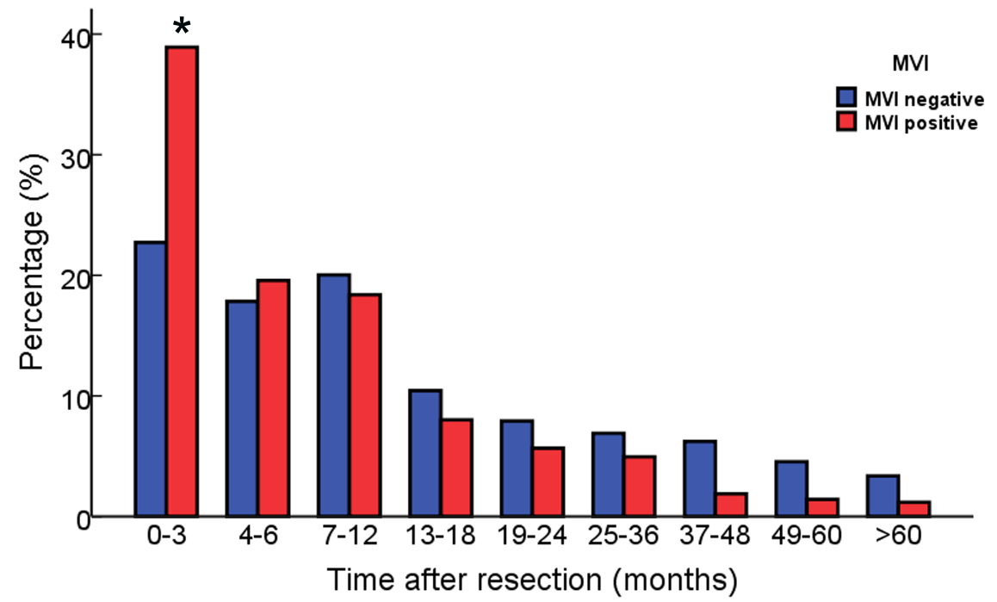

Supplementary Table 1. Occurrence rates of extrahepatic organs metastasis
Variables | Metastasis in the entire cohort
Variables | Total No. (n=1756) | MVI⁽⁺⁾  (n=581) | MVI⁽⁻⁾  (n=1175) | P  value
Lung | 149 (8.5) | 83 (14.3) | 66 (5.6) | <0.001
Lymph node | 49 (2.8) | 25 (4.3) | 24 (2.0) | 0.007
Other peritoneus organs† | 67 (3.8) | 29 (5.0) | 38 (3.2) | 0.070
Bone | 6 (0.34) | 2 (0.34) | 4 (0.36) | 0.990
Brain | 1 (0.06) | 1 (0.02) | 0 (0) | 0.155
Values in parentheses are percentage. †Included adrenal grand, peritoneum, omentum, intestines

Supplementary Table 2. Univariate analysis of risk factors associated with early and late recurrence in the entire cohort.
Variables | Early recurrence  HR (95% CI) P value |  | Late recurrence  HR (95% CI) P value
Age (year), ≤50 vs. >50 | 0.773 (0.675-0.884) | <0.001 | 1.345 (0.985-1.834) | 0.062
Sex, male vs. female | 0.912 (0.742-1.121) | 0.382 | 0.468 (0.266-0.824) | 0.009
HBsAg, positive vs. negative | 1.243 (1.036-1.492) | 0.019 | 1.743 (1.161-2.618) | 0.007
Cirrhosis, yes vs. no | 1.139 (0.995-1.303) | 0.059 | 2.473 (1.835-3.334) | <0.001
ALBI grade, 2,3 vs. 1 | 1.272 (1.116-1.450) | <0.001 | 1.853 (1.375-2.497) | <0.001
ALT (U/L), >40 vs. ≤40 | 1.125 (0.983-1.288) | 0.087 | 1.367 (1.009-1.852) | 0.044
NLR, >1.9 vs. ≤1.9* | 1.525 (1.332-1.747) | <0.001 | 1.008 (0.743-1.368) | 0.958
AFP (μg/L), >400 vs. ≤400 | 1.817 (1.588-2.080) | <0.001 | 0.436 (0.295-0.645) | <0.001
Tumor size (cm), >5 vs. ≤5 | 1.658 (1.421-1.936) | <0.001 | 0.440 (0.325-0.605) | 0.001
Tumor number, multiple vs. solitary | 1.480 (1.338-1.636) | <0.001 | 0.845 (0.610-1.169) | 0.309
Tumor capsule, incomplete vs. complete | 1.047 (0.903-1.231) | 0.546 | 0.571 (0.402-0.811) | 0.021
Differentiation, Ⅲ-Ⅳ vs. Ⅰ-Ⅱ | 1.379 (1.246-1.526) | <0.001 | 1.710 (1.341-2.182) | <0.001
MVI, positive vs. negative | 2.068 (1.806-2.369) | <0.001 | 1.366 (0.957-1.951) | 0.086
Blood transfusion, yes vs. no | 1.595 (1.366-1.861) | <0.001 | 0.887 (0.571-1.378) | 0.595
Type of resection, NAR vs. AR | 0.856 (0.746-0.982) | 0.027 | 1.037 (0.745-1.445) | 0.829
Resection margin, ≤1cm vs. >1cm | 0.761 (0.655-0.884) | <0.001 | 1.189 (0.870-1.625) | 0.277
HR, hazard ratio; CI, confidence interval; HBsAg, hepatitis B surface antigen; ALT; alanime transaminase; NLR, neutrophil to lymphocyte ratio; AFP, alpha fetoprotein; MVI, microvascular invasion; NAR, non-anatomical resection; AR, anatomical resection. *1.9 was the median value of NLR.

Supplementary Table 3. Univariate analysis of risk factors associated with early and late recurrence in the MVI⁽⁺⁾ group
Variables | Early recurrence  HR (95% CI) P value |  | Late recurrence  HR (95% CI) P value
Age (year), ≤50 vs. >50 | 0.828 (0.678-1.011) | 0.064 | 2.086 (1.071-4.066) | 0.032
Sex, male vs. female | 1.020 (0.738-1.410) | 0.906 | 0.580 (0.176-1.919) | 0.372
HBsAg, positive vs. negative | 1.078 (0.828-1.403) | 0.578 | 1.124 (0.532-2.375) | 0.759
Cirrhosis, yes vs. no | 1.307 (1.051-1.625) | 0.016 | 3.338 (1.733-6.431) | <0.001
ALBI grade, 2,3 vs. 1 | 1.199 (0.994-1.446) | 0.058 | 1.415 (0.785-2.551) | 0.248
ALT (U/L), >40 vs. ≤40 | 1.025 (0.839-1.252) | 0.809 | 1.160 (0.619-2.174) | 0.643
NLR, >1.9 vs. ≤1.9* | 1.317 (1.075-1.615) | 0.008 | 1.136 (0.610-2.113) | 0.688
AFP (μg/L), >400 vs. ≤400 | 1.505 (1.230-1.840) | <0.001 | 0.631 (0.324-1.230) | 0.177
Tumor size (cm), >5 vs. ≤5 | 1.658 (1.421-1.936) | <0.001 | 0.310 (0.159-0.606) | 0.001
Tumor number, multiple vs. solitary | 1.535 (1.077-1.441) | 0.003 | 0.874 (0.477-1.600) | 0.662
Tumor capsule, incomplete vs. complete | 0.832 (0.676-1.024) | 0.083 | 0.377 (0.200-0.713) | 0.030
Differentiation, Ⅲ-Ⅳ vs. Ⅰ-Ⅱ | 1.235 (0.979-1.558) | 0.074 | 2.817 (1.305-6.084) | 0.008
Blood transfusion, yes vs. no | 1.148 (0.918-1.438) | 0.228 | 0.758 (0.333-1.722) | 0.508
Type of resection, NAR vs. AR | 0.945 (0.773-1.155) | 0.582 | 0.975 (0.500-1.903) | 0.941
Resection margin, ≤1cm vs. >1cm | 0.626 (0.498-0.786) | <0.001 | 0.750 (0.584-2.108) | 0.750
HR, hazard ratio; CI, confidence interval; HBsAg, hepatitis B surface antigen; ALT; alanime transaminase; NLR, neutrophil to lymphocyte ratio; AFP, alpha fetoprotein; MVI, microvascular invasion; NAR, non-anatomical resection; AR, anatomical resection. *1.9 was the median value of NLR.

Supplementary Table 4. Univariate analysis of risk factors associated with early and late recurrence in the MVI⁽⁻⁾ group
Variables | Early recurrence  HR (95% CI) P value |  | Late recurrence  HR (95% CI) P value
Age (year), ≤50 vs. >50 | 0.778 (0.649-0.933) | 0.007 | 1.176 (0.823-1.679) | 0.373
Sex, male vs. female | 0.921 (0.705-1.203) | 0.545 | 0.446 (0.234-0.852) | 0.014
HBsAg, positive vs. negative | 1.362 (1.060-1.751) | 0.016 | 2.097 (1.272-3.456) | 0.004
Cirrhosis, yes vs. no | 0.917 (0.768-1.096) | 0.342 | 2.387 (1.695-3.361) | <0.001
ALBI grade, 2,3 vs. 1 | 1.133 (0.942-1.363) | 0.186 | 2.007 (1.412-2.853) | <0.001
ALT (U/L), >40 vs. ≤40 | 1.127 (0.939-1.352) | 0.201 | 1.392 (0.979-1.978) | 0.065
NLR, >1.9 vs. ≤1.9* | 1.562 (1.302-1.873) | <0.001 | 0.958 (0.671-1.368) | 0.815
AFP (μg/L), >400 vs. ≤400 | 1.721 (1.429-2.072) | <0.001 | 0.333 (0.199-0.556) | <0.001
Tumor size (cm), >5 vs. ≤5 | 1.584 (1.295-1.937) | <0.001 | 0.480 (0.336-0.687) | <0.001
Tumor number, multiple vs. solitary | 1.643 (1.434-1.883) | <0.001 | 0.809 (0.545-1.201) | 0.239
Tumor capsule, incomplete vs. complete | 0.984 (0.793-1.220) | 0.881 | 0.579 (0.373-0.897) | 0.015
Differentiation, Ⅲ-Ⅳ vs. Ⅰ-Ⅱ | 1.196 (0.892-1.603) | 0.232 | 1.151 (0.469-2.824) | 0.759
Blood transfusion, yes vs. no | 1.804 (1.457-2.234) | <0.001 | 0.916 (0.542-1.548) | 0.742
Type of resection, NAR vs. AR | 0.923 (0.762-1.118) | 0.412 | 1.078 (0.732-1.588) | 0.704
Resection margin, ≤1cm vs. >1cm | 0.857 (0.702-1.045) | 0.128 | 1.186 (0.826-1.704) | 0.356
HR, hazard ratio; CI, confidence interval; HBsAg, hepatitis B surface antigen; ALT; alanime transaminase; NLR, neutrophil to lymphocyte ratio; AFP, alpha fetoprotein; MVI, microvascular invasion; NAR, non-anatomical resection; AR, anatomical resection. *1.9 was the median.

