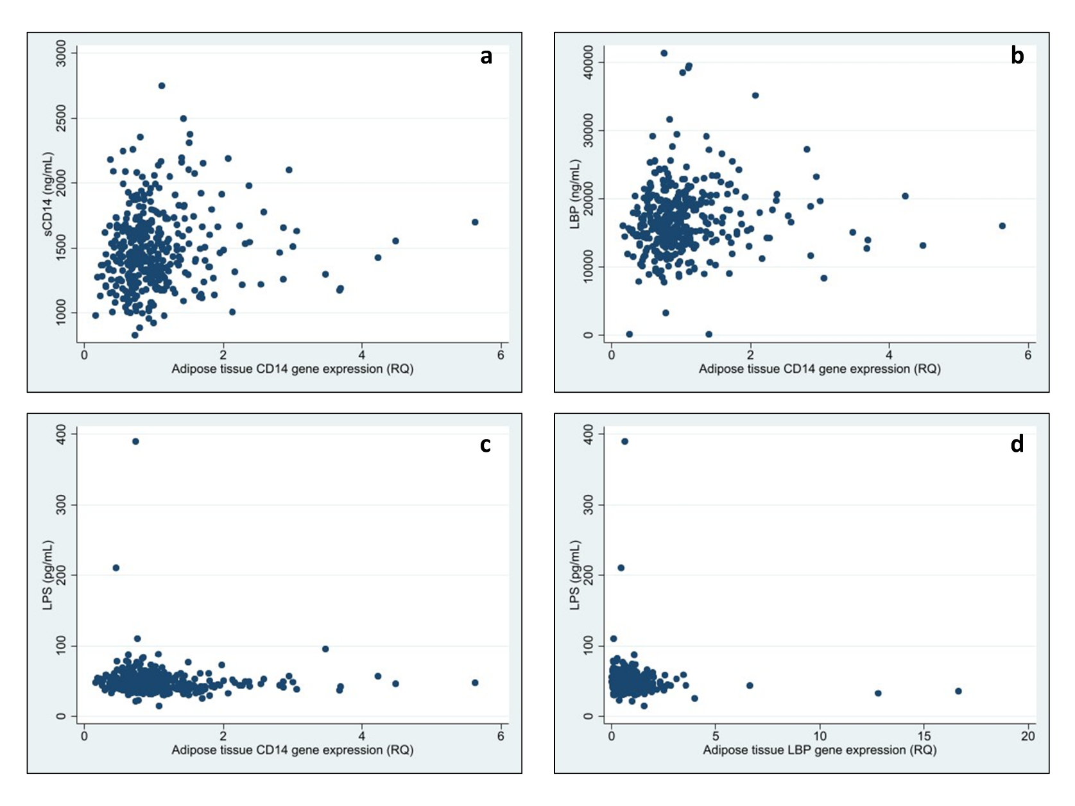
Supplementary figure 1 a-d
Supplementary figure 1 a-d Correlation between circulating gut leakage markers and corresponding gene expression in SAT.
Abbreviations: CD14=cluster of differentiation 14. sCD14= soluble CD14. LBP=LPS-binding protein. RQ=relative quantification.

Supplementary figure 2 a-g
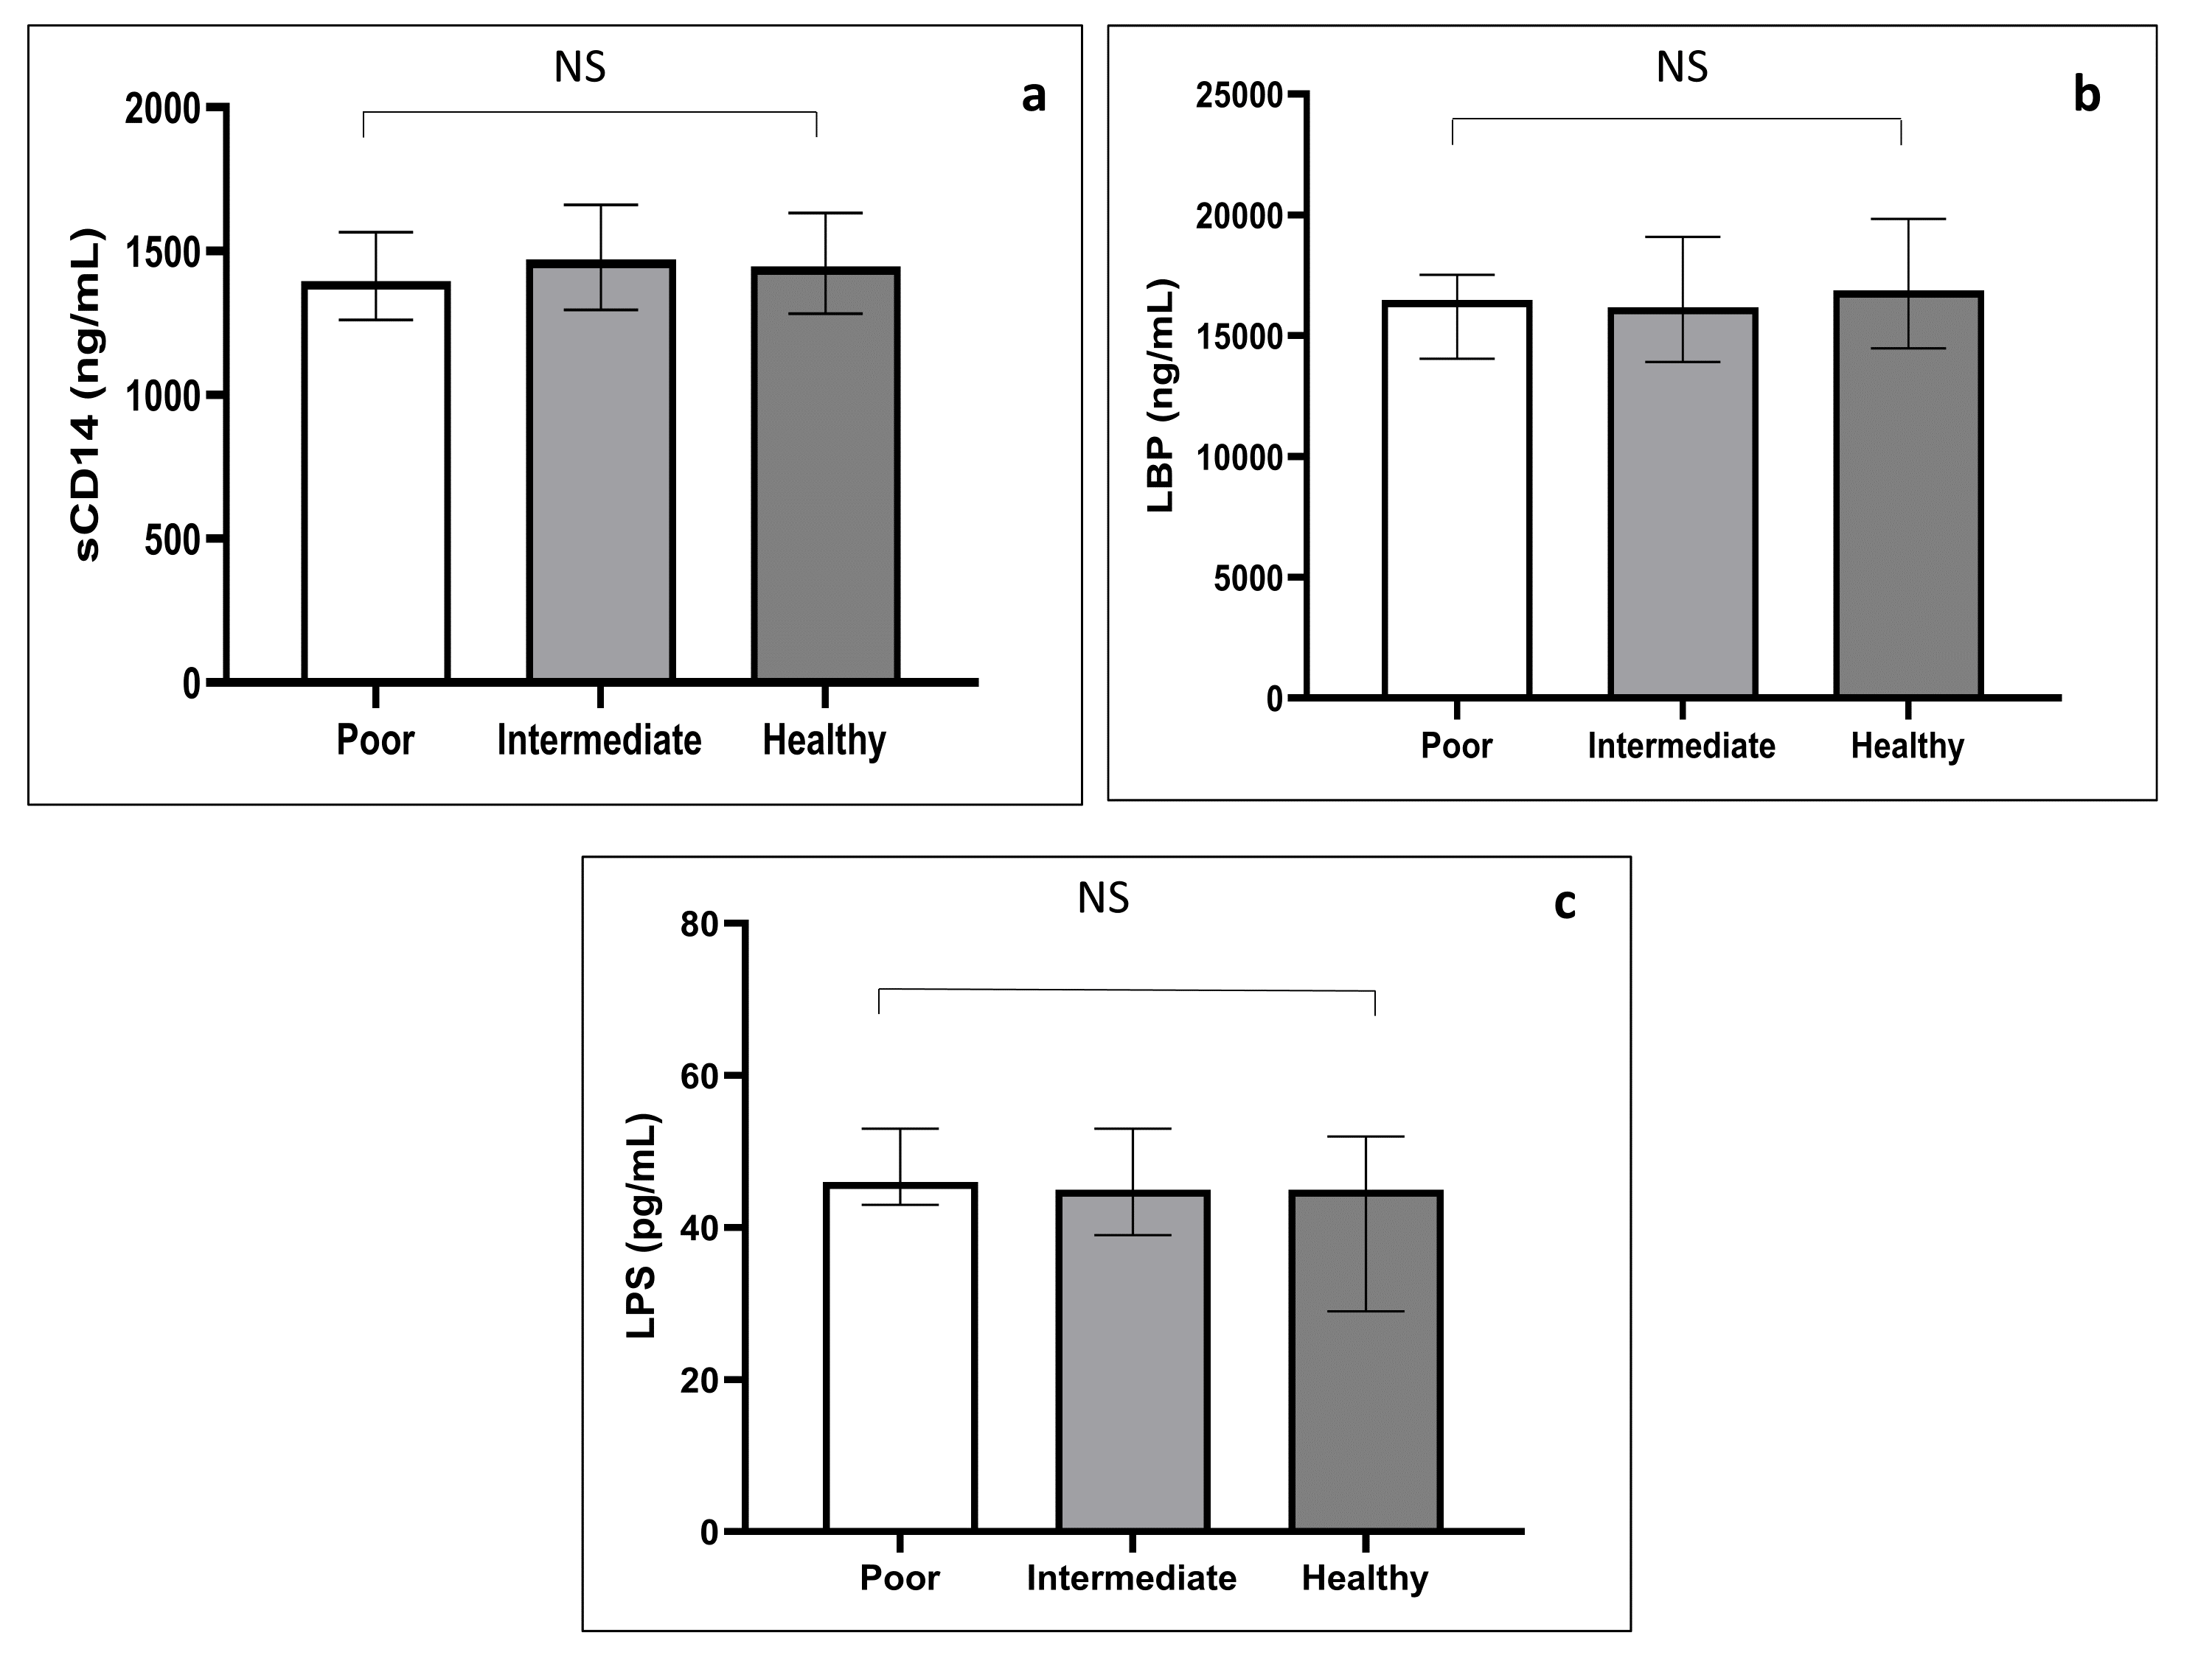

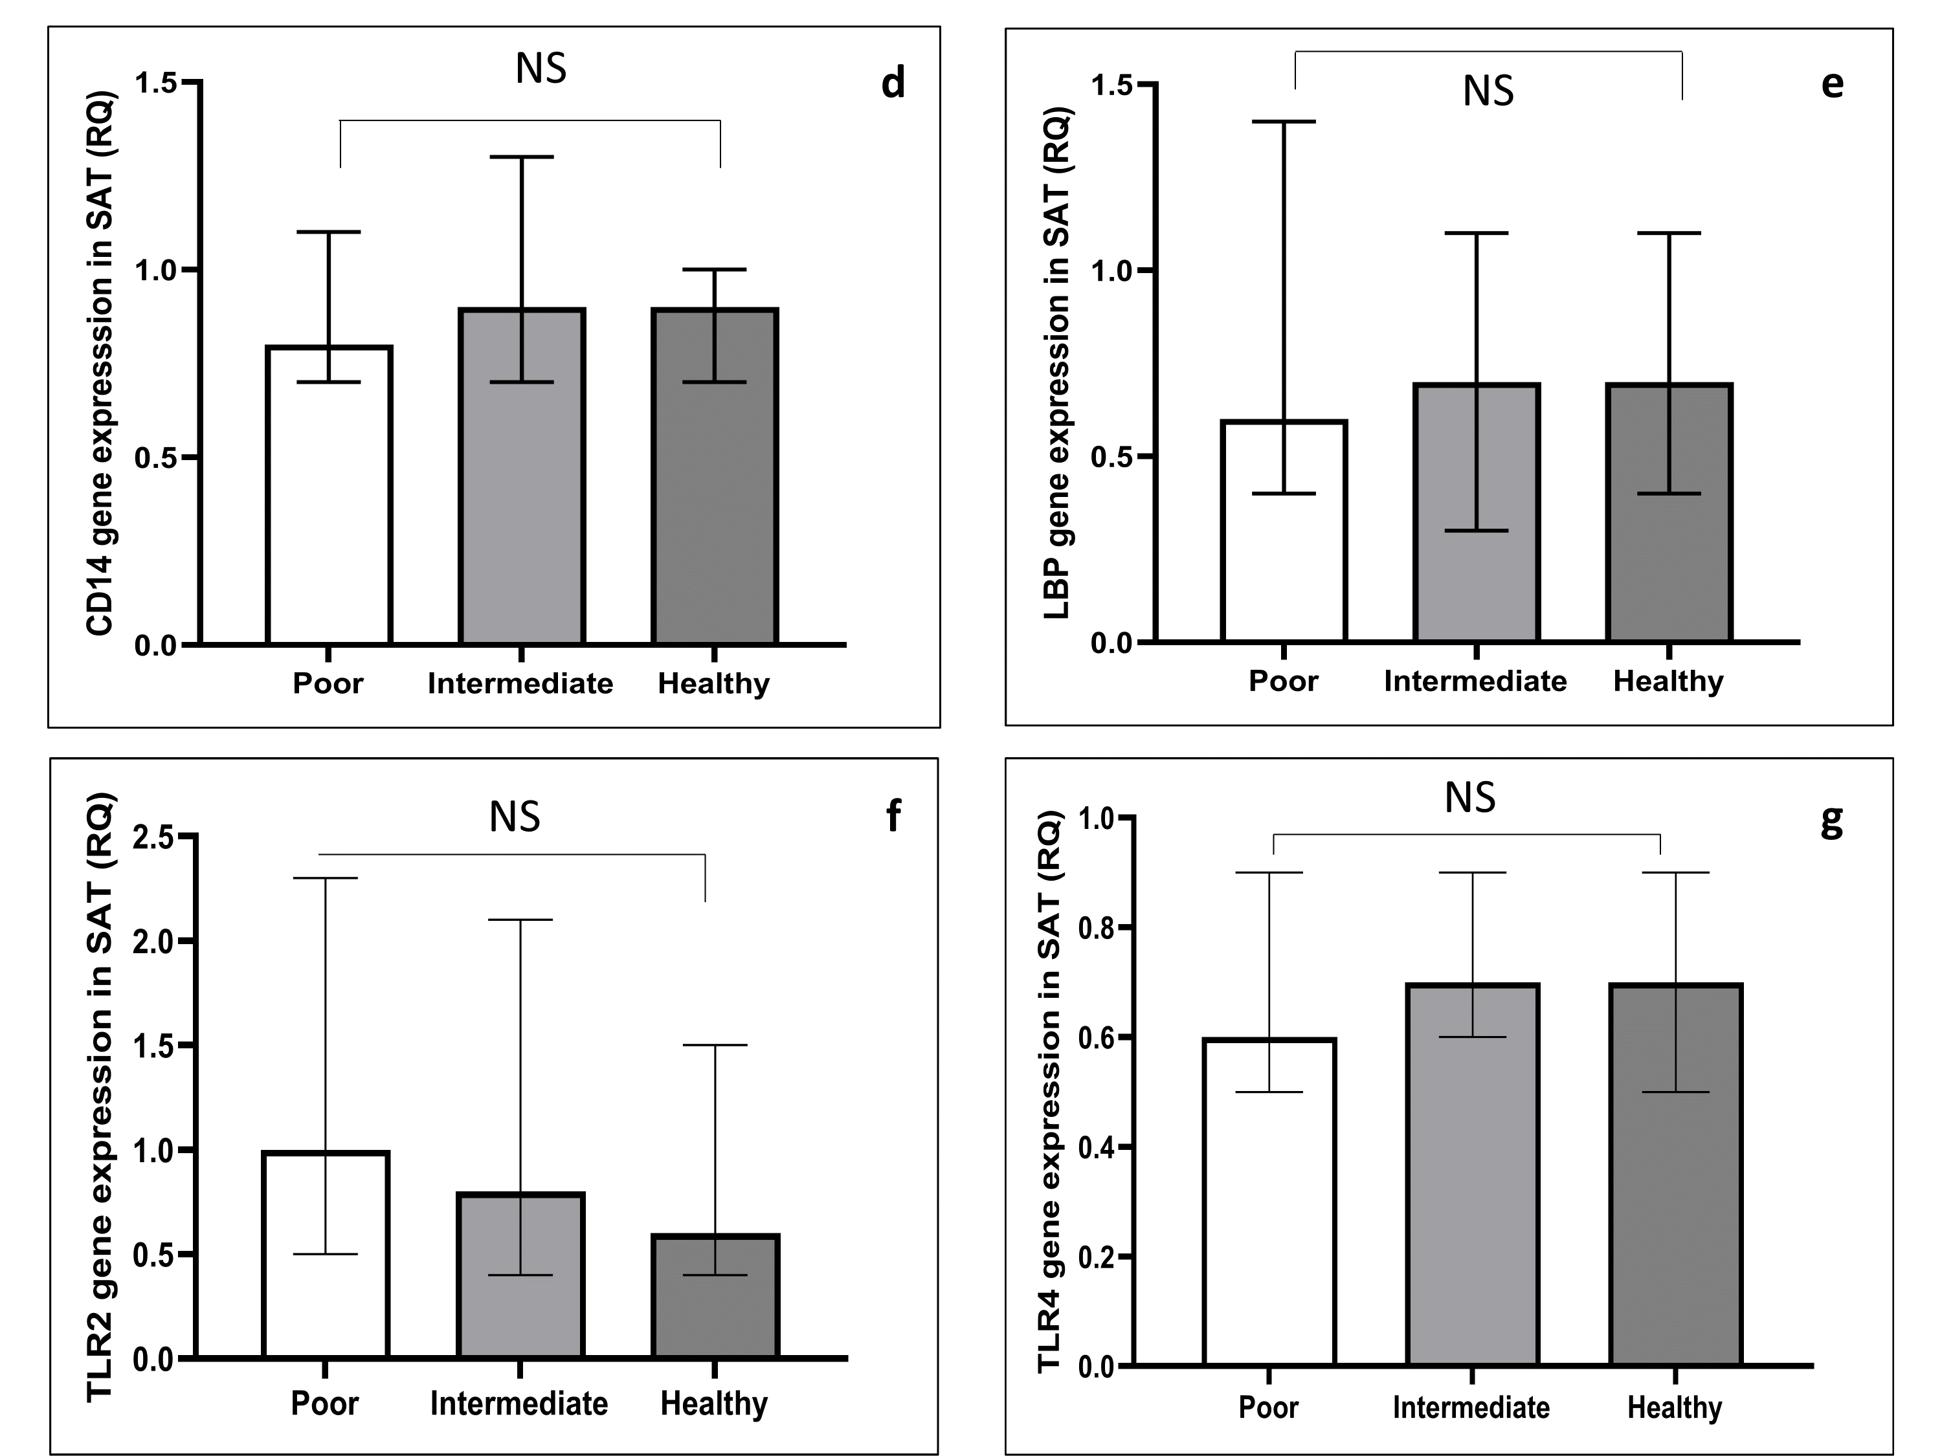
Supplementary figure 2 a-g Circulating levels and genetic expression in SAT of gut leakage markers in relation to diet.
Abbreviations: CD14=cluster of differentiation 14. sCD14= soluble CD14. LPS=Lipopolysaccharide. LBP=LPS-binding protein. TLR2/4=Toll-like receptor 2/4. RQ=relative quantification. SAT=subcutaneous adipose tissue. NS=Not significant. Diet is defined as “poor”, “intermediate” or “healthy”.

