Supplementary Table 1. Diagnostic criteria of the cardiac arrhythmia diseases in current study
Disease Diagnosis | Minnesota code | Diagnostic criteria
Atrioventricular block (AVB)
First-degree AVB | 6-3 | P waves associated with 1:1 atrioventricular conduction and a PR interval >200ms (this is more accurately defined as atrioventricular delay because no P waves are blocked).
Second-degree AVB | 6-2 | P waves with a constant rate (<100 bpm) where atrioventricular conduction is present but not 1:1
Second-degree AVB | 6-2 | Mobitz type I: P waves with a constant rate (<100 bpm) with a periodic single nonconducted P wave associated with P waves before and after the nonconducted P wave with inconstant PR intervals.
Second-degree AVB | 6-2 | Mobitz type II is characterized by fixed PR intervals before and after blocked beats and is usually associated with a wide QRS complex.
Third-degree AVB | 6-1 | P wave and QRS wave were rhythmical and uncorrelated with each other. Atrial rate was faster than ventricular rate.
Bundle branch block (BBB)
Right BBB (RBBB)
Complete RBBB | 7-2 | 1) QRS duration of 120ms or longer in the presence of normal sinus rhythm or supraventricular rhythm; 2) R or rSR′ complex in lead V1; 3) rS in leads V5, V6, I, or aVL with prolonged shallow S wave.
Incomplete RBBB | 7-3 | Same QRS morphology criteria as complete RBBB but with a QRS duration between 110 and 119ms.
Left BBB (LBBB)
Complete LBBB | 7-1 | 1) QRS duration of 120ms or longer in the presence of normal sinus rhythm or supraventricular rhythm (not atrial fibrillation); 2) QS or rS complex in lead V1; 3) broad R waves in leads I, aVL, V5-V6 (or an rS pattern in V5-V6); 4) absence of Q waves in leads V5, V6, or I.
Incomplete LBBB | 7-6 | 1) QRS duration between 110 and 119ms in adults; 2) Presence of left ventricular hypertrophy pattern; 3) R peak time >60ms in leads V4, V5, and V6; 4) Absence of Q wave in leads I, V5, and V6.
Left anterior fascicular block |  | 1) QRS duration <120ms; 2) Frontal plane axis between −45° and −90°; 3) R-peak time in lead aVL of ≥45ms; 4) qR (small r, tall R) pattern in lead aVL; 5) rS pattern (small r, deep S) in leads II, III, and aVF.
Left posterior fascicular block |  | 1) QRS duration <120ms; 2) Frontal plane axis between 90° and 180°; 3) rS (small r, deep S) pattern in leads I and aVL4) qR (small q, tall R) pattern in leads III and aVF.
Nonspecific intraventricular conduction disturbance (NS-IVCD) | 7-4 | QRS duration >110 ms when both RBBB and LBBB are excluded.

Supplementary Table 2. Associations between the level of MLR and the risk of CCB and its subtypes
 | HR (95% CI)
 | Q1 | Q2 | Q3 | Q4
Cardiac conduction block, N (%) | 806 (4.05) | 719 (3.49) | 836 (3.89) | 861 (4.21)
Incidence density (per 1000 persons-years) | 3.829 | 3.322 | 3.756 | 4.121
Model 1 | 1.106 (1.000-1.223) | Ref. | 1.134 (1.027-1.253) | 1.218 (1.102-1.345)
Model 2 | 1.106 (1.000-1.223) | Ref. | 1.134 (1.027-1.253) | 1.216 (1.101-1.344)
Model 3 | 1.107 (1.001-1.224) | Ref. | 1.133 (1.026-1.252) | 1.211 (1.096-1.339)
Model 4 | 1.106 (1.000-1.224) | Ref. | 1.134 (1.026-1.253) | 1.212 (1.097-1.340)
Atrioventricular block, N (%) | 256 (1.29) | 193 (0.94) | 250 (1.16) | 250 (1.22)
Incidence density (per 1000 persons-years) | 1.203 | 0.882 | 1.109 | 1.182
Model 1 | 1.293 (1.072-1.558) | Ref. | 1.263 (1.047-1.525) | 1.310 (1.084-1.582)
Model 2 | 1.291 (1.070-1.556) | Ref. | 1.264 (1.055-1.536) | 1.322 (1.094-1.582)
Model 3 | 1.283 (1.064-1.547) | Ref. | 1.273 (1.054-1.535) | 1.326 (1.097-1.602)
Model 4 | 1.282 (1.063-1.546) | Ref. | 1.273 (1.055-1.537) | 1.325 (1.096-1.601)
Right bundle branch block, N (%) | 403 (2.02) | 347 (1.68) | 407 (1.89) | 349 (1.71)
Incidence density (per 1000 persons-years) | 1.900 | 1.591 | 1.812 | 1.653
Model 1 | 1.149 (0.995-1.326) | Ref. | 1.151 (0.997-1.328) | 1.046 (0.901-1.215)
Model 2 | 1.148 (0.994-1.325) | Ref. | 1.151 (0.998-1.329) | 1.046 (0.901-1.215)
Model 3 | 1.148 (0.995-1.326) | Ref. | 1.153 (0.999-1.331) | 1.048 (0.902-1.218)
Model 4 | 1.148 (0.994-1.325) | Ref. | 1.154 (1.000-1.332) | 1.048 (0.902-1.218)
Left bundle branch block, N (%) | 153 (0.77) | 165 (0.80) | 168 (0.78) | 214 (1.05)
Incidence density (per 1000 persons-years) | 0.718 | 0.754 | 0.744 | 1.011
Model 1 | 0.918 (0.736-1.144) | Ref. | 0.982 (0.792-1.218) | 1.281 (1.044-1.572)
Model 2 | 0.919 (0.737-1.145) | Ref. | 0.982 (0.792-1.217) | 1.278 (1.041-1.568)
Model 3 | 0.923 (0.741-1.151) | Ref. | 0.976 (0.787-1.210) | 1.261 (1.027-1.549)
Model 4 | 0.924 (0.741-1.151) | Ref. | 0.976 (0.787-1.210) | 1.261 (1.027-1.548)
Model 1 adjusted for age and sex. Model 2 adjusted for variables in model 1 and smoking, alcohol consumption, body mass index, and physical activity. Model 3 adjusted for variables in model 2 and diabetes, hypertension, hyperlipidemia, eGFR, hs-CRP, and snoring. Model 4 adjusted for variables in model 3 and antihypertensive, lipid-lowering and glucose-lowering drugs. Q1: MLR<0.125, Q2: MLR 0.125-0.167, Q3: MLR 0.167-0.219, Q4: MLR≥0.219; Abbreviation: MLR, monocyte to lymphocyte ratio; hs-CRP, high-sensitivity C-reactive protein; eGFR, estimated glomerular filtration rate; Ref, reference; HR, hazard ratio and CI, confidence interval.

Supplementary Table 3. Associations between the level of MLR and the risk of LBBB
 | HR (95% CI) |  |  |  | P_{fortrend} | Per 1 Risk-factor Control
 | Q1 | Q2 | Q3 | Q4 | P_{fortrend} | Per 1 Risk-factor Control
MLR score | <0.125 | 0.125-0.167 | 0.167-0.219 | ≥0.219
Left bundle branch block
Model | Ref. | 1.083 (0.869-1.349) | 1.056 (0.848-1.316) | 1.365 (1.106-1.685) | <0.05 | 3.05 (1.520-6.118)
Model adjusted for age, sex, smoking, alcohol consumption, body mass index, physical activity, diabetes, hypertension, hyperlipidemia, eGFR, hs-CRP, snoring, antihypertensive, lipid-lowering and glucose-lowering drugs.
Abbreviation: MLR, monocyte to lymphocyte ratio; hs-CRP, high-sensitivity C-reactive protein; eGFR, estimated glomerular filtration rate; Ref, reference; HR, hazard ratio and CI, confidence interval.

Supplementary Table 4. Associations between the level of MC and LC and the risk of CCB
Cardiac conduction block | Model 1  HR (95% CI) | Model 2  HR (95% CI) | Model 3  HR (95% CI) | Model 4  HR (95% CI)
MC (10⁹/L)
<0.3 | Ref. | Ref. | Ref. | Ref.
0.3-0.4 | 1.008 (0.911-1.115) | 1.007 (0.910-1.113) | 1.006 (0.910-1.113) | 1.006 (0.910-1.113)
0.4-0.5 | 1.100 (1.001-1.209) | 1.101 (1.002-1.210) | 1.096 (0.997-1.205) | 1.097 (0.997-1.206)
≥0.5 | 1.025 (0.919-1.143) | 1.024 (0.918-1.142) | 1.018 (0.912-1.137) | 1.020 (0.913-1.138)
LC (10⁹/L)
<1.8 | 1.015 (0.922-1.118) | 1.016 (0.922-1.118) | 1.017 (0.924-1.120) | 1.017 (0.923-1.120)
1.8-2.2 | Ref. | Ref. | Ref. | Ref.
2.2-2.7 | 1.026 (0.926-1.136) | 1.025 (0.926-1.136) | 1.024 (0.925-1.134) | 1.024 (0.925-1.134)
≥2.7 | 1.022 (0.928-1.126) | 1.023 (0.928-1.126) | 1.021 (0.927-1.124) | 1.021 (0.927-1.125)
Model 1 adjusted for age and sex. Model 2 adjusted for variables in model 1 and smoking, alcohol consumption, body mass index, and physical activity. Model 3 adjusted for variables in model 2 and diabetes, hypertension, hyperlipidemia, eGFR, hs-CRP, and snoring. Model 4 adjusted for variables in model 3 and antihypertensive, lipid-lowering and glucose-lowering drugs.
Abbreviation: MC, monocyte count; LC, lymphocyte count; hs-CRP, high-sensitivity C-reactive protein and eGFR indicates estimated glomerular filtration rate.

Supplemental Table 5. Sensitive analysis for the association of different MLR groups with risk of cardiac conduction block
Cardiac conduction block | HR (95% CI)
Cardiac conduction block | Q1 | Q2 | Q3 | Q4
MLR score | <0.125 | 0.125-0.167 | 0.167-0.219 | ≥0.219
Model 1ª | 1.115 (1.002-1.239) | Ref. | 1.097 (0.986-1.220) | 1.195 (1.074-1.328)
Model 2ª | 1.107 (1.000-1.226) | Ref. | 1.140 (1.031-1.261) | 1.210 (1.093-1.339)
Model 3^{b} | 1.029 (0.971-1.091) | Ref. | 1.122 (1.056-1.191) | 1.145 (1.081-1.213)
Model 4ª | 1.107 (1.001-1.224) | Ref. | 1.133 (1.026-1.252) | 1.212 (1.097-1.340)
Model 1 excluding new onset Cardiac conduction block were followed up within 2 years.
Model 2 excluding new onset myocardial infarction, atrial fibrillation and heart failure during follow-up.
Model 3 Time varying MLR.
Model 4 Competing risk analysis.
ª Model adjusted for age, sex, smoking, alcohol consumption, body mass index, physical activity, diabetes, hypertension, hyperlipidemia, eGFR, hs-CRP, snoring, antihypertensive, lipid-lowering and glucose-lowering drugs.
^{b} Model adjusted for time-dependent variables age smoking, alcohol consumption, body mass index, physical activity, diabetes, hypertension, hyperlipidemia, eGFR, hs-CRP, snoring, antihypertensive, lipid-lowering and glucose-lowering drugs, and for non-time-dependent variables sex.
Abbreviation: MLR, monocyte to lymphocyte ratio; hs-CRP, high-sensitivity C-reactive protein ; eGFR, estimated glomerular filtration rate; Ref, reference; HR, hazard ratio and CI, confidence interval.

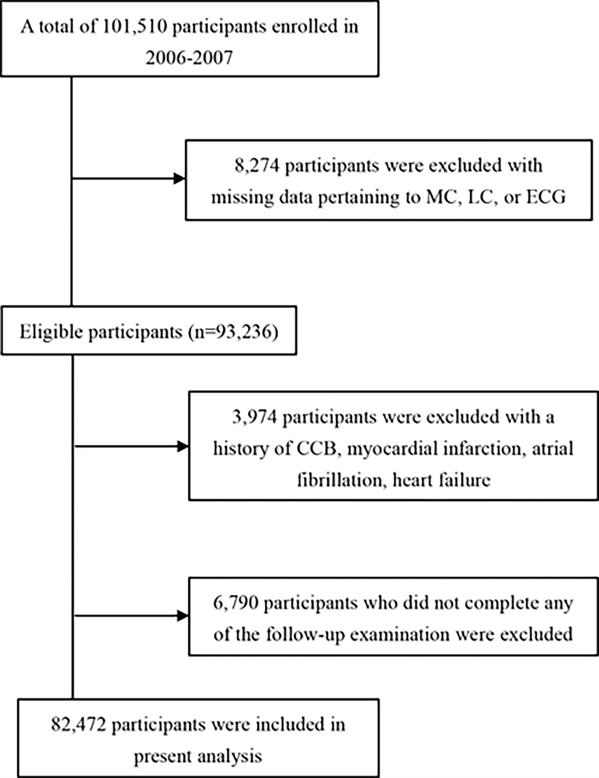
Supplementary Figure 1. Flow chart of study participants.
Abbreviations: MC, monocyte count; LC, lymphocyte count; ECG, electrocardiograph; CCB, cardiac conduction block.

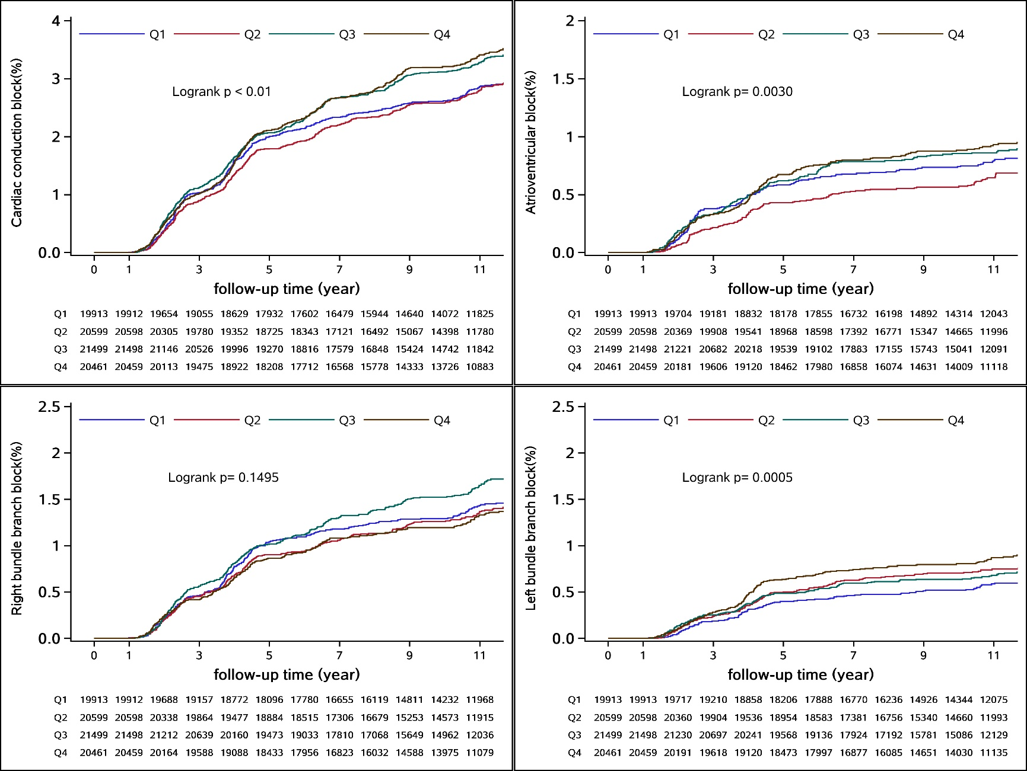
Supplementary Figure 2. Cumulative incidence of cardiac conduction block and its subtypes according to categories of monocyte to lymphocyte ratio.

