Supplementary Tables and Figures
Supplementary Tables
Supplementary Table S1. Interval likelihood ratios for the prediction of weaning failure using lung ultrasound score measured during the RR and RSBI
 | Weaning failure  (n=13) | Weaning success  (n=22) | Likelihood  Ratio | 95%CI
RR
≤ 18 | 1 | 4 | 0.4 | 0.23-0.59
18-25 | 4 | 16 | 0.4 | 0.17-0.67
≥ 25 | 8 | 2 | 6.8 | 1.69-27.16
RSBI
< 50 | 1 | 8 | 0.2 | 0.03-1.51
50-67 | 5 | 12 | 0.7 | 0.32-1.55
≥ 67 | 7 | 2 | 5.9 | 1.44-24.35
RR respiratory rate, RSBI rapid shallow breathing index.

Supplementary Figures
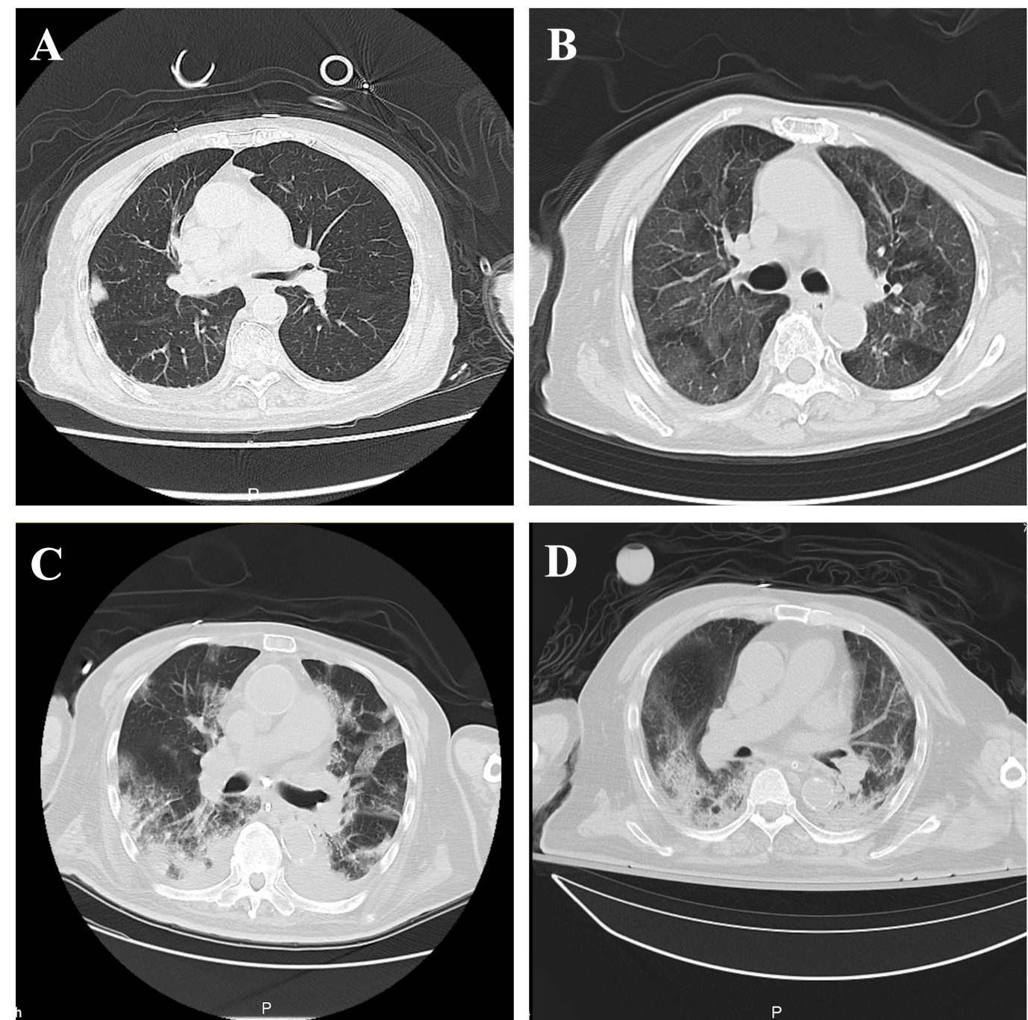
Supplementary Figure S1. Chest computed tomographic features of patients with COVID-19. (A) Isolated ground glass opacity below the pleura of the right lung; (B) Extensive ground glass opacities in both lungs; (C) Multiple patchy opacities present in both lungs, local changes like paving stones, a small amount of pleural effusion on both sides; (D) Extensive consolidation and ground-glass opacities in both lungs, with accompanying reticular changes.

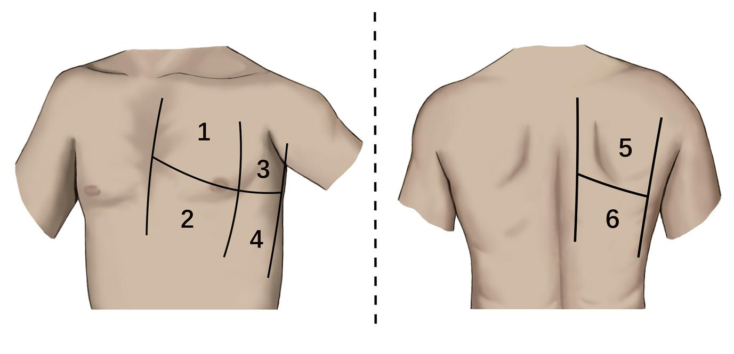
Supplementary Figure S2. The six regions into which the lungs were divided in order to calculate the 12-region lung ultrasound score.

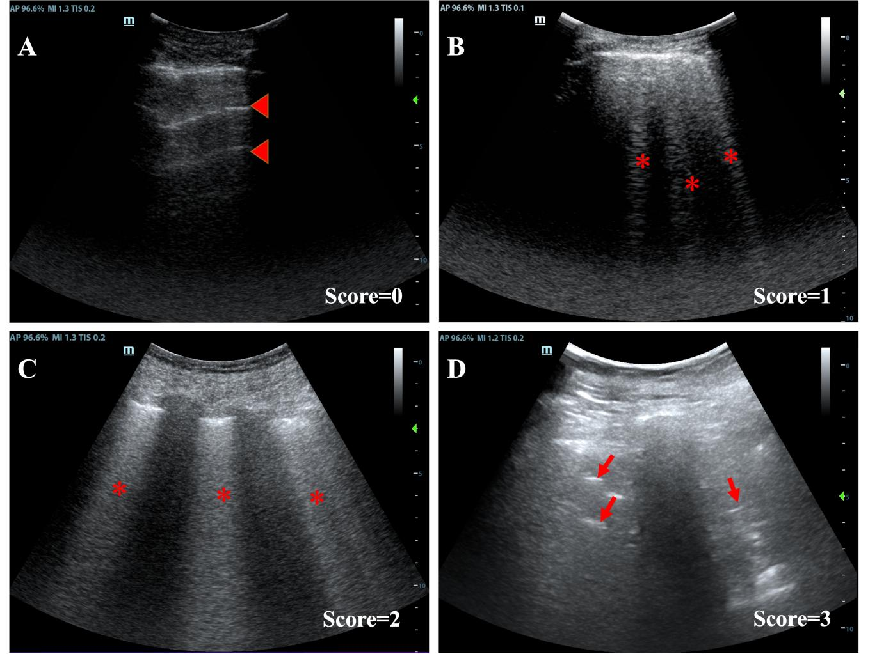
Supplementary Figure S3. Representative examples of patients showing different extents of aeration loss. Lung ultrasound scores are shown at the lower right of each image. (A) A patient scoring 0. Red triangles indicate horizontal reverberation artifacts (A lines). (B) A patient scoring 1. Asterisks indicate multiple well-defined B lines. (C) A patient scoring 2. Asterisks indicate coalescent B lines. (D) A patient scoring 3. Red arrows indicate air bronchograms.

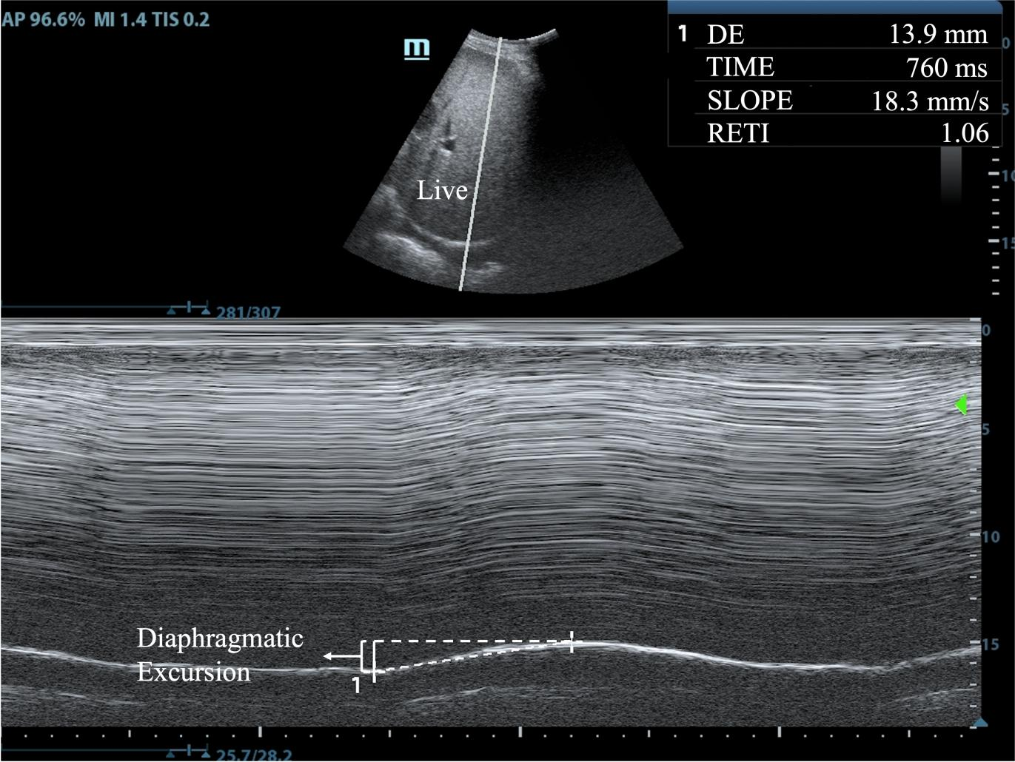
Supplementary Figure S4. An M-mode ultrasound image illustrating how right diaphragmatic excursion was measured in this study. In this patient, the excursion was found to be 13.9 mm.
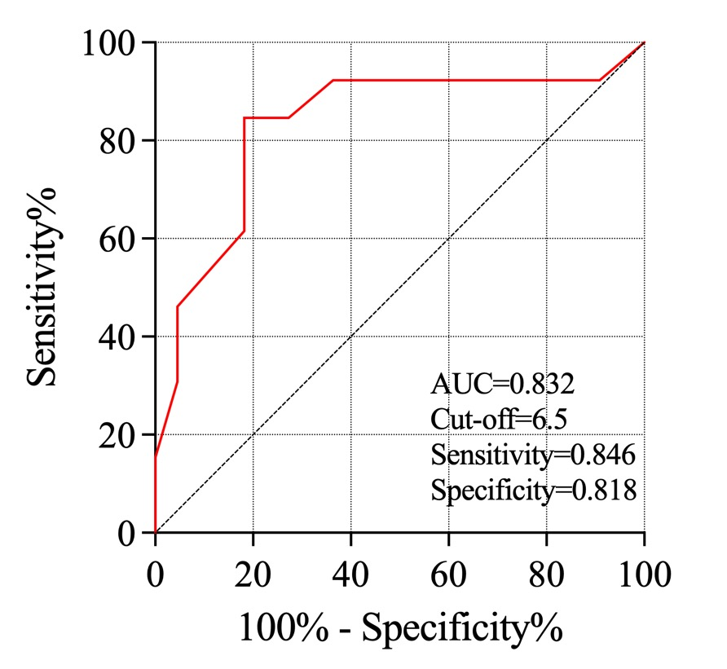
Supplementary Figure S5. Receiver operating characteristic curve to assess the ability of an 8-region lung ultrasound score to predict weaning failure.

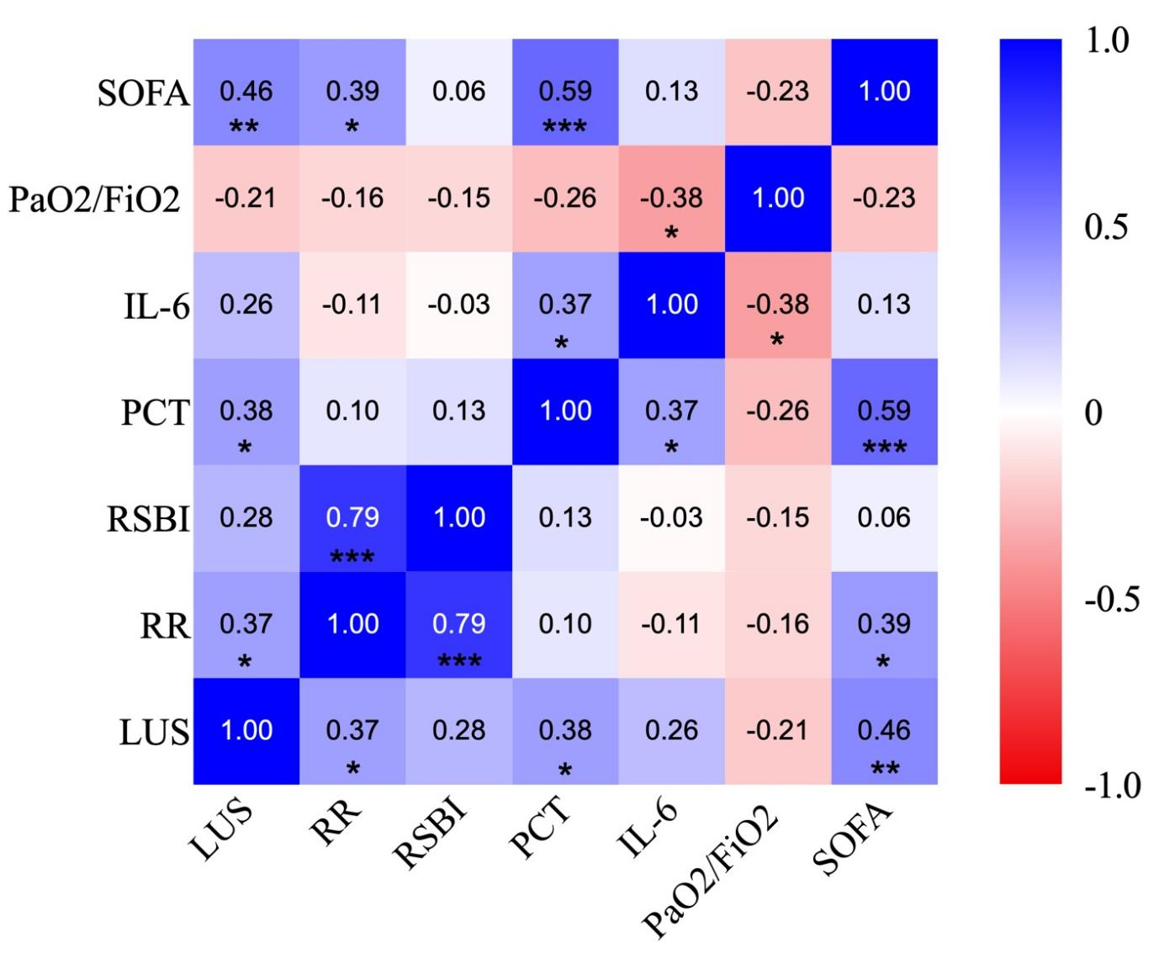
Supplementary Figure S6. Heat map of pairwise Spearman rank correlations between the indicated variables. *p < 0.05, **p < 0.01, ***p < 0.001. IL, interleukin; FiO₂, fraction of inspired oxygen; LUS, lung ultrasound score; PaO₂, partial pressure of oxygen; PCT, Procalcitonin; RR, respiratory rate; SOFA, sequential organ failure assessment score.

