Supplementary figures
Figure S1. Real-time SPR sensorgrams of response curves for the assay of (A) anti-PAPP-A and (B) anti-PAPP-A2 immobilization processing steps. The SPR angle of anti-PAPP-A reached 292.99 millidegrees (mDeg) at 2000 sec and decreased to 207.14 mDeg at 4300 sec after injection of BSA. In the last step, 10 mM of NaOH was injected and the SPR angle dropped to 146.03 mDeg. The SPR angle of anti-PAPP-A2 reached 148.83 mDeg at 2000 sec and increased to 324.91 mDeg at 4300 sec after injection of BSA. Finally, 10 mM of NaOH was injected and the SPR angle dropped to 273.88 mDeg.

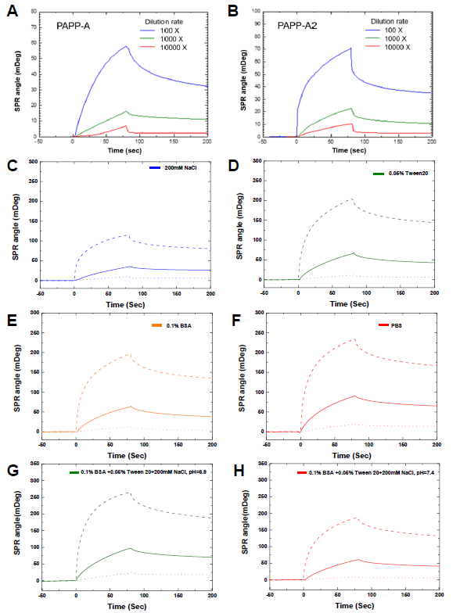
Figure S2. Reducing non-specific binding in SPR experiments. (A, B) Measurement of PAPP-A and PAPP-A2 with dilution rates of 100, 1000 and 10000 times by the GO-SPR biochip. The response time between the antibody-antigen association and dissociation is about 200 seconds. (C-F) The serum samples are diluted 100 (dash line), 1000 (continuous line), 10000 (dotted line) times with running buffer. The running buffer is composed of 200 mM NaCl (C), 0.05% Tween-20 (D), 0.1% BSA (E), and PBS (F). (G, H) Adjustment of running buffer at pH 6.9 and pH 7.4. The buffer at pH 7.4 reduces more non-specific binding than at pH 6.9. The graphics were generated using the OriginPro 9.1 software.

