Supplementary Materials
Development and Validation of an Intracranial Hemorrhage Risk Score in Older Adults with Atrial Fibrillation Treated with Oral Anticoagulant

Lily Gui Bessette¹, Daniel E. Singer², Ajinkya Pawar¹, Vincent Wong¹, Dae Hyun Kim*^{1,3}, Kueiyu Joshua Lin^{1,2*}

Supplementary Materials Table S1. Inclusion/Exclusion Criteria Definitions
Criteria | Definition | Measurement
Atrial Fibrillation | ICD-9 Diagnosis Code: 427.3, 427.31, 427.32  ICD-10 Diagnosis Code: I48, I48.0, I48.1, I48.2, I48.3, I48.4, I48.9, I48.91, I48.92 | Any Diagnosis Position, Any Care Setting
Valvular Disease | ICD-9 Diagnosis Code: 093.2, 093.20, 394, 394.0, 394.1, 394.2, 395.2, 395.9, 396, 396.0, 396.2, 396.8, 396.9, 397.0, 746.0, 746.01, 746.02, 746.2, 746.3, 746.4, 746.6, 093.21, 093.22, 093.23, 093.24, 394.9, 395, 395.0, 395.1, 396.1, 396.3, 397.1, 424.0, 424.1, 424.2, 424.3, 746.00, 746.09, 746.1, 746.5, 996.02, 996.71, V42.2, V42.3  ICD-10 Diagnosis Code: T82.03XA, T82.03XD, T82.03XS, T82.02XA, T82.02XD, T82.02XS, T82.221, T82.221A, T82.221D, T82.221S, T82.222, T82.222A, T82.222D, T82.222S, T82.223, T82.223A, T82.223D, T82.223S, T82.228, T82.228A, T82.228D, T82.228S, T82.01XA, T82.01XD, T82.01XS, I05.0, I05.1, I05.2, I05.9, I06, I06.1, I06.2, I06.9, I07, I07.0, I07.1, I07.2, I07.8, I07.9, I08, I08.0, I08.3, I08.8, I34, I34.1, I34.2, I34.8, I35.0, I35.2, I36.0, I36.9, I37, I37.0, I37.2, I37.8, Q22.3, Q22.4, Q22.5, Q22.6, Q22.8, Q23.0, Q23.1, Q23.2, Q23.3, Q23.4, Q23.8, Q23.9, T82.02, T82.03, T82.6XXD, I05, I05.8, I06.0, I06.8, I08.1, I08.2, I08.9, I34.0, I34.9, I35, I35.1, I35.8, I35.9, I36, I36.1, I36.2, I36.8, I37.1, I37.9, I39, Q22, Q22.0, Q22.1, Q22.2, Q22.9, Q23, T82.0, T82.01, T82.22, T82.6, T82.6XXA, T82.6XXS, Z95.2, Z95.3, Z95.4, T82.09, T82.09XA, T82.09XD, T82.09XS  HCPCS Procedure Codes: 33420, 33427, 33460, 33463, 33464, 0257T, 0258T, 0259T, 0262T, 33400, 33401, 33403, 33422, 33425, 33426, 33430, 33465, 33468, 33475, 33496, 33660, 33665 | Any Diagnosis Position, Any Care Setting
Anticoagulant | NDC Generic Name: WARFARIN SODIUM, APIXABAN, RIVAROXABAN, DABIGATRAN ETEXILATE MESYLATE, EDOXABAN TOSYLATE

Supplementary Materials Table S2. Outcome Definitions
Outcome Name | Definition | Measurement
Atraumatic Intracranial Hemorrhage | ICD-9 Diagnosis Code: 430, 432, 432.9, 852, 852.0, 852.00, 852.04, 852.05, 852.10, 852.11, 852.12, 852.16, 852.20, 852.21, 852.22, 852.23, 852.25, 852.29, 852.3, 852.31, 852.32, 852.35, 852.36, 852.40, 852.43, 852.5, 852.51, 852.52, 852.53, 852.54, 852.59, 853.0, 853.00, 853.04, 853.05, 853.09, 853.10, 853.11, 853.13, 853.19, 431, 432.0, 432.1, 852.01, 852.02, 852.03, 852.06, 852.09, 852.1, 852.13, 852.14, 852.15, 852.19, 852.2, 852.24, 852.26, 852.30, 852.33, 852.34, 852.39, 852.4, 852.41, 852.42, 852.44, 852.45, 852.46, 852.49, 852.50, 852.55, 852.56, 853, 853.01, 853.02, 853.03, 853.06, 853.1, 853.12, 853.14, 853.15, 853.16  ICD-10 Diagnosis Code: I60.0, I60.01, I60.10, I60.11, I60.3, I60.31, I60.5, I60.51, I60.52, I60.6, I60.8, I61, I61.4, I61.8, I62.1, S06.4X0D, S06.4X0S, S06.4X1, S06.4X1S, S06.4X2, S06.4X2D, S06.4X3, S06.4X3A, S06.4X4, S06.4X4A, S06.4X5S, S06.4X6, S06.4X6A, S06.4X6D, S06.4X6S, S06.4X7, S06.4X7A, S06.4X8A, S06.5X, S06.5X0, S06.5X0S, S06.5X1, S06.5X1A, S06.5X1S, S06.5X2, S06.5X2D, S06.5X2S, S06.5X3, S06.5X3A, S06.5X3D, S06.5X3S, S06.5X4, S06.5X4A, S06.5X4D, S06.5X5D, S06.5X6A, S06.5X6S, S06.5X8, S06.5X8A, S06.5X9A, S06.6, S06.6X0, S06.6X0D, S06.6X1, S06.6X1A, S06.6X1S, S06.6X2, S06.6X2D, S06.6X2S, S06.6X3, S06.6X3A, S06.6X3D, S06.6X4S, S06.6X5A, S06.6X5S, S06.6X6D, S06.6X7A, S06.6X8, S06.6X8A, S06.6X9S, I60, I60.00, I60.02, I60.1, I60.12, I60.2, I60.30, I60.32, I60.4, I60.50, I60.7, I60.9, I61.0, I61.1, I61.2, I61.3, I61.5, I61.6, I61.9, I62, I62.0, I62.00, I62.01, I62.02, I62.03, I62.9, S06.4, S06.4X, S06.4X0, S06.4X0A, S06.4X1A, S06.4X1D, S06.4X2A, S06.4X2S, S06.4X3D, S06.4X3S, S06.4X4D, S06.4X4S, S06.4X5, S06.4X5A, S06.4X5D, S06.4X8, S06.4X9, S06.4X9A, S06.4X9D, S06.4X9S, S06.5, S06.5X0A, S06.5X0D, S06.5X1D, S06.5X2A, S06.5X4S, S06.5X5, S06.5X5A, S06.5X5S, S06.5X6, S06.5X6D, S06.5X7, S06.5X7A, S06.5X9, S06.5X9D, S06.5X9S, S06.6X, S06.6X0A, S06.6X0S, S06.6X1D, S06.6X2A, S06.6X3S, S06.6X4, S06.6X4A, S06.6X4D, S06.6X5, S06.6X5D, S06.6X6, S06.6X6A, S06.6X6S, S06.6X7, S06.6X9, S06.6X9A, S06.6X9D | Primary Diagnosis Position, Inpatient Care Setting
Intraparenchymal hemorrhage (IPH) | ICD-9 Diagnosis Code: 431  ICD-10 Diagnosis Code: I61, I61.4, I61.8, I61.0, I61.1, I61.2, I61.3, I61.5, I61.6, I61.9 | Primary Diagnosis Position, Inpatient Care Setting
Subdural hemorrhage (SDH) | ICD-9 Diagnosis Code: 852.20, 852.21, 852.22, 852.23, 852.25, 852.29, 852.3, 852.31, 852.32, 852.35, 852.36, 432.1, 852.2, 852.24, 852.26, 852.30, 852.33, 852.34, 852.39  ICD-10 Diagnosis Code: S06.5X, S06.5X0, S06.5X0S, S06.5X1, S06.5X1A, S06.5X1S, S06.5X2, S06.5X2D, S06.5X2S, S06.5X3, S06.5X3A, S06.5X3D, S06.5X3S, S06.5X4, S06.5X4A, S06.5X4D, S06.5X5D, S06.5X6A, S06.5X6S, S06.5X8, S06.5X8A, S06.5X9A, I62.0, I62.00, I62.01, I62.02, I62.03, S06.5, S06.5X0A, S06.5X0D, S06.5X1D, S06.5X2A, S06.5X4S, S06.5X5, S06.5X5A, S06.5X5S, S06.5X6, S06.5X6D, S06.5X7, S06.5X7A, S06.5X9, S06.5X9D, S06.5X9S | Primary Diagnosis Position, Inpatient Care Setting

Supplementary Materials Table S3. AF ICH Model Predictor Definitions
Predictor Name | Definition
Number of Hospitalizations | Count of inpatient claims in past 365 days from CED
Number of Office visits | Count of outpatient claims in past 365 days from CED
Hospitalization in past 30 days | Occurrence of inpatient claim in past 30 days from CED
Number of Skilled nursing facility stays | Count of skilled nursing facility claims in past 365 days from CED
Diabetic footwear | HCPCS Procedure Code: A5500, A5501, A5508, A5509, A5510, A5511, A5513, A5502, A5503, A5504, A5505, A5506, A5507, A5512
Walking aids and attachments | HCPCS Procedure Code: E0100, E0111, E0113, E0120, E0130, E0131, E0140, E0143, E0144, E0145, E0147, E0149, E0153, E0105, E0110, E0112, E0114, E0115, E0116, E0117, E0118, E0135, E0138, E0139, E0141, E0142, E0146, E0148, E0154, E0155, E0156, E0157, E0158, E0159
Wheelchairs, components, and accessories | HCPCS Procedure Code: K0010, K0012, K0013, K0017, K0018, K0020, K0021, K0022, K0023, K0024, K0025, K0028, K0029, K0030, K0031, K0032, K0034, K0035, K0036, K0037, K0038, K0040, K0043, K0048, K0049, K0050, K0051, K0055, K0056, K0057, K0060, K0061, K0063, K0065, K0068, K0069, K0070, K0075, K0080, K0081, K0082, K0084, K0086, K0087, K0088, K0092, K0096, K0097, K0098, K0100, K0101, K0103, K0104, K0116, K0121, K0123, K0138, K0143, K0156, K0168, K0169, K0170, K0174, K0175, K0176, K0177, K0181, K0185, K0187, K0189, K0192, K0193, K0194, K0199, K0204, K0209, K0215, K0248, K0258, K0261, K0268, K0269, K0270, K0281, K0283, K0284, K0401, K0402, K0407, K0409, K0411, K0415, K0417, K0418, K0419, K0421, K0426, K0427, K0428, K0430, K0432, K0433, K0435, K0437, K0438, K0439, K0440, K0441, K0442, K0447, K0448, K0449, K0452, K0455, K0456, K0459, K0461, K0001, K0002, K0003, K0004, K0005, K0006, K0007, K0008, K0009, K0011, K0014, K0015, K0016, K0019, K0026, K0027, K0033, K0039, K0041, K0042, K0044, K0045, K0046, K0047, K0052, K0053, K0054, K0058, K0059, K0062, K0064, K0066, K0067, K0071, K0072, K0073, K0074, K0076, K0077, K0078, K0079, K0083, K0085, K0089, K0090, K0091, K0093, K0094, K0095, K0099, K0102, K0105, K0106, K0107, K0108, K0109, K0112, K0113, K0114, K0115, K0118, K0119, K0120, K0122, K0137, K0139, K0171, K0172, K0173, K0178, K0179, K0180, K0182, K0183, K0184, K0186, K0188, K0190, K0191, K0195, K0207, K0217, K0235, K0260, K0266, K0277, K0278, K0279, K0280, K0400, K0405, K0408, K0410, K0412, K0416, K0420, K0422, K0423, K0424, K0425, K0429, K0431, K0434, K0436, K0443, K0444, K0445, K0446, K0450, K0451, K0457, K0458, K0460, K0462, K0669
Inhalation solutions | HCPCS Procedure Code: J7609, J7610, J7614, J7615, J7617, J7622, J7626, J7627, J7628, J7629, J7630, J7631, J7633, J7635, J7636, J7637, J7640, J7642, J7644, J7647, J7650, J7651, J7654, J7657, J7658, J7660, J7665, J7670, J7672, J7674, J7675, J7676, J7681, J7608, J7611, J7612, J7613, J7616, J7618, J7619, J7620, J7621, J7624, J7625, J7632, J7634, J7638, J7639, J7641, J7643, J7645, J7648, J7649, J7652, J7653, J7655, J7659, J7667, J7668, J7669, J7680, J7682, J7683, J7684
Anesthesia, intrathoracic | HCPCS Procedure Code: 00524, 00528, 00530, 00534, 00537, 00542, 00544, 00546, 00560, 00561, 00566, 00570, 00500, 00508, 00520, 00522, 00529, 00532, 00539, 00540, 00541, 00548, 00550, 00562, 00563, 00567, 00580
Anesthesia, knee and popliteal | HCPCS Procedure Code: 01360, 01382, 01399, 01420, 01432, 01320, 01340, 01380, 01390, 01392, 01400, 01402, 01404, 01415, 01430, 01431, 01440, 01442, 01444
Congestive heart failure | ICD-9 Diagnosis Code: 398.91, 402.01, 402.11, 402.91, 404.01, 404.03, 404.11, 404.13, 404.91, 404.93, 428.0, 428.1, 428.2, 428.20, 428.21, 428.22, 428.23, 428.3, 428.30, 428.31, 428.32, 428.33, 428.4, 428.40, 428.41, 428.42, 428.43, 428.9, 425.0, 425.9, 429.3, 425.18, 428, 425.1, 425.3, 425.5, 425.7, 425, 425.11, 425.2, 425.4, 425.8  ICD-10 Diagnosis Code: I42.0, I42.4, I43, I50.1, I50.4, I50.42, I42, I42.2, I42.3, I42.6, I42.7, I42.8, I50.32, I11.0, I42.5, I42.9, I50.2, I50.20, I50.21, I50.43, A18.84, I50, I50.23, I50.3, I50.30, I50.40, I50.41, I50.9, I42.1, I50.22, I50.31, I50.33
Hypertension | ICD-9 Diagnosis Code: 401.0, 401.1, 401.9, 402.0, 402.00, 402.01, 402.1, 402.10, 402.11, 402.9, 402.90, 402.91, 403.0, 403.00, 403.01, 403.1, 403.10, 403.11, 403.9, 403.90, 403.91, 404.0, 404.00, 404.01, 404.02, 404.03, 404.1, 404.10, 404.11, 404.12, 404.13, 404.9, 404.90, 404.91, 404.92, 404.93, 405.0, 405.01, 405.09, 405.1, 405.11, 405.19, 405.9, 405.91, 405.99  ICD-10 Diagnosis Code: I10, I13.2, I15.0, I15.8, I13.11, I13.10, I12.0, I13.0, I11.9, I12.9
Ischemic heart disease | ICD-9 Diagnosis Code: 410.00, 410.01, 410.12, 410.22, 410.31, 410.40, 410.52, 410.60, 410.70, 410.71, 410.72, 410.80, 410.82, 410.91, 411.0, 411.1, 412, 414.04, 414.05, 414.4, 414.8, 410.02, 410.10, 410.11, 410.20, 410.21, 410.30, 410.32, 410.41, 410.42, 410.50, 410.51, 410.61, 410.62, 410.81, 410.90, 410.92, 411.81, 411.89, 413.0, 413.1, 413.9, 414.00, 414.01, 414.02, 414.03, 414.06, 414.07, 414.12, 414.2, 414.3, 414.9  ICD-10 Diagnosis Code: I20.0, I20.1, I20.8, I21.01, I21.11, I21.4, I22.0, I22.1, I22.2, I22.8, I22.9, I23.5, I23.7, I23.8, I24.1, I24.8, I25.10, I25.110, I25.119, I25.3, I25.41, I25.42, I25.5, I25.701, I25.709, I25.718, I25.720, I25.721, I25.728, I25.729, I25.730, I25.731, I25.750, I25.751, I25.760, I25.790, I25.798, I25.799, I25.811, I25.82, I25.83, I25.89, I20.9, I21.02, I21.09, I21.19, I21.21, I21.29, I21.3, I21.A1, I21.A9, I23.0, I23.1, I23.2, I23.3, I23.4, I23.6, I24.0, I24.9, I25.111, I25.118, I25.2, I25.6, I25.700, I25.708, I25.710, I25.711, I25.719, I25.738, I25.739, I25.758, I25.759, I25.761, I25.768, I25.769, I25.791, I25.810, I25.812, I25.84, I25.9
Stroke | ICD-9 Diagnosis Code: 433.00, 433.20, 433.30, 433.90, 434.1, 434.9, 434.91, 438.19, 438.30, 438.40, 438.41, 438.51, 438.7, 438.85, 433.01, 433.1, 433.11, 433.3, 434.00, 434.10, 438.11, 438.21, 438.50, 438.6, 438.89, 433.2, 433.8, 433.80, 433.9, 436, 437.1, 438.1, 438.12, 438.13, 438.22, 438.31, 438.32, 438.42, 438.53, 438.82, 438.83, 433.10, 433.31, 433.81, 434.90, 438.10, 438.2, 438.20, 438.5, 438.52, 438.8, 438.81, 438.84, 431, 433.0, 433.21, 433.91, 434.0, 434.01, 434.11, 438.0, 438.14, 438.3, 438.4, 438.9  ICD-10 Diagnosis Code: G45.9, G46.6, I63.013, I63.031, I63.033, I63.232, I63.323, I63.331, I63.342, I63.349, I63.50, I63.513, I63.521, I63.522, I63.523, I63.529, I63.541, I63.8, I65.21, I65.23, I66.02, I67.1, I67.7, G46.2, I63.00, I63.012, I63.12, I63.211, I63.213, I63.219, I63.239, I63.29, I63.313, I63.319, I63.329, I63.341, I63.39, I63.411, I63.413, I63.419, I63.432, I63.433, I63.449, I63.511, I63.532, I63.543, I63.549, I63.59, I65.9, I66.03, I66.22, I66.29, I66.9, I67.4, I67.89, I67.9, I68.8, G45.4, G45.8, G46.7, I63.019, I63.032, I63.112, I63.113, I63.131, I63.20, I63.233, I63.322, I63.333, I63.339, I63.40, I63.421, I63.422, I63.429, I63.431, I63.442, I63.443, I63.533, I63.539, I63.6, I63.9, I65.01, I65.02, I65.03, I65.1, I65.29, I65.8, I66.09, I66.12, I66.23, I66.3, I66.8, I67.2, I67.5, I67.6, I67.848, G45.0, G45.1, G45.2, G46.4, G46.5, G46.8, I63.02, I63.111, I63.133, I63.139, I63.19, I63.212, I63.231, I63.30, I63.312, I63.332, I63.343, I63.49, I63.512, I63.531, I63.542, I66.19, I66.21, I67.81, I68.2, G46.0, G46.1, G46.3, I63.011, I63.039, I63.09, I63.10, I63.119, I63.132, I63.22, I63.311, I63.321, I63.412, I63.423, I63.439, I63.441, I63.519, I65.09, I65.22, I66.01, I66.11, I66.13, I67.82, I67.841, I68.0
Transient ischemic attack | ICD-9 Diagnosis Code: 435.1, 435.9, 435, 435.0, 435.2, 435.3, 435.8  ICD-10 Diagnosis Code: G45.1, G45.2, G45, G45.0, G45.3, G45.4, G45.8, G45.9
Alcohol use disorder | ICD-9 Diagnosis Code: 291.2, 291.5, 291.82, 303.00, 303.91, 303.92, 305.00, 305.02, 305.03, 357.5, 535.3, 571.0, 571.1, 571.3, 790.3, V11.3, 291, 291.0, 291.1, 291.3, 291.4, 291.8, 291.81, 291.89, 291.9, 303, 303.0, 303.01, 303.02, 303.03, 303.9, 303.90, 303.93, 305.0, 305.01, 425.5, 571.2, E860.0  ICD-10 Diagnosis Code: F10, F10.11, F10.12, F10.120, F10.121, F10.14, F10.150, F10.151, F10.18, F10.180, F10.181, F10.182, F10.19, F10.20, F10.221, F10.229, F10.23, F10.231, F10.232, F10.25, F10.251, F10.259, F10.27, F10.28, F10.281, F10.29, F10.92, F10.920, F10.921, F10.929, F10.94, F10.950, F10.951, F10.959, F10.96, F10.981, F10.988, F10.99, F10.1, F10.10, F10.129, F10.15, F10.159, F10.188, F10.2, F10.21, F10.22, F10.220, F10.230, F10.239, F10.24, F10.250, F10.26, F10.280, F10.282, F10.288, F10.9, F10.95, F10.97, F10.98, F10.980, F10.982, Z71.4, Z71.41
Anemia | ICD-9 Diagnosis Code: 281.4, 282, 283.9, 284.0, 285.29, 280, 281.1, 281.2, 282.2, 282.8, 283, 283.1, 283.19, 284, 284.89, 285.1, 285.2, 285.9, 280.1, 281.3, 281.8, 282.3, 283.10, 280.0, 280.8, 280.9, 281.0, 281.9, 283.0, 284.09, 285, 285.21, 285.22, 285.3, 285.8, 281, 282.9, 284.8, 284.9, 285.0  ICD-9 Diagnosis Code: 280, 280.0, 280.1, 280.8, 280.9, 281, 281.0, 281.1, 281.2, 281.3, 281.4, 281.8, 281.9, 282, 282.2, 282.3, 282.8, 282.9, 283, 283.0, 283.1, 283.10, 283.19, 283.9, 284, 284.0, 284.09, 284.8, 284.89, 284.9, 285, 285.0, 285.1, 285.2, 285.21, 285.22, 285.29, 285.3, 285.8, 285.9
Dementia | ICD-9 Diagnosis Code: 290.0, 290.1, 290.11, 290.13, 290.20, 290.21, 290.42, 290.43, 294.11, 294.21, 294.8, 331.7, 290.12, 290.3, 290.40, 290.41, 294.0, 294.10, 294.20, 331.0, 331.11, 331.19, 331.2, 797  ICD-10 Diagnosis Code: F01.50, F01.51, F03.91, G30.1, G30.8, G30.9, G31.01, G31.09, F02.80, F02.81, F03.90, G30.0, F01.5, F02.8, F03.9, G31.0
Diabetes | ICD-9 Diagnosis Code: 249.00, 249.10, 249.11, 249.40, 249.41, 249.50, 249.51, 249.60, 249.61, 249.81, 249.91, 250.01, 250.02, 250.10, 250.11, 250.13, 250.20, 250.32, 250.42, 250.51, 250.61, 250.63, 250.70, 250.72, 250.73, 250.83, 249.01, 249.20, 249.21, 249.30, 249.31, 249.70, 249.71, 249.80, 249.90, 250.00, 250.03, 250.12, 250.21, 250.22, 250.23, 250.30, 250.31, 250.33, 250.40, 250.41, 250.43, 250.50, 250.52, 250.53, 250.60, 250.62, 250.71, 250.80, 250.81, 250.82, 250.90, 362.01, 362.02, 362.03, 362.06, 250.91, 250.92, 250.93, 357.2, 362.04, 362.05, 366.41  ICD-10 Diagnosis Code: E08.00, E08.10, E08.11, E08.21, E08.29, E08.311, E08.319, E08.321, E08.3211, E08.3212, E08.329, E08.3291, E08.3292, E08.331, E08.339, E08.3392, E08.3393, E08.3413, E08.3419, E08.3491, E08.3493, E08.3499, E08.351, E08.3512, E08.3513, E08.3522, E08.3523, E08.3529, E08.3533, E08.3539, E08.3543, E08.3549, E08.3551, E08.3552, E08.36, E08.37X3, E08.39, E08.42, E08.52, E08.610, E08.620, E08.621, E08.622, E08.628, E08.630, E08.641, E08.8, E09.01, E09.29, E09.321, E09.3212, E09.3213, E09.3219, E09.3291, E09.3292, E09.3293, E09.331, E09.3313, E09.339, E09.3419, E09.3493, E09.3499, E09.351, E09.3511, E09.3512, E09.3513, E09.3519, E09.3522, E09.3523, E09.3532, E09.3542, E09.3552, E09.3553, E09.359, E09.3593, E09.36, E09.37X1, E09.39, E09.42, E09.43, E09.51, E09.52, E09.59, E09.610, E09.620, E09.622, E09.630, E09.649, E09.69, E09.8, E10.22, E10.29, E10.321, E10.3211, E10.3212, E10.329, E10.3291, E10.3299, E10.3311, E10.3312, E10.3319, E10.339, E10.3391, E10.3392, E10.3399, E10.3419, E10.349, E10.3491, E10.3492, E10.351, E10.3511, E10.3512, E10.3519, E10.37X1, E10.37X3, E10.37X9, E10.39, E10.40, E10.43, E10.49, E10.51, E10.52, E10.59, E10.610, E10.620, E10.622, E10.628, E08.01, E08.22, E08.3213, E08.3219, E08.3293, E08.3299, E08.3311, E08.3312, E08.3313, E08.3319, E08.3391, E08.3399, E08.341, E08.3411, E08.3412, E08.349, E08.3492, E08.3511, E08.3519, E08.3521, E08.3531, E08.3532, E08.3541, E08.3542, E08.3553, E08.3559, E08.359, E08.3591, E08.3592, E08.3593, E08.3599, E08.37X1, E08.37X2, E08.37X9, E08.40, E08.41, E08.43, E08.44, E08.49, E08.51, E08.59, E08.618, E08.638, E08.649, E08.65, E08.69, E08.9, E09.00, E09.10, E09.11, E09.21, E09.22, E09.311, E09.319, E09.3211, E09.329, E09.3299, E09.3311, E09.3312, E09.3319, E09.3391, E09.3393, E09.3399, E09.341, E09.3412, E09.3413, E09.349, E09.3491, E09.3533, E09.3551, E09.3591, E09.3592, E09.3599, E09.37X9, E09.40, E09.41, E09.44, E09.49, E09.618, E09.621, E09.628, E09.638, E09.641, E09.65, E09.9, E10.10, E10.11, E10.21, E10.311, E10.319, E10.3213, E10.3219, E10.3292, E10.3293, E10.331, E10.3313, E10.3393, E10.341, E10.3411, E10.3412, E10.3413, E10.3493, E10.3499, E10.3513, E10.359, E10.36, E10.37X2, E10.41, E10.42, E10.44, E10.618, E10.621, E10.630, E10.649, E10.69, E10.8, E10.9, E11.00, E11.10, E11.11, E11.22, E11.319, E11.321, E11.3212, E11.329, E11.3293, E11.331, E11.3312, E11.3313, E11.339, E11.3391, E11.3393, E11.3399, E11.3411, E11.3413, E11.3419, E11.349, E11.3491, E11.3492, E11.3511, E11.3512, E11.3521, E11.3522, E11.3523, E11.3529, E11.3531, E11.3532, E11.3533, E11.3551, E11.3552, E11.3553, E11.3593, E11.37X1, E11.37X2, E11.37X3, E11.37X9, E11.40, E11.43, E11.44, E11.49, E11.52, E11.59, E11.618, E11.622, E11.628, E11.630, E11.641, E11.649, E11.9, E13.00, E13.21, E13.22, E13.29, E13.311, E13.319, E13.3211, E13.3291, E13.3292, E13.331, E13.3312, E13.3319, E13.339, E13.3391, E13.3392, E13.3399, E13.3411, E13.3412, E13.3493, E13.3511, E13.3521, E13.3522, E13.3523, E13.3531, E13.3533, E13.3539, E13.3542, E13.3549, E13.3551, E13.3552, E13.3553, E13.3559, E13.36, E13.40, E13.51, E13.52, E13.59, E13.610, E13.618, E13.621, E13.622, E13.628, E13.630, E13.641, E13.649, E13.65, E10.638, E10.641, E10.65, E11.01, E11.21, E11.29, E11.311, E11.3211, E11.3213, E11.3219, E11.3291, E11.3292, E11.3299, E11.3311, E11.3319, E11.3392, E11.341, E11.3412, E11.3493, E11.3499, E11.351, E11.3513, E11.3519, E11.3539, E11.3541, E11.3542, E11.3543, E11.3549, E11.3559, E11.359, E11.3591, E11.3592, E11.3599, E11.36, E11.39, E11.41, E11.42, E11.51, E11.610, E11.620, E11.621, E11.638, E11.65, E11.69, E11.8, E13.01, E13.10, E13.11, E13.321, E13.3212, E13.3213, E13.3219, E13.329, E13.3293, E13.3299, E13.3311, E13.3313, E13.3393, E13.341, E13.3413, E13.3419, E13.349, E13.3491, E13.3492, E13.3499, E13.351, E13.3512, E13.3513, E13.3519, E13.3529, E13.3532, E13.3541, E13.3543, E13.359, E13.39, E13.41, E13.42, E13.43, E13.44, E13.49, E13.620, E13.638, E13.69, E13.8, E13.9
Hip/Pelvic fracture | ICD-9 Diagnosis Code: 733.14, 733.97, 808.0, 808.3, 808.41, 808.44, 808.49, 808.51, 808.52, 808.53, 808.59, 808.9, 820.00, 820.01, 820.02, 820.03, 820.11, 820.13, 820.20, 820.22, 733.15, 733.96, 733.98, 808.1, 808.2, 808.42, 808.43, 808.54, 808.8, 820.09, 820.10, 820.12, 820.19, 820.21, 820.30, 820.32, 820.8, 820.9, 820.31  ICD-10 Diagnosis Code: S32.481B, S32.482A, S32.483A, S32.484B, S32.485B, S32.486A, S32.491B, S32.492B, S32.499A, S32.499B, S32.501A, S32.501B, S32.502A, S32.502B, S32.512A, S32.512B, S32.519B, S32.591A, S32.591B, S32.592A, S32.592B, S32.599A, S32.599B, S32.601A, S32.609B, S32.611A, S32.612A, S32.615A, S32.615B, S32.616B, S32.691B, S32.699A, S32.811B, S32.82XA, S32.9XXA, S32.9XXB, S72.002B, S72.002C, S72.011A, S72.011B, S72.019A, S72.019B, S72.021A, S72.021C, S72.022A, S72.023B, S72.023C, S72.024B, S72.025C, S72.026C, S72.031B, S72.032A, S72.032C, S72.033A, S72.033C, S72.034A, S72.035A, S72.036B, S72.036C, S72.041A, S72.041C, S72.042A, S72.043B, S72.045B, S72.046B, S72.046C, S72.051B, S72.052B, S72.059B, S72.061A, S72.061B, S72.062C, S72.063A, S72.063C, S72.091A, S72.091C, S72.099A, S72.099B, S72.101A, S72.101B, S72.102A, S72.102B, S72.102C, S72.109A, S72.109B, S72.109C, S72.111B, S72.112A, S72.112B, S72.112C, S72.113B, S72.114A, S72.114C, S72.115A, S72.115B, S72.115C, S72.116B, S72.121B, S72.122B, S72.123C, S72.125B, S72.125C, S72.126A, S72.126C, S72.131B, S72.131C, S72.132B, S72.133A, S72.133B, S72.133C, S72.134B, S72.135B, S72.135C, S72.136B, S72.141B, S72.141C, S72.142C, S72.143B, S72.144A, S72.144C, S72.145A, S72.145B, S72.145C, S72.146A, S72.22XC, S72.23XC, S72.24XB, S72.24XC, S72.25XB, S79.002A, S79.009A, S79.011A, S79.012A, S79.019A, S32.482B, S32.483B, S32.484A, S32.485A, S32.486B, S32.491A, S32.492A, S32.509A, S32.509B, S32.511A, S32.511B, S32.519A, S32.601B, S32.602A, S32.602B, S32.609A, S32.611B, S32.612B, S32.613A, S32.613B, S32.614A, S32.614B, S32.616A, S32.691A, S32.692A, S32.692B, S32.699B, S32.810A, S32.810B, S32.811A, S32.82XB, S32.89XA, S32.89XB, S72.001A, S72.001B, S72.001C, S72.002A, S72.009A, S72.009B, S72.009C, S72.011C, S72.012A, S72.012B, S72.012C, S72.019C, S72.021B, S72.022B, S72.022C, S72.023A, S72.024A, S72.024C, S72.025A, S72.025B, S72.026A, S72.026B, S72.031A, S72.031C, S72.032B, S72.033B, S72.034B, S72.034C, S72.035B, S72.035C, S72.036A, S72.041B, S72.042B, S72.042C, S72.043A, S72.043C, S72.044A, S72.044B, S72.044C, S72.045A, S72.045C, S72.046A, S72.051A, S72.051C, S72.052A, S72.052C, S72.059A, S72.059C, S72.061C, S72.062A, S72.062B, S72.063B, S72.064A, S72.064B, S72.064C, S72.065A, S72.065B, S72.065C, S72.066A, S72.066B, S72.066C, S72.091B, S72.092A, S72.092B, S72.092C, S72.099C, S72.101C, S72.111A, S72.111C, S72.113A, S72.113C, S72.114B, S72.116A, S72.116C, S72.121A, S72.121C, S72.122A, S72.122C, S72.123A, S72.123B, S72.124A, S72.124B, S72.124C, S72.125A, S72.126B, S72.131A, S72.132A, S72.132C, S72.134A, S72.134C, S72.135A, S72.136A, S72.136C, S72.141A, S72.142A, S72.142B, S72.143A, S72.143C, S72.144B, S72.146B, S72.146C, S72.21XA, S72.21XB, S72.21XC, S72.22XA, S72.22XB, S72.23XA, S72.23XB, S72.24XA, S72.25XA, S72.25XC, S72.26XA, S72.26XB, S72.26XC, S79.001A, S79.091A, S79.092A, S79.099A, M80.851A, M80.852A, M84.350A, M84.352A, M84.359A, M84.452A, M84.453A, M84.459A, M84.550A, M84.551A, M84.650A, M84.651A, M84.652A, M84.653A, M84.659A, S32.301A, S32.309A, S32.311A, S32.311B, S32.312A, S32.312B, S32.316A, S32.316B, S32.391A, S32.391B, S32.392A, S32.392B, S32.401B, S32.409A, S32.409B, S32.411B, S32.412A, S32.412B, S32.413A, S32.413B, S32.415A, S32.415B, S32.416A, S32.424A, S32.424B, S32.425A, S32.426A, S32.426B, S32.432A, S32.432B, S32.433B, S32.435A, S32.441A, S32.442A, S32.443B, S32.444A, S32.445A, S32.445B, S32.446A, S32.451A, S32.452A, S32.454A, S32.454B, S32.455A, S32.455B, S32.456B, S32.461B, S32.462B, S32.463A, S32.463B, S32.464A, S32.464B, S32.465A, S32.465B, S32.466B, S32.471A, S32.472A, S32.472B, S32.474A, S32.481A, M80.051A, M80.052A, M80.059A, M80.859A, M84.351A, M84.353A, M84.451A, M84.552A, M84.553A, M84.559A, S32.301B, S32.302A, S32.302B, S32.309B, S32.313A, S32.313B, S32.314A, S32.314B, S32.315A, S32.315B, S32.399A, S32.399B, S32.401A, S32.402A, S32.402B, S32.411A, S32.414A, S32.414B, S32.416B, S32.421A, S32.421B, S32.422A, S32.422B, S32.423A, S32.423B, S32.425B, S32.431A, S32.431B, S32.433A, S32.434A, S32.434B, S32.435B, S32.436A, S32.436B, S32.441B, S32.442B, S32.443A, S32.444B, S32.446B, S32.451B, S32.452B, S32.453A, S32.453B, S32.456A, S32.461A, S32.462A, S32.466A, S32.471B, S32.473A, S32.473B, S32.474B, S32.475A, S32.475B, S32.476A, S32.476B
GI Bleed | ICD-9 Diagnosis Code: 531.0, 531.00, 531.01, 531.2, 531.20, 531.21, 531.4, 531.40, 531.41, 531.6, 531.60, 531.61, 532.0, 532.00, 532.01, 532.2, 532.20, 532.21, 532.4, 532.40, 532.41, 532.6, 532.60, 532.61, 533.0, 533.00, 533.01, 533.2, 533.20, 533.21, 533.4, 533.40, 533.41, 533.6, 533.60, 533.61, 534.0, 534.00, 534.01, 534.2, 534.20, 534.21, 534.4, 534.40, 534.41, 534.6, 534.60, 534.61, 578.0  ICD-9 Diagnosis Code: 562.02, 562.03, 562.12, 562.13, 569.3, 578.1, 578.9  ICD-9 Diagnosis Code: 423.0, 432.0, 531.00, 531.20, 532.2, 532.20, 532.6, 532.61, 533.40, 534.00, 534.2, 534.20, 534.4, 534.40, 534.41, 562.03, 569.86, 578.0, 719.1, 719.16, 719.19, 784.8, 786.30, 432.9, 459.0, 531.2, 531.21, 531.4, 531.40, 531.61, 534.0, 534.21, 562.13, 569.83, 578.9, 599.71, 599.72, 786.3, 786.39, 531.01, 531.41, 532.0, 532.00, 532.4, 532.60, 533.2, 533.20, 533.4, 533.41, 533.6, 533.61, 534.01, 534.6, 534.60, 534.61, 562.02, 569.3, 569.85, 599.7, 719.12, 719.15, 784.7, 786.31, 430, 531.0, 531.60, 532.01, 532.21, 533.00, 533.60, 562.12, 568.81, 578.1, 599.70, 431, 432.1, 531.6, 532.40, 532.41, 533.0, 533.01, 533.21, 719.10, 719.11, 719.13, 719.14, 719.17, 719.18, K92.2  ICD-10 Diagnosis Code: I60.2, I60.31, I60.50, I61.8, K25.2, K25.4, K25.6, K28.2, K28.4, K62.5, M25.051, R04.1, I60.52, I62.02, K26.0, K26.2, K27.6, K57.31, K57.91, K63.1, M25.011, M25.019, M25.022, M25.031, M25.032, M25.059, M25.072, R04.0, R31.1, R31.21, R31.29, I60.00, I60.02, I60.10, I60.30, I60.9, I61.0, I61.1, I61.5, I61.9, I62.01, I62.9, K57.01, K57.41, K66.1, K92.1, M25.012, M25.041, M25.049, M25.061, R04.2, R04.9, R31.2, R31.9, R58, I31.2, I60.4, I60.6, I60.7, I61.3, I61.6, I62.00, I62.1, K25.0, K27.0, K57.11, K57.13, K57.21, K57.51, K57.81, K57.93, K92.0, M25.00, M25.039, M25.052, M25.071, M25.073, M25.076, M25.08, R04, I60.01, I60.11, I60.12, I60.32, I60.51, I60.8, I61.2, I61.4, I62.03, K26.4, K26.6, K27.2, K27.4, K28.0, K28.6, K55.21, K56.60, K57.33, K57.53, K63.81, K92.2, M25.021, M25.029, M25.042, M25.062, M25.069, M25.074, M25.075, R04.8, R04.81, R04.89, R31, R31.0  ICD-9 Procedure Code: 44.43  ICD-10 Procedure Code: 0W3P8ZZ  HCPCS Procedure Code: 43255
Home oxygen use | ICD-9 Diagnosis Code: V46.2  ICD-10 Diagnosis Code: Z99.81
Acute renal failure | ICD-9 Diagnosis Code: 584, 584.5, 584.6, 584.7, 584.8, 584.9  ICD-10 Diagnosis Code: N17.8, N17.9, N17.2, N17.0, N19, N17.1
CKD 3-4 | ICD-9 Diagnosis Code: 585.3, 585.4, 585.9  ICD-10 Diagnosis Code: N18.3, N18.9, N18.4
Obesity | ICD-9 Diagnosis Code: 278.0, 278.00, 278.01, 278.03, V85.3, V85.30, V85.32, V85.33, V85.37, V85.4, V85.41, V85.42, V85.43, V85.44, V85.31, V85.34, V85.35, V85.36, V85.38, V85.39, V85.45  ICD-10 Diagnosis Code: E66.09, E66.1, E66.8, E66.9, Z68.30, Z68.31, Z68.33, Z68.34, Z68.37, Z68.42, Z68.44, Z68.45, E66.01, E66.2, Z68.32, Z68.35, Z68.36, Z68.38, Z68.39, Z68.41, Z68.43
Syncope | ICD-9 Diagnosis Code: 780.2, 992.1  ICD-10 Diagnosis Code: R55
Anticoagulants, injectable | NDC Generic Name: DALTEPARIN SODIUM,PORCINE, ENOXAPARIN SODIUM, FONDAPARINUX SODIUM
Antiplatelet | NDC Generic Name: ASPIRIN, TICAGRELOR, CLOPIDOGREL BISULFATE, ASPIRIN (CALCIUM CARB & MAGNESIUM BUFFERS)/PRAVASTATIN, ASPIRIN/ACETAMINOPHEN, ASPIRIN/ACETAMINOPHEN/CAFFEINE, ASPIRIN/ACETAMINOPHEN/CAFFEINE/CALCIUM, ASPIRIN/ACETAMINOPHEN/CAFFEINE/POTASSIUM, ASPIRIN/ACETAMINOPHEN/CALCIUM CARBONATE, ASPIRIN/ACETAMINOPHEN/MAGNESIUM/ALUMINUM HYDROXIDE/CAFFEINE, ASPIRIN/CAFFEINE, ASPIRIN/CALCIUM CARBONATE, ASPIRIN/CALCIUM CARBONATE/MAGNESIUM, ASPIRIN/CALCIUM CARBONATE/MAGNESIUM/ALUMINUM HYDROXIDE, ASPIRIN/CODEINE PHOSPHATE, ASPIRIN/DIPHENHYDRAMINE CITRATE, ASPIRIN/DIPHENHYDRAMINE HCL, ASPIRIN/DIPHENHYDRAMINE/SODIUM BICARBONATE/CITRIC ACID, ASPIRIN/DIPYRIDAMOLE, ASPIRIN/MAGNESIUM CARBONATE/DIHYDROXYALUMINUM AMINOACETATE, ASPIRIN/MAGNESIUM HYDROXIDE/ALUMINUM HYDROXIDE, ASPIRIN/MAGNESIUM HYDROXIDE/ALUMINUM HYDROXIDE/CAFFEINE, ASPIRIN/MEPROBAMATE, ASPIRIN/SALICYLAMIDE/ACETAMINOPHEN/CAFFEINE, ASPIRIN/SALICYLAMIDE/CAFFEINE, ASPIRIN/SODIUM BICARBONATE/CITRIC ACID, BUTALBITAL/ASPIRIN/CAFFEINE, CARISOPRODOL/ASPIRIN, CHLORPHENIRAMINE MAL/PHENYLEPHRINE/D-METHORPHAN HB/ASPIRIN, CHLORPHENIRAMINE MALEATE/PHENYLEPHRINE BITARTRATE/ASPIRIN, CINNAMEDRINE HCL/ASPIRIN/CAFFEINE, CODEINE PHOSPHATE/BUTALBITAL/ASPIRIN/CAFFEINE, CODEINE PHOSPHATE/CARISOPRODOL/ASPIRIN, CODEINE/ASPIRIN/SALICYLAMIDE/ACETAMINOPHEN/CAFFEINE, DIHYDROCODEINE BITARTRATE/ASPIRIN/CAFFEINE, DIHYDROCODEINE/ASPIRIN/CAFFEINE, EPHEDRINE/ASPIRIN/ACETANILIDE/CAFFEINE, HYDROCODONE BITARTRATE/ASPIRIN, METHOCARBAMOL/ASPIRIN, ORPHENADRINE CITRATE/ASPIRIN/CAFFEINE, OXYCODONE HCL/ASPIRIN, OXYCODONE HCL/OXYCODONE TEREPHTHALATE/ASPIRIN, OXYCODONE/ASPIRIN, PENTAZOCINE HCL/ASPIRIN, PHENYLEPHRINE HCL/ASPIRIN, PHENYLPROPANOLAMINE BITARTRATE/ASPIRIN, PHENYLPROPANOLAMINE BITARTRATE/ASPIRIN/CHLORPHENIRAMINE, PHENYLPROPANOLAMINE HCL/ASPIRIN, PHENYLPROPANOLAMINE HCL/ASPIRIN/CHLORPHENIRAMINE, PHENYLPROPANOLAMINE HCL/ASPIRIN/CHLORPHENIRAMINE/CAFFEINE, PHENYLPROPANOLAMINE HCL/ASPIRIN/DIPHENHYDRAMINE, PROPOXYPHENE HCL/ASPIRIN/CAFFEINE, PSEUDOEPHEDRINE HCL/ASPIRIN/CHLORPHENIRAMINE, PRASUGREL HCL
Calcium channel blockers | NDC Generic Name: ISRADIPINE, NIFEDIPINE, NIMODIPINE, NISOLDIPINE  NDC Brand Name: ADALAT, CALAN, CARDENE, CARDIZEM, CLEVIPREX, COVERA-HS, DILT-CD, DYNACIRC, ISRADIPINE, NIFEDIPINE, NIMODIPINE, NISOLDIPINE, NORVASC, NYMALIZE, PLENDIL, PROCARDIA, SULAR, TIAZAC, VASCOR, VERELAN
SSRI/SNRI | NDC Generic Name: CITALOPRAM HYDROBROMIDE, DULOXETINE HCL, ESCITALOPRAM OXALATE, FLUOXETINE, FLUOXETINE HCL, FLUOXETINE HCL/DIETARY SUPPLEMENT,MISC COMB17, FLUOXETINE HCL/DIETARY SUPPLEMENT,MISC.COMBO8, FLUVOXAMINE MALEATE, OLANZAPINE/FLUOXETINE HCL, PAROXETINE HCL, PAROXETINE MESYLATE, SERTRALINE HCL, DESVENLAFAXINE, DESVENLAFAXINE FUMARATE, DESVENLAFAXINE SUCCINATE, VENLAFAXINE HCL, LEVOMILNACIPRAN HYDROCHLORIDE
Bronchodilators | NDC Generic Name: ALBUTEROL, ALBUTEROL SULFATE, IPRATROPIUM BROMIDE/ALBUTEROL SULFATE, LEVALBUTEROL HCL, LEVALBUTEROL TARTRATE, METAPROTERENOL SULFATE, PIRBUTEROL ACETATE, SALMETEROL XINAFOATE, FLUTICASONE PROPIONATE/SALMETEROL XINAFOATE, FORMOTEROL FUMARATE, ARFORMOTEROL TARTRATE, BUDESONIDE/FORMOTEROL FUMARATE, MOMETASONE FUROATE/FORMOTEROL FUMARATE
Dementia medications | NDC Generic Name: DONEPEZIL HCL, MEMANTINE HCL/DONEPEZIL HCL, RIVASTIGMINE, RIVASTIGMINE TARTRATE, GALANTAMINE HBR, MEMANTINE HCL
Insulin | NDC Generic Name: DILUENT,INSULIN ASPART COMBINATION #1, INSULIN ASPART, INSULIN ASPART PROTAMINE HUMAN/INSULIN ASPART, INSULIN DETEMIR, INSULIN GLARGINE,HUMAN RECOMBINANT ANALOG, INSULIN GLULISINE, INSULIN LISPRO, INSULIN LISPRO PROTAMINE & INSULIN LISPRO
Sulfonylurea | NDC Generic Name: CHLORPROPAMIDE, GLIMEPIRIDE, GLIPIZIDE, GLIPIZIDE/METFORMIN HCL, GLYBURIDE, GLYBURIDE,MICRONIZED, GLYBURIDE/METFORMIN HCL, PIOGLITAZONE HCL/GLIMEPIRIDE, ROSIGLITAZONE MALEATE/GLIMEPIRIDE, TOLAZAMIDE, TOLBUTAMIDE
All predictors were measured in any diagnosis/procedure position and any care setting.

Supplementary Materials Table S4. HAS-BLED Score Predictors
Measure | Definition | Score Component
Elderly | Age $≥$ 65 | +1
Abnormal Liver Function | ICD-9 Diagnosis Code: 794.8  ICD-10 Diagnosis Code: R94.5 | +1
Abnormal Renal Function | ICD-9 Diagnosis Code: 794.4  ICD-10 Diagnosis Code: R94.4 | +1
Stroke | ICD-9 Diagnosis Code: 433.01, 433.21, 433.81, 433.91, 434.11, 433.11, 433.31, 434.01, 434.91  ICD-10 Diagnosis Code: I63.019, I63.032, I63.113, I63.119, I63.132, I63.133, I63.20, I63.212, I63.22, I63.231, I63.232, I63.233, I63.239, I63.30, I63.312, I63.321, I63.332, I63.341, I63.343, I63.349, I63.39, I63.411, I63.413, I63.419, I63.421, I63.432, I63.433, I63.439, I63.443, I63.49, I63.512, I63.521, I63.522, I63.523, I63.529, I63.531, I63.542, I63.549, I63.8, I63.00, I63.011, I63.012, I63.013, I63.02, I63.031, I63.033, I63.039, I63.09, I63.10, I63.111, I63.112, I63.12, I63.131, I63.139, I63.19, I63.211, I63.213, I63.219, I63.29, I63.311, I63.313, I63.319, I63.322, I63.323, I63.329, I63.331, I63.333, I63.339, I63.342, I63.40, I63.412, I63.422, I63.423, I63.429, I63.431, I63.441, I63.442, I63.449, I63.50, I63.511, I63.513, I63.519, I63.532, I63.533, I63.539, I63.541, I63.543, I63.59, I63.6, I63.9 | +1
Hypertension | ICD-9 Diagnosis Code: 401.1, 402.0, 402.00, 402.91, 403.01, 403.11, 403.9, 403.90, 404.00, 404.01, 404.02, 404.03, 404.9, 404.90, 404.93, 405.09, 405.1, 405.11, 405.9, 405.91, 401.0, 401.9, 402.01, 402.1, 402.10, 402.11, 402.9, 402.90, 403.0, 403.00, 403.1, 403.10, 403.91, 404.0, 404.1, 404.10, 404.11, 404.12, 404.13, 404.91, 404.92, 405.0, 405.01, 405.19, 405.99  ICD-10 Diagnosis Code: I15.1, I15.2, I15.8, I16.0, I16.1, I16.9, N26.2, I10, I11.0, I11.9, I12.0, I12.9, I13.0, I13.10, I13.11, I13.2, I15.0, I15.9 | +1
Bleeding History or Predisposition | ICD-9 Diagnosis Code: 280.0, 280.8, 281.0, 281.1, 281.2, 281.3, 281.8, 281.9, 282.1, 282.41, 282.49, 282.61, 282.62, 282.63, 282.69, 282.8, 283.2, 283.9, 284.0, 284.09, 284.1, 284.19, 285.0, 285.1, 285.2, 285.3, 285.8, 285.9, 280.1, 280.9, 281.4, 282.0, 282.2, 282.3, 282.4, 282.40, 282.42, 282.43, 282.44, 282.45, 282.46, 282.47, 282.5, 282.6, 282.60, 282.64, 282.68, 282.7, 282.9, 283.0, 283.1, 283.10, 283.11, 283.19, 284.01, 284.11, 284.12, 284.2, 284.8, 284.81, 284.89, 284.9, 285.21, 285.22, 285.29  ICD-10 Diagnosis Code: D50.0, D50.9, D51.0, D51.1, D51.2, D51.3, D51.8, D51.9, D52.8, D53.0, D55.2, D55.8, D56.0, D57.01, D57.1, D57.219, D57.411, D57.811, D57.812, D58.1, D59.0, D59.3, D59.4, D60.0, D60.1, D61.01, D61.1, D61.818, D61.82, D63.8, D64.0, D64.1, D64.4, D64.81, D64.89, D50.1, D50.8, D52.0, D52.1, D52.9, D53.1, D53.2, D53.8, D53.9, D55.0, D55.1, D55.3, D55.9, D56.1, D56.2, D56.3, D56.4, D56.5, D56.8, D56.9, D57.00, D57.02, D57.20, D57.211, D57.212, D57.3, D57.40, D57.412, D57.419, D57.80, D57.819, D58.0, D58.2, D58.8, D58.9, D59.1, D59.2, D59.5, D59.6, D59.8, D59.9, D60.8, D60.9, D61.09, D61.2, D61.3, D61.810, D61.811, D61.89, D61.9, D63.0, D63.1, D64.2, D64.3, D64.9, D62 | +1
Concomitant drugs/alcohol | ICD-9 Diagnosis Code: 303.93, 305.03, V11.3, 303.00, 303.01, 303.02, 303.03, 303.90, 303.91, 303.92, 305.00, 305.01, 305.02  ICD-10 Diagnosis Code: F10.11, F10.120, F10.20, F10.229, F10.10, F10.129, F10.21, F10.220, Z65.8 | +1

Supplementary Materials Table S5. Comparison between Homer’s model and HAS-BLED Score vs. new ICH model: Reclassification of predicted 1-Year ICH risk categories in the training set

HAS-BLED Score
 | AF ICH Risk Model
HAS-BLED Score | 0 - 0.4% |  | 0.4% - 0.8% |  | 0.8 % - 100% | Total Population
0 to < 0.4%
Persons included, n (%) | 31,722 (43.0) |  | 37,861 (51.3) |  | 4,211 (5.7) | 73,794 (11.7)
Case patients, n (%) | 61 (21.2) |  | 184 (63.9) |  | 43 (14.9) | 288 (7.3)
Control patients, n (%) | 31,661(43.1) |  | 37,677 (51.3) |  | 4,168 (5.7) | 73,506 (11.7)
Observed risk, % | 0.216 |  | 0.551 |  | 1.224 | 0.442
0.4 % to < 0.8 %
Persons included, n (%) | 74,449 (22.6) |  | 186,240 (56.6) |  | 68,167 (20.7) | 328,856 (52.2)
Case patients, n (%) | 186 (10.9) |  | 899 (52.7) |  | 622 (36.4) | 1,707 (43.1)
Control patients, n (%) | 74,263 (22.7) |  | 185,341 (56.7) |  | 67,545 (20.6) | 327,149 (52.3)
Observed risk, % | 0.280 |  | 0.550 |  | 1.100 | 0.596
≥ 0.8 %
Persons included, n (%) | 13,811 (6.1) |  | 86,541 (38.1) |  | 126,802 (55.8) | 227,154 (36.1)
Case patients, n (%) | 33 (1.7) |  | 522 (26.5) |  | 1,413 (71.8) | 1,968 (49.7)
Control patients, n (%) | 13,778 (6.1) |  | 86,019 (38.2) |  | 125,389 (55.7) | 225,186 (36.0)
Observed risk, % | 0.271 |  | 0.707 |  | 1.398 | 1.051
Total Population
Persons included, n (%) | 119,982 (19.1) |  | 310,642 (49.3) |  | 199,180 (31.6) | 629,804
Case patients, n (%) | 280 (7.1) |  | 1605 (40.5) |  | 2,078 (52.4) | 3,963
Control patients, n (%) | 119,702 (19.1) |  | 309,037 (49.4) |  | 197,102 (31.5) | 625,841
Observed risk, % | 0.262 |  | 0.593 |  | 1.290 | 0.735
NRI: 0.14 95% CI (0.12, 0.16), Event NRI: 0.03 95% CI (0.01, 0.05), Non-event NRI: 0.10 95% CI (0.10, 0.11)
Homer Score
 | AF ICH Risk Model
Homer’s Model | 0 - 0.4% |  | 0.4% - 0.8% |  | 0.8 % - 100% | Total Population
0 to < 0.4%
Persons included, n (%)* | 0 (-) |  | 0 (-) |  | 0 (-)
0.4 % to < 0.8 %
Persons included, n (%) | 119,190 (22.3) |  | 294,143 (54.9) |  | 122,202 (22.8) | 535,535 (85.0)
Case patients, n (%) | 276 (9.4) |  | 1,485 (50.3) |  | 1,189 (40.3) | 2,950 (74.4)
Control patients, n (%) | 118,914 (22.3) |  | 292,658 (55.0) |  | 121,013 (22.7) | 532,585 (85.1)
Observed risk, % | 0.260 |  | 0.579 |  | 1.183 | 0.637
≥ 0.8 %
Persons included, n (%) | 792 (0.8) |  | 16,499 (17.5) |  | 76,978 (81.7) | 94,269 (15.0)
Case patients, n (%) | 4 (0.4) |  | 120 (11.8) |  | 889 (87.8) | 1,013 (25.6)
Control patients, n (%) | 788 (0.8) |  | 16,379 (17.6) |  | 76,089 (81.6) | 93,256 (14.9)
Observed risk, % | 0.553 |  | 0.843 |  | 1.466 | 1.339
Total Population
Persons included, n (%) | 119,982 (19.1) |  | 310,642 (49.3) |  | 199,180 (31.6) | 629,804
Case patients, n (%) | 280 (7.1) |  | 1605 (40.5) |  | 2,078 (52.4) | 3,963
Control patients, n (%) | 119,702 (19.1) |  | 309,037 (49.4) |  | 197,102 (31.5) | 625,841
Observed risk, % | 0.262 |  | 0.593 |  | 1.290 | 0.735
NRI: 0.24 95% CI (0.22, 0.26), Event NRI: 0.21 95% CI (0.19, 0.23), Non-event NRI: 0.02 95% CI (0.02, 0.03)
Red shading denotes an increase in risk category. Blue shading denotes a decrease in risk category.
Abbreviations: AF, atrial fibrillation; ICH, intracranial hemorrhage; NRI, net reclassification index
* No patients were classified to the low risk group by Homer’s model.

Supplementary Materials Table S6. Prediction model for the risk of one-year risk of censoring status due to death, disenrollment, or end of data (IPCW Model)
Predictor | Hazard Ratio  (95% CI) | Coefficient | Standard Error
Age: 75-84 | 1.00 (1.00, 1.01) | 0.002 | 0.003
Age: >84 | 1.00 (1.00, 1.01) | 0.004 | 0.005
Gender: Female | 1.00 (0.99, 1.01) | 0.000 | 0.004
Race: Black | 1.00 (0.98, 1.01) | -0.003 | 0.007
Race: Asian | 1.01 (0.98, 1.03) | 0.006 | 0.012
Race: Hispanic | 1.00 (0.98, 1.03) | 0.003 | 0.013
Race: Other/Unknown | 1.00 (0.98, 1.02) | 0.003 | 0.010
Other supplies including diabetes supplies and contraceptives | 1.00 (0.99, 1.01) | 0.000 | 0.005
Diabetic footwear | 1.00 (0.99, 1.02) | 0.004 | 0.009
Walking aids and attachments | 1.00 (0.99, 1.01) | 0.000 | 0.007
Hospital beds and associated supplies | 1.00 (0.98, 1.03) | 0.004 | 0.013
Accessories for oxygen delivery devices | 1.00 (0.98, 1.01) | -0.004 | 0.006
Drugs, administered by injection | 1.00 (0.99, 1.01) | 0.001 | 0.003
Inhalation solutions | 1.00 (0.98, 1.01) | -0.002 | 0.007
Wheelchairs, components, and accessories | 1.00 (0.98, 1.02) | -0.002 | 0.010
Vaccine administration | 1.00 (0.99, 1.01) | 0.000 | 0.003
Screening examinations and disease management training | 1.00 (0.99, 1.01) | 0.001 | 0.004
Preventive medicine services | 1.00 (0.98, 1.02) | -0.002 | 0.009
Anesthesia – head | 1.00 (0.99, 1.01) | 0.001 | 0.006
Anesthesia – intrathoracic | 1.00 (0.98, 1.01) | -0.002 | 0.007
Anesthesia – knee and popliteal area | 1.00 (0.98, 1.02) | -0.001 | 0.010
Surgery – respiratory system | 1.00 (0.99, 1.01) | 0.000 | 0.006
Surgery – nervous system | 1.00 (0.99, 1.01) | 0.000 | 0.005
Therapeutic drug assays | 1.00 (0.99, 1.01) | -0.002 | 0.006
Cytopathology | 1.00 (0.99, 1.01) | 0.000 | 0.006
Surgical pathology | 1.00 (0.99, 1.01) | 0.001 | 0.003
Medicine – Ophthalmology | 1.00 (0.99, 1.01) | 0.001 | 0.005
Medicine – Cardiovascular | 1.00 (0.99, 1.01) | -0.001 | 0.006
Medicine – Noninvasive vascular diagnostic studies | 1.00 (0.99, 1.01) | 0.001 | 0.004
Physical medicine and rehabilitation | 1.00 (0.99, 1.01) | -0.001 | 0.004
Transportation services including ambulance | 1.00 (0.99, 1.01) | 0.001 | 0.004
Diseases of male genital organs | 1.00 (0.99, 1.01) | 0.000 | 0.005
Infections of skin and subcutaneous tissue | 1.00 (0.99, 1.01) | 0.000 | 0.005
Other inflammatory conditions of skin and subcutaneous tissue | 1.00 (0.99, 1.01) | -0.001 | 0.004
Congenital anomalies in urinary system | 1.00 (0.98, 1.03) | 0.002 | 0.013
Nonspecific abnormal findings | 1.00 (0.99, 1.01) | -0.002 | 0.003
Contusion with intact skin surface | 1.00 (0.99, 1.01) | 0.002 | 0.006
Other and unspecified effects of external causes | 1.00 (0.99, 1.01) | 0.000 | 0.006
Persons with a condition influencing their health status | 1.00 (0.99, 1.01) | 0.000 | 0.003
Other psychoses | 1.00 (0.99, 1.02) | 0.003 | 0.006
Neurotic Disorders, Personality Disorders, And Other Nonpsychotic Mental Disorders | 1.00 (0.99, 1.01) | 0.002 | 0.004
Hereditary and degenerative diseases of the central nervous system | 1.00 (0.99, 1.01) | 0.001 | 0.005
Other disorders of the central nervous system | 1.00 (0.99, 1.02) | 0.004 | 0.006
Disorders of the peripheral nervous system | 1.00 (0.99, 1.01) | -0.002 | 0.005
Disorders of the eye and adnexa | 1.00 (0.99, 1.01) | 0.000 | 0.005
Hypertensive disease | 1.00 (0.99, 1.01) | 0.001 | 0.004
Ischemic heart disease | 1.00 (0.99, 1.01) | 0.000 | 0.003
Cerebrovascular disease | 1.00 (1.00, 1.01) | 0.004 | 0.004
Diseases of arteries, arterioles, and capillaries | 1.00 (0.99, 1.01) | 0.000 | 0.004
Diseases of esophagus, stomach, and duodenum | 1.00 (0.99, 1.01) | -0.001 | 0.004
Nephritis, nephrotic syndrome, and nephrosis | 1.00 (0.99, 1.01) | 0.001 | 0.004
Other bacterial diseases | 1.00 (0.99, 1.01) | -0.003 | 0.006
Malignant neoplasm of other and unspecified sites | 1.00 (0.99, 1.01) | 0.000 | 0.006
Disorders of thyroid gland | 1.00 (0.99, 1.01) | 0.001 | 0.003
Diseases of other endocrine glands | 1.00 (0.99, 1.01) | 0.000 | 0.004
Other metabolic and immunity disorders | 1.00 (0.99, 1.01) | 0.000 | 0.004
Other and unspecified anemias | 1.00 (0.99, 1.01) | 0.000 | 0.004
Purpura and other hemorrhagic conditions | 1.00 (0.99, 1.02) | 0.002 | 0.007
Diseases of white blood cells | 1.00 (0.99, 1.01) | 0.001 | 0.007
Organic psychotic conditions | 1.00 (0.99, 1.01) | -0.001 | 0.006
IPCW predictor definitions are detailed in: Kim DH, Schneeweiss S, Glynn RJ, Lipsitz LA, Rockwood K, Avorn J. Measuring Frailty in Medicare Data: Development and Validation of a Claims-Based Frailty Index. The Journals of Gerontology: Series A. 2017;73(7):980-987. doi:10.1093/gerona/glx229

Supplementary Materials Table S7. Prediction model for the risk of one-year risk of intracranial bleeding outcome in IPCW weighted pseudo-population (AF ICH IPCW Model)
Predictor | Hazard Ratio (95% CI) | Coefficient | Robust Standard Error
Age: 75-84 | 1.48 (1.37, 1.60) | 0.394 | 0.040
Age: >84 | 1.94 (1.77, 2.13) | 0.663 | 0.048
Gender: Female | 0.91 (0.85, 0.97) | -0.094 | 0.034
Race: Black | 1.01 (0.88, 1.16) | 0.010 | 0.071
Race: Asian | 1.59 (1.31, 1.92) | 0.462 | 0.097
Race: Hispanic | 1.16 (0.93, 1.44) | 0.148 | 0.111
Race: Other/Unknown | 1.21 (0.99, 1.49) | 0.194 | 0.104
Number of Hospitalizations | 1.04 (1.01, 1.08) | 0.044 | 0.016
Number of Office visits | 1.01 (1.00, 1.01) | 0.006 | 0.002
Hospitalization in past 30 days | 1.15 (1.07, 1.23) | 0.137 | 0.037
Number of Skilled nursing facility stays | 0.95 (0.92, 0.98) | -0.050 | 0.017
Number of ED visits | 1.03 (1.02, 1.05) | 0.032 | 0.007
Diabetic footwear | 1.09 (0.92, 1.28) | 0.083 | 0.085
Walking aids and attachments | 1.09 (0.97, 1.24) | 0.090 | 0.063
Wheelchairs, components, and accessories | 1.21 (1.05, 1.40) | 0.194 | 0.073
Inhalation solutions | 0.90 (0.77, 1.04) | -0.108 | 0.076
Anesthesia, intrathoracic | 0.85 (0.73, 0.98) | -0.168 | 0.076
Anesthesia, knee and popliteal | 0.63 (0.48, 0.81) | -0.466 | 0.132
Home oxygen use | 0.88 (0.74, 1.06) | -0.123 | 0.092
Congestive heart failure | 1.09 (1.02, 1.18) | 0.090 | 0.037
Hypertension | 1.15 (1.05, 1.25) | 0.137 | 0.046
Ischemic heart disease | 1.04 (0.97, 1.11) | 0.037 | 0.036
Stroke | 1.38 (1.28, 1.49) | 0.325 | 0.039
Transient ischemic attack | 1.12 (1.00, 1.25) | 0.111 | 0.056
Alcohol use disorder | 1.28 (1.03, 1.59) | 0.246 | 0.111
Anemia | 1.11 (1.03, 1.19) | 0.104 | 0.037
Dementia | 1.27 (1.13, 1.41) | 0.235 | 0.057
Diabetes | 1.04 (0.97, 1.13) | 0.043 | 0.039
Hip/Pelvic fracture | 1.14 (0.97, 1.33) | 0.130 | 0.080
GI Bleed | 1.05 (0.95, 1.17) | 0.050 | 0.053
Acute renal failure | 1.15 (1.05, 1.27) | 0.144 | 0.050
CKD 3-4 | 1.06 (0.97, 1.16) | 0.058 | 0.044
Obesity | 0.83 (0.75, 0.91) | -0.192 | 0.050
Syncope | 1.12 (1.02, 1.23) | 0.115 | 0.046
Prior intracranial hemorrhage | 1.89 (1.60, 2.24) | 0.638 | 0.086
Anticoagulants, injectable | 0.82 (0.63, 1.06) | -0.200 | 0.131
Antiplatelet | 1.06 (0.97, 1.15) | 0.055 | 0.044
Calcium channel blockers | 1.29 (1.09, 1.52) | 0.252 | 0.086
SSRI/SNRI | 1.34 (1.24, 1.44) | 0.291 | 0.039
Bronchodilators | 0.91 (0.84, 1.00) | -0.092 | 0.045
Dementia medications | 1.20 (1.06, 1.37) | 0.185 | 0.065
Insulin | 1.09 (0.97, 1.23) | 0.084 | 0.061
Sulfonylurea | 1.14 (1.02, 1.27) | 0.132 | 0.055
Proton pump inhibitors | 0.91 (0.84, 0.97) | -0.099 | 0.036
NSAIDs | 0.86 (0.79, 0.94) | -0.149 | 0.045

Supplementary Materials Table S8. AF ICH risk model, HAS-BLED score, Homer fall risk model, and sensitivity analysis AF ICH model trained without Warfarin users: AUC in predicting 1-year risk of ICH, IPH, and SDH in populations including and excluding Warfarin users
 | Original AF ICH Model Trained and Evaluated Including Warfarin Users  (i.e. Originally Reported) |  | Original AF ICH Model Trained Including Warfarin Users and Evaluated Excluding Warfarin Users |  | Sensitivity Analysis AF ICH Model Trained and Evaluated Excluding Warfarin Users
 | Training | Validation | Training | Validation | Training | Validation
AUC ICH | 0.653 | 0.647 | 0.651 | 0.653 | 0.658 | 0.642
AUC IPH | 0.631 | 0.625 | 0.627 | 0.648 | 0.635 | 0.642
AUC SDH | 0.665 | 0.664 | 0.670 | 0.674 | 0.677 | 0.652
 | HAS-BLED Score Evaluated Including Warfarin Users  (i.e. Originally Reported) |  | HAS-BLED Score Evaluated Including Warfarin Users  (i.e. Originally Reported)
 | Training | Validation | Training | Validation
AUC ICH | 0.580 | 0.567 | 0.577 | 0.557
AUC IPH | 0.586 | 0.579 | 0.583 | 0.597
AUC SDH | 0.583 | 0.568 | 0.577 | 0.535
 | Homer Score Evaluated Including Warfarin Users  (i.e. Originally Reported) |  | Homer Score Evaluated Excluding Warfarin Users
 | Training | Validation | Training | Validation
AUC ICH | 0.624 | 0.623 | 0.628 | 0.628
AUC IPH | 0.598 | 0.591 | 0.595 | 0.594
AUC SDH | 0.635 | 0.640 | 0.650 | 0.658

Supplementary Materials Table S9. Comparison of Original Model and Sensitivity Analysis repeating modeling procedures in a cohort excluding Warfarin Users

Original Model |  |  |  | Sensitivity Analysis AF ICH Model Trained and Validated in DOAC users only (i.e. excluding Warfarin Users)
Predictor | Hazard Ratio (95% CI) | Coefficient | Standard Error | Predictor | Hazard Ratio (95% CI) | Coefficient | Standard Error
Demographic Variables
Age: 75-84 | 1.48 (1.37, 1.60) | 0.394 | 0.04 | Age: 75-84 | 1.56 (1.40, 1.74) | 0.443 | 0.055
Age: >84 | 1.94 (1.77, 2.12) | 0.662 | 0.047 | Age: >84 | 2.08 (1.84, 2.37) | 0.734 | 0.065
Gender: Female | 0.91 (0.85, 0.97) | -0.094 | 0.034 | Gender: Female | 0.86 (0.79, 0.94) | -0.148 | 0.047
Race: Black | 1.01 (0.88, 1.16) | 0.009 | 0.07 | Race: Black | 0.95 (0.77, 1.17) | -0.049 | 0.106
Race: Asian | 1.59 (1.31, 1.92) | 0.462 | 0.097 | Race: Asian | 1.36 (1.03, 1.80) | 0.309 | 0.142
Race: Hispanic | 1.16 (0.93, 1.44) | 0.148 | 0.111 | Race: Hispanic | 1.09 (0.80, 1.49) | 0.088 | 0.157
Race: Other/Unknown | 1.21 (0.99, 1.49) | 0.194 | 0.104 | Race: Other/Unknown | 1.04 (0.77, 1.41) | 0.043 | 0.153
Healthcare Resource Utilization Variables
Number of Hospitalizations* | 1.05 (1.01, 1.08) | 0.044 | 0.016 | Number of Hospitalizations | 1.02 (0.98, 1.07) | 0.025 | 0.023
Number of Office visits* | 1.01 (1.00, 1.01) | 0.006 | 0.002
Hospitalization in past 30 days | 1.15 (1.07, 1.23) | 0.137 | 0.037 | Hospitalization in past 30 days | 1.08 (0.98, 1.20) | 0.079 | 0.052
Number of Skilled nursing facility stays | 0.95 (0.92, 0.98) | -0.05 | 0.017
Number of ED visits* | 1.03 (1.02, 1.05) | 0.032 | 0.007 | Number of ED visits* | 1.04 (1.02, 1.06) | 0.039 | 0.008
Frailty-Related Predictors
Diabetic footwear | 1.09 (0.92, 1.28) | 0.082 | 0.084
Walking aids and attachments | 1.09 (0.97, 1.24) | 0.091 | 0.062
Wheelchairs, components, and accessories | 1.21 (1.05, 1.40) | 0.194 | 0.073 | Wheelchairs, components, and accessories | 1.25 (1.01, 1.53) | 0.220 | 0.106
Inhalation solutions | 0.90 (0.78, 1.04) | -0.108 | 0.075 | Anesthesia, head | 0.86 (0.70, 1.05) | -0.215 | 0.114
Anesthesia, intrathoracic | 0.85 (0.73, 0.98) | -0.168 | 0.076 | Anesthesia, intrathoracic | 0.81 (0.64, 1.01) | -0.482 | 0.195
Anesthesia, knee and popliteal | 0.63 (0.49, 0.81) | -0.466 | 0.131
Home oxygen use | 0.88 (0.74, 1.06) | -0.123 | 0.09
 |  |  |  | Anesthesia, knee and popliteal | 0.62 (0.42, 0.91) | -0.154 | 0.101
 |  |  |  | Accessories for oxygen delivery devices | 0.89 (0.74, 1.07) | -0.113 | 0.094
Comorbidities
Congestive heart failure | 1.09 (1.02, 1.17) | 0.09 | 0.036
Hypertension | 1.15 (1.05, 1.26) | 0.138 | 0.046 | Hypertension | 1.30 (1.14, 1.47) | 0.259 | 0.063
Ischemic heart disease | 1.04 (0.97, 1.11) | 0.037 | 0.035
Stroke | 1.38 (1.28, 1.49) | 0.325 | 0.039 | Stroke | 1.47 (1.33, 1.64) | 0.388 | 0.054
Transient ischemic attack | 1.12 (1.00, 1.25) | 0.11 | 0.056 | Transient ischemic attack | 1.11 (0.95, 1.29) | 0.102 | 0.078
Alcohol use disorder | 1.28 (1.03, 1.59) | 0.246 | 0.111 | Alcohol use disorder | 1.38 (1.04, 1.83) | 0.321 | 0.146
Anemia | 1.11 (1.03, 1.19) | 0.104 | 0.037 | Anemia | 1.09 (0.99, 1.20) | 0.086 | 0.051
Dementia | 1.26 (1.14, 1.41) | 0.235 | 0.054 | Dementia | 1.28 (1.10, 1.49) | 0.247 | 0.078
Diabetes | 1.04 (0.97, 1.13) | 0.043 | 0.039
Hip/Pelvic fracture | 1.14 (0.97, 1.33) | 0.129 | 0.08 | Hip/Pelvic fracture | 1.17 (0.94, 1.47) | 0.159 | 0.115
GI Bleed | 1.05 (0.95, 1.17) | 0.05 | 0.053
Acute renal failure | 1.15 (1.05, 1.27) | 0.143 | 0.048 | Acute renal failure | 1.22 (1.08, 1.39) | 0.202 | 0.066
CKD 3-4 | 1.06 (0.97, 1.15) | 0.058 | 0.043
Obesity | 0.82 (0.75, 0.91) | -0.193 | 0.05 | Obesity | 0.86 (0.75, 0.99) | -0.145 | 0.070
Syncope | 1.12 (1.02, 1.23) | 0.115 | 0.046 | Syncope | 1.11 (0.98, 1.26) | 0.105 | 0.064
Prior intracranial hemorrhage | 1.89 (1.60, 2.24) | 0.637 | 0.085 | Prior intracranial hemorrhage | 1.70 (1.32, 2.18) | 0.529 | 0.127
 |  |  |  | Coronary Revascularization | 1.19 (0.85, 1.66) | 0.172 | 0.172
 |  |  |  | Prior fall | 1.58 (1.16, 2.14) | 0.457 | 0.156
Dispensed Prescription Medications
Anticoagulants, injectable | 0.82 (0.63, 1.06) | -0.201 | 0.13
Antiplatelet | 1.06 (0.97, 1.15) | 0.055 | 0.043 | Antiplatelet | 1.11 (0.99, 1.25) | 0.104 | 0.059
Calcium channel blockers | 1.29 (1.09, 1.52) | 0.252 | 0.086 | Calcium channel blockers | 1.35 (1.06, 1.71) | 0.297 | 0.122
SSRI/SNRI | 1.34 (1.24, 1.44) | 0.291 | 0.038 | SSRI/SNRI | 1.29 (1.16, 1.43) | 0.253 | 0.054
Bronchodilators | 0.91 (0.84, 1.00) | -0.092 | 0.045 | Bronchodilators | 0.94 (0.84, 1.06) | -0.061 | 0.061
Dementia medications | 1.20 (1.06, 1.36) | 0.184 | 0.064 | Dementia medications | 1.28 (1.08, 1.52) | 0.245 | 0.088
Insulin | 1.09 (0.97, 1.22) | 0.084 | 0.06
Sulfonylurea | 1.14 (1.02, 1.27) | 0.131 | 0.055 | Sulfonylurea | 1.21 (1.04, 1.40) | 0.188 | 0.076
Proton pump inhibitors | 0.91 (0.85, 0.97) | -0.099 | 0.036 | Proton pump inhibitors | 0.89 (0.81, 0.99) | -0.112 | 0.050
NSAIDs | 0.86 (0.79, 0.94) | -0.149 | 0.045 | NSAIDs | 0.89 (0.79, 1.00) | -0.120 | 0.061
 |  |  |  | Metformin | 1.11 (0.98, 1.27) | 0.108 | 0.066
 |  |  |  | ACE inhibitors | 1.11 (1.00, 1.22) | 0.101 | 0.051
 |  |  |  | Statins | 0.90 (0.82, 0.99) | -0.106 | 0.047
 |  |  |  | Tricyclic antidepressants | 1.19 (0.94, 1.51) | 0.174 | 0.121
 |  |  |  | Other Antidepressants | 1.10 (0.95, 1.28) | 0.099 | 0.076
 |  |  |  | Antipsychotic Agents | 1.21 (0.99, 1.47) | 0.188 | 0.102
 |  |  |  | Anxiolytics (except benzodiazepines) | 0.66 (0.42, 1.04) | -0.411 | 0.232
* In the baseline period (i.e., 365 days before cohort entry)

Supplementary Materials Figure S1. Study Design Diagram
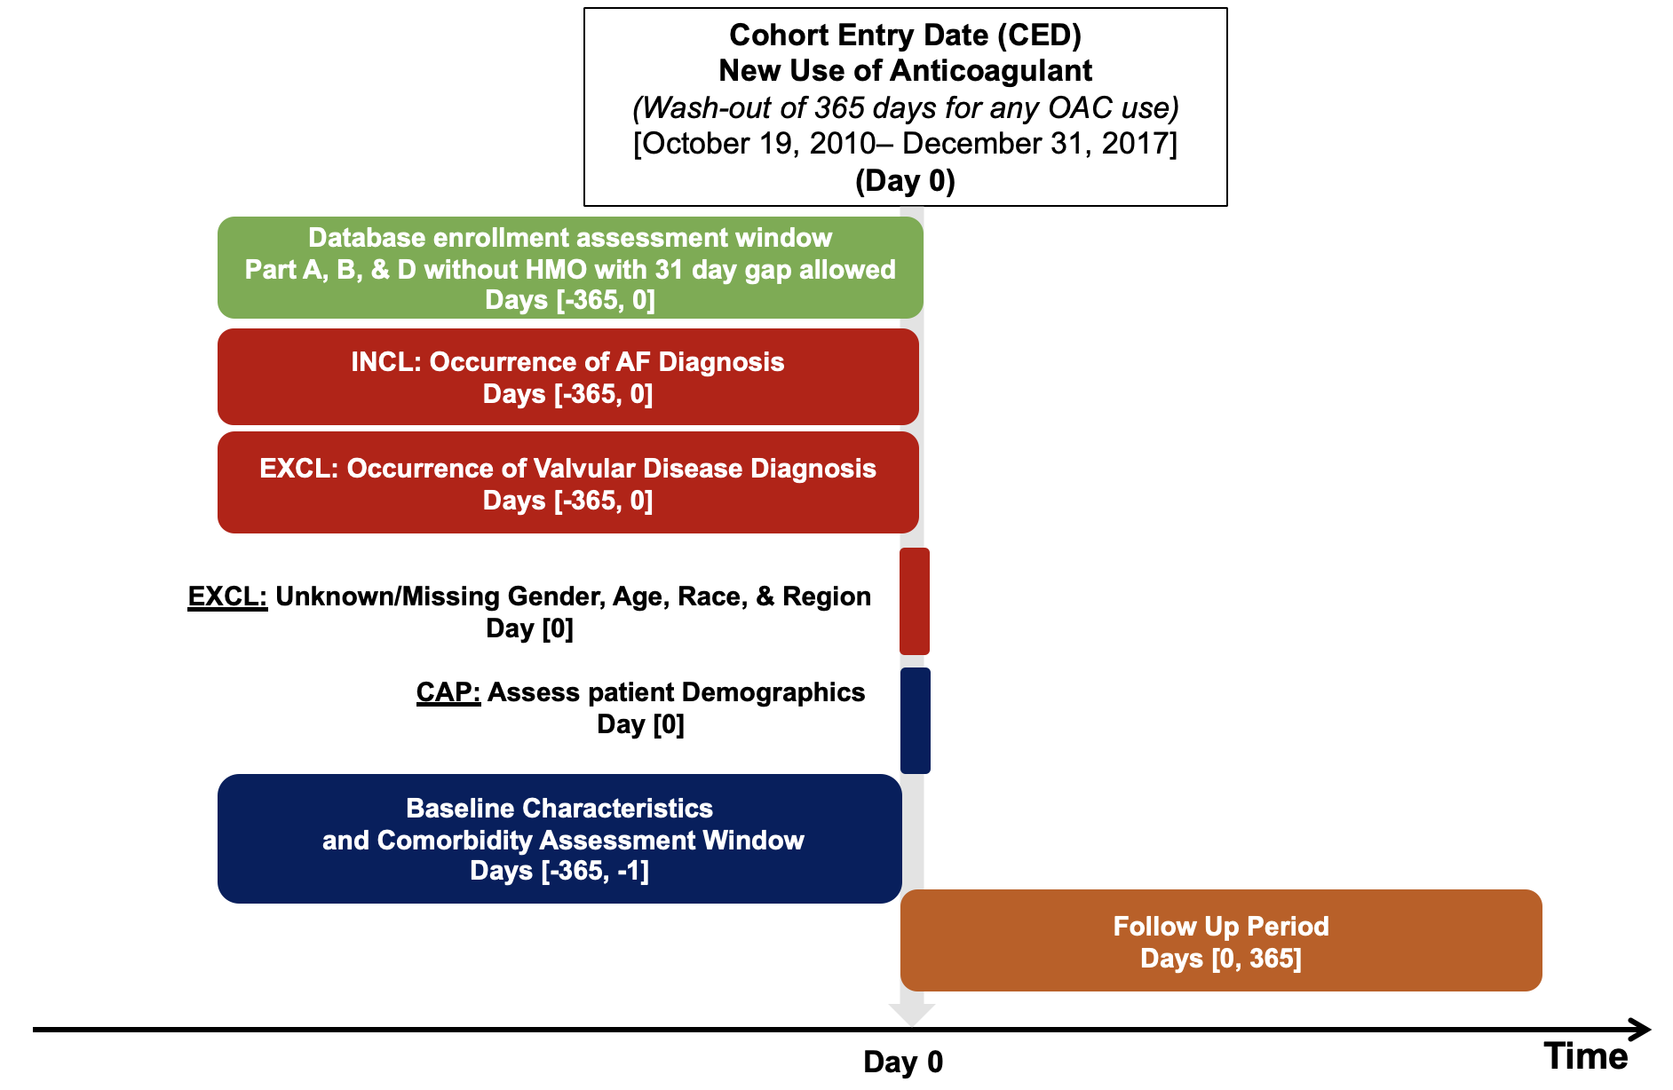

Supplementary Materials Figure S2. Observed vs. predicted ICH events based on AF ICH risk model with interaction terms
Abbreviations: ICH, intracranial hemorrhage; AF, atrial fibrillation
Chi-squared values based on the Hosmer-Lemeshow test were 177.1 (p<0.01) in the training set and 52.3 (p<0.01) in the validation set.
Supplementary Materials Figure S3. Comparison of AF ICH risk model with interaction terms vs. HAS-BLED score and vs. Homer fall risk model: AUC in predicting 1-year risk of ICH
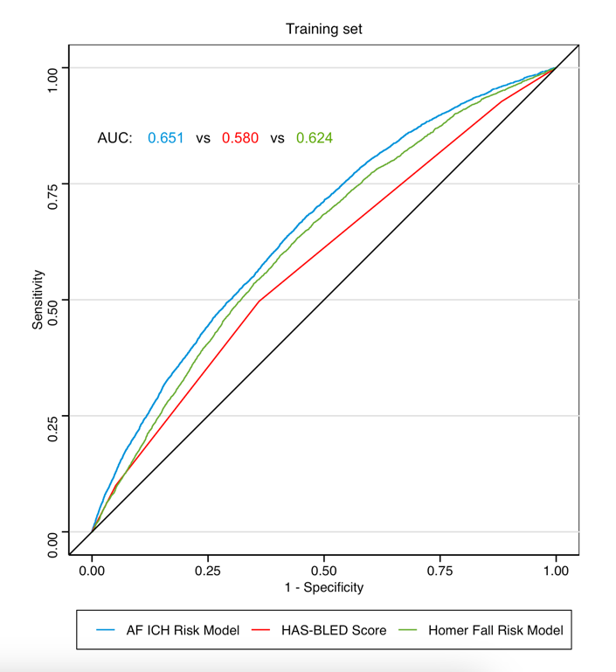 | 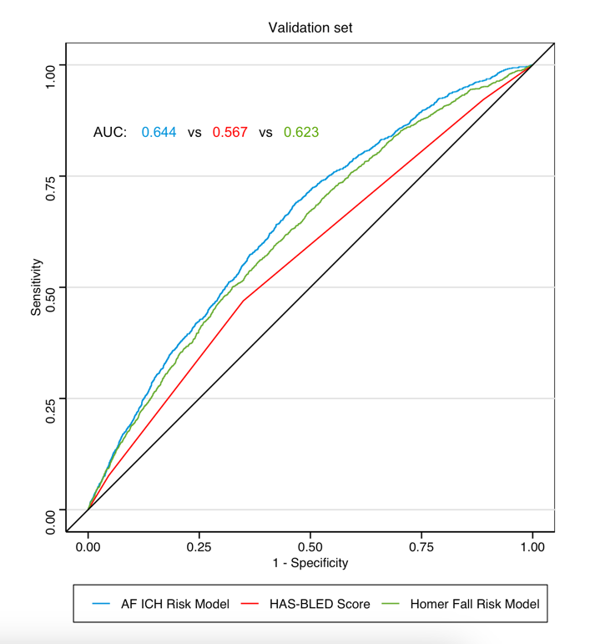
Abbreviations: AF, atrial fibrillation; ICH, intracranial hemorrhage; AUC, area under receiver operating characteristic curve

Supplementary Materials Figure S4. Observed vs. predicted ICH events based on AF ICH risk model weighted by IPCW
Abbreviations: ICH, intracranial hemorrhage; AF, atrial fibrillation; IPCW, inverse probability censoring weighting
Chi-squared values based on the Hosmer-Lemeshow test were 2651.4 (p<0.01) in the training set and 648.8 (p<0.01) in the validation set.
Supplementary Materials Figure S5. Comparison of AF ICH risk model weighted by IPCW vs. HAS-BLED score and vs. Homer fall risk model: AUC in predicting 1-year risk of ICH
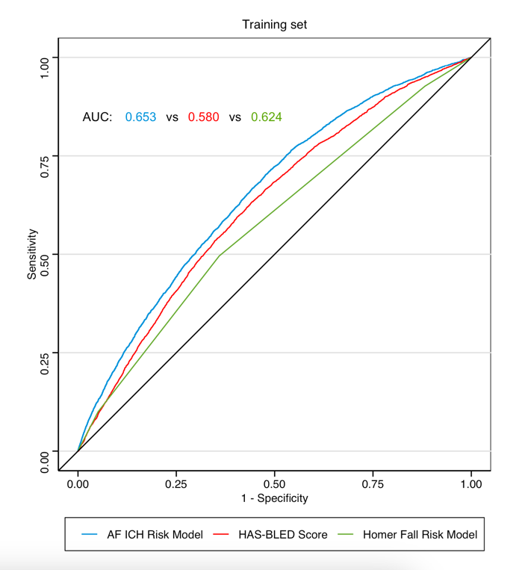 | 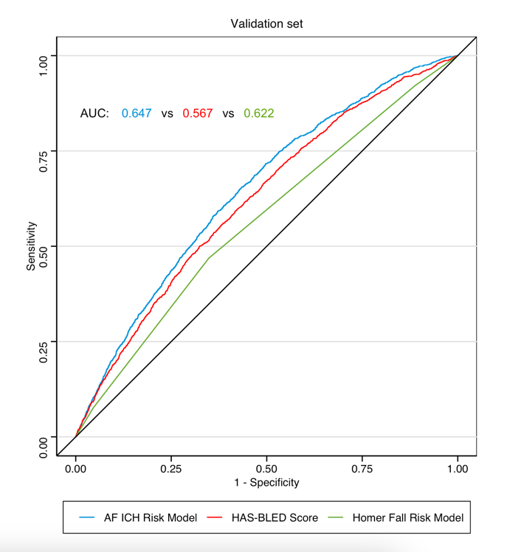
Abbreviations: AF, atrial fibrillation; ICH, intracranial hemorrhage; IPCW, inverse probability censoring weighting, AUC, area under receiver operating characteristic curve

Supplementary Materials Figure S6. Observed vs. predicted IPH events based on AF ICH risk model
Abbreviations: IPH, intraparenchymal hemorrhage, ICH, intracranial hemorrhage; AF, atrial fibrillation
Chi-squared values based on the Hosmer-Lemeshow test were 2516.5 (p<0.01) in the training set and 850.8 (p<0.01) in the validation set.
Supplementary Materials Figure S7. Comparison of AF ICH risk model vs. HAS-BLED score and vs. Homer fall risk model: AUC in predicting 1-year risk of IPH
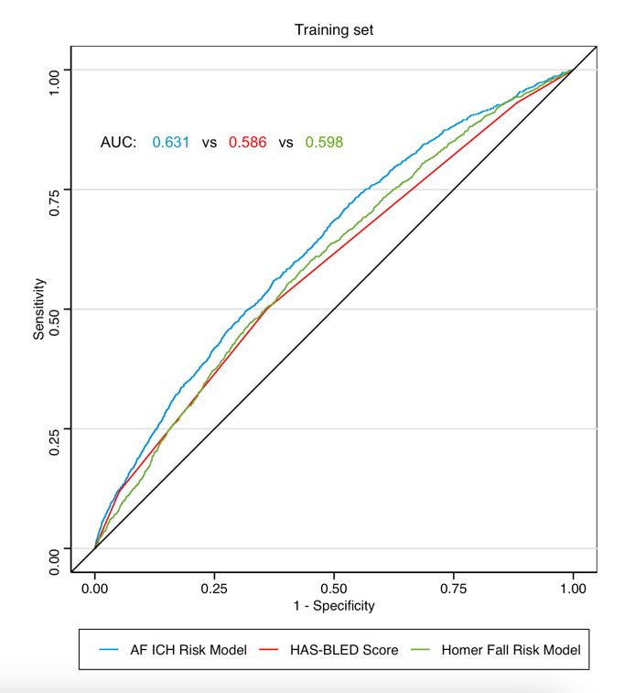 | 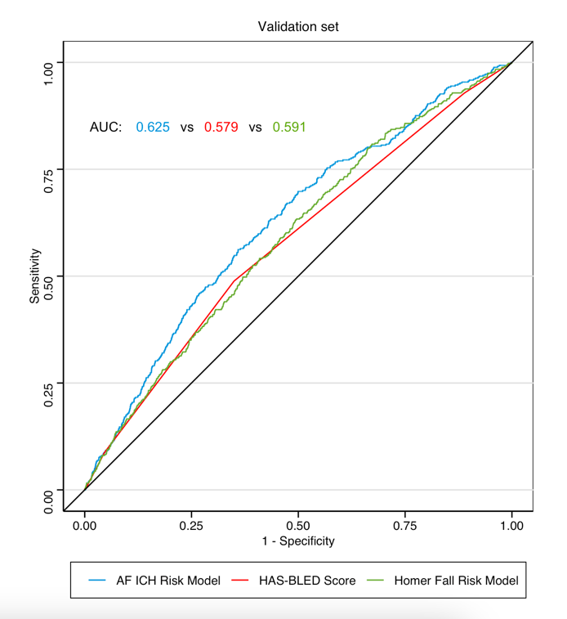
Abbreviations: AF, atrial fibrillation; ICH, intracranial hemorrhage; AUC, area under receiver operating characteristic curve; IPH, intraparenchymal hemorrhage

Supplementary Materials Figure S8. Observed vs. predicted SDH events based on AF ICH risk model
Abbreviations: SDH, subdural hemorrhage, ICH, intracranial hemorrhage; AF, atrial fibrillation
Chi-squared values based on the Hosmer-Lemeshow test were 2082.4 (p<0.01) in the training set and 619.5 (p<0.01) in the validation set.
Supplementary Materials Figure S9. Comparison of AF ICH risk model vs. HAS-BLED score and vs. Homer fall risk model: AUC in predicting 1-year risk of SDH
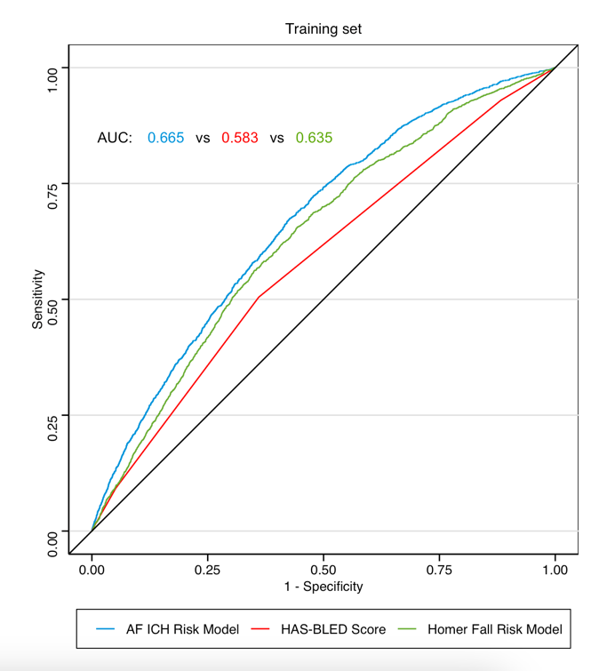 | 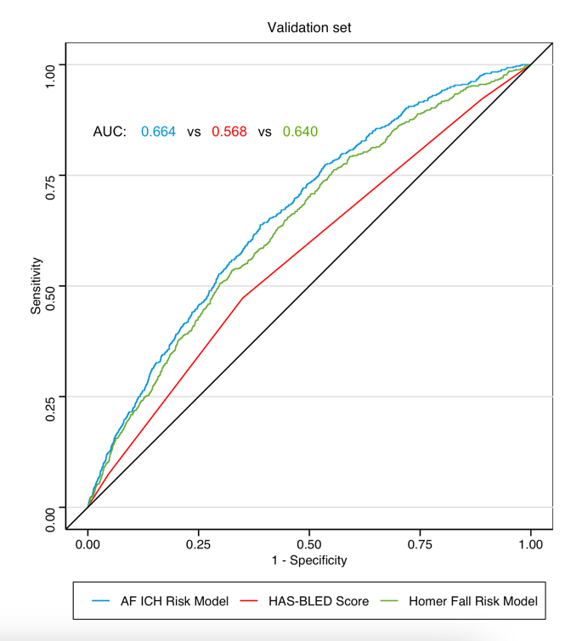
Abbreviations: AF, atrial fibrillation; ICH, intracranial hemorrhage; AUC, area under receiver operating characteristic curve; SDH, subdural hemorrhage

Supplementary Materials Figure S10. Observed vs. predicted ICH events based on AF ICH risk model in population excluding Warfarin users
Abbreviations: ICH, intracranial hemorrhage; AF, atrial fibrillation
Chi-squared values based on the Hosmer-Lemeshow test were 321.89 (p<0.01) in the training set and 98.21 (p<0.01) in the validation set.
Supplementary Materials Figure S11. Comparison of AF ICH risk model vs. HAS-BLED score and vs. Homer fall risk model in population excluding Warfarin users: AUC in predicting 1-year risk of ICH
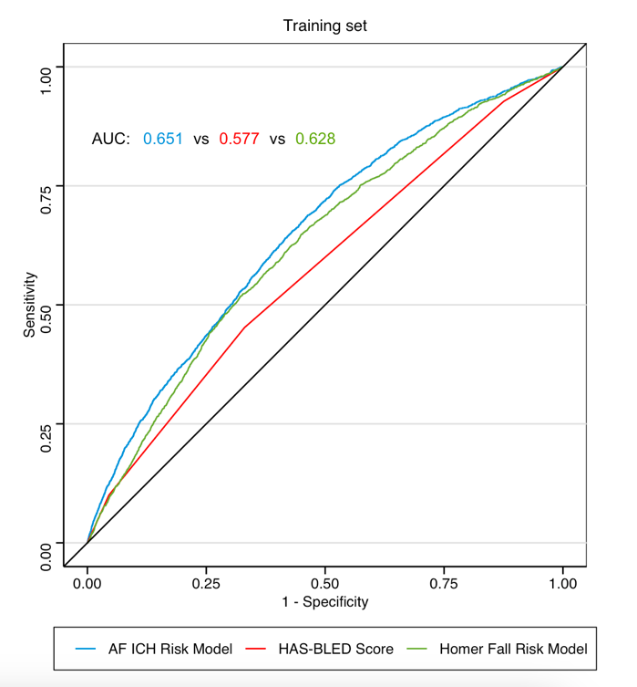 | 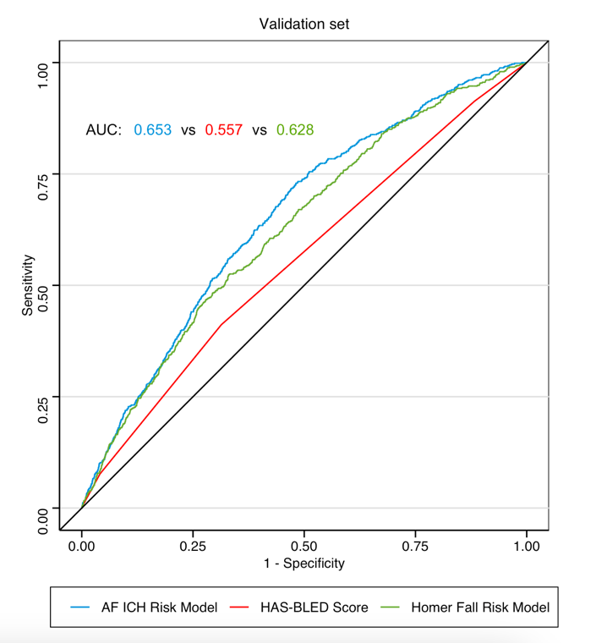
Abbreviations: AF, atrial fibrillation; ICH, intracranial hemorrhage; AUC, area under receiver operating characteristic curve

Supplementary Materials TRIPOD Checklist: Transparent reporting of a multivariable prediction model for individual prognosis or diagnosis (TRIPOD) checklist for Prediction Model Development and Validation
Section/Topic | Item |  | Checklist Item | Page # of Original Manuscript
Title and abstract
Title | 1 | D;V | Identify the study as developing and/or validating a multivariable prediction model, the target population, and the outcome to be predicted. | 1
Abstract | 2 | D;V | Provide a summary of objectives, study design, setting, participants, sample size, predictors, outcome, statistical analysis, results, and conclusions. | 2
Introduction
Background and objectives | 3a | D;V | Explain the medical context (including whether diagnostic or prognostic) and rationale for developing or validating the multivariable prediction model, including references to existing models. | 3
Background and objectives | 3b | D;V | Specify the objectives, including whether the study describes the development or validation of the model or both. | 3
Methods
Source of data | 4a | D;V | Describe the study design or source of data (e.g., randomized trial, cohort, or registry data), separately for the development and validation data sets, if applicable. | 4
Source of data | 4b | D;V | Specify the key study dates, including start of accrual; end of accrual; and, if applicable, end of follow-up. | 2, 4
Participants | 5a | D;V | Specify key elements of the study setting (e.g., primary care, secondary care, general population) including number and location of centers. | 4
Participants | 5b | D;V | Describe eligibility criteria for participants. | 4
Participants | 5c | D;V | Give details of treatments received, if relevant. | 4
Outcome | 6a | D;V | Clearly define the outcome that is predicted by the prediction model, including how and when assessed. | 4, Table S2
Outcome | 6b | D;V | Report any actions to blind assessment of the outcome to be predicted. | NA
Predictors | 7a | D;V | Clearly define all predictors used in developing or validating the multivariable prediction model, including how and when they were measured. | 5, Table S3
Predictors | 7b | D;V | Report any actions to blind assessment of predictors for the outcome and other predictors. | NA
Sample size | 8 | D;V | Explain how the study size was arrived at. | 4, Fig. 1
Missing data | 9 | D;V | Describe how missing data were handled (e.g., complete-case analysis, single imputation, multiple imputation) with details of any imputation method. | 4
Statistical analysis methods | 10a | D | Describe how predictors were handled in the analyses. | 5, 6
Statistical analysis methods | 10b | D | Specify type of model, all model-building procedures (including any predictor selection), and method for internal validation. | 6
Statistical analysis methods | 10c | V | For validation, describe how the predictions were calculated. | 6, 7
Statistical analysis methods | 10d | D;V | Specify all measures used to assess model performance and, if relevant, to compare multiple models. | 6, 7
Statistical analysis methods | 10e | V | Describe any model updating (e.g., recalibration) arising from the validation, if done. | 7 (for Homer and HAS-BLED)
Risk groups | 11 | D;V | Provide details on how risk groups were created, if done. | 6, 7
Development vs. validation | 12 | V | For validation, identify any differences from the development data in setting, eligibility criteria, outcome, and predictors. | 6
Results
Participants | 13a | D;V | Describe the flow of participants through the study, including the number of participants with and without the outcome and, if applicable, a summary of the follow-up time. A diagram may be helpful. | 8, Table 3
Participants | 13b | D;V | Describe the characteristics of the participants (basic demographics, clinical features, available predictors), including the number of participants with missing data for predictors and outcome. | 8,  Figure 1, Table 1 (p19, 20)
Participants | 13c | V | For validation, show a comparison with the development data of the distribution of important variables (demographics, predictors and outcome). | Table 1 (p19, 20)
Model development | 14a | D | Specify the number of participants and outcome events in each analysis. | 8
Model development | 14b | D | If done, report the unadjusted association between each candidate predictor and outcome. | NA
Model specification | 15a | D | Present the full prediction model to allow predictions for individuals (i.e., all regression coefficients, and model intercept or baseline survival at a given time point). | Table 2 (p20,21)
Model specification | 15b | D | Explain how to the use the prediction model. | 11, 12
Model performance | 16 | D;V | Report performance measures (with CIs) for the prediction model. | 8, 9, Table 3 (p 22-23)
Model-updating | 17 | V | If done, report the results from any model updating (i.e., model specification, model performance). | NA
Discussion
Limitations | 18 | D;V | Discuss any limitations of the study (such as nonrepresentative sample, few events per predictor, missing data). | 13, 14
Interpretation | 19a | V | For validation, discuss the results with reference to performance in the development data, and any other validation data. | 10, 11, 12
Interpretation | 19b | D;V | Give an overall interpretation of the results, considering objectives, limitations, results from similar studies, and other relevant evidence. | 11, 12, 13, 14
Implications | 20 | D;V | Discuss the potential clinical use of the model and implications for future research. | 11, 12
Other information
Supplementary information | 21 | D;V | Provide information about the availability of supplementary resources, such as study protocol, Web calculator, and data sets. | Supplement
Funding | 22 | D;V | Give the source of funding and the role of the funders for the present study. | 14

