Appendix 1
RNA-seq
Poly (A) mRNA was isolated using Beads (Invitrogen) with oligo (dT) after collecting total RNA. To fragment the mRNA and obtain short fragments, fragmentation buffer was added. Random hexamer primer were then used with these short fragments as templates to synthesize the first-strand cDNA. The second-strand cDNA was synthesized using buffer, dNTPs, RNase H, and DNA polymerase I. The short fragments were purified using the QIAQuick PCR Extraction Kit (Qiagen) and treated with EB buffer for end reparation and addition of poly(A) tails. Sequencing adaptors were connected to the short fragments. Suitable fragments were selected as templates for PCR amplification based on agarose gel electrophoresis. Finally, the library was sequenced using the HiSeq X TEN platform. FASTQ files were generated and sequencing reads aligned to human GRCh37/hg19 using the Omicsoft sequence aligner.¹ Gene expression levels were quantified by upper quantile normalized fragments per kilobyte of transcript per million mapped reads (log10).
- Hu J, Ge H, Newman M, Liu K. OSA: a fast and accurate alignment tool for RNA-Seq. Bioinformatics. 2012;28(14):1933-1934.

Appendix 2
Immunohistochemistry and Immunoscore calculation
The previous article has provided information on the methodology of immunohistochemistry and Immunoscore calculation.¹ Surgical tissue specimens were prepared using paraffin blocks and then incubated with CD3 (2GV6, Ventana) and CD8 (C8/44, Dako) monoclonal antibodies at 4℃ for 24 hours. The EnVision system and DAB-chromogen (Dako) were applied, and methylene blue was used for counterstaining. High power magnification (20X) with the ZEISS Axio Scan.Z1 Slide Scanner (the University of Sydney, Bosch Institute) was used to examine sections. Three representative areas of the center of the tumor (CT) and invasive margin (IM) were captured respectively. The captured images were imported into ImagePro Plus software (Media Cybernetics) to quantify the number of CD3 and CD8 positive cells. The density of positive cells was recorded as the number of cells per mm² of tissue surface.² The mean density of the three areas of CT/IM was calculated for each section and used for analysis. The median cell density for all patients was used as the cutoff value to separate patients into different groups based on the extent of tumor infiltration.³ The cut-off thresholds for CD3 and CD8 cell densities were 189, 92 cells/mm² in CT areas, and 474, 284 cells/mm² in IM areas, respectively. Cell densities in both CT and IM areas were analyzed. A binary score (0 for low, 1 for high) was assigned for each immune cell type (CD3+ and CD8+) in CT and IM based on the predefined thresholds. The Immunoscore for each patient was calculated by summing the scores in CT and IM, resulting in a range of 0-4.⁴ Patients with an immunoscore ≥ 3 were classified as having a high immunoscore, while those with an immunoscore ≤ 2 were classified as having a low immunoscore.
- Chen S, Feng S, Wei J, et al. Pretreatment prediction of immunoscore in hepatocellular cancer: a radiomics-based clinical model based on Gd-EOB-DTPA-enhanced MRI imaging. Eur Radiol. 2019;29(8):4177-4187.
- Galon J, Costes A, Sanchez-Cabo F, et al. Type, density, and location of immune cells within human colorectal tumors predict clinical outcome. Science. 2006;313(5795):1960-1964.
- Gabrielson A, Wu Y, Wang H, et al. Intratumoral CD3 and CD8 T-cell Densities Associated with Relapse-Free Survival in HCC. Cancer Immunol Res. 2016;4(5):419-430.
- Galon J, Mlecnik B, Bindea G, et al. Towards the introduction of the 'Immunoscore' in the classification of malignant tumours. J Pathol. 2014;232(2):199-209.

Table S1 A Summary of features extracted by the Ultrasomics-Platform (Version 2.1, Ultrasomics Artificial Intelligence X-lab, Guangzhou) .
Features Class | Sub-class | No. of Features | Total Number
Original[1] | First-order | 18 | 122
Original[1] | GLCM | 23 | 122
Original[1] | GLRLM | 16 | 122
Original[1] | GLSZM | 16 | 122
Original[1] | NGTDM | 5 | 122
Original[1] | GLDM | 13 | 122
Original[1] | Shape | 31 | 122
Ipris | - | 48 | 48
CoLIAGe [2] | - | 1170 | 1170
Wavelets | - | 432 | 432
shearlet | - | 2944 | 2944
Gabors [3] | glbp | 120 | 1080
Gabors [3] | gldp | 480 | 1080
Gabors [3] | gltp | 240 | 1080
Gabors [3] | gLTCoPs | 240 | 1080
PLBP[4]+WLLBP | - | 140 | 140
Total | - | 5936 | 5936
- https://pyradiomics.readthedocs.io/en/latest/features.html.
- Prasanna P, Tiwari P, Madabhushi A. Co-occurrence of Local Anisotropic Gradient Orientations (CoLlAGe): A new radiomics descriptor. Sci Rep. 2016;6:37241.
- Murala, S. and Q.M. Jonathan Wu, Local ternary co-occurrence patterns: A new feature descriptor for MRI and CT image retrieval. Neurocomputing. 2013. 119: p. 399-412.
- Cai L, Wang X, Wang Y, Guo Y, Yu J, Wang Y. Robust phase-based texture descriptor for classification of breast ultrasound images. Biomed Eng Online. 2015;14:26.

Appendix 3
Tertiary lymphoid structures (TLS) are organized aggregates of immune cells that form postnatally in nonlymphoid tissues. With few exceptions, the presence of TLSs in tumors correlates with better prognosis and clinical outcome of immunotherapy.¹ It has been demonstrated that TLS density correlates with that of CD8+ T cells and CD4+ T cells in tumors.² In the cohort of 257 patients in our study, there were intra-tumor TLS in 140 patients (54.4%). The median GEP value was -0.384 (IQR: 0.578) in the TLS+ group and -0.665 (IQR: 0.362) in the TLS-group. There was a statistical difference in GEP values between the two groups (p < 0.01) (Figure S1).

Figure S1 Analysis of correlation between the GEP and the presence of TLS in the primary cohort. T cell-inflamed GEP of the TLS+ group (blue) was significantly higher than that of the TLS- group (red).
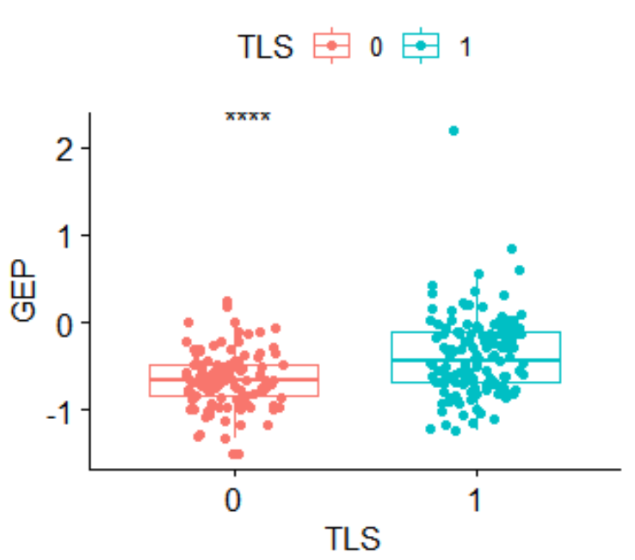
- Schumacher TN, Thommen DS. Tertiary lymphoid structures in cancer. Science. 2022;375(6576):eabf9419.
- Goc J, Germain C, Vo-Bourgais TK, et al. Dendritic cells in tumor-associated tertiary lymphoid structures signal a Th1 cytotoxic immune contexture and license the positive prognostic value of infiltrating CD8+ T cells. Cancer Res. 2014;74(3):705-715.

Table S2 Clinic-pathologic characteristics in the independent cohort

Parameters | Total | Parameters | Total
Age, years, mean (SD) | 53.9(11.9) | PT, S
Gender |  | <14 | 43(93.5%)
Male | 40(87.0%) | >=14 | 3(6.5%)
Female | 6(13.0%) | TBIL, umol/L
Lesion size, cm, median (IQR)  Lesion number  1  ≥2  Liver cirrhosis  Positive  Negative | 5.1 (3.5,8.2)  21(45.7%)  25(54.3%)  36(78.3%)  10(21.7%) | <22  >=22  DBIL, umol/L  <7  >=7  ALB, g/L  <35  >=35 | 37(80.4%)  9(19.6%)  42(91.3%)  4(8.7%)  9(19.6%)  37(80.4%)
CEA, ug/L |  | ALT, U/L
<5 | 37(80.4%) | <40 | 22(47.8%)
>=5 | 9(19.6%) | >=40 | 24(52.2%)
AFP, ug/L |  | AST, U/L
<400 | 22(47.8%) | <37 | 15(32.6%)
>=400 | 24(52.2%) | >=37 | 31(67.4%)
HBsAg |  | ALP, U/L
Positive | 38(82.6%) | <110 | 29(63.0%)
Negative | 8(17.4%) | >=110 | 17(37.0%)
WBC, 10^9/L |  | GGT, U/L
<10 | 43(93.5%) | <50 | 15(32.6%)
>=10 | 3(6.5%) | >=50 | 31(67.4%)
NE% |  | BCLC stage
<0.75 | 45(97.8%) | 0 | 1(2.2%)
>=0.75 | 1(2.2%) | A | 14(30.4%)
PLT, 10^9/L |  | B | 8(17.4%)
<100 | 5(10.9%) | C | 23(50.0%)
>=100 | 41(89.1%)

Continuous variables were presented in mean with standard deviation or median with interquartile rage. Categorical variables are presented as n (%). SD, standard deviation; IQR, inter-quartile range;

Table S3 The key features and their coefficients of the AP model
Feature number | Feature name | Class | Coefficient
F112 | textural_phenotype_level_10-20% | Original | -0.284915234
F159 | Ipris_shell2_gd_std | Ipris | 0.18199094
F504 | CoLIAGe2D_WindowSize5_Sum Average_firstorder_Mean | CoLIAGe | -0.288652906
F509 | CoLIAGe2D_WindowSize5_Sum Average_firstorder_RootMeanSquared | CoLIAGe | 0.128665492
F596 | CoLIAGe2D_WindowSize5_Difference Entropy_firstorder_ Minimum | CoLIAGe | 0.639708812
F772 | CoLIAGe2D_WindowSize7_Sum Entropy_firstorder_ Maximum | CoLIAGe | -0.940423835
F967 | CoLIAGe2D_WindowSize9_Sum Average_firstorder_ Entropy | CoLIAGe | -0.579710153
F1244 | CoLIAGe2D_WindowSize11_Sum Entropy_firstorder_ Minimum | CoLIAGe | 1.472448823
F1382 | wavelet-LLH_lbp-3D-k_firstorder_InterquartileRange | Wavelets | -0.560098851
F1561 | wavelet-HLH_lbp-3D-m1_firstorder_Entropy | Wavelets | -0.187639152
F1579 | wavelet-HLH_lbp-3D-m2_firstorder_Entropy | Wavelets | -0.56667924
F1835 | shearlet2DIdxs[ 1 1 -2]_glszm_GrayLevelNonUniformity Normalized | shearlet | -0.279645424
F1934 | shearlet2DIdxs[ 1 1 -1]_glszm_LowGrayLevelZone Emphasis | shearlet | -0.665547615
F2294 | shearlet2DIdxs[ 1 2 -2]_glszm_GrayLevelNonUniformity | shearlet | -0.452277039
F2744 | shearlet2DIdxs[ 1 3 -4]_glrlm_RunVariance | shearlet | -0.090336406
F3214 | shearlet2DIdxs[1 3 1]_glszm_GrayLevelNonUniformity | shearlet | 0.666718453
F3402 | shearlet2DIdxs[1 3 3]_glszm_ZonePercentage | shearlet | 0.632623327
F3611 | shearlet2DIdxs[ 2 1 -1]_gldm_SmallDependenceHighGray LevelEmphasis | shearlet | 0.124344612
F3767 | shearlet2DIdxs[2 1 1]_glszm_GrayLevelNonUniformity Normalized | shearlet | -0.553376932
F3770 | shearlet2DIdxs[2 1 1]_glszm_ZonePercentage | shearlet | -0.578464203
F3960 | shearlet2DIdxs[2 2 0]_glszm_SmallAreaLowGrayLevel Emphasis | shearlet | -0.295848303
F4087 | shearlet2DIdxs[ 2 3 -3]_firstorder_RootMeanSquared | shearlet | -0.524797305
F4136 | shearlet2DIdxs[ 2 3 -3]_glszm_SizeZoneNonUniformity | shearlet | -0.24329869
F4138 | shearlet2DIdxs[ 2 3 -3]_glszm_ZonePercentage | shearlet | -0.186223694
F4143 | shearlet2DIdxs[ 2 3 -3]_glszm_HighGrayLevelZone Emphasis | shearlet | -0.218225695
F4640 | shearlet2DIdxs[2 3 3]_firstorder_Skewness | shearlet | 0.528283286
F4844 | gldp_hist_0_kernel0_6 | Gabors | 0.416723835
F4917 | gldp_hist_0_kernel7_9 | Gabors | 0.228927827
F5019 | gldp_hist_45_kernel6_1 | Gabors | 0.564998149
F5103 | gldp_hist_90_kernel2_5 | Gabors | 0.595410277
F5123 | gldp_hist_90_kernel4_5 | Gabors | -0.187576991
F5232 | gldp_hist_135_kernel3_4 | Gabors | 1.252368849
F5259 | gldp_hist_135_kernel6_1 | Gabors | 0.32211153
F5310 | gldp_hist_135_kernel11_2 | Gabors | -0.461462434
F5894 | WL_lbp_hist_cV2_6 | PLBP+WLLBP | -0.41976954
F5897 | WL_lbp_hist_cV2_9 | PLBP+WLLBP | -0.732865322
Intercept: -0.000564

Figure S2 Radiomics feature selection of PVP model (a) or DP model (b) using LASSO regression in the primary cohort.
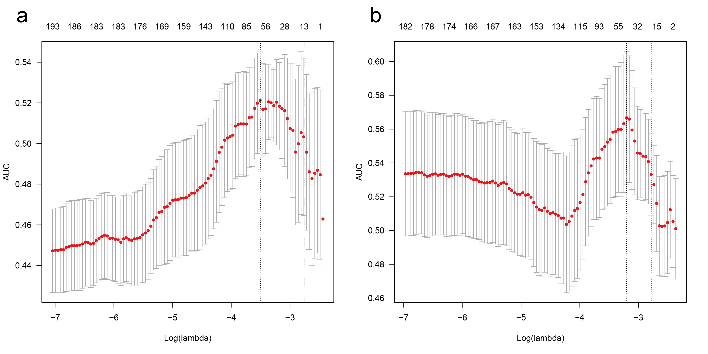
Table S4 The key features and their coefficients of the PVP model
Feature number | Feature name | Class | Coefficient
F740 | CoLIAGe2D_WindowSize7_Sum Average_firstorder_Minimum | CoLIAGe | -0.324512052
F1064 | CoLIAGe2D_WindowSize9_Difference Entropy_firstorder_ Minimum | CoLIAGe | -0.102234505
F1210 | CoLIAGe2D_WindowSize11_Sum Average_firstorder_Robust MeanAbsoluteDeviation | CoLIAGe | -0.363710913
F2118 | shearlet2DIdxs[1 1 1]_glszm_LowGrayLevelZoneEmphasis | shearlet | 0.339995562
F2758 | shearlet2DIdxs[ 1 3 -4]_glszm_ZonePercentage | shearlet | -0.378852161
F2845 | shearlet2DIdxs[ 1 3 -3]_glszm_LargeAreaEmphasis | shearlet | 0.086764525
F3590 | shearlet2DIdxs[ 2 1 -1]_glszm_LowGrayLevelZoneEmphasis | shearlet | -0.325892205
F3965 | shearlet2DIdxs[2 2 0]_ngtdm_Contrast | shearlet | -0.154209796
F4043 | shearlet2DIdxs[2 2 1]_glszm_GrayLevelNonUniformity Normalized | shearlet | -0.123616095
F4143 | shearlet2DIdxs[ 2 3 -3]_glszm_HighGrayLevelZoneEmphasis | shearlet | -0.077537049
F4889 | gldp_hist_0_kernel5_1 | Gabors | 0.201782653
F4913 | gldp_hist_0_kernel7_5 | Gabors | -0.559208288
F5191 | gldp_hist_90_kernel11_3 | Gabors | -0.293964048
Intercept: -0.00752

Table S5 The key features and their coefficients of the DP model
Feature number | Feature name | Class | Coefficient
F435 | CoLIAGe2D_WindowSize5_Contrast_firstorder_Range | CoLIAGe | -0.356022181
F517 | CoLIAGe2D_WindowSize5_Sum Variance_firstorder_Entropy | CoLIAGe | 0.128468536
F993 | CoLIAGe2D_WindowSize9_Sum Variance_firstorder_Range | CoLIAGe | -0.183386553
F1442 | wavelet-LHL_lbp-3D-k_firstorder_Minimum | Wavelets | -0.041287702
F1842 | shearlet2DIdxs[ 1 1 -2]_glszm_LowGrayLevelZoneEmphasis | shearlet | -0.113658194
F1934 | shearlet2DIdxs[ 1 1 -1]_glszm_LowGrayLevelZoneEmphasis | shearlet | -0.309361942
F2210 | shearlet2DIdxs[1 1 2]_glszm_LowGrayLevelZoneEmphasis | shearlet | -0.087655237
F2493 | shearlet2DIdxs[1 2 0]_ngtdm_Contrast | shearlet | -0.161217341
F2670 | shearlet2DIdxs[1 2 2]_glszm_LowGrayLevelZoneEmphasis | shearlet | -0.608513012
F2845 | shearlet2DIdxs[ 1 3 -3]_glszm_LargeAreaEmphasis | shearlet | -0.00064716
F3167 | shearlet2DIdxs[1 3 1]_firstorder_RootMeanSquared | shearlet | -0.436225109
F3306 | shearlet2DIdxs[1 3 2]_glszm_GrayLevelNonUniformity | shearlet | -0.459545507
F3459 | shearlet2DIdxs[1 3 4]_glcm_JointEntropy | shearlet | 0.205112039
F3462 | shearlet2DIdxs[1 3 4]_glcm_Idm | shearlet | 0.767717353
F3805 | shearlet2DIdxs[ 2 2 -1]_firstorder_MeanAbsoluteDeviation | shearlet | -0.517186501
F4232 | shearlet2DIdxs[ 2 3 -2]_glszm_ZoneVariance | shearlet | 0.432626031
F4973 | gldp_hist_45_kernel1_5 | Gabors | -1.142234402
F5129 | gldp_hist_90_kernel5_1 | Gabors | 0.36819745
F5274 | gldp_hist_135_kernel7_6 | Gabors | -0.271874944
Intercept: -0.113854

Table S6 The coefficients of the integrated model
Factor | AP model prediction value | PVP model prediction value | DP model prediction value
Coefficient | 0.9321 | 0.8148 | 0.3973

Intercept: 0.0668

Table S7 Performance of the four Models
Model | Number of features | AUC | Sensitivity | Specificity | Accuracy | P value
AP model | 36 | 0.889 | 0.799 | 0.828 | 0.813 | P1<0.01
PVP model | 13 | 0.740 | 0.769 | 0.597 | 0.683
DP model | 19 | 0.812 | 0.771 | 0.722 | 0.746 | P2=0.02
integrated model | 68 | 0.923 | 0.870 | 0.850 | 0.860 | P3=0.20
The p-value indicates the result of the DeLong test of a comparison between the AP model and the other three models. P1: AP model vs PVP model, P2: AP model vs DP model, P3: AP model vs integrated model

Figure S3 ROC of PVP model (a), DP model (b) and integrated model (c) for 5-fold cross-validation.
